**ARNAB SAHA**

**SOFTWARE DEVELOPMENT ENGINEER**

# Experience 3 years

 **Amazon India Dev. Center**

**Software Development Engineer**

December 2020 – Present

Working as a Machine Learning Engineer for Amazon Connect, an Omni-channel cloud contact center for providing customer service.

**FEATURES DELIVERED / ACCOMPLISHMENTS:**

* Responsible for multiple AWS development deliverables across the multiple AWS services like Lambda, Connect, S3, Dynamo DB, Sage Maker, and Kinesis.
* Tech-stack includes **Python**, Node JS, and Shell.

**Paytm India**

**Software Engineer**

June 2020 – December 2020

Worked as a Full stack Developer in application, which does insurance brokering for the subscribers & users. Worked in a **Unified Engineering methodology**, designing, developing, testing and deploying the product by myself.

**FEATURES DELIVERED / ACCOMPLISHMENTS:**

* Successfully integrated E2E, four commercial partners providing motor-insurance with the Paytm ecosystem: Kotak, SBI General, HDFC Ergo, & Reliance.
* 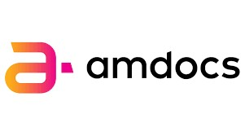Tech-stack included **Kafka**, Vault, Kibana, Roll bar, Argo-CD, **Spring boot & Kotlin**, **Vue.JS**, Docker, Kubernetes, Jenkins and **Cassandra**, MYSQL DB.

## Amdocs Dev. Center India

**Software Developer (Experienced)**

June2018 – June 2020

Worked as Developer in application, which does Billing and Charging of Usages for our subscription contracts, implementing **IFRS-15**. Product followed Micro-services architecture with Spring Boot framework paradigm.

**FEATURES DELIVERED / ACCOMPLISHMENTS:**

* **Went to onsite** for leading and guiding the team for developing the business logic customization of the software. Our clients were leading Telecom leaders from the Europe and the US.
* Acted as a **point of contact** for **Production** issues from European and US counterparts and ensure timely deliveries.
* Worked in fast-paced and time-sensitive **agile development** methodology. Our

Tech-stack included Kafka, Ansible, Spring boot & Java, Docker, Kubernetes, OpenShift, Jenkins and **Oracle DB**.

Education

**Indian Institute of Technology (ISM), Dhanbad, Jharkhand –** **2014-18**

Computer Science & Engineering

B.Tech (Honours)– 8.14/10



Summer Research Internship – IIT KGP, Kharagpur, WB

Summer – 2015

Software Development Internship – Wipro, Kochi, KL

Summer – 2017

|  |
| --- |
| [arnabofficial1996@gmail.com](mailto:arnabofficial1996@gmail.com) |

(+91)-8877586233



[Hyderabad,](https://www.google.com/maps/place/Amazon+Development+Center/@17.4372081,78.3829512,512m/data=!3m1!1e3!4m5!3m4!1s0x3bcb9158929e141f:0xce4890b152374ab!8m2!3d17.437407!4d78.3855381) India [arnabsaha1996](https://www.linkedin.com/in/arnabsaha1996/)

<https://arnab1996.github.io/>  [Arnab1996](https://github.com/Arnab1996)

# Skills & Proficiency

Java



AWS Utilities: S3, Connect, Lex, Transcribe, Comprehend, Kinesis, Lambda

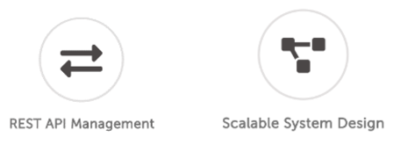

UNIX Scripting



Python



Web Technologies: HTML, CSS, JavaScript (Node JS & React JS)



Frameworks: Spring boot, NumPy



CI/CD: Kubernetes, Docker, Ansible, Jenkins, OpenShift, Argo-CD



**For latest list of certifications, please visit my LinkedIn page.**



**My Software Developmental Specialties**

# Outside Work

* **Portfolio Website** - I did the UX Design and Coding of my personal portfolio websit[e arnab1996.github.io/](https://arnab1996.github.io/)
* Spending time on online forums like **geeksforgeeks, stack overflow, medium** etc.
* Discussing and teaching others in ACM-SIG about technical topics, Competitive coding in leisure time.