Magarpatta City, Pune, Maharashtra, 411028  
+91-8877586233  
[arnabofficial1996@gmail.com](mailto:arnabofficial1996@gmail.com)

To the concerned authority,

I am applying for the position of Senior Software Engineer, which I saw posted on your Career site. Arcesium is a leading post-trade technology and professional services firm, which offers a new way for alternative asset managers to scale their business while maintaining control of critical noninvestment activities. I believe that my experience in development makes me an ideal candidate for this position at your company.

As a graduate from the Indian Institute of Technology (ISM) Dhanbad, I have a significant background in Computer Science Fundamentals. As a major in CSE with Honors, currently, an SDE Experienced at Amdocs India in the Billing and Charging department. I have both technical and Research internships, I have several internships including Software Developer Intern at Wipro, Kochi.

You state in your job listing that you are looking for someone who will build next-generation software used by some of the most sophisticated alternative asset managers, as well as architecting solutions to support new technologies and business initiatives.

I tend to type well-documented and readable production-ready codes while keeping efficiency in mind. I want to contribute to a place where such things do matters. I am quite passionate about learning and experiencing new technologies and stuff. My perseverance and hardworking spirit will benefit your team.

These strengths, combined with a deep and varied academic, internship, and employment experience, prepare me to make a strong and immediate impact at Arcesium.

I am excited about the opportunity to join the Arcesium team as it moves to greater achievements. Thank you for your time and consideration.

Sincerely,

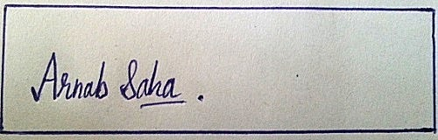  
  
Arnab Saha