Outputs

Assignment 12

Name : Arnab Chakraborty

Stream : CSE

Section : A

University Roll No. : 13000120040

**#Program104:**

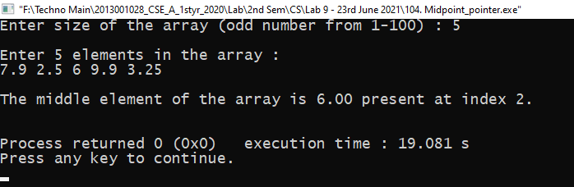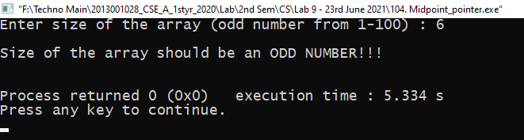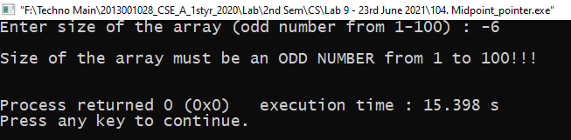

**#Program105:**

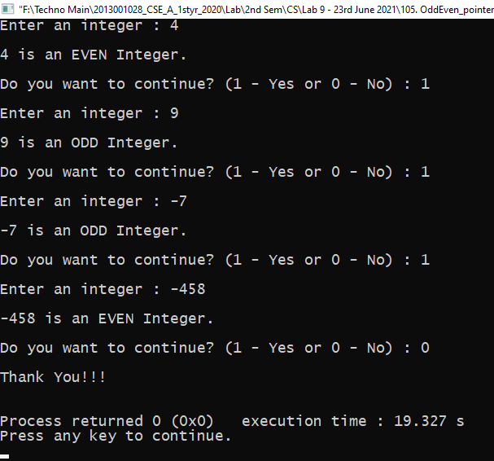

**#Program106:**

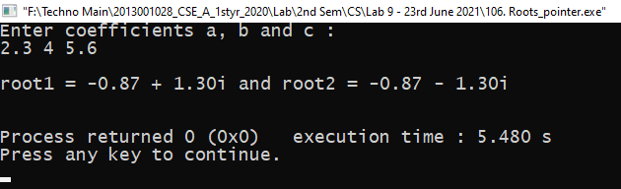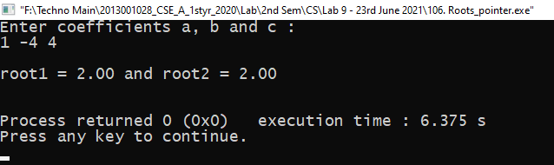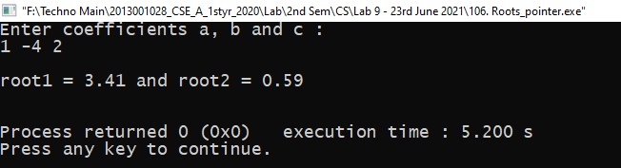

**#Program107:**

