Outputs

Assignment 13

Name : Arnab Chakraborty

Stream : CSE

Section : A

University Roll No. : 13000120040

**#Program108:**

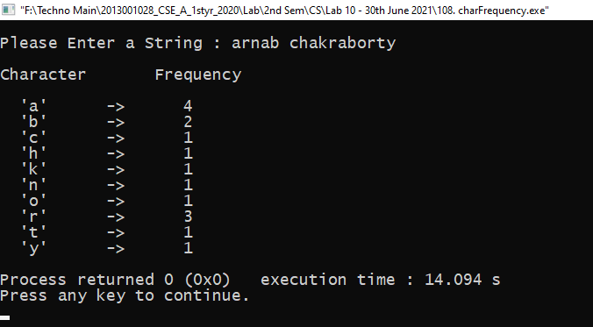

**#Program109:**

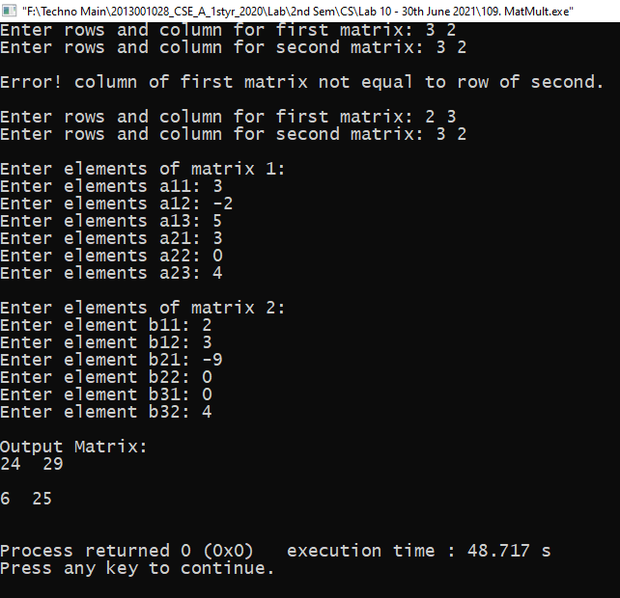

**#Program110:**

