Outputs

Assignment 14

Name : Arnab Chakraborty

Stream : CSE

Section : A

University Roll No. : 13000120040

**#Program110:**

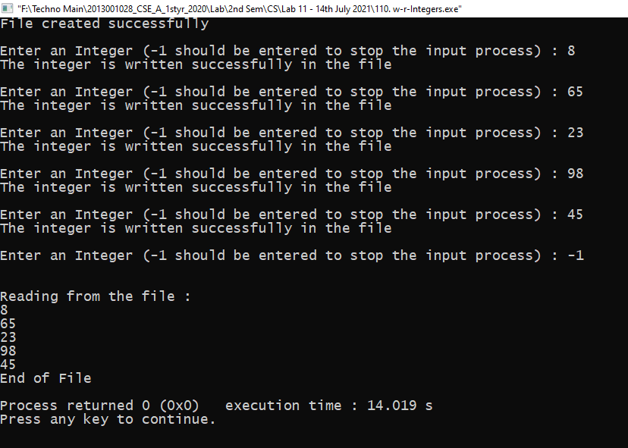

The file **‘test.txt’** is attached in the assignment folder.

**#Program111:**

The file **‘text.txt’** is attached in the assignment folder.

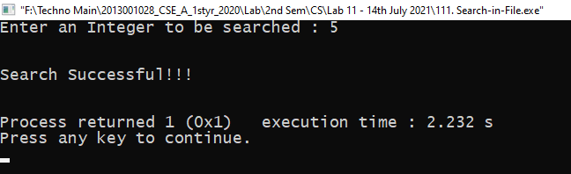

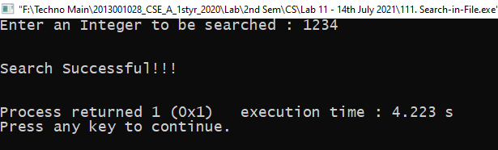

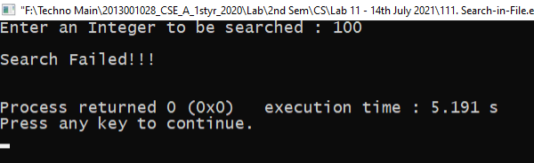

**#Program110:**

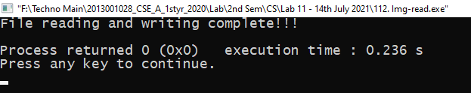

The file **‘black.jpeg’ , ‘black.bin’ and ‘res.txt’** are attached in the assignment folder.