Outputs

Assignment 2

Name : Arnab Chakraborty

Stream : CSE

Section : A

University Roll No. : 13000120040

7.

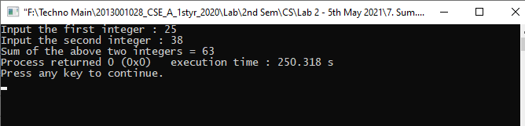

8.

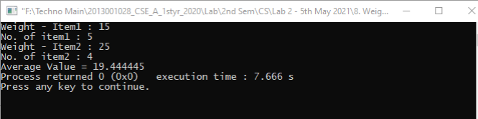

9.

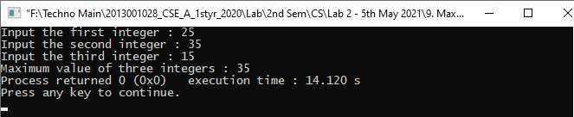

10.

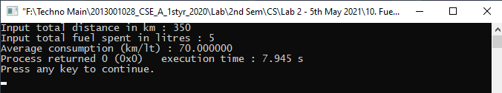

11.

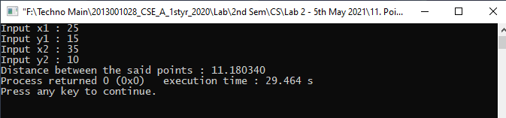

12.

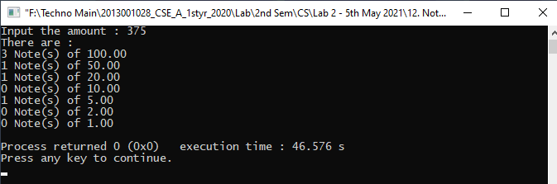

13.

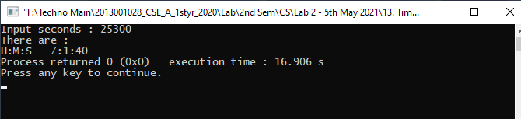

14.

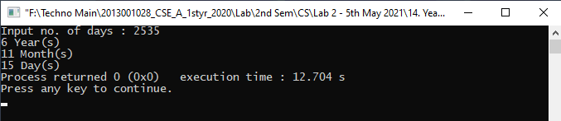

15.

