Outputs

Assignment 7

Name : Arnab Chakraborty

Stream : CSE

Section : A

University Roll No. : 13000120040

40:

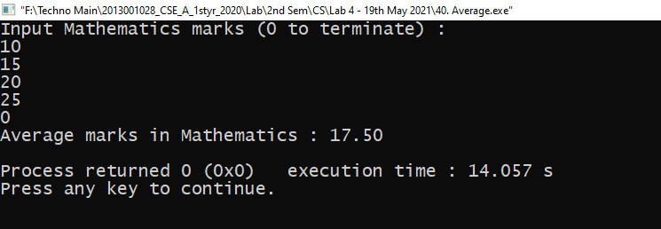

41:

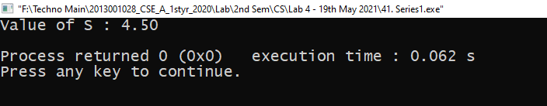

42:

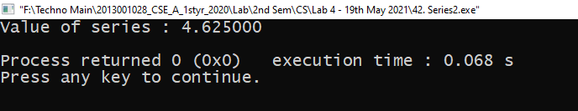

43:

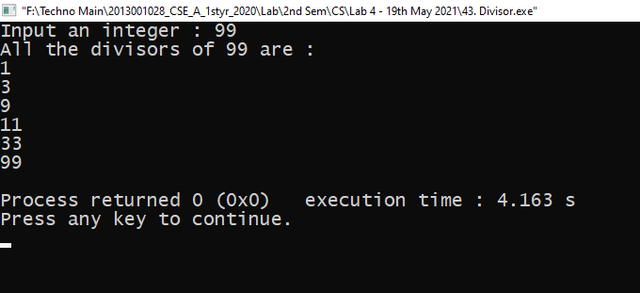

44:

