Outputs

Assignment 10

Name : Arnab Chakraborty

Stream : CSE

Section : A

University Roll No. : 13000120040

**#Program93:**

Recursion:

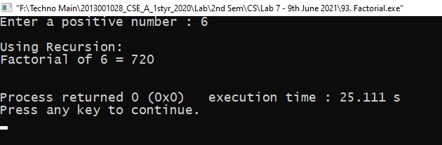

Invalid Case:

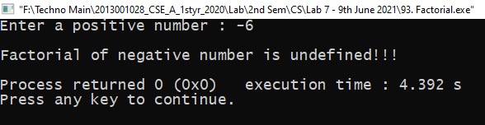

**#Program94:**

Recursive Case:

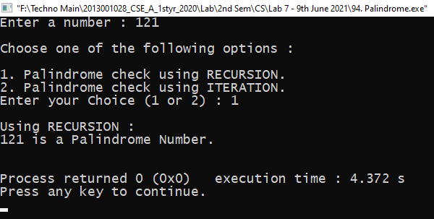

Iterative Case:

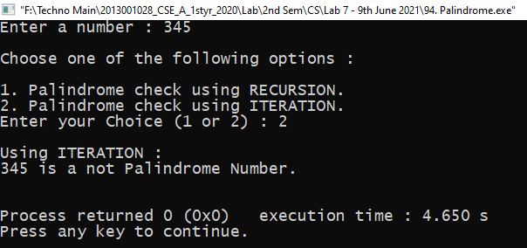

Invalid Case:

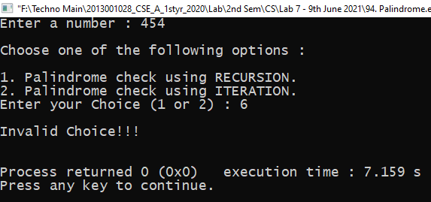

**#Program95:**

Recursive Case:

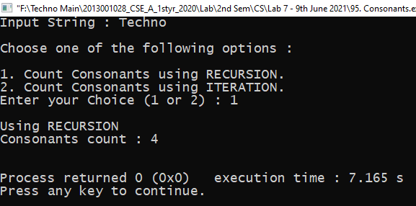

Iterative Case:

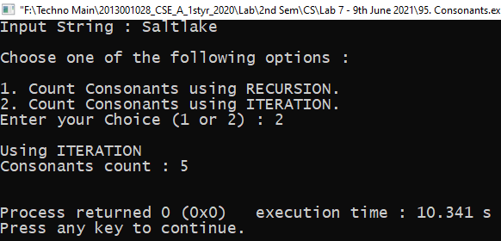

Invalid Case:

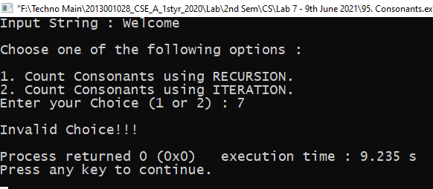

**#Program96:**

Recursion:

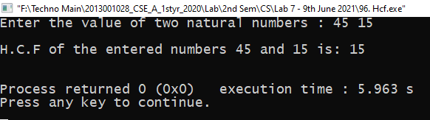

Invalid Case:

