Output

PCA 1

Name : Arnab Chakraborty

Stream : CSE

Section : A

University Roll No. : 13000120040

**SET 2**

**Given Input in Question :**

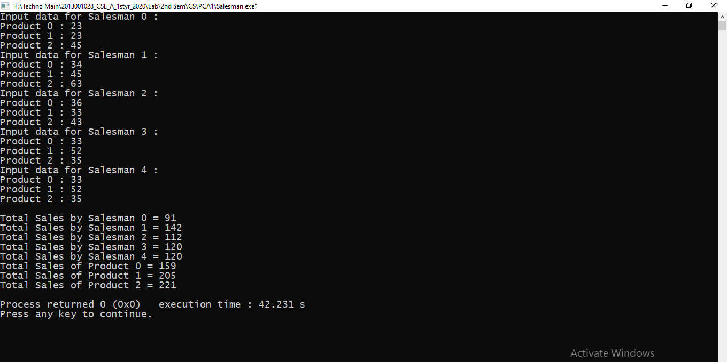

**Random Input :**

