So by the name it is sure that all are confused what is **DoCu_It**  and how it will solve real world problem? Yes it is normal.

Well **DoCu_It**  is a automation tool designed to search data and automate it for school projects. As a student I know what struggle we have to face when we have to prepare projects and atleast it takes 2-3 days to complete it. And the specialty of this tool is that it works on **Client-Server Model**. That means it will have the server running in the background to authenticate with all the happening in the GUI client. It has a **Realational Database** which is playing major role in the authentication.

* Works on the principle of Client-Server Model.
* Server is build on the **famous API architecture REST model**.
* Client works on multi thread which reduces the chances of application crash.
* Supports **manual editing along with the automations**.
* We can search any valid topic and it will give us the result.
* Password toggling(show and hide).
* **We can store our projects in the server which makes it a great tool for the students**.
* Responsive client means it will show you each and every event.
* It will not allow you to open more than one window which reduces the load on the CPU.
* It has a **virtual environment** which makes it separate from global environments.
* **Passwords are stored in encypted format**.
* **Since server is build externally we can make multiple clients.**
* **Here I have made a GUI client but we can also connect a mobile application or websites.**
* **It can become a huge selling product.**
* **Moreover no one will be able to hack as the database is encrypted.**
* **Folder Structure**

**Docu_It:.**

**| client.py**

**| server.py**

**+---DATABASE**

**| DOCu_It.db**

**+---Images**

**+---MY_PACKAGE**

**| | main_win.py**

**| | project_parser.py**

**| | __init__.py**

**| +---Images**

**+---Your Projects**

**| \---files from docuit server**

* **Requirements**

* A requirements.txt is provided where all the things are listed.

Run **pip install –r requirements.txt** to install all

Following modules are used:-

* + **bs4**
  + **Flask**
  + **Flask-SQLAlchemy**
  + **Pillow**
  + **python-docx**
  + **requests**
  + **tkinter**
  + **os**
* **Full stack development :-** It is a full stack project (Frontend,Database & Backend) totally based on my own idea.
* **Web Scraping :-** To collect data.
* **HTML Tree :-** Since web scraping has been done, one have to know the HTML tree.
* **Working of Internet :-** HTTP methods are used to build a connection between the client and server.
* **Python Packages,Modules & Paths :-** I have made a MY_PACKAGE including two modules main_win.py & project_parser.py . Both of them are executing the main and heavy tasks. They are used as packages to **encapsulate** them.
* **Object Oriented Programming(OOP)** :- Concepts of classes and objects are used in the packages made by me to give the modules a proper structure.
* **Database Relationships :-** It has been used to maintain the data in proper formatted way.
* **Version Control & GitHub:-** Since it was a huge project I had to use GIT to maintain the codebase. Since it solves a issue of student I hosted it on my online public repo **ArnabChatterjee20k** in Github**(My public profile)**.
* **Automation Skills :-** Last but not the least it is the technique used by me which is also the main attraction of the project.

1. First we have to start the server and GUI client.
2. First of all user has to register through GUI client by an email and that must be unique.
3. After registration he can log into the main window. Moreover one window can be only opened at one time.
4. Then search for the topic you want to make project in the inputbox provided. For example I want to make to project on databases. So search it.(*Internet connection required otherwise it will warn you.)
5. Click automate to save it directly or overview to make some changes to the automated projects.
6. After the project is created we can choose to upload it into the **docuit server made by me**. It is present in the upload section. Later on you can even download it.
7. Download location is DOCU_IT\Your Projects\files from docuit server.

**A image of my server database:->**

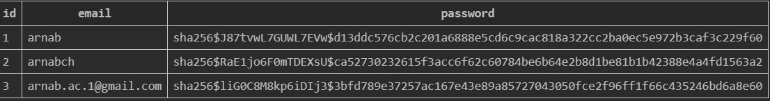

All things are encrypted and it is the user table and another table is table to store the files.

* Start the server and client file
* Auth and Main window(Automated a project on topic Database):-

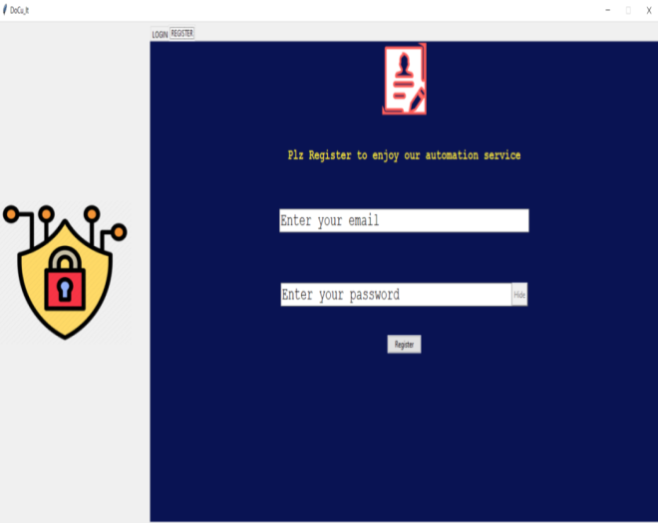

* Overview window and manually editing some things(*not necessary):-

We can see the the box surrounded by box. **99 paragrpahs in 2secs**

* Project saved and Upload and download:-