|  |  |  |  |  |  |  |
| --- | --- | --- | --- | --- | --- | --- |
| Choose Safari | Customize Safari | For Students | Destinations | Prepare for your Trip | About Us | Brochure Request |

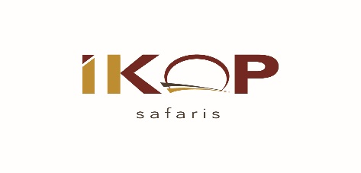

WELCOME   
IKOP Safaris Ltd.

Change Language

Search Bar

Contact Us:

History

_______________________________________

_______________________________________

Services

_______________________________________

­­­­­­­­­­­­­­­­ __________________________________________________

Why IKOP?

_______________________________________

_______________________________________

|  |  |  |  |  |  |
| --- | --- | --- | --- | --- | --- |
| Connect With Us | Terms & Conditions | Privacy Policy | Sitemap | Contact Us | Feedback |

|  |
| --- |
| Credits |