Graph Representation using Adjacency Matrix [CodeStudio](https://www.codingninjas.com/studio/problems/create-a-graph-and-print-it_1214551?leftPanelTabValue=PROBLEM)

This program illustrates the representation of a graph using an adjacency matrix. The graph class encapsulates the logic for initializing, creating, and printing a graph. The adjacency matrix provides a compact way to store and visualize relationships between nodes.

Example:

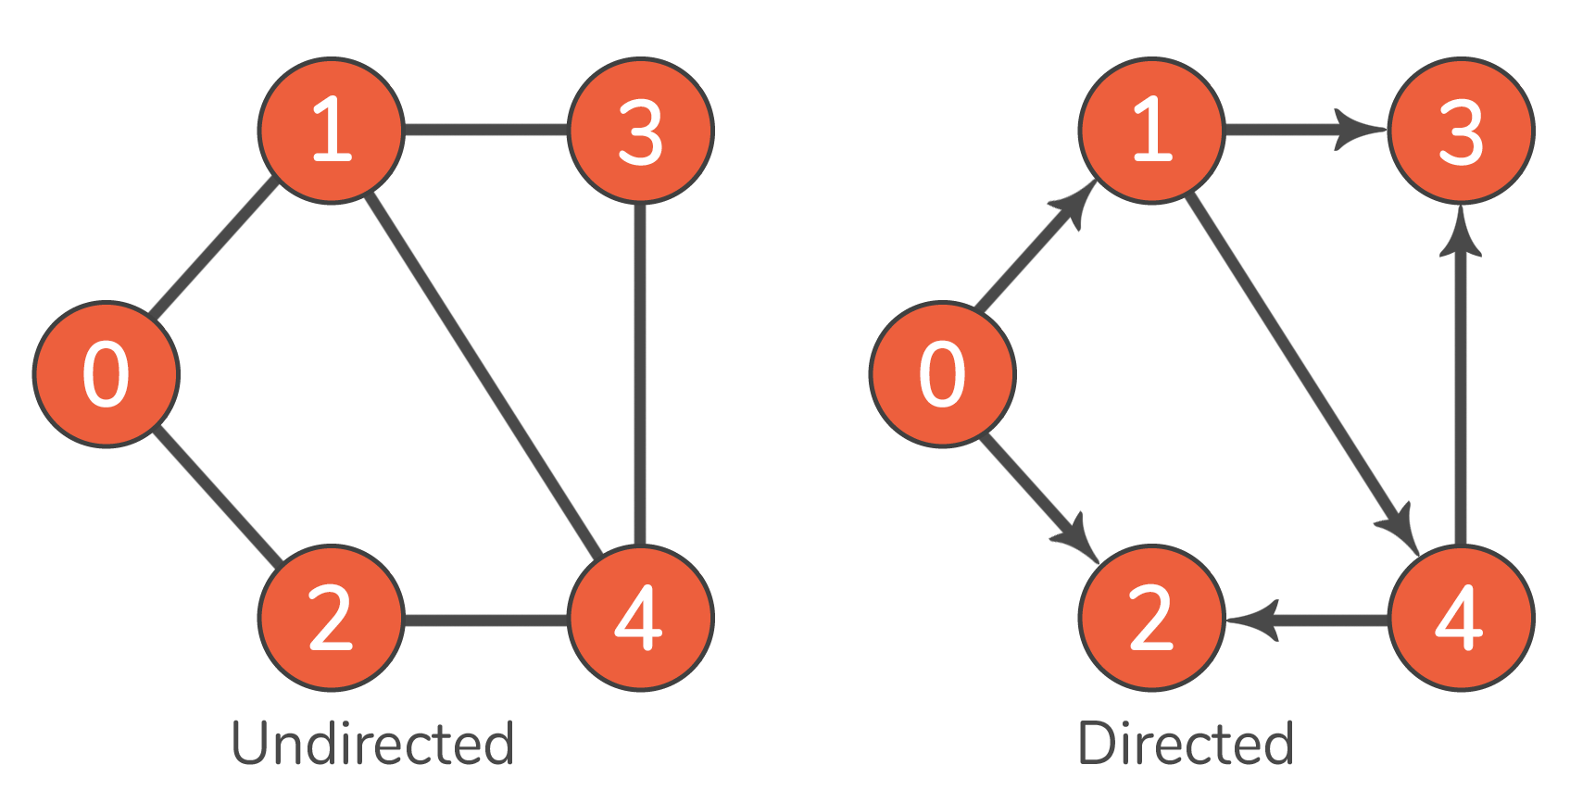

Output:

Undirected Graph

0 : 0 1 1 0 0

1 : 1 0 0 1 1

2 : 1 0 0 0 1

3 : 0 1 0 0 1

4 : 0 0 1 1 0

Directed Graph

0 : 0 1 1 0 0

1 : 0 0 0 1 1

2 : 0 0 0 0 0

3 : 0 0 0 0 0

4 : 0 0 1 1 0

**Graph Class**

The **Graph** class is designed to efficiently represent graphs using an adjacency matrix. This matrix allows for a clear representation of connections between nodes.

**Graph Constructor**

Purpose:

* Initializes a graph with a specified number of nodes.

**Time Complexity:**

* **O(V^2): Nested loops for initializing the adjacency matrix.**

**Space Complexity:**

* **O(V^2): Space required to store the adjacency matrix.**

**createGraph Function**

Purpose:

* Creates the graph based on provided edges.

**Time Complexity:**

* **O(E), where E is the number of edges: Iterates over each edge once.**

**Space Complexity:**

* **O(1): Constant space for variables.**

**printGraph Function**

Purpose:

* Prints the adjacency matrix of the graph.

**Time Complexity:**

* **O(V^2): Nested loops for printing the adjacency matrix.**

**Space Complexity:**

* **O(1): Constant space for variables.**