Find The Articulation Points in Graph

If removing a vertex and its related edges causes the graph to become disconnected, the vertex is considered to be an articulation point in the graph. Therefore, the number of related components in a graph grows as articulation points are removed. A connected component, or simply component, is a subgraph where every pair of nodes is connected to every other node by a path.

Sometimes articulation points are referred to as cut vertices.

Example:

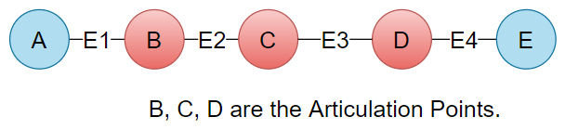

Example 2:

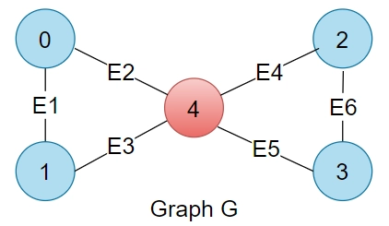

Output: 4

Example 3:

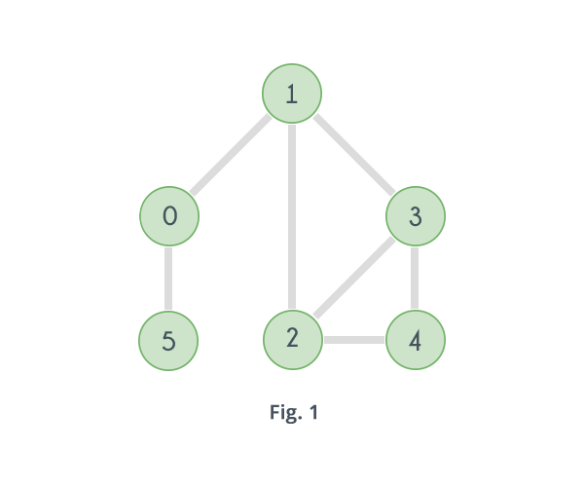

Output: {1, 0}

**Approach 1: Function to find articulation points in a graph using DFS Traversal**

* **Explanation:**
  + The algorithm uses DFS traversal to find articulation points in the graph.
  + It maintains information about discovery and lowest times for each node.
  + An articulation point is identified by checking if the lowest time of any child is greater than or equal to the discovery time of the current node.
  + The algorithm handles the special case of the root node in the DFS tree separately.
  + The result is a vector containing the identified articulation points.
* **Time Complexity:**
  + **The algorithm performs DFS traversal, which is O(V + E), where V is the number of vertices and E is the number of edges.**
* **Space Complexity:**
  + **Additional space for arrays to store discovery and lowest times: O(V)**
  + **Additional space for the result vector: O(A), where A is the number of articulation points.**
  + **Overall space complexity: O(V + A)**