Find Bridges in Graph [CodeStudio](https://www.codingninjas.com/studio/problems/bridges-in-graph_893026?leftPanelTabValue=PROBLEM)

Given an undirected graph of V vertices and E edges. Your task is to find all the bridges in the given undirected graph. A bridge in any graph is defined as an edge which, when removed, makes the graph disconnected (or more precisely, increases the number of connected components in the graph).

Example:

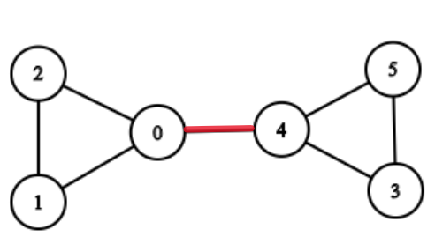 Output: {{0, 4}}

Example 2:

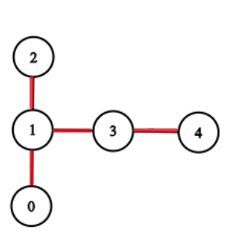 Output: {{1, 2}, {3, 4}, {1, 3}, {0, 1}}

**Approach 1: Function to find bridges in a graph**

* **Explanation:**
  + Depth-First Search (DFS) traversal is performed on the graph, keeping track of discovery and lowest times for each node.
  + While traversing, bridges are identified based on the comparison of lowest times.
  + The result is a vector of vectors, where each inner vector represents a bridge with its two endpoints.
* **Time Complexity:**
  + **DFS traversal: O(V + E), where V is the number of vertices and E is the number of edges.**
  + **Overall time complexity: O(V + E)**
* **Space Complexity:**
  + **Additional space for arrays to store discovery and lowest times: O(V)**
  + **Additional space for the result vector: O(B), where B is the number of bridges.**
  + **Overall space complexity: O(V + B)**