Cycle Detection in Directed Graph [CodeStudio](https://www.codingninjas.com/studio/problems/detect-cycle-in-a-directed-graph_1062626?leftPanelTabValue=PROBLEM)

You are given a directed graph having ‘N’ nodes. A matrix ‘EDGES’ of size M x 2 is given which represents the ‘M’ edges such that there is an edge directed from node EDGES[i][0] to node EDGES[i][1].

Find whether the graph contains a cycle or not, return true if a cycle is present in the given directed graph else return false.

Example:

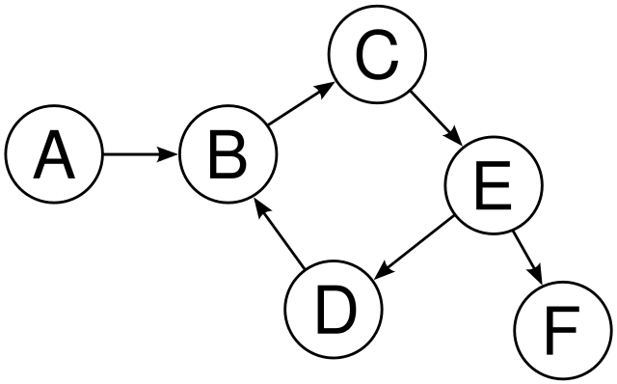

Output: True

**addEdge Function:**

* **Purpose:**
  + Populates the graph's adjacency list based on the provided edge list.
* **Explanation:**
  + Iterates through each edge in the **edges** vector.
  + For each edge, extracts the source vertex **u** and iterates over the connected vertices.
  + Adds an edge from **u** to **v** in the adjacency list.
* **Time Complexity:**
  + **O(E), where E is the number of edges in the input vector.**
* **Space Complexity:**
  + **O(E), where E is the number of edges. Each edge results in the creation of an entry in the adjacency list.**

**Approach 1: Function to detect cycles in a directed graph using BFS (Modified Kahn's Algorithm)**

* **Purpose:**
  + Detects cycles in directed graphs using BFS.
* **Explanation:**
  + Utilizes in-degrees to identify nodes with no incoming edges and enqueues them.
  + Decreases in-degrees of neighbors during BFS traversal.
  + A directed graph has a cycle if and only if it is not a Directed Acyclic Graph (DAG).
* **Time Complexity:**
  + **O(V + E), where V is the number of vertices and E is the number of edges.**
  + **Combined with addEdge Function:**
    - **Total Time Complexity: O(V + E) + O(E) = O(V + 2E) ≈ O(V + E)**
* **Space Complexity:**
  + **O(V + E), where V is the number of vertices and E is the number of edges.**
  + **Combined with addEdge Function:**
    - **Total Space Complexity: O(V + E)**

**Approach 2: Function to detect cycles in a directed graph using DFS**

* **Purpose:**
  + Detects cycles in directed graphs using DFS.
* **Explanation:**
  + Employs a recursive DFS approach with two sets of visited flags (**visited** and **dfsVisited**).
  + A cycle is detected if a node is visited in the current DFS traversal.
* **Time Complexity:**
  + **O(V + E), where V is the number of vertices and E is the number of edges.**
  + **Combined with addEdge Function:**
    - **Total Time Complexity: O(V + E) + O(E) = O(V + 2E) ≈ O(V + E)**
* **Space Complexity:**
  + **O(V), where V is the number of vertices.**
  + **Combined with addEdge Function:**
    - **Total Space Complexity: O(V + E)**

**Conclusion:**

* Both BFS and DFS approaches effectively detect cycles in directed graphs.
* The **addEdge** function is essential for establishing graph connections, contributing to the overall time and space complexity.
* The choice between BFS and DFS depends on specific requirements, with both approaches offering comparable performance.