Cycle Detection in Undirected Graph [CodeStudio](https://www.codingninjas.com/studio/problems/cycle-detection-in-undirected-graph_1062670?leftPanelTabValue=PROBLEM)

You have been given an undirected graph with 'N' vertices and 'M' edges. The vertices are labelled from 1 to 'N'.

Your task is to find if the graph contains a cycle or not.

Example:

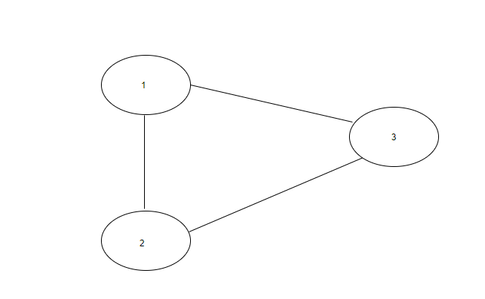Output: True

**Explanation**:

**addEdge Function:**

* **Purpose:**
  + Populates the graph's adjacency list based on the provided edge list.
* **Explanation:**
  + Iterates through each edge in the **edges** vector.
  + For each edge, extracts the source vertex **u** and iterates over the connected vertices.
  + Adds an edge from **u** to **v** and from **v** to **u** in the adjacency list.
* **Time Complexity:**
  + **O(E), where E is the number of edges in the input vector.**
* **Space Complexity:**
  + **O(E), where E is the number of edges. Each edge results in the creation of two entries in the adjacency list.**

**Approach 1: Function to perform cycle detection using Breadth-First Search (BFS)**

* **Purpose:**
  + Detects cycles in an undirected graph using BFS.
* **Explanation:**
  + Uses BFS to traverse the graph.
  + Maintains a visited map to keep track of visited nodes and a parent map for each node during BFS.
  + If, during BFS, a visited node is encountered that is not the parent of the current node, a cycle is detected.
* **Time Complexity:**
  + **O(V + E), where V is the number of vertices and E is the number of edges.**
  + **Combined with addEdge Function:**
    - **Total Time Complexity: O(V + E)**
* **Space Complexity:**
  + **O(V), where V is the number of vertices. Space is needed for the visited and parent maps.**
  + **Combined with addEdge Function:**
    - **Total Space Complexity: O(V + E)**

**Approach 2: Function to perform cycle detection using Depth-First Search (DFS)**

* **Purpose:**
  + Detects cycles in an undirected graph using DFS.
* **Explanation:**
  + Uses DFS to traverse the graph.
  + Calls a recursive helper function for each unvisited node.
  + If a cycle is detected in any DFS traversal, returns true.
* **Time Complexity:**
  + **O(V + E), where V is the number of vertices and E is the number of edges in the connected component.**
  + **Combined with addEdge Function:**
    - **Total Time Complexity: O(V + E)**
* **Space Complexity:**
  + **O(V), where V is the number of vertices. Space is needed for the visited map.**
  + **Combined with addEdge Function:**
    - **Total Space Complexity: O(V + E)**

**Conclusion:**

* Both approaches effectively detect cycles in undirected graphs.
* The **addEdge** function is a prerequisite for both approaches, and its complexities are combined with each approach's complexities.
* **The choice between BFS and DFS may depend on factors such as memory constraints, specific use cases, or preferences in terms of implementation.**