Find Minimum Spanning Tree by using Krukshal’s Algorithm [CodeStudio](https://www.codingninjas.com/studio/problems/prim-s-mst_1095633?leftPanelTabValue=PROBLEM)

You are given an undirected connected weighted graph having ‘N’ nodes numbered from 1 to 'N'. A matrix ‘E’ of size M x 2 is given which represents the ‘M’ edges such that there is an edge directed from node E[i][0] to node E[i][1]. You are supposed to return the minimum spanning tree where you need to return weight for each edge in the MST.

Example:

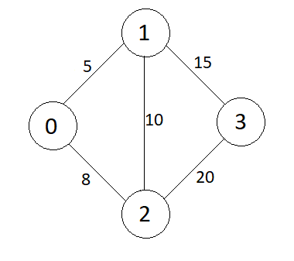

Output:

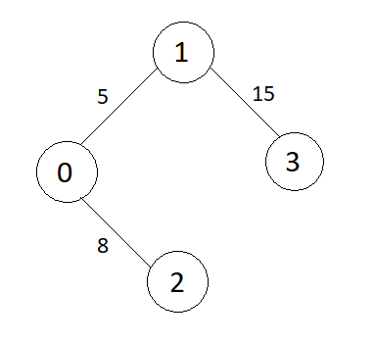

**Approach 1: Kruskal's algorithm to find the minimum spanning tree**

* **Explanation:**
  + The edges are sorted in ascending order based on their weights.
  + Union-find operations with path compression and ranking are employed to efficiently check and merge sets of nodes.
  + Iterate through sorted edges and add to the minimum spanning tree if it doesn't form a cycle.
  + The minimum spanning tree is constructed as a vector of edges and their weights.
* **Time Complexity:**
  + **Sorting the edges: O(E log E) where E is the number of edges.**
  + **Performing union-find operations: O(E log V) in practice, where V is the number of vertices.**
  + **Overall time complexity: O(E log E)**
* **Space Complexity:**
  + **Additional space for parent and rank arrays: O(V)**
  + **Additional space for the minimum spanning tree vector: O(E)**
  + **Overall space complexity: O(V + E)**