Network Delay Time [LeetCode](https://leetcode.com/problems/network-delay-time/description/)

You are given a network of n nodes, labeled from 1 to n. You are also given times, a list of travel times as directed edges times[i] = (ui, vi, wi), where ui is the source node, vi is the target node, and wi is the time it takes for a signal to travel from source to target.

We will send a signal from a given node k. Return *the****minimum****time it takes for all the* n *nodes to receive the signal*. If it is impossible for all the n nodes to receive the signal, return -1.

Example:

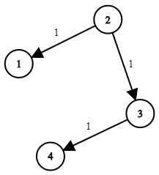 N = 4, K = 2

Output: 2

**Approach 1: Function to find the minimum time to receive a signal to all nodes in the network using Dijakstra's Algorithm**

* **Explanation:**
  + The **networkDelayTime** function calculates the minimum time to receive a signal to all nodes in the network using Dijkstra's algorithm.
  + It utilizes an adjacency list to represent the graph and a set to maintain nodes with their minimum distances.
  + The distances are updated as shorter paths are discovered during traversal.
  + The maximum distance among all nodes is returned as the result.
* **Time Complexity:**
  + **The time complexity is O((V + E) * log(V)), where V is the number of vertices and E is the number of edges in the graph.**
    - **Dijkstra's algorithm time complexity.**
* **Space Complexity:**
  + **The space complexity is O(V + E), where V is the number of vertices and E is the number of edges in the graph.**
    - **Storing adjacency list information and the set for Dijkstra's algorithm.**