Wageningen Social and Economic Research

Arnab Gupta

Nienke Beintema

Carlo Cucchi



Data Management Manual

Metadata integration Manual

for WUR SharePoint, W-Drive and office computers

Wageningen Social and Economic Research

Wageningen, Month 2024

Primo-Secundo, A., B. Tertio, C. Quarto, 2024. *Metadata integration Manual; for WUR SharePoint.* Wageningen Social and Economic Research, Wageningen University & Research. Confidential Report WSER-. Wageningen.

Abstract UK

Abstract NL

Keywords:

Choose, for a public report or delete, for a confidential report:

This report can be downloaded for free at <https://doi.org/10.18174/xxxxxx> or at [www.wur.eu/WSER](http://www.wur.eu/wcdi) (under knowledge products).



© 2024 Wageningen Social and Economic Research, part of the Stichting Wageningen Research. P.O. Box 88, 6700 AB Wageningen, The Netherlands. T + 31 (0)317 48 68 00, E [info.cdi@wur.nl](mailto:info.cdi@wur.nl), [www.wur.eu/WSER](http://www.wur.eu/wcdi).

Choose, for a public report or delete, for a confidential report:



The Wageningen Social and Economic Research uses a Creative Commons Attribution 4.0 (Netherlands) licence for its reports.

The user may copy, distribute and transmit the work and create derivative works. Third-party material that has been used in the work and to which intellectual property rights apply may not be used without prior permission of the third party concerned. The user must specify the name as stated by the author or licence holder of the work, but not in such a way as to give the impression that the work of the user or the way in which the work has been used are being endorsed. The user may not use this work for commercial purposes.

The Wageningen Social and Economic Research accepts no liability for any damage arising from the use of the results of this research or the application of the recommendations.

Confidential | Report WSER-

Photo cover: XXXX

Contents

Preface 7

Acknowledgements 9

List of abbreviations and acronyms 11

Summary 13

1 Background 16

2 Introduction 17

3 Objectives 18

4 Step-by-Step Guide to Metadata Integration in Sharepoint 19

4.1 Initial Setup 19

4.2 Create Metadata Columns in SharePoint 19

4.3 Create Metadata Fields: 20

4.4 Populate Metadata for Individual Files 21

4.5 Final Steps and Review 23

5 Metadata Implementation in Files on Laptops, W-Drive, and Microsoft Office 24

6 Introduction 25

7 Objectives 26

8 Part 1: Adding Metadata to Files on Laptops 27

8.1 Challenges 27

8.2 Proposed Solution 27

9 Step-by-Step Implementation 28

9.1 Use Built-In Document Properties 28

9.2 Apply File Naming Conventions 28

9.3 Utilize File Tags in Windows Explorer 28

10 Adding Metadata to Files on the W-Drive 31

10.1 Challenges 31

10.2 Proposed Solution 31

11 Step-by-Step Implementation 32

11.1 Standardize Folder Structures 32

11.2 Use Descriptive File Naming Conventions 32

11.3 Utilize File Properties for Additional Metadata 32

11.4 Assign Responsibility for Folder Maintenance 32

12 Using Microsoft Office for Metadata 33

12.1 Embedding Metadata in Microsoft Office Files 33

12.2 Support and Resources 33

12.3 Conclusion 33

13 Appendix 34

13.1 DataCite Metadata properties tailored to the types of data handled in WSER projects, based on both the DataCite Metadata Schema and the specific project examples. 34

13.2 Dublin Core Metadata Schema tailored to WSER projects. This schema is widely used for general resource description and is suitable for managing a variety of data types. 35

Preface

In an era where data is a pivotal asset, effective data management is essential for driving innovation and collaboration. Over the past year, the Wageningen Data Compliance Centre (WDCC) has led a comprehensive project to enhance data practices across Wageningen University & Research (WUR). WDCC has worked with several WR (Wageningen Research) centres in the past year, among which Wageningen Social and Economic Research (WSER) to enhance its data management practices. This "Metadata Integration Manual for WUR SharePoint" is a significant outcome of this year-long endeavour.

The manual provides practical, step-by-step guidance on how to incorporate metadata into WSER daily workflows using familiar tools like Microsoft SharePoint and Teams. By aligning practices with internationally recognized standards such as Dublin Core and DataCite, we aim to improve data findability, accessibility, and interoperability within WUR and with our external partners.

This initiative reflects WSER commitment to fostering a culture of compliance, efficiency, and collaborative excellence. By adopting these metadata practices, WSER staff can ensure that its valuable data assets are organized, discoverable, and effectively shared among researchers and stakeholders.We do encourage all staff members to embrace the guidelines presented in this manual. Your active participation is essential in realizing the full benefits of this project and enhancing our collective impact.

Thank you for your dedication to advancing our data management capabilities.

Acknowledgements

The development of this "Metadata Integration Manual for WUR SharePoint" is the culmination of a year-long project led by the Wageningen Data Compliance Centre (WDCC). We extend our deepest gratitude to the WDCC team for their vision, expertise, and unwavering commitment to enhancing data management practices across Wageningen University & Research.

Special thanks go to the data management specialists at WEcR and researchers who contributed their insights during the stocktaking phase of the project. Your collaborative efforts have been instrumental in shaping a manual that is both practical and aligned with international metadata standards.

A heartfelt thank you to all WUR staff members who participated in stocktaking interviews programs, provided feedback, and helped refine the manual. Your engagement and constructive input have significantly enhanced the usability and relevance of this guide.

Lastly, we appreciate the support of the WUR leadership in prioritizing data compliance and fostering an environment that values innovation, collaboration, and continuous improvement.

Thank you to everyone who contributed to this important initiative.

______________

Arnab Gupta, Nienke Beintema, Carlo Cucchi

List of abbreviations and acronyms

WSER Wageningen Social and Economic Research, Wageningen University & Research

WUR Wageningen University & Research

Summary

Effective data management is crucial for fostering collaboration, ensuring compliance, and enhancing efficiency within any research institution. Recognizing this, the Wageningen Data Compliance Centre (WDCC) embarked on a year-long project to improve data practices across Wageningen University & Research (WUR). This "Metadata Integration Manual for WUR SharePoint" is a key outcome of that initiative.

The manual serves as a practical guide for WUR staff to seamlessly incorporate metadata into their daily workflows using Microsoft SharePoint and Teams. By aligning with internationally recognized standards like Dublin Core and DataCite, the manual ensures consistency, interoperability, and adherence to best practices in data management and compliance. This manual has the following objectives: First, giving guidelines to enhancing the Data Findability and Accessibility. Thus, improving the ability to locate and retrieve important files efficiently. Second key objective is to minimize additional Workload. That means prompting the use of familiar tools and conventions such as current file naming practices that staff are already accustomed to. Third, boosting collaboration and efficiency, which in practice is reflected into facilitate better teamwork among colleagues and with external partners. Lastly, these guidelines aim at aligning with Recognized Standards and Implement metadata fields based on globally recognized standards like Dublin Core or DataCite to ensure consistency and interoperability.

More specifically, the Manual cover the following topics: First, at the core of the manual lies a **Step-by-Step Guide with d**etailed instructions on setting up metadata fields in SharePoint, populating metadata for individual files, and reviewing entries for accuracy. The guide emphasizes that metadata integration is intended for important and meaningful files that could benefit others. **Metadata Implementation for Other Platforms**: Additional guidance on adding metadata to files stored on researchers' laptops and the W-Drive, ensuring comprehensive data management and compliance across all storage environments. Finally, in the appendix we do provide tailored explanations of the Dublin Core and DataCite metadata properties, specifically adapted to the types of data handled in WSER projects. This helps users understand the purpose of each field and fill them in accurately.

The "Metadata Integration Manual for WUR SharePoint" represents a significant advancement in WUR's data management and compliance capabilities. It is the product of collaborative efforts across departments and the culmination of a dedicated project by the WDCC. By adopting the practices outlined in this manual, WUR staff can significantly enhance data organization, accessibility, and collaboration. This not only benefits individual researchers but also strengthens WUR's position as a leader in research innovation and compliance excellence. We encourage all staff to read the manual, participate in any available training sessions, and begin integrating metadata into their workflows. Your active involvement is crucial to the success of this initiative and to maximizing the collective impact of our work.

# Background

At the Wageningen Social and Economic Research (WSER), effective data management is essential for promoting collaboration, boosting efficiency, and ensuring compliance. To streamline our data practices and adding compliance to the WUR standards, we are introducing an easy-to-use process for adding metadata that aligns with widely recognized standards. You have the option to use either the Dublin Core or DataCite metadata standards—both are utilized within WUR to maintain consistency and compliance.

This manual narrates a straightforward, step-by-step guide to help you seamlessly integrate metadata into your daily workflows using Microsoft SharePoint and Teams. We are focusing on creating metadata for files and datasets that are important and meaningful—those that other researchers might find useful. Detailed descriptions for each metadata field, following these standards, are included in the appendix to ensure consistency and ease of use.

# Introduction

Think of metadata as "data about data." It provides structured information that describes, explains, or helps locate an information resource. By aligning our metadata practices with the Dublin Core or DataCite standards, we ensure consistency, interoperability, and adherence to widely accepted conventions. Metadata Integration brings several benefits, among which improved Searchability (metadata enhances the discoverability of files, making it easier for researchers and staff to find and utilize shared resources), and enhanced Collaboration (by providing structured information about files, metadata facilitates better teamwork and knowledge sharing, compliance). Moreover, metadata enhance Interoperability (aligning with international standards ensures that WUR's data management practices are compliant with regulations and compatible with global research communities) and efficiency Gains (prompting processes s designed to integrate smoothly into existing workflows, minimizing additional workload while maximizing benefits).

We have designed this process to minimize any additional workload by leveraging tools and file naming conventions you are already familiar with. You will only need to create the metadata fields once and populate them for files and data that are significant and potentially useful to others. The provided descriptions will help everyone understand the purpose of each field and fill them in accurately.

# Objectives

* **Enhance Data Findability and Accessibility:** Improve the ability to locate and retrieve important files efficiently.
* **Minimize Additional Workload:** Ensure the process adds minimal extra steps to your existing practices.
* **Utilize Familiar Tools and Conventions:** Leverage SharePoint, Teams, and current file naming conventions you are already using.
* **Boost Collaboration and Efficiency:** Facilitate better teamwork among colleagues and with external partners.
* **Align with Recognized Standards:** Implement metadata fields based on globally recognized standards like Dublin Core or DataCite to ensure consistency and interoperability.

# Step-by-Step Guide to Metadata Integration in Sharepoint

As metadata serves as the backbone of research data management, transforming unstructured file storage into a smart, searchable, and organized system, is one of the key requirements. The following steps will walk you through a detailed process of integrating metadata in SharePoint, enabling your team to create a more structured, findable, and valuable document repository. By implementing this systematic approach to metadata, you'll not only improve file organization but also enhance team collaboration, streamline information retrieval, and ensure that critical institutional knowledge is properly captured and easily accessible.

## Initial Setup

* Navigate to SharePoint:
  + Open your browser and go to the Microsoft365 SharePoint homepage.
  + Log in with your Microsoft credentials if prompted.
* Access Group Files:
  + On the homepage, find the **Group** section and click on it to access your team or department's group files.
  + From the group menu, click on **Documents** to open the shared document library.

## Create Metadata Columns in SharePoint

This step is only required once to set up metadata fields for your team or group in SharePoint. You can choose to follow the Dublin Core or DataCite metadata standard, both detailed in the appendix for your reference. These descriptions will help everyone understand and use these fields easily. See the steps blow and the screenshots thereafter to guide you through the process

Access Metadata Settings:

* Open SharePoint as a desktop app or from the browser.
* Navigate to the SharePoint site/ Teams Site that you want to share
* Open the document library where you want to integrate metadata, by clicking the “Documents” in the navigation panel on the left side of the window.
* At the top of the page, click on **Column Settings** (you might find this under the "More" or settings menu).
* Select **Edit Columns** from the dropdown menu.
* After entering each column name and description, click **Save**.
* Inform your team that these columns should be used for important and meaningful files that could benefit others.

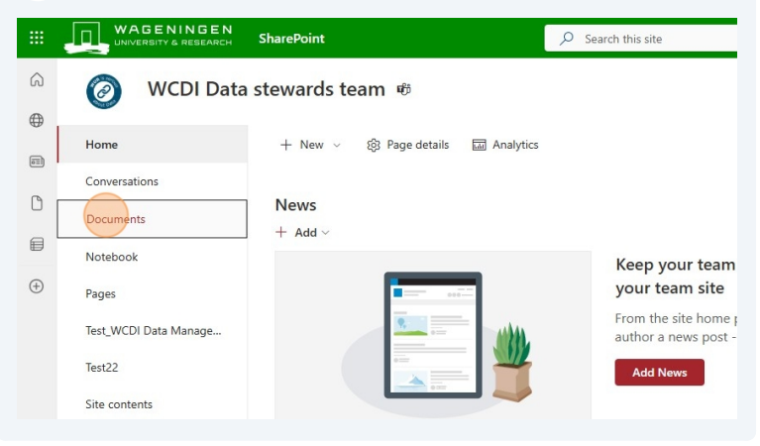

Figure 1: Navigate to the SharePoint site and go to the documents library

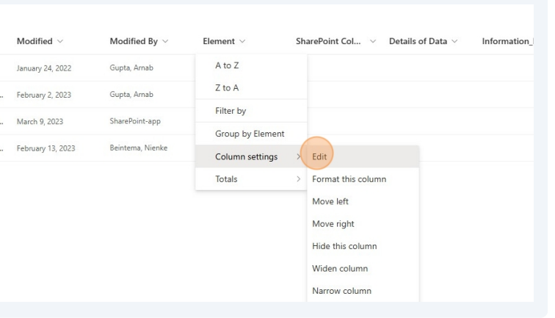

Figure 2: Edit columns

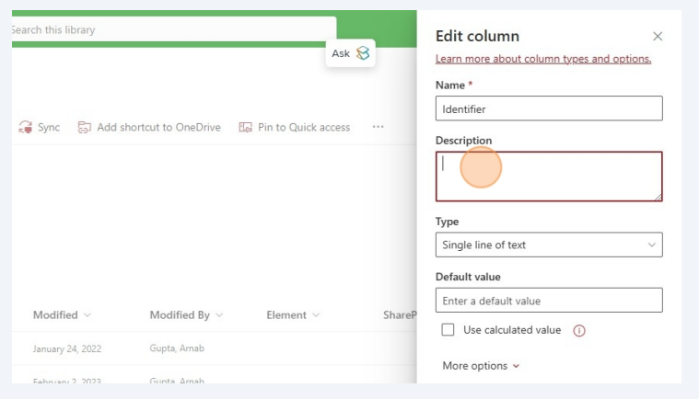

Figure 3: Add Name and description. Descriptions are to guide other members so as what to enter here

## Create Metadata Fields:

Add the following metadata columns one by one, and include the descriptions provided in the appendix for consistency:

1. **Identifier:** A unique ID like a DOI or internal reference number, project code (if available).
2. **Title:** The title of the project, document, or dataset.
3. **Publisher:** The organization making the dataset or document available.
4. **Publication Year:** The year the project or document was created or published.
5. **Subject and Keywords:** Themes or topics related to the data, along with relevant keywords.
6. **Name of Contributors:** Individuals, institutions, and partners involved in developing the data.
7. **Geo Locations:** Geographical areas or regions relevant to the data.
8. **Funding Agency:** Names of all donors or funding bodies supporting the project.

## Populate Metadata for Individual Files

Locate the File:

* Go to the document library where the file is stored.

Access File Details:

* Click the three dots (more options) next to the file name.
* Select **Details** from the dropdown menu.

Edit Metadata Fields:

* For each metadata field, click on the empty box or where it says "Enter value here."
* Populate the metadata fields using the descriptions in the appendix as a guide:
  + **Identifier:** Enter a unique reference like "DM Checklist."
  + **Title:** Provide the file's title, e.g., "Project on Data Stewardship."
  + **Keywords:** Add specific terms like "Data Management, FAIR Data" to enhance searchability.
  + **Geo Locations:** Specify relevant locations, e.g., "Wageningen, NL."
  + **Publisher:** Enter the organization's name, e.g., "WUR."
  + **Funding Agency:** Include all donors or funding bodies.
  + **Sensitive Data:** Indicate if the file contains sensitive information.
* **Save Metadata:** After filling in all fields, click **Save** to update the metadata for the file.

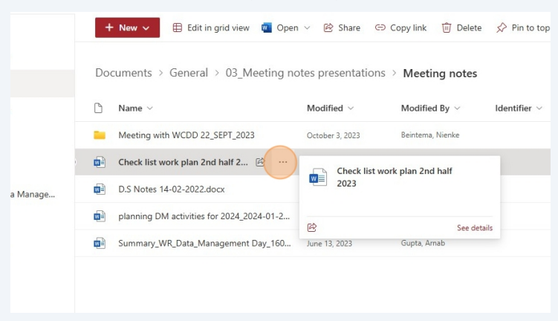

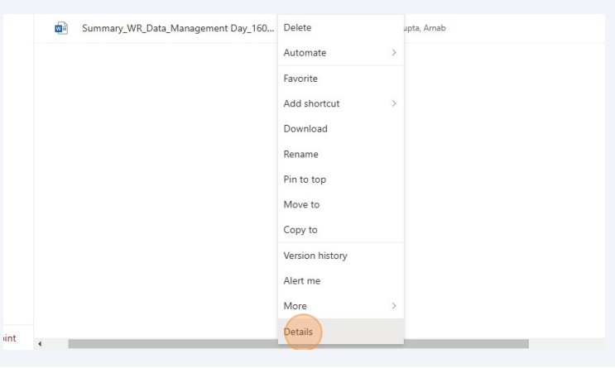

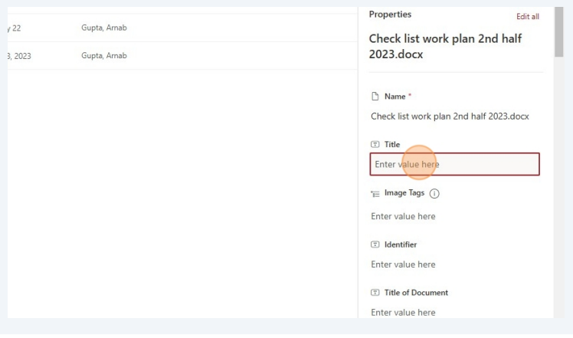

After completing all the entries, you can see all the metadata about the data in the document library

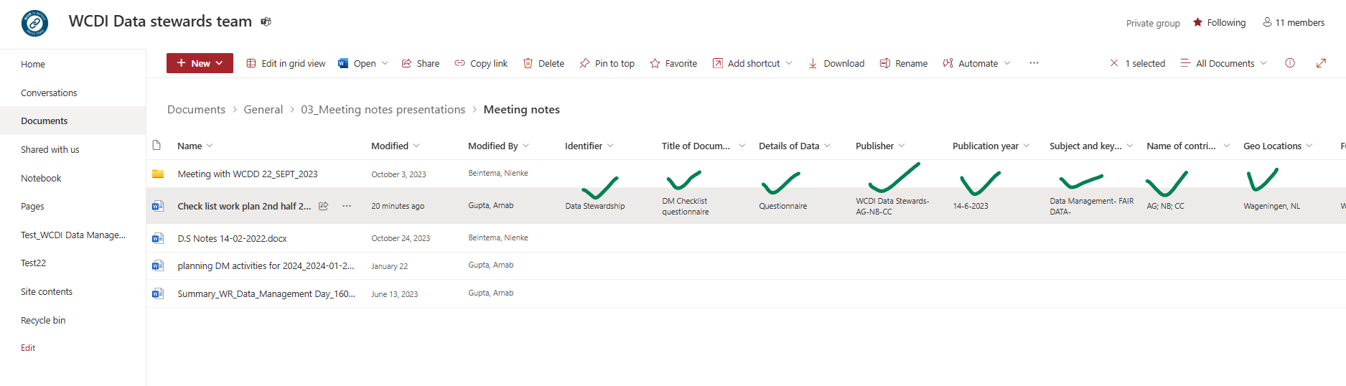

## Final Steps and Review

* **Verify Metadata:** Open the Details pane for each file to ensure all metadata fields are accurately filled.
* **Test Findability:** Use the search function in SharePoint to see if files are easily discoverable using the added metadata.
* **Share Files:** Share the files or folders with team members, ensuring they adhere to the metadata guidelines for better collaboration.
* **Communicate Usage:** Remind everyone that metadata integration is intended for files that are important and meaningful to others.

# Metadata Implementation in Files on Laptops, W-Drive, and Microsoft Office

# Introduction

At Wageningen University & Research (WUR), a substantial amount of research data resides on researchers' laptops and the W-Drive, in addition to centralized platforms like SharePoint and Teams. To address the challenges of data management in these contexts, this manual introduces workflows for embedding metadata into files. By leveraging tools such as Microsoft Office and Windows Explorer, and implementing structured practices on the W-Drive, WUR aims to enhance **data findability, accessibility, and organization**.

This manual provides step-by-step guidance, ensuring that researchers can seamlessly integrate metadata practices into their workflows with minimal disruption. By following these guidelines, your files will not only be easier to manage but also future-proof for collaboration and compliance with WUR policies.

# Objectives

* **Enhance Data Findability and Accessibility**: Ensure critical files are easy to locate and retrieve.
* **Minimize Additional Workload**: Embed metadata using familiar tools with minimal extra effort.
* **Leverage Existing Tools**: Maximize the use of Microsoft Office, Windows Explorer, and folder structures.
* **Standardize Practices**: Promote uniformity in metadata management across laptops and the W-Drive.

# Part 1: Adding Metadata to Files on Laptops

## Challenges

* Locally stored files are harder to manage, access and retrieve.
* Lack of metadata makes it difficult to search for or understand files.
* Offline work requires a reliable and structured local organization system.

## Proposed Solution

Use built-in file properties, file naming conventions, and tagging features in Windows Explorer to embed metadata directly into files, improving organization and searchability.

# Step-by-Step Implementation

## Use Built-In Document Properties

* **Action**: Populate metadata fields in Microsoft Office files (Word, Excel, PowerPoint).
* Steps:
  + Open the file and navigate to File > Info.
  + Fill in fields such as:
    - **Title**: A meaningful and descriptive name for the document.
    - **Author**: Your name (ensure accuracy).
    - **Comments**: A summary of the content.
    - **Keywords**: Tags to improve searchability.
* Benefits:
  + Metadata stays embedded with the file.
  + Simplifies file retrieval via search tools.

## Apply File Naming Conventions

* **Action**: Create descriptive and standardized file names.
* **Format**: YYYY-MM-DD_ProjectName_DocumentType_Description_Version
* **Example**: 2024-09-15_ProjectX_Report_Summary_v1.docx
* **Guidelines**:Include the date, project name, document type, description, and version.
* **Benefits**: Immediate context and improved searchability.

## Utilize File Tags in Windows Explorer

* **Action**: Add tags to files directly through Windows Explorer.
* Steps:
  + Right-click the file and select Properties.
  + Navigate to the Details tab and add keywords under Title, Subject, Category, Tags etc
  + Add as much as info as possible as these will be indexed and searched first when you use a search string.

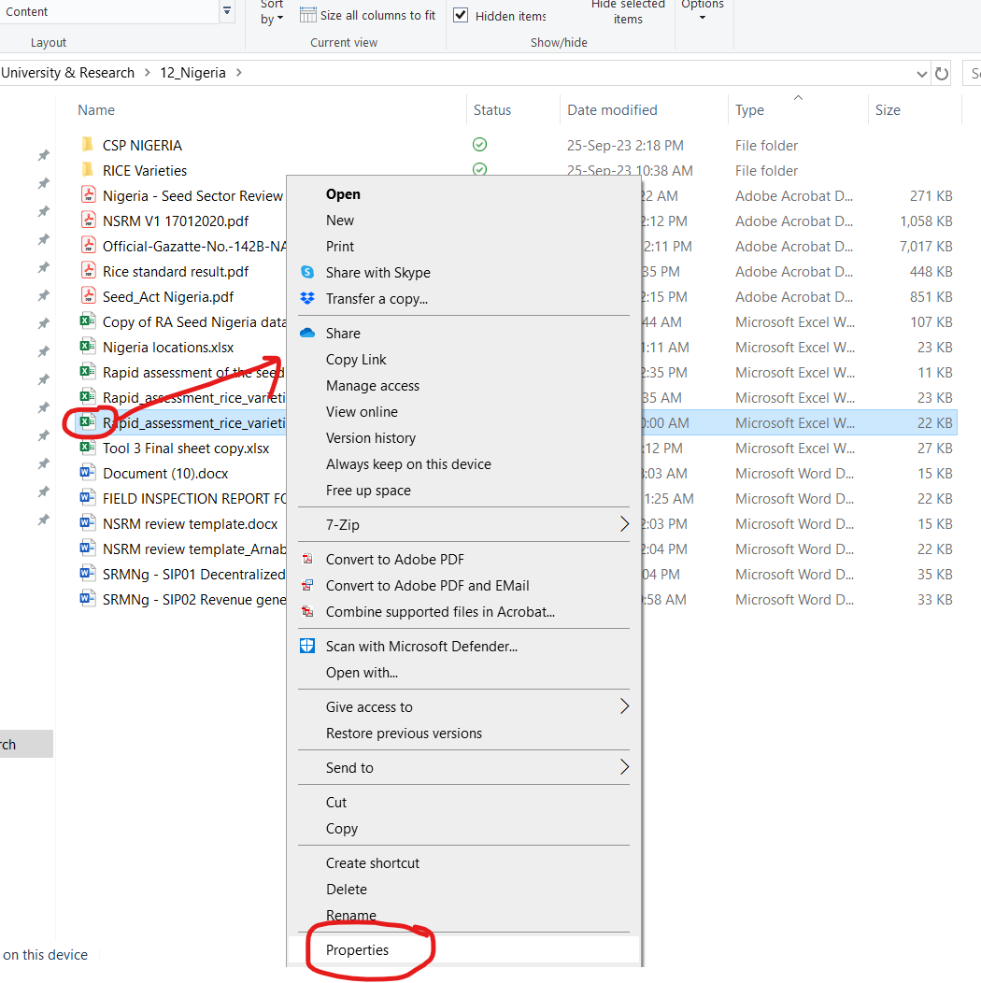

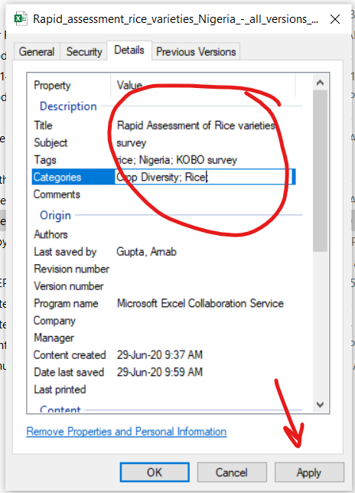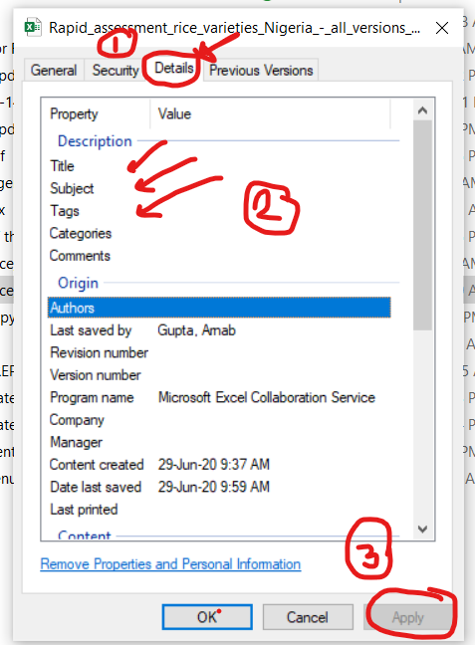

* **Supported File Types**: Microsoft Office documents, JPEGs, PNGs, and PDFs.
* Benefits:
  + Manual indexing helps in fast and enhanced system-wide searchability.

# Adding Metadata to Files on the W-Drive

## Challenges

* The files we store in W-Drive lacks metadata management features.
* A large volume of untagged files makes organization challenging.
* Limited tagging and indexing done for network drives.

## Proposed Solution

Introduce a structured folder hierarchy, enforce file naming conventions, and use metadata fields in document properties to improve organization and retrieval.

# Step-by-Step Implementation

## Standardize Folder Structures

* **Action**: Organize W-Drive files using a clear hierarchy.
* Structure Examples:
  + W:\WSER\Projects\ProjectName\Reports\2024\
  + W:\WSER\Projects\ProjectName\Subprojects\WorkstreamA\
* Benefits:
  + Easier file location based on project or document type.
  + Streamlined access control through folder permissions.

## Use Descriptive File Naming Conventions

* **Action**: Apply the same file naming practices as on laptops.
* Benefits:
  + Provides clarity and consistency across storage locations.

## Utilize File Properties for Additional Metadata

* **Action**: Populate document properties before saving files to the W-Drive, same as the previous section as the W-Drive uses regular Windows File explorer to store and navigate files.
* Benefits:
  + Metadata remains embedded and aids in retrieval, even on network drives.

## Assign Responsibility for Folder Maintenance

* **Action**: Designate a folder custodian or manager for each project folder.
* **Role**: Ensure proper organization and compliance with folder structures.
* Benefits:
  + Accountability for file organization.

# Using Microsoft Office for Metadata

Microsoft Office applications offer robust features for embedding metadata. These tools ensure that key information is retained with the file, improving searchability and long-term usability.

## Embedding Metadata in Microsoft Office Files

1. Accessing Metadata Fields
   * Navigate to File > Info and edit the **Title**, **Author**, **Comments**, and **Keywords**.
2. Adding Custom Properties
   * Use Properties > Advanced Properties > Custom Tab to add fields like **Project ID** or **Funding Source**.
3. Creating Document Templates
   * Save templates with pre-filled metadata for commonly used document types.
4. Preserving Metadata
   * Use File > Info > Check for Issues > Inspect Document to ensure metadata is intact before sharing files.

## Support and Resources

* Available Resources:
  + Guidelines and templates for metadata in the Appendix.
  + [](https://www.wur.nl/en/value-creation-cooperation/partnerships-collaborations/wdcc-2/research-data-management-wdcc/doing/research-data-documentation.htm)[](https://wageningenur4-my.sharepoint.com/:b:/g/personal/arnab_gupta_wur_nl/EY4eFHVVvC9JoFZU7HgCvzgBWG6Ag6B_hUllM_cDxCC45A?e=YDzxQS)Step-by-step instructions with screenshots at this [link](https://wageningenur4-my.sharepoint.com/:b:/g/personal/arnab_gupta_wur_nl/EY4eFHVVvC9JoFZU7HgCvzgBWG6Ag6B_hUllM_cDxCC45A?e=YDzxQS) .
  + WUR Guidelines at this [link](https://www.wur.nl/en/value-creation-cooperation/partnerships-collaborations/wdcc-2/research-data-management-wdcc/doing/research-data-documentation.htm)

## Conclusion

By embedding metadata practices into daily workflows for laptops, the W-Drive, and Microsoft Office files, WUR ensures that data is not only organized and accessible but also future-proof for compliance and collaboration. These practices benefit individual researchers and contribute to institutional excellence in data management.

For further assistance, refer to the templates and quick guides or contact the support team. Let us work together to make our data smarter and more manageable!

# Appendix

## DataCite Metadata properties tailored to the types of data handled in WSER projects, based on both the DataCite Metadata Schema and the specific project examples.

|  |  |  |
| --- | --- | --- |
| DataCite Metadata Property | Explanation Tailored to WSER Projects | Enter value |
| Identifier | Unique DOI assigned to the project or dataset to ensure findability and citation. |  |
| Creator | The individuals or organizations responsible for generating the data, such as WSER staff, partners (e.g., Wasafiri Consulting), and affiliated researchers in leadership programs. |  |
| Title | The title of the dataset or project, such as "African Food Fellowship Leadership Data" or "Ethio-NL Seed Partnership Data." |  |
| Publisher | The organization making the dataset available, typically Wageningen Social and Economic Research (WSER) or project partners like Wasafiri Consulting. |  |
| Publication Year | The year when the dataset or project files are made publicly available or submitted for publication. |  |
| Subject | The thematic focus of the dataset, such as "Food Systems Leadership," "Seed Systems," "Sustainable Agriculture," or "Project Monitoring and Evaluation." |  |
| Contributor | Other individuals or institutions involved in the creation of the data, such as fellows, partners, or external consultants (e.g., Gareth in the Ethio-NL Seed Partnership). |  |
| Date | The date of data collection, analysis, or release, including multiple dates for project milestones or updates. |  |
| Language | The primary language(s) in which the data and associated metadata are provided, often English, but can include other languages based on the project scope (e.g., Amharic for Ethiopia). |  |
| Resource_Type | The nature of the data being described, such as "Dataset," "Survey Data," "Case Studies," or "Event Data" (e.g., videos or workshop outputs). |  |
| Alternate Identifier | Any other identifiers related to the project, such as grant numbers or internal project codes used by WSER. |  |
| Related_Identifier | Identifiers of related resources, such as publications, reports, or project documentation tied to the data, e.g., research reports or case studies. |  |
| Size | The size of the dataset, which could include the number of documents, survey responses, or files generated from workshops or leadership sessions. |  |
| Format | The file formats of the data, which may include Microsoft Office files (e.g., Word, Excel), CSV, PDFs, or multimedia formats (e.g., videos or photos). |  |
| Version | The version number of the dataset, especially relevant if the dataset is updated over time with new leadership programs or additional case studies. |  |
| Rights | Details on data ownership and access rights, adhering to WSER’s privacy policies, GDPR, and potential intellectual property agreements with project partners. |  |
| Description | A summary of the dataset’s contents and purpose, such as leadership data from fellows, monitoring and evaluation data from seed systems, or research interview transcripts. |  |
| Geo_Location | The geographic locations related to the data, such as "Ethiopia" for the Ethio-NL Seed Partnership, or "Kenya" for AFF. |  |
| Funding_Reference | Information on the funding sources for the project, such as the Dutch Ministry of Foreign Affairs or other specific funding agencies supporting WSER’s seed systems work. |  |
| Related_Item | References to related items such as publications, presentations, or media outputs (e.g., videos from workshops) that are associated with the project. |  |

This table maps DataCite properties to the type of data used in WSER projects, which includes leadership program data, seed system monitoring, and research case studies​

## Dublin Core Metadata Schema tailored to WSER projects. This schema is widely used for general resource description and is suitable for managing a variety of data types.

|  |  |  |
| --- | --- | --- |
| Dublin Core Property | Explanation Tailored to WSER Projects |  |
| Title | The main title of the project or dataset, such as "African Food Fellowship Leadership Program Data" or "Ethio-NL Seed Partnership Case Studies." |  |
| Creator | The entity responsible for the creation of the content, such as WSER staff, fellows, or external partners involved in generating project data. |  |
| Subject | The main topics or keywords describing the data, e.g., "Leadership Development," "Seed Systems," "Sustainable Agriculture," or "Food Security." |  |
| Description | A summary of the dataset, including its scope, purpose, and methodology, such as "Data collected from leadership development workshops for food system transformation in East Africa." |  |
| Publisher | The entity that makes the data available, often Wageningen Social and Economic Research (WSER) or project collaborators like Wasafiri Consulting. |  |
| Contributor | Additional contributors to the dataset, such as research partners, local universities, or consultants working on seed systems or monitoring data. |  |
| Date | Key dates related to the dataset, including data collection, creation, or publication dates, such as the date of leadership workshops or the start of seed partnership initiatives. |  |
| Type | The nature or genre of the resource, such as "Dataset," "Case Study," "Survey Data," or "Video Recordings of Workshops." |  |
| Format | The file format of the dataset, such as "PDF," "Word Document," "Excel Spreadsheet," or multimedia files (e.g., videos, audio). |  |
| Identifier | A unique identifier for the resource, like a project code or a DOI if assigned, ensuring each dataset can be accurately cited and retrieved. |  |
| Source | References to the original source of the dataset or research materials, such as reports, conference materials, or publications relevant to WSER's projects. |  |
| Language | The language(s) in which the dataset is presented, often English, but potentially Amharic or other local languages relevant to specific WSER initiatives. |  |
| Relation | Connections to related datasets or documents, such as links to reports, research outputs, or other WSER project materials. |  |
| Coverage | The geographic scope of the dataset, such as "Ethiopia," "Kenya," or "East Africa," relevant to WSER's seed system or leadership projects. |  |
| Rights | Information on usage rights and access restrictions, including GDPR compliance, intellectual property (Creative Commons etc.), or sharing agreements for sensitive data collected from fellows or research participants. |  |

Wageningen Social and Economic Research

Wageningen University & Research

P.O. Box 88

6700 AB Wageningen

The Netherlands

T +31 (0)317 48 68 00

[wur.eu/WSER](http://www.wur.eu/wcdi)



The mission of Wageningen University & Research is “To explore the potential of nature to improve the quality of life”. Under the banner Wageningen University & Research, Wageningen University and the specialised research institutes of the Wageningen Research Foundation have joined forces in contributing to finding solutions to important questions in the domain of healthy food and living environment. With its roughly 30 branches, 7,700 employees (7,000 fte), 2,500 PhD and EngD candidates, 13,100 students and over 150,000 participants to WUR’s Life Long Learning, Wageningen University & Research is one of the leading organisations in its domain. The unique Wageningen approach lies in its integrated approach to issues and the collaboration between different disciplines.