Computational Finance Problem Set 4

Nitish Ramkumar

# QUESTION 1

All the prices for the 4 types and various values of N are

|  |  |  |  |  |  |  |  |
| --- | --- | --- | --- | --- | --- | --- | --- |
| **N** | **10** | **20** | **40** | **80** | **100** | **200** | **500** |
| **Method1** | 3.76994 | 3.72614 | 3.72615 | 3.72688 | 3.72163 | 3.72428 | 3.72297 |
| **Method2** | 3.75763 | 3.70258 | 3.73276 | 3.71787 | 3.72394 | 3.72224 | 3.72191 |
| **Method3** | 3.75416 | 3.7008 | 3.73197 | 3.71745 | 3.72364 | 3.72209 | 3.72185 |
| **Method4** | 3.76389 | 3.72307 | 3.72474 | 3.72614 | 3.72103 | 3.72398 | 3.72285 |

The convergence price which can be decided by Black Scholes price using S0=32, K=30, r = 5%, $σ$ = 24%, time = 0.5 years is **3.72244**

All the 4 methods converge towards the Black Scholes price

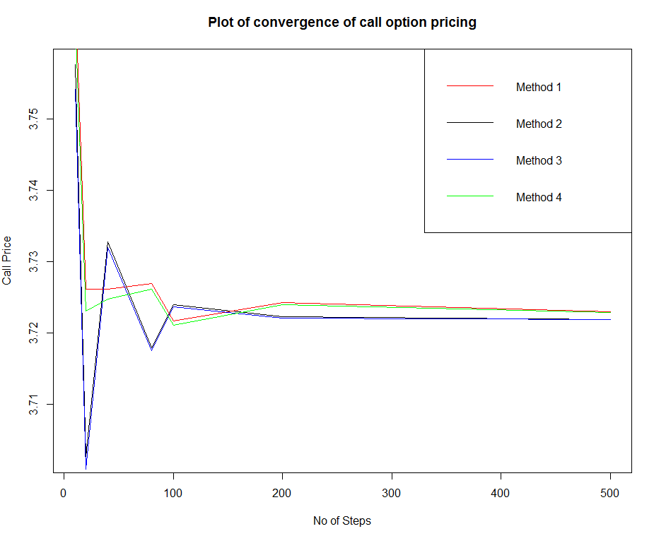

# QUESTION 2

All necessary information (stock and call option prices) were retrieved out of yahoo finance.

The current price (April end of month) for the Google stock is **916.44**

For the historical volatility, we can first retrieve past 61 months’ prices (not including current month), from which we can calculate the past 60 returns. We can convert this to annual data and calculate the annual standard deviation of these annual data. Time to maturity of the option was set as *0.75 (9 months) – (8/252)*, as the expiry of the January option is on that date.

The annual historical volatility = **22.9348%**

The price based on the historical volatility = $**40.9548**

The implied volatility which makes call price equal to the market price of $23.9 (Google call option with current stock price = 916.44, strike = 1000) is **15.93%** (Calculated by making the price equal to the market call price = $23.63).

# QUESTION 3

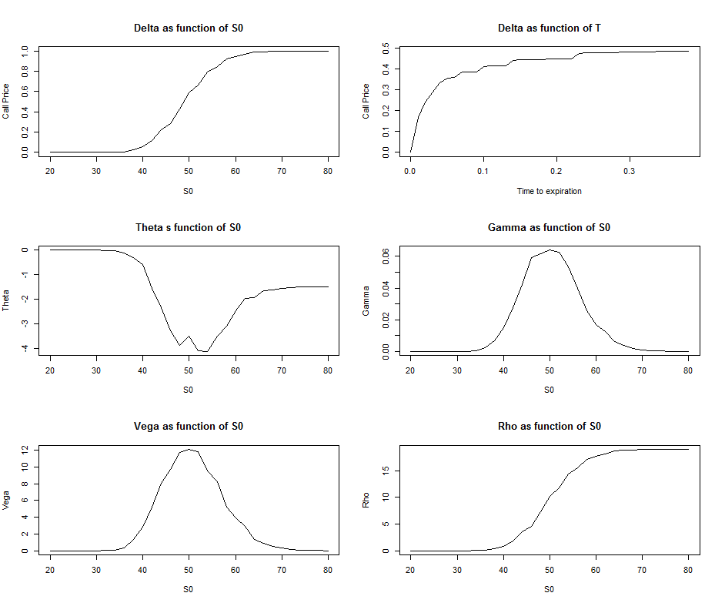

# QUESTION 4

Prices of European and American call are as below

|  |  |  |  |  |  |  |  |  |  |  |  |
| --- | --- | --- | --- | --- | --- | --- | --- | --- | --- | --- | --- |
| Stock price | 80 | 84 | 88 | 92 | 96 | 100 | 104 | 108 | 112 | 116 | 120 |
| European | 19.71 | 16.93 | 14.97 | 13.0 | 11.03 | 9.17 | 8.06 | 6.95 | 5.84 | 4.74 | 3.9 |
| American | 21.35 | 18.37 | 15.94 | 13.8 | 11.72 | 9.75 | 8.43 | 7.25 | 6.11 | 5.0 | 4.06 |

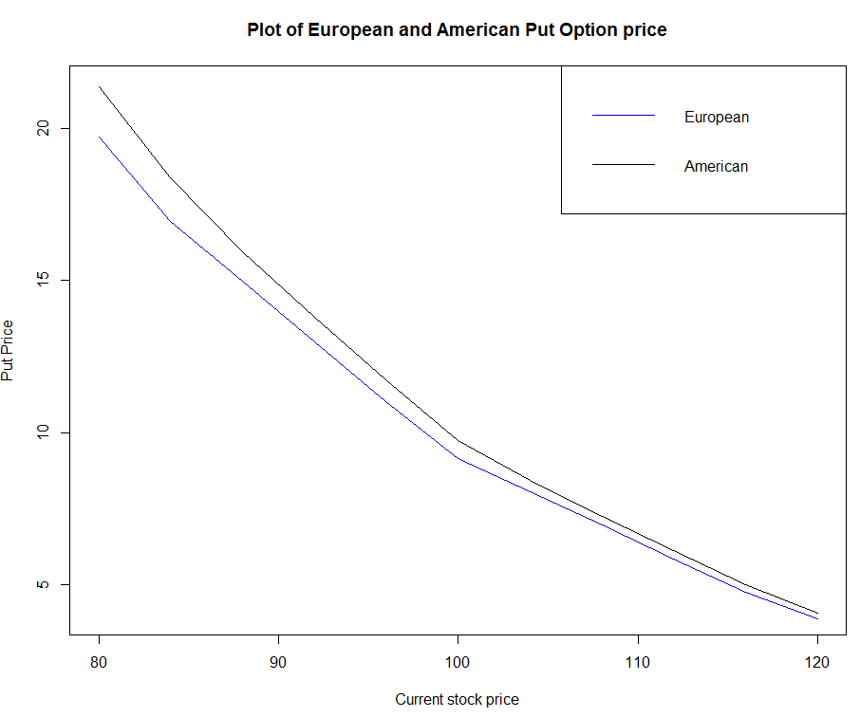

The American put is more expensive than the European put. The difference reduces as the stock price increases. This is because of time value of money. If we get the strike early on, we can invest it at risk free rate and get the time value return on it.

# QUESTION 5

The Trinomial returns for the call option is

|  |  |  |  |  |  |  |  |  |  |
| --- | --- | --- | --- | --- | --- | --- | --- | --- | --- |
| **Intervals** | **10** | **15** | **20** | **40** | **70** | **80** | **100** | **200** | **500** |
| **Stock Price** | 3.730 | 3.712 | 3.7 | 3.725 | 3.72 | 3.717 | 3.721 | 3.721 | 3.722 |
| **Log normal stock prices** | 3.736 | 3.716 | 3.702 | 3.727 | 3.721 | 3.718 | 3.722 | 3.721 | 3.722 |

The convergence price which can be decided by Black Scholes price using S0=32, K=30, r = 5%, $σ$ = 24%, time = 0.5 years is = **3.72244**

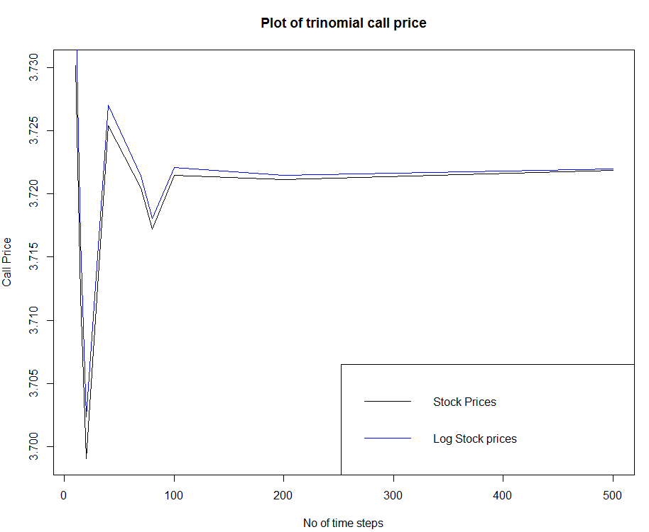

# QUESTION 6

Price of call option for Halton sequenes (b1=2, b2=7) using S0=32, K=30, r = 5%, $σ$ = 24%, time = 0.5 years is **3.73656.**

The convergence price which can be decided by Black Scholes price using S0=32, K=30, r = 5%, $σ$ = 24%, time = 0.5 years is = **3.72244**