Computational Finance Project 9

Nitish Ramkumar

# Question 1

# 1a)

# The price of the MBS using the Numerix prepayment model is after simulating using Monte Carlo simulation is **100782.3946**

# 1b)

|  |  |
| --- | --- |
| k | Price |
| 0.3 | 101882.793 |
| 0.4 | 101358.433 |
| 0.5 | 101018.135 |
| 0.6 | 100782.395 |
| 0.7 | 100611.694 |
| 0.8 | 100483.789 |
| 0.9 | 100385.427 |

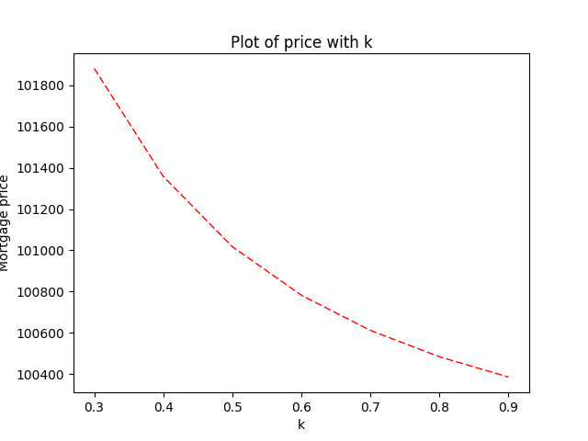

Price of the MBS using numerix prepayment method reduces with increase in k

1c)

|  |  |
| --- | --- |
| RAvg | Price |
| 0.03 | 11247.8642 |
| 0.04 | 11047.0195 |
| 0.05 | 10905.0613 |
| 0.06 | 10767.7852 |
| 0.07 | 10506.3989 |
| 0.08 | 10078.2395 |
| 0.09 | 95714.7266 |

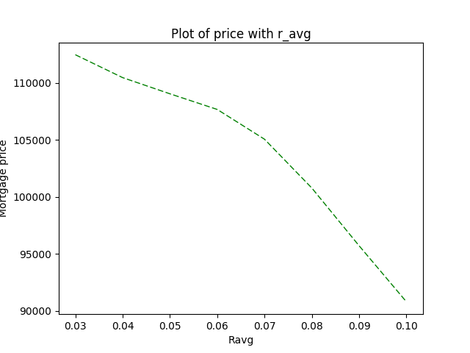

Price of the MBS using numerix prepayment method reduces with increase in Ravg. The negative convexity can be observed at lower Ravg, which is a feature of the option on the MBS.

# Question 2

2a)

Price of the MBS using the PSA prepayment model after performing Monte Carlo simulations is **100837.9729**

2b)

|  |  |
| --- | --- |
| K | Price |
| 0.3 | 1.02369594 |
| 0.4 | 1.01590140 |
| 0.5 | 1.01131384 |
| 0.6 | 1.00837973 |
| 0.7 | 1.00638385 |
| 0.8 | 1.00496035 |
| 0.9 | 1.00390632 |

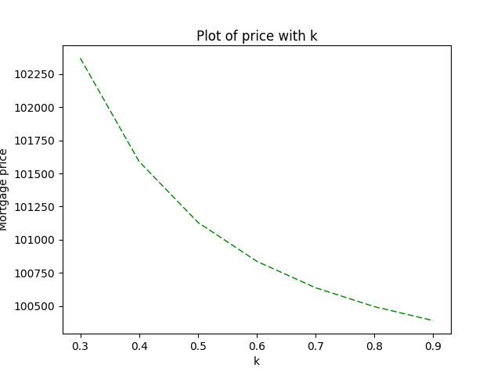

Price of the MBS using the PSA prepayment model reduces with increase in k.

# Question 3

The OAS for the MBS with market value of 110000 is **-0.0133 (-1.33%)**

# Question 4

The OAS Duration of the MBS with market value of 110000 is **6.8212**

The OAS Convexity of the MBS with market value of 110000 is **41.7405**

# Question 5

The price of the PO and IO tranches for different values of ravg are as follows:

(P.S.: The PO and IO were done on a OAS MBS, to make sure the IO + PO leads to the market value of 110000)

|  |  |  |
| --- | --- | --- |
| **RAvg** | **IO** | **PO** |
| 0.03 | 30458.917965 | 87937.665246 |
| 0.04 | 31385.150314 | 85035.548151 |
| 0.05 | 34726.809912 | 80788.509307 |
| 0.06 | 41398.756307 | 73837.313386 |
| 0.07 | 49294.519273 | 64474.261816 |
| 0.08 | 54755.134632 | 55244.865368 |
| 0.09 | 56341.593026 | 48350.313697 |
| 0.10 | 55397.309791 | 43751.094093 |

The sum of the IO and PO at 0.08 is almost 110000. It was at this point, we calculated the OAS for the MBS.

