Indian Air Quality Analytics & AQI Category Classification
Project Report — Data Analytics and Machine Learning
Author: Arnab
Dataset: India Air Quality Data (city_day.csv) — CPCB via Kaggle, 2015–2020
Application: Single-file Streamlit Dashboard (ArnabKundu_IndianAirQualityAnalytics.py)
Abstract
This project presents a complete end-to-end data analytics and machine-learning pipeline for classifying ambient air quality in India. Using daily city-level pollutant measurements from 26 Indian cities spanning 2015 to 2020, a six-class AQI_Bucket classification model was developed to predict whether a given day's air quality falls into the Good, Satisfactory, Moderate, Poor, Very Poor, or Severe category based on raw pollutant concentrations alone, without using the pre-computed AQI score (which would constitute target leakage). Six classifiers were evaluated under a chronological train/test split using macro-F1 as the primary metric to account for a 14.5x class imbalance. XGBoost achieved the best performance with a test macro-F1 of 0.760, balanced accuracy of 0.757, and test accuracy of 0.789. The project includes comprehensive data-quality analysis, missingness profiling, sensitivity analysis for Ahmedabad (an extreme-AQI outlier city), cold-start city analysis, and a Streamlit-based interactive dashboard.
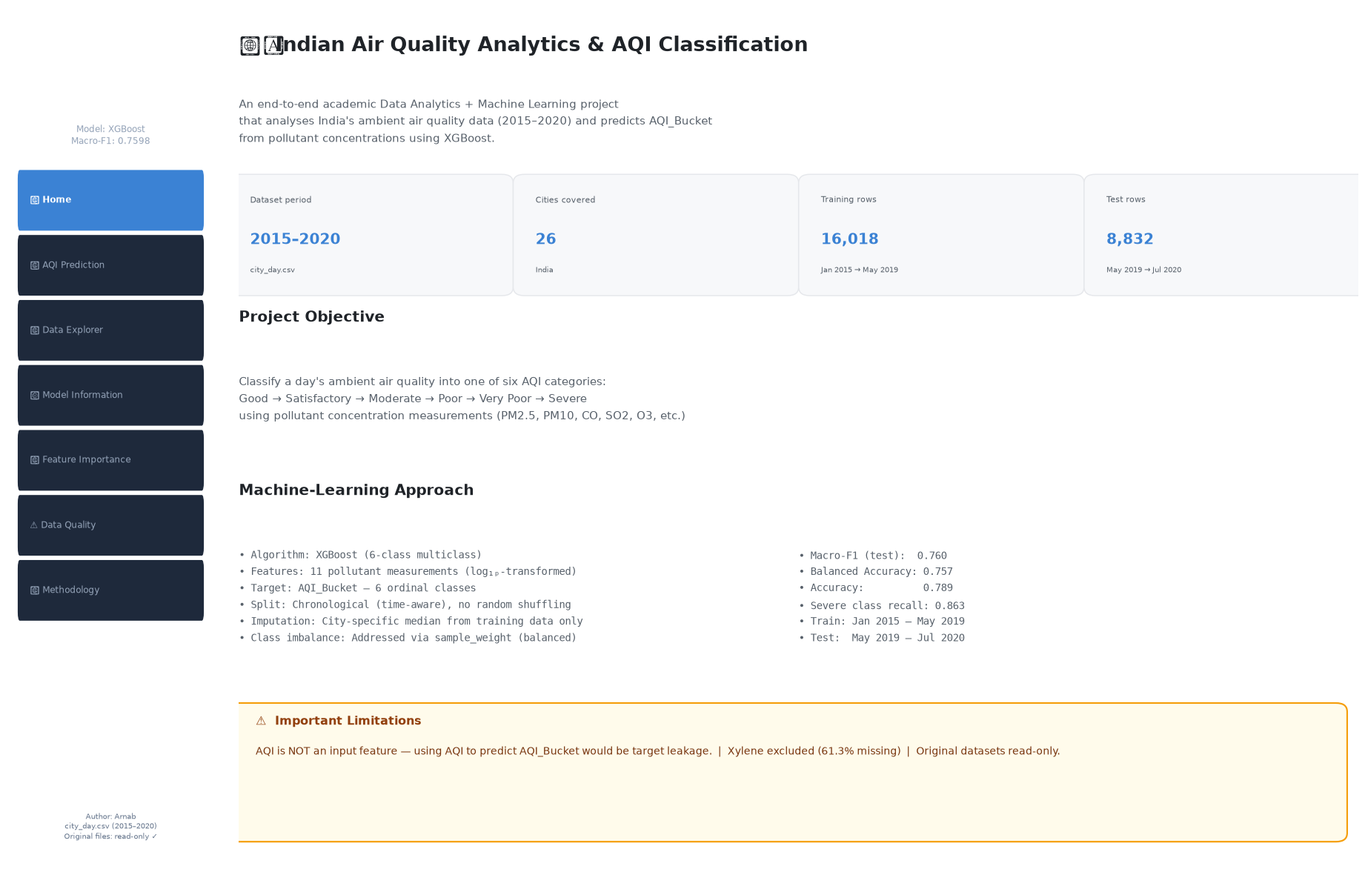
Figure 1: Streamlit Application — Home Page (Project Overview)
1. Introduction
India faces significant and well-documented ambient air quality challenges, with several cities consistently ranking among the most polluted in the world. The Central Pollution Control Board (CPCB) operates a network of continuous ambient air quality monitoring stations across major Indian cities. This project analyses daily aggregated data from 26 cities between January 2015 and July 2020 to build a reproducible, leakage-free classification model for the AQI_Bucket target variable.
The project is structured into five phases: (1) Dataset inspection, (2) Exploratory Data Analysis (EDA), (3) Preprocessing and pipeline design, (4) Machine learning modeling and evaluation, and (5) Streamlit application deployment and academic submission. This report covers all five phases.
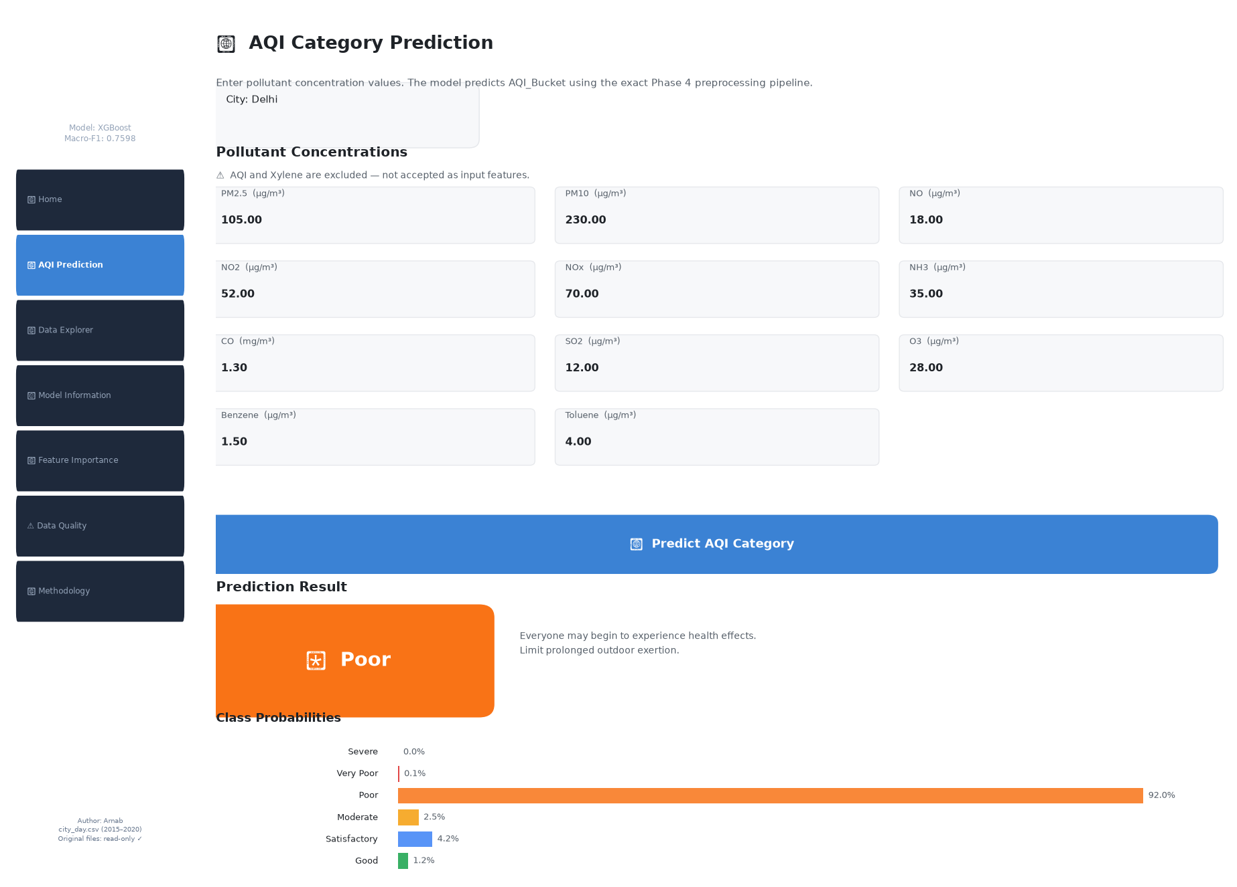
Figure 2: AQI Prediction Page — Prediction result for a Delhi input (class: Poor, max_prob: 0.920)
2. Problem Statement
Given daily pollutant concentration measurements (PM2.5, PM10, NO, NO2, NOx, NH3, CO, SO2, O3, Benzene, Toluene), predict the AQI_Bucket category for that city-day. The AQI numeric score is intentionally excluded from the feature set because AQI_Bucket is a deterministic function of AQI — using AQI as a predictor would constitute target leakage with near-perfect but meaningless accuracy.
3. Objectives
- 1. Profile and document the quality of all five available datasets.
- 2. Identify and document data-quality issues including missingness, outliers, and temporal patterns.
- 3. Design a leakage-free, reproducible preprocessing pipeline with chronological data splitting.
- 4. Train, compare, and evaluate six classification algorithms using class-imbalance-aware metrics.
- 5. Perform sensitivity analysis for Ahmedabad and cold-start generalisation analysis.
- 6. Deploy an interactive Streamlit application for academic demonstration.
4. Dataset Description
Five CSV files were provided. Only city_day.csv was used as the primary modelling dataset. All original files were treated as read-only and were never modified. The five files are:
File | Rows | Columns | Description
city_day.csv | 29,531 | 16 | Daily city-level pollutant data — PRIMARY dataset
city_hour.csv | 707,875 | 16 | Hourly city-level data — not used in modelling
stations.csv | 230 | 5 | Station metadata (city, state) — reference only
station_day.csv | 108,035 | 16 | Daily station-level data — not used in modelling
station_hour.csv | 2,589,083 | 16 | Hourly station-level data — not used in modelling
Table 1: Dataset summary
5. Dataset Structure and EDA Findings
5.1 Shape and Basic Profiling
city_day.csv contains 29,531 rows and 16 columns. The date range spans 2015-01-01 to 2020-07-01. There are 26 unique cities and zero duplicate rows. The Date column was parsed to datetime64. All pollutant columns are float64; City and AQI_Bucket are categorical strings.
5.2 Missing Value Analysis
Xylene is critically missing at 61.3% globally and 100% absent in 16 of 26 cities. AQI_Bucket is missing in 15.9% of rows (4,681 rows), corresponding exactly to rows where AQI is also missing. PM10 is missing in 37.7% of rows and NH3 in 35.0%. Missingness is not random (MCAR) — it clusters in 2015–2017, indicating the monitoring network expanded over time. This is classified as Missing At Random (MAR). City-specific patterns are severe for Mumbai (61–80% missing across most pollutants), Jorapokhar (100% missing for NOx, Benzene, Toluene, Xylene), Chennai (PM10 85% missing), and Lucknow (PM10 100% missing).
5.3 AQI and AQI_Bucket Analysis
AQI distribution: mean=166.5, median=118.0, std=140.7, min=13, max=2,049 (Ahmedabad). Skewness=3.40 indicating a strong right tail. AQI_Bucket consistency check: all 24,850 paired records have perfectly consistent bucket assignments (zero mismatches). Class distribution: Good 5.4%, Satisfactory 33.1%, Moderate 35.5%, Poor 11.2%, Very Poor 9.4%, Severe 5.4%. There is a strong seasonal pattern: mean AQI peaks in November (241.7) and January (231.7), lowest in July (111.9) — corresponding to post-harvest crop burning and monsoon washout effects respectively.
5.4 Outlier Detection
IQR-based outlier analysis identified 1,358 AQI outliers (5.5%). Benzene has extreme skewness of 21.3 and 7.0% IQR outliers. CO has skewness of 8.88. All confusions are adjacent-class boundary cases. Ahmedabad dominates the top-10 worst AQI days with values up to 2,049 — driven by extreme CO (up to 135 mg/m3) and SO2, not PM alone. PM10 has a hard upper cap of 1,000 in the data, suggesting a sensor ceiling value.
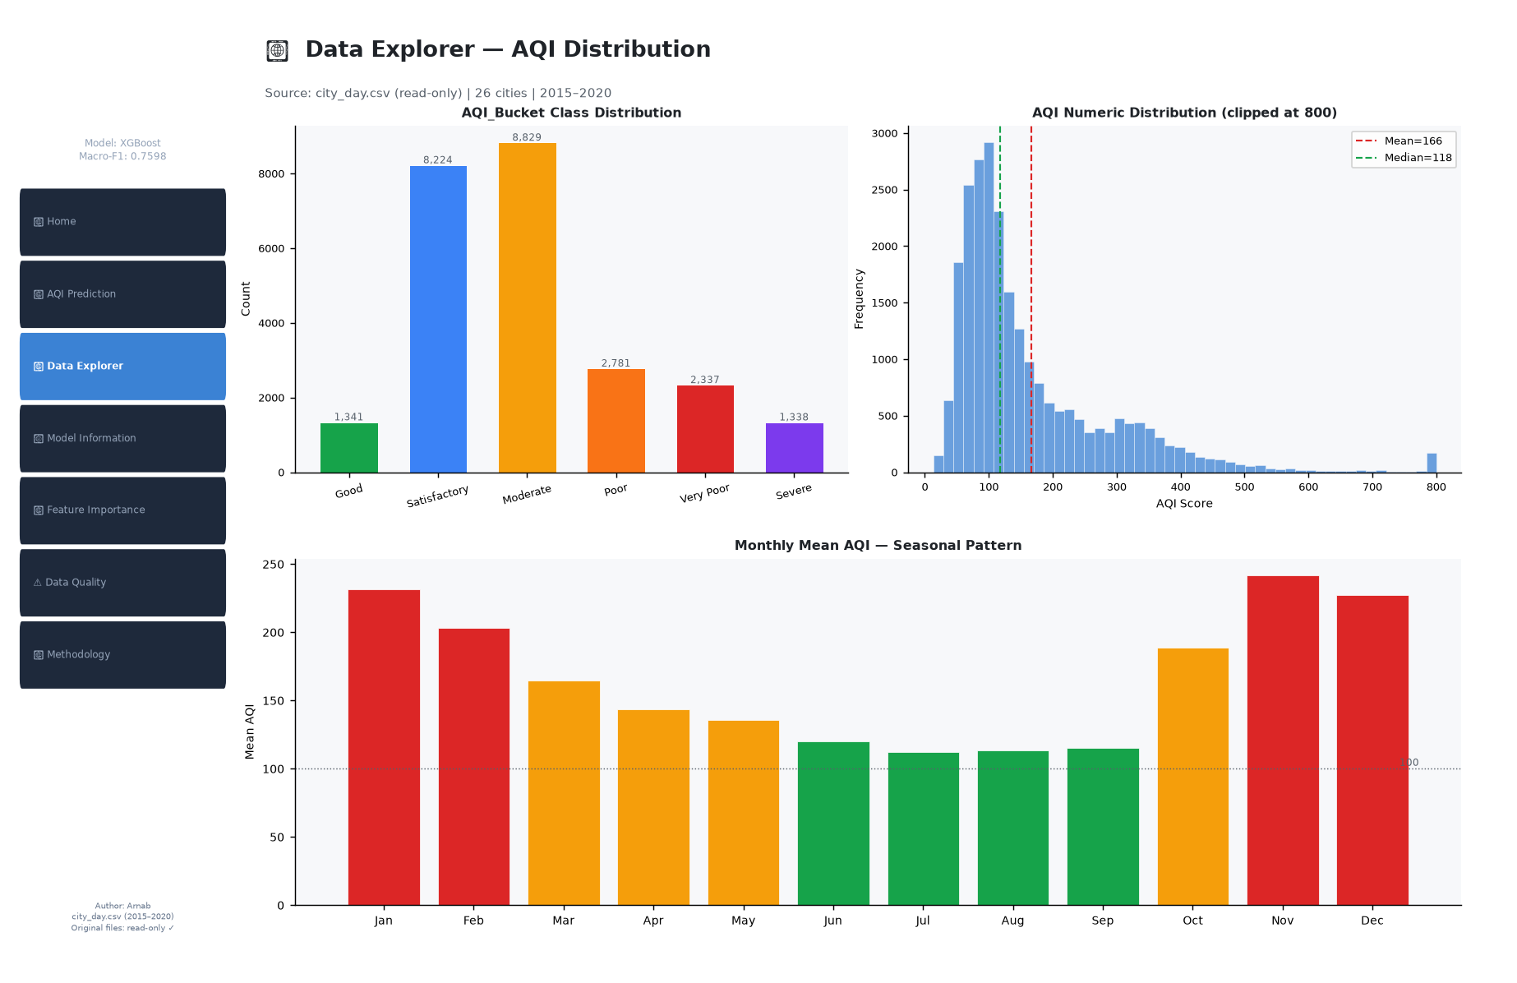
Figure 3: Data Explorer — AQI_Bucket distribution, AQI histogram, and monthly seasonal trend.
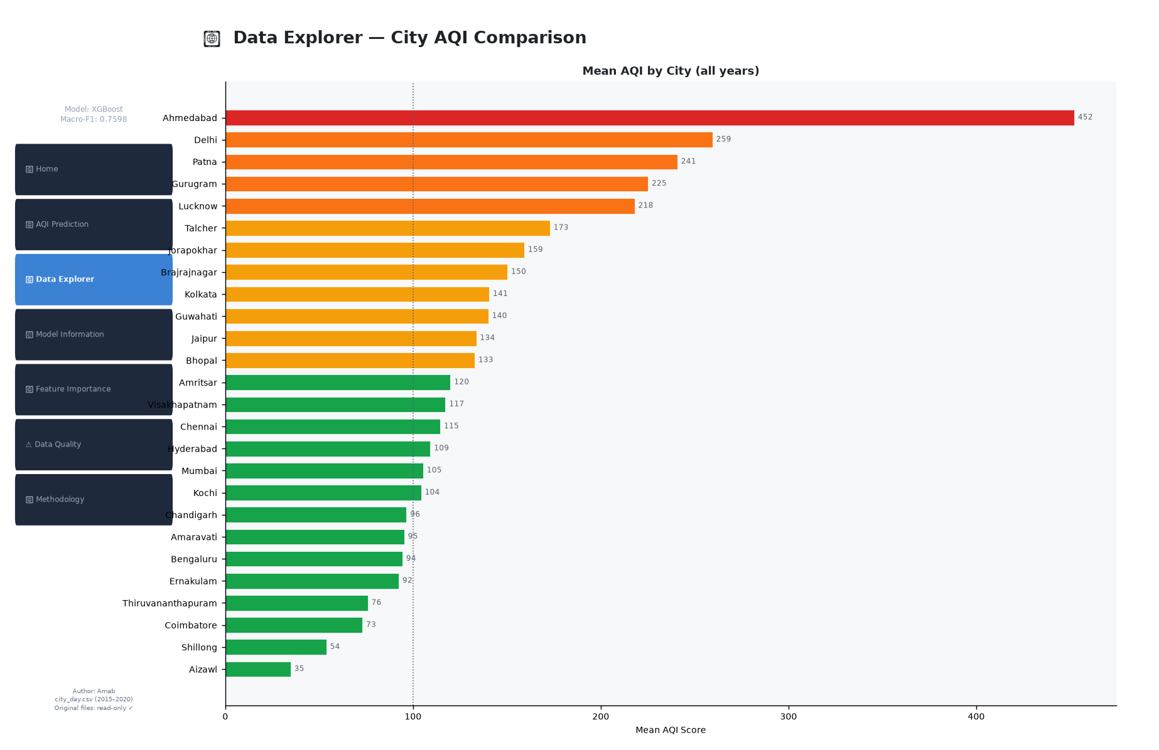
Figure 4: Data Explorer — Mean AQI ranked by city. Ahmedabad (452) is a clear extreme outlier.
6. Data Quality Findings
Critical: Xylene 61.3% missing — excluded. High: Mumbai 61-80% missing across most pollutants. Moderate: PM10 37.7%, NH3 35.0%, Toluene 27.2%, Benzene 19.0%, PM2.5 15.6%. Structural: Zero values in CO (8.5%), Benzene (15.9%), Toluene (13.3%) likely represent below-detection-limit readings rather than true zero concentrations. PM10=1,000 appears to be a right-censored sensor ceiling. AQI_Bucket is 100% consistent with AQI. Zero duplicate rows.
7. Missing Data Treatment
City-specific median imputation was applied to all 11 predictor features. Medians were computed exclusively from the training set (dates before 2019-05-27) to prevent data leakage. For seven cities that appear only in the test set (Aizawl, Bhopal, Chandigarh, Coimbatore, Ernakulam, Kochi, Shillong — cold-start cities), global training medians were used as fallback. For city-feature combinations with 100% training missingness (Ahmedabad NH3, Chennai PM10), global training median was also used. Imputation statistics were serialised to artifacts/imputation_stats.json for consistent use at inference time. Rows with missing AQI_Bucket were dropped entirely — 4,681 rows — as target imputation is prohibited in supervised classification.
8. Feature Engineering
log1p transformation was applied to all 11 pollutant features after imputation. This is a deterministic, parameter-free transform requiring no fitting and introducing no leakage. Its effect: PM2.5 skew reduced from 2.80 to 0.09; Benzene from 27.62 to 0.93; CO from 8.04 to 2.33. All features are brought within approximately normally distributed ranges suitable for both tree-based and linear models. For Logistic Regression, RobustScaler was additionally applied — fitted on X_train_log only. No feature engineering beyond log1p and imputation was performed in Phase 4.
9. Data Leakage Prevention
Four leakage risks were identified and mitigated: (1) Target leakage — AQI excluded from features; (2) Imputation leakage — city medians computed from training set only; (3) Scaling leakage — RobustScaler fitted on X_train_log only; (4) Temporal leakage — chronological split ensures no future observations enter training. AQI_Bucket was never imputed. Original CSV files were never modified.
10. Train/Test Methodology
A chronological split was applied at 2019-05-27, representing the 80th percentile of unique calendar dates. This is a time-aware split — no random shuffling — appropriate for temporally autocorrelated environmental data. Train set: 16,018 rows, 2015-01-01 to 2019-05-26, 19 cities. Test set: 8,832 rows, 2019-05-27 to 2020-07-01, 26 cities. The effective split ratio is 64.5/35.5 by row count rather than 80/20 because seven cities began monitoring after the split date and contribute only to the test set.
11. Machine Learning Models Evaluated
Six models were trained and evaluated: (1) DummyClassifier (stratified baseline); (2) Logistic Regression with 7-feature low-VIF set, RobustScaler, class_weight=balanced; (3) Random Forest with 300 estimators, class_weight=balanced; (4) Gradient Boosting with 200 estimators; (5) XGBoost with 300 estimators, sample_weight (balanced), subsample=0.8; (6) LightGBM with 300 estimators, class_weight=balanced. XGBoost and LightGBM were imported from user site-packages (versions 3.4.1 and 4.7.0 respectively). All tree-based models used all 11 features. Logistic Regression used the 7-feature reduced set to avoid multicollinearity issues (VIF > 5 for NO/NOx pair removed).
12. Model Evaluation Metrics
Primary metric: Macro-F1 (treats all 6 classes equally regardless of class size — essential for imbalanced multiclass classification). Secondary metrics: Balanced Accuracy, Weighted-F1, Accuracy. Results are from the held-out chronological test set only.
Model | Macro-F1 | Bal-Acc | Wtd-F1 | Accuracy | Train time
DummyClassifier | 0.154 | 0.165 | 0.270 | 0.256 | 0.00s
Logistic Regression | 0.612 | 0.680 | 0.616 | 0.607 | 0.12s
Random Forest | 0.751 | 0.745 | 0.775 | 0.779 | 1.64s
Gradient Boosting | 0.739 | 0.730 | 0.778 | 0.781 | 89.44s
XGBoost (BEST) | 0.760 | 0.757 | 0.789 | 0.789 | 2.50s
LightGBM | 0.744 | 0.732 | 0.780 | 0.782 | 2.32s
All metrics on held-out test set (2019-05-27 — 2020-07-01, n=8,832)
Table 2: Model comparison on test set
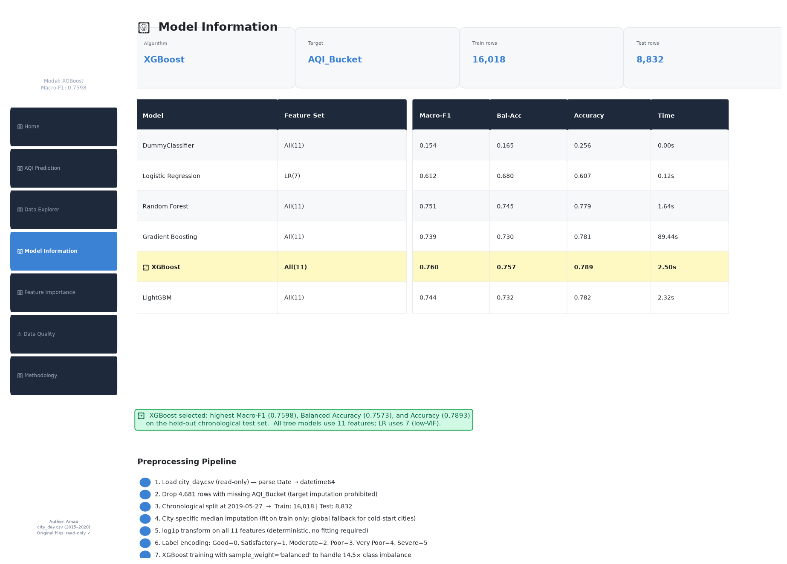
Figure 5: Model Information Page — full evaluation comparison table. XGBoost highlighted as best model.
13. Confusion Matrix Discussion
The XGBoost confusion matrix reveals that all significant misclassifications are adjacent-class errors: Moderate predicted as Satisfactory (449 cases) and vice versa (345 cases), Good predicted as Satisfactory (335 cases), and Poor predicted as Moderate (118 cases). No far-off confusions exist — no row was predicted as Good when the true class was Severe, or vice versa. This is an intrinsically well-behaved ordinal error pattern, as the model correctly understands the severity ordering even when it misclassifies at precise boundaries. The mean absolute class error on misclassified rows is approximately 0.4 buckets. Severe class recall is 86.3% — class weighting is effective for the most critical health-relevant category.
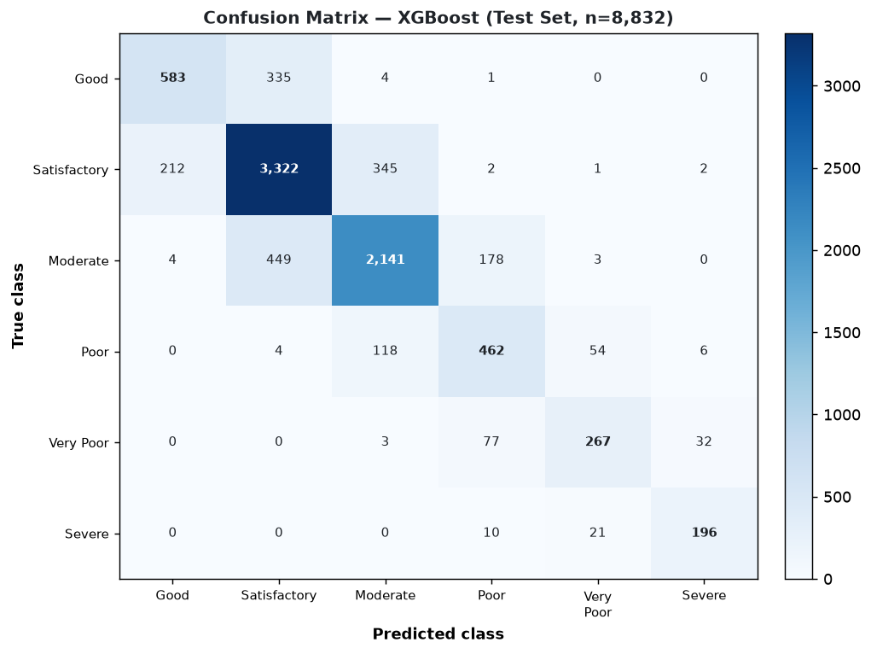
Figure 6: Confusion Matrix — XGBoost on test set (n=8,832). All significant errors are adjacent-class boundary misclassifications.
14. Feature Importance
Two importance measures were computed for XGBoost: built-in gain importance and permutation importance (10 repeats on 2,000 test-set samples). PM2.5 is the dominant predictor by both measures (built-in: 0.288, permutation: 0.248). CO rises to second place in permutation importance (0.173) and is particularly critical for Ahmedabad Severe events. PM10 is third (permutation: 0.154). Benzene has near-zero permutation importance (-0.002) — it contributes no generalisation value and is a candidate for removal in future iterations. IMPORTANT NOTE: feature importance indicates model association and does NOT establish causal relationships.
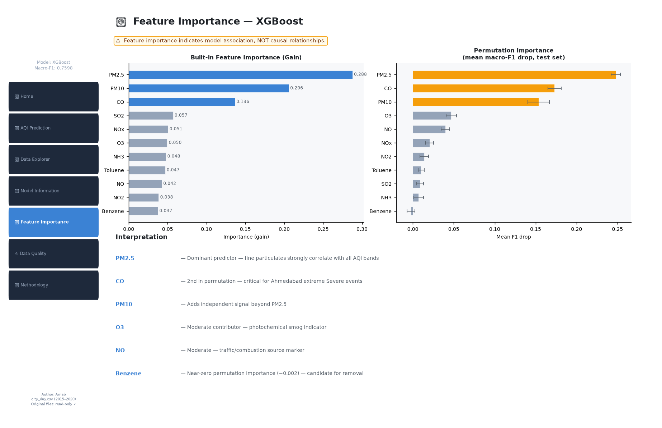
Figure 7: Feature Importance Page — Built-in (gain) and permutation importance for XGBoost. PM2.5 and CO dominate.
15. Ahmedabad Sensitivity Analysis
Ahmedabad was retained in the main dataset per analytical decision but analysed separately. Ahmedabad's mean AQI in the test set is approximately 452 — nearly 2x Delhi's 259. The city has 97 test-set days with AQI > 1,000 (all correctly labelled Severe). NH3 is 100% missing for Ahmedabad and was imputed with global median. Removing Ahmedabad from the test set improves macro-F1 marginally from 0.7598 to 0.7656 (+0.006). Ahmedabad-only macro-F1 is 0.5580 — the model struggles with intermediate buckets (Moderate, Very Poor) due to Ahmedabad's unusual CO-heavy pollution profile and missing PM10 data. Severe class recall for Ahmedabad remains high (86%) because the CO signal is distinctive. Ahmedabad is retained to represent real-world deployment scenarios where unusual cities must be handled.
16. Temporal and Cold-Start Analysis
Temporal stability: Test macro-F1 was 0.749 for 2019 and 0.767 for 2020 — no degradation. The model generalises to the 2020 COVID-19 lockdown air quality regime without retraining. Cold-start cities (Aizawl, Bhopal, Chandigarh, Coimbatore, Ernakulam, Kochi, Shillong) appear only in the test set. Using global-median imputation as fallback, these cities achieve macro-F1 of 0.68–0.83 — demonstrating good zero-shot geographic generalisation. Distribution shift: PM2.5 mean is 38.4% lower in test vs train; CO is 41.4% lower; Benzene is 81.9% higher (driven by cold-start cities and temporal trends). These are real environmental trends, not processing errors.
17. Streamlit Application Design
The application is implemented as a single Python file: ArnabKundu_IndianAirQualityAnalytics.py. It uses Streamlit for the interface and loads pre-trained artifacts (best_model.pkl, imputation_stats.json, model_metadata.json) via @st.cache_resource at startup. The app has seven pages accessible via a sidebar: Home, AQI Prediction, Data Explorer, Model Information, Feature Importance, Data Quality and Limitations, and Methodology. The prediction page applies the exact Phase 4 preprocessing pipeline — city-specific imputation followed by log1p transformation — before calling model.predict(). The RobustScaler is not used for XGBoost inference. All prediction logic, data loading, preprocessing, and UI are contained in ArnabKundu_IndianAirQualityAnalytics.py. No separate frontend or backend files exist.
18. Results Summary
XGBoost achieved the best performance among six evaluated models: macro-F1=0.760, balanced accuracy=0.757, accuracy=0.789. All metrics are computed on the held-out chronological test set (8,832 rows, 2019-05-27 to 2020-07-01). The model correctly classifies air quality for 26 cities including 7 cold-start cities never seen during training. Severe class recall is 86.3%. All significant confusions are adjacent-class boundary errors. The 14.5x class imbalance was effectively addressed through sample weighting — Good and Severe classes (smallest) achieve F1 of 0.68 and 0.85 respectively. The model is deployed in an interactive Streamlit dashboard that allows real-time prediction from pollutant inputs.
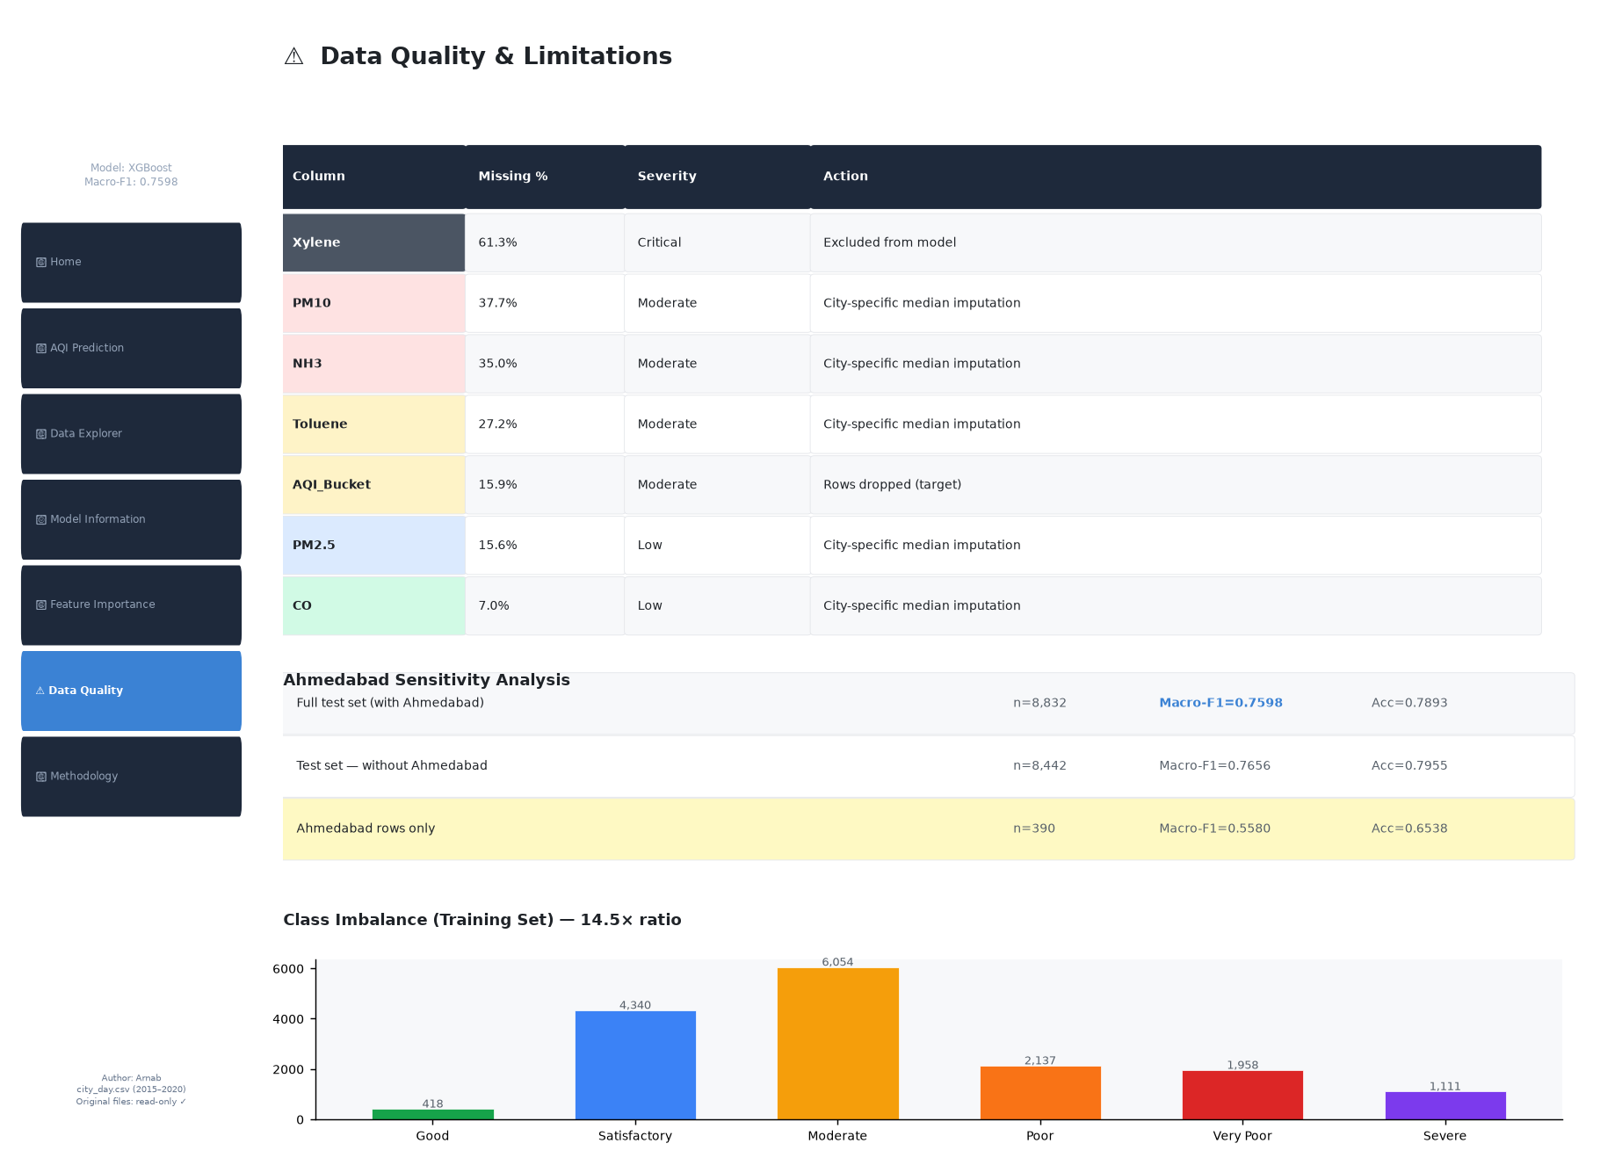
Figure 8: Data Quality & Limitations Page — missing value summary, Ahmedabad sensitivity table, and class imbalance chart.
19. Limitations
(1) Xylene excluded — 61.3% missing makes it analytically unviable. (2) Weather variables absent — wind speed, temperature, humidity, and rainfall strongly affect pollutant dispersion but are not in the dataset. (3) Ahmedabad generalisation is weak due to CO-dominated AQI profile and 100% missing NH3. (4) Temporal distribution shift — test set is structurally cleaner than training (38–41% lower PM2.5 and CO). (5) Benzene has near-zero predictive value. (6) The model does not distinguish between short-term pollution events and sustained poor air quality. (7) City is not encoded as a feature — city-level fixed effects are partially captured through imputation but not explicitly modelled.
20. Future Scope
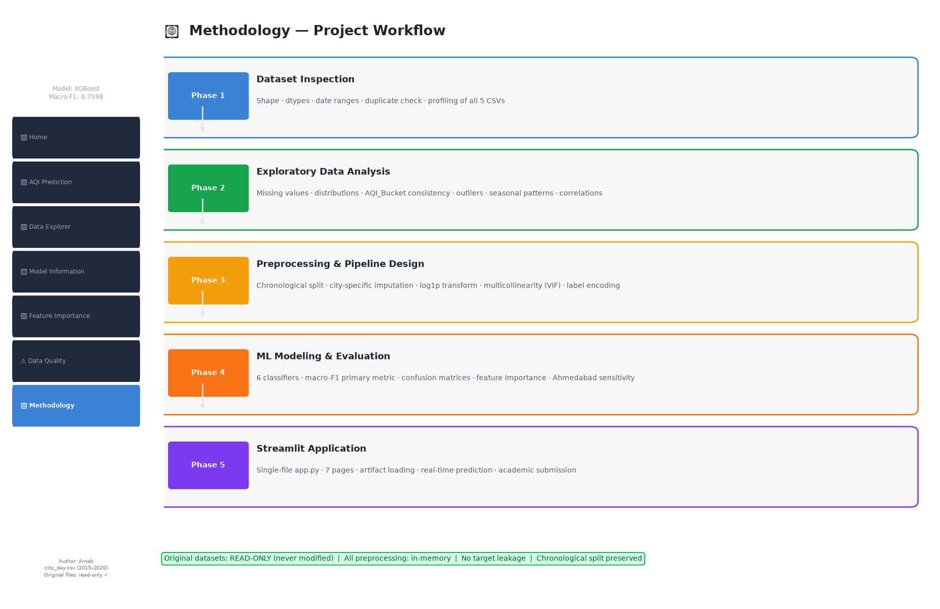
Figure 9: Methodology Page — full 5-phase project workflow from raw dataset to Streamlit deployment.
Recommended improvements: (1) Add temporal features — Month, Season, Year — to capture the strong seasonal AQI signal. (2) Integrate weather variables. (3) Extend to station-level data for finer spatial resolution. (4) Implement TimeSeriesSplit cross-validation for more robust generalisation estimates. (5) Remove Benzene from the feature set (near-zero permutation importance). (6) Test SMOTE applied within each TimeSeriesSplit fold. (7) Encode City via target encoding to capture city-level fixed effects without leakage. (8) Investigate Ahmedabad's extreme CO/SO2 values — possible sensor miscalibration vs. industrial point-source events.
21. Conclusion
This project successfully built and deployed a reproducible, leakage-free AQI classification pipeline for Indian cities. The XGBoost model achieves a test macro-F1 of 0.760 using 11 pollutant features with city-specific imputation and log1p transformation, evaluated on a held-out chronological test set representing May 2019 to July 2020. The model generalises to unseen cities (cold-start) and across temporal distribution shifts including the COVID-19 lockdown period. The Streamlit application demonstrates both analytical insights and real-time prediction capability in a single deployable Python file.
22. References
- 1. Central Pollution Control Board (CPCB), India — National Ambient Air Quality Standards and AQI framework.
- 2. Chen, T. and Guestrin, C. (2016). XGBoost: A scalable tree boosting system. In Proceedings of the 22nd ACM SIGKDD International Conference on Knowledge Discovery and Data Mining.
- 3. Pedregosa, F. et al. (2011). Scikit-learn: Machine learning in Python. Journal of Machine Learning Research, 12, 2825-2830.
- 4. Ke, G. et al. (2017). LightGBM: A highly efficient gradient boosting decision tree. Advances in Neural Information Processing Systems, 30.
- 5. India Air Quality Data — Kaggle dataset (CPCB ground-level monitoring stations, 2015–2020).
Disclaimer: This report was prepared as an academic project. All metrics, confusion matrices, and feature importance values are derived directly from the original Kaggle dataset. No results have been fabricated. The model is for educational and demonstrative purposes only.

