**Part A**

**I**

**A**

**B**

**C**

**D**

**E**

**F**

**G**

**Objective** : Name and decribe each component

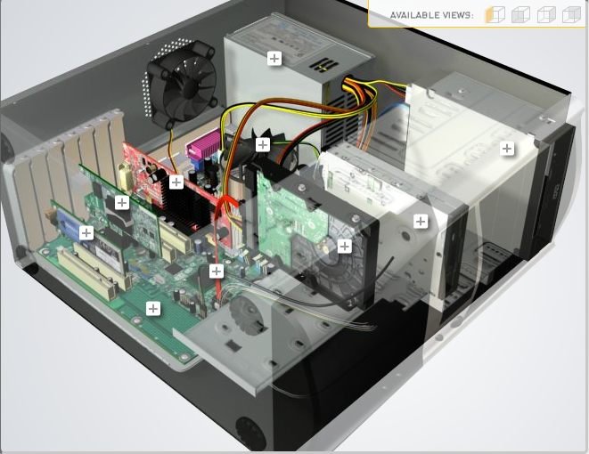

**H**

|  |  |  |
| --- | --- | --- |
| Download [**http://tinyurl.com/CW208-CAG-SIM**](http://tinyurl.com/CW208-CAG-SIM) PC Build Simulator.  Go through steps of building a PC, as you complete the simulation find and describe in detail components A to I. To run simulator first install <http://www.swffileplayer.com/> and open ***RootMovie.swf*** using SWF player. Alternatively install [Macromedia Flashplayer](https://fpdownload.macromedia.com/pub/flashplayer/updaters/32/flashplayer_32_sa.exe) . Ideally use a simulator as listed in class. | | |
| Label | Name each component | Description |
| A | RAM | short term memory where data is stored as the processor needs it |
| B | GPU | designed to accelerate graphics rendering |
| C | CPU | the portion of a computer that retrieves and executes instructions |
| D | PSU (Power Supply) | to supply power to all of your PC components |
| E | Disk Drive | enables the reading, writing, deleting and modifying of data on a computer storage disk |
| F | Hard Drive | where all your permanent computer data is stored |
| G | SSD | flash-based memory, which is much faster than a traditional mechanical hard disk |
| H |  |  |
| I | Motherboard | the backbone that ties the computer's components together at one spot and allows them to talk to each other |

**Part B**

**Objective**

Compare a pre-assembled system and the components that could be assembled to build a comparable system. After completing this practical, you should be able to:

1. Identify the components of a pre-assembled system
2. Locate prices for components needed to assemble a comparable system
3. Compare the cost of a pre-assembled system and a self-assembled system.

If you can’t find exact match for components, find the closest possible substitute. Use the Internet and available computer-related publications as your sources for information. Examples of websites for computer parts [www.komplett.ie](http://www.komplett.ie), [www.dell.ie](http://www.dell.ie), [www.custompc.ie](http://www.custompc.ie) [www.amazon.de](http://www.amazon.de)

MAKE SURE TO INCLUDE VALID LINKS TO WEB REFERENCES

|  |  |  |
| --- | --- | --- |
|  | **Pre-Assembled Computer Package** | **Computer Package**  **Components** |
| **CPU** | Intel® Core™ i5-11600K processor | AMD Ryzen 7 3700X processor |
| **Storage / Memory** | | |
| |  | | --- | |  | | RAM | | Hard Drive | |  | | |  | | --- | |  | | 16 GB RAM | |  | |  |   512 GB | 16 GB RAM  512 GB |
| **Input/Output** | | |
| |  | | --- | | Keyboard | | Pointing Device | | Monitor | | Speakers | | Network Adapter | |  | |  | | Microsoft Keyboard Wired USB Compact  Microsoft Basic 3 Button Wired Compact Optical Mouse  SAMSUNG LS22F350FHUXEN Full HD 22” LED Monitor  ewent Stereo Speaker  D-Link N300 WiFi USB 2.0 Dongle | ADVENT AKBMM15 Wireless Keyboard  Anker® Ergonomic Optical USB Wired Vertical Mouse  HP V24i Full HD 23.8" IPS LCD Monitor  Trust Remo 2.0 Speaker  Intel AC8265 Bluetooth, WiFi Wireless Adapter |
| **Bundled Software**  (Including Operating System) | Windows 11 Home | Windows 11 Home |
| **Total Cost** | 1100 € | 1250 € |

**Part C**

**Objective**

You have been asked by a family friend to assist them with a computer purchase. They’re unfamiliar with technology and the terms used and have presented you with two alternatives machine choices. They would like to be able to write word documents, surf internet and play Minecraft © Mojang and Half-Life © Valve Software. They are considering playing Fortnight but are not sure yet, as it depends on machine cost and if they can extract some money from their Bitcoin wallet.

Compare Personal Computer Option A and B in relation to each of the side headings and recommend a system and any alterations.

|  |  |  |
| --- | --- | --- |
|  | Personal Computer  Option A | Personal Computer  Option B |
| CPU | 2.2 GHz Intel Celeron 450 | 3.2 GHz Intel Core i5 |
| Memory |  |  |
| |  | | --- | | Cache | | RAM | | Hard Drive | | CD-ROM/DVD | | |  | | --- | | 512 KB Cache | | 4 GB RAM | | 320 GB Hard Drive | | DVD+/-RW drive | | |  | | --- | | 4 MB Cache | | 8 GB RAM | | 1 TB Hard Drive | | DVD+/-RW drive | |
| Input/Output |  |  |
| |  | | --- | | Keyboard | | Pointing Device | | Screen | | Speakers | | Network Adapter | | |  | | --- | | USB multifunction keyboard | | USB optical mouse | | 20’’ HD flatscreen monitor | | Multimedia Speaker System | | Integrated 10/100/1000 Ethernet | | |  | | --- | | wireless multifunction keyboard | | wireless optical mouse | | 25’’ HD flatscreen monitor | | Dolby Surround Sound Speakers | | Integrated 10/100/1000 Ethernet | |

|  |
| --- |
| **Recommendations** |
| Option A is a smaller more compact PC that will still run fine for office work of the 4GB RAM  But will struggle to run multiple applications at once. The mouse and keyboard are also wired meaning more cables in the way.  Option B offers more than half the RAM and has an extra 680 GB on the hard drive.This option also has a larger monitor with wireless peripherals meaning less annoying cables |

**Your Recommend System**

|  |  |
| --- | --- |
|  | Personal Computer  Recommendation |
| **CPU** | AMD Ryzen 7 3800x |
| **Memory** | |
| |  | | --- | |  | | RAM | | Hard Drive | | SSD Drive | | |  | | --- | | (2x16GB) Trident Z RGB | | TOSHIBA 3TB | | Gigabyte Aorus 512GB | |  | |
| **Input/Output** | |
| |  | | --- | | Keyboard | | Pointing Device | | Screen | | Speakers | | Network Adapter  GPU | | |  | | --- | | Steelseries Apex 3  Logitech MX Master Wireless Mouse  ASUS VG248QG  Logitech Z200 speakers  Inter AC8265 Bluetooth, Wifi  Geforce rtx 2080 Super | |  | |  | |  | |  | |

Hand up this practical report at the end of session and ensure it has been checked

|  |  |  |  |
| --- | --- | --- | --- |
| **Student Name** | **Arnas Karalius** | **Student Number** | **C00261113** |
| **Date** | **27/10/2021** | **Checked** |  |
| **Group** | **A / B** |  |  |