**Trello Tutorial**

**MCTV**

In this tutorial I will show how you how to perform basic tasks in Trello. Trello is an easy to use collaborative software package that helps the users to collaborate on almost anything including notes, files, recommedendations. Trello allows all team members from the group to modify, upload and see all the information in the group. It is very useful collaborative tool as we can use it to effetively share information between everyone in our company.

**Step 1: Sign Up**

You will need to go to [www.trello.com](http://www.trello.com) in order to create a new account for yourself: 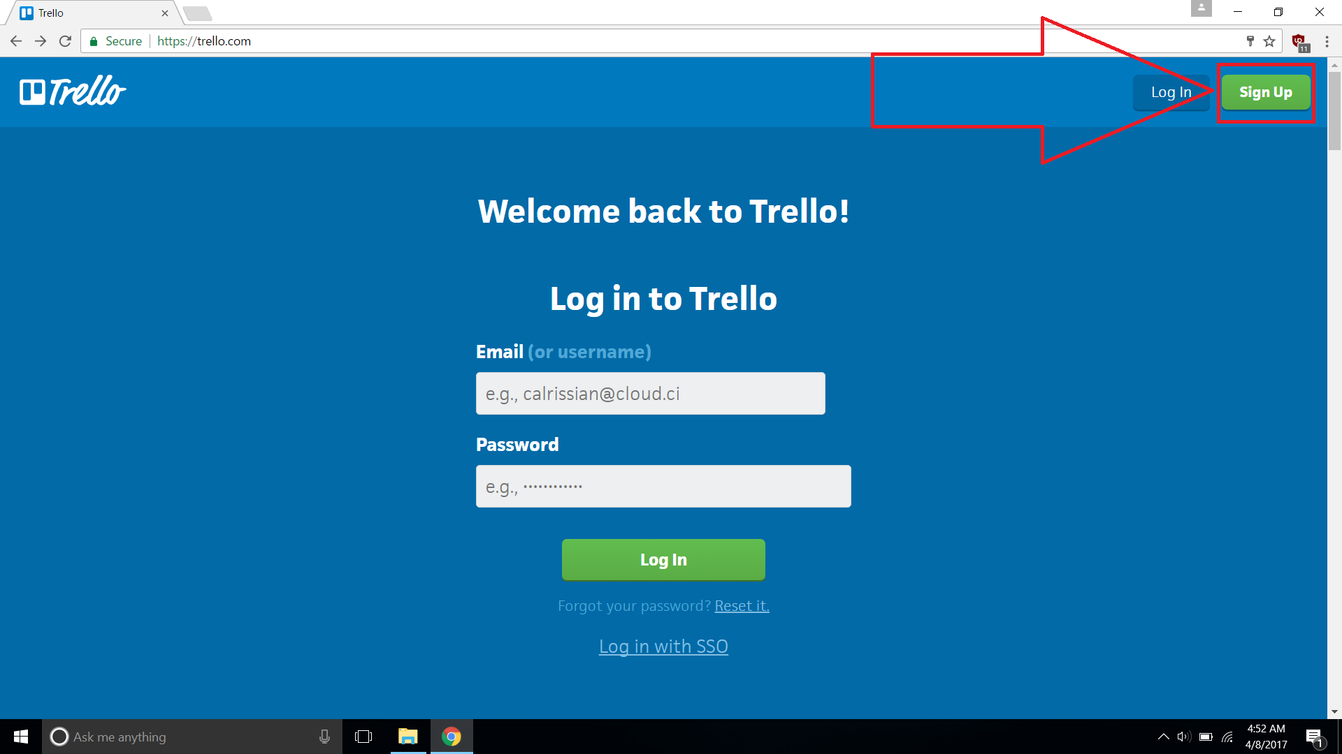

On the main page you will need to press the Sign Up button.

After pressing the Sign Up button you will be redirected to a page that looks like this:

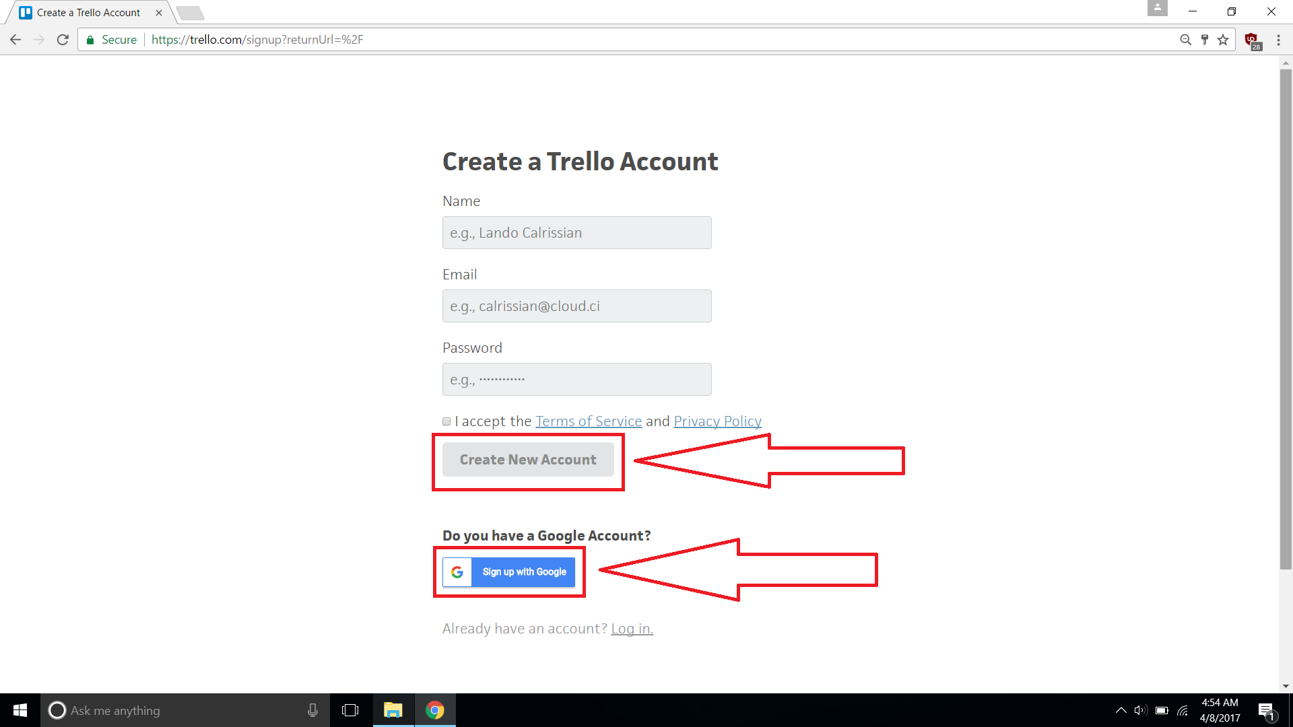

On this page you have 2 options:

Option 1: If you do not have a google account you will have to enter your details manually which includes your Name, E-mail and password.

Option 2: You can sign up using Google. You just press the blue button as shown in the screenshot and press confirm.

As you will be most likely using company e-mail, you will need to enter your details manually. After entering your details and pressing Create New Account you will be sent a confirmation e-mail. You will need to access your e-mail and you will find there a message from Trello which requires your confirmation. Select the message and press the green button “Verify Address”.

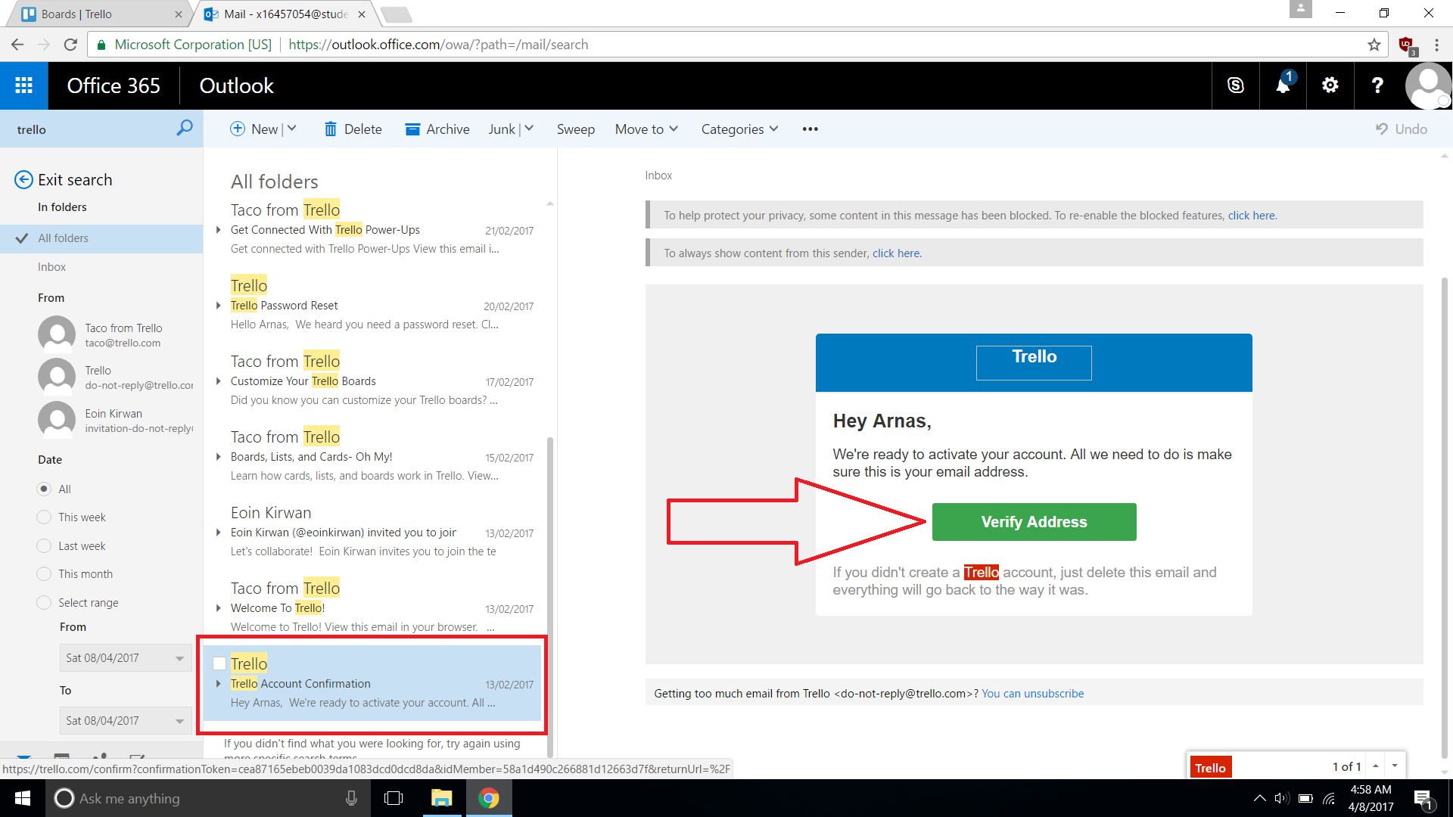

**Step 2: Main Page**

After confirming your E-mail you will then be asked to create a team. In our case I have already created a team so you can skip this step, otherwise enter a team name and press continue.

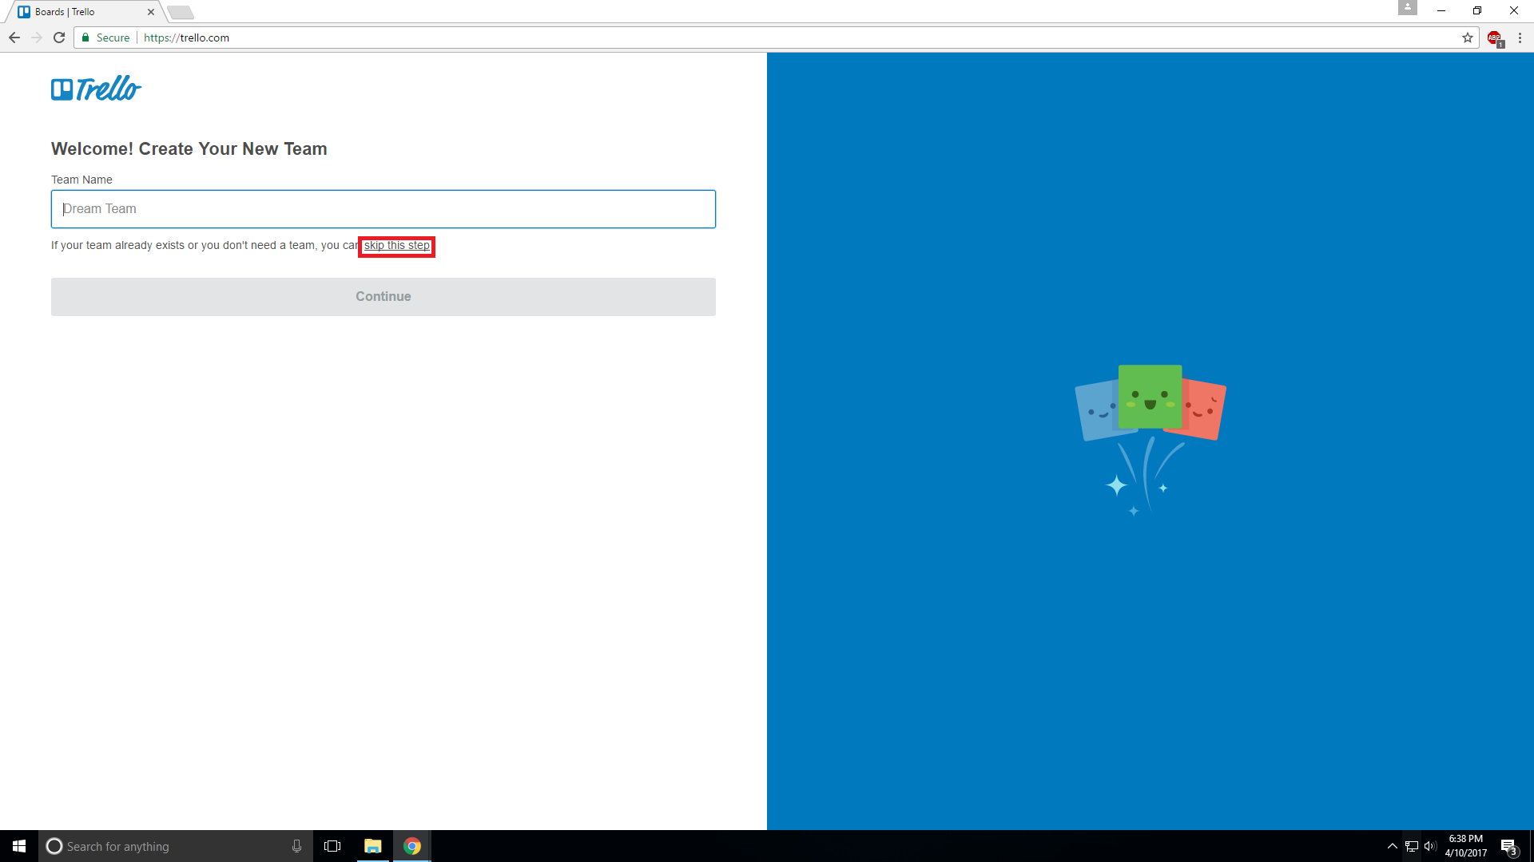

**You will then be brought to the main Trello screen where you are able to access most of the features. On this screen you are able to create new boads, create a team, change settings, see all your boards and teams, etc.**

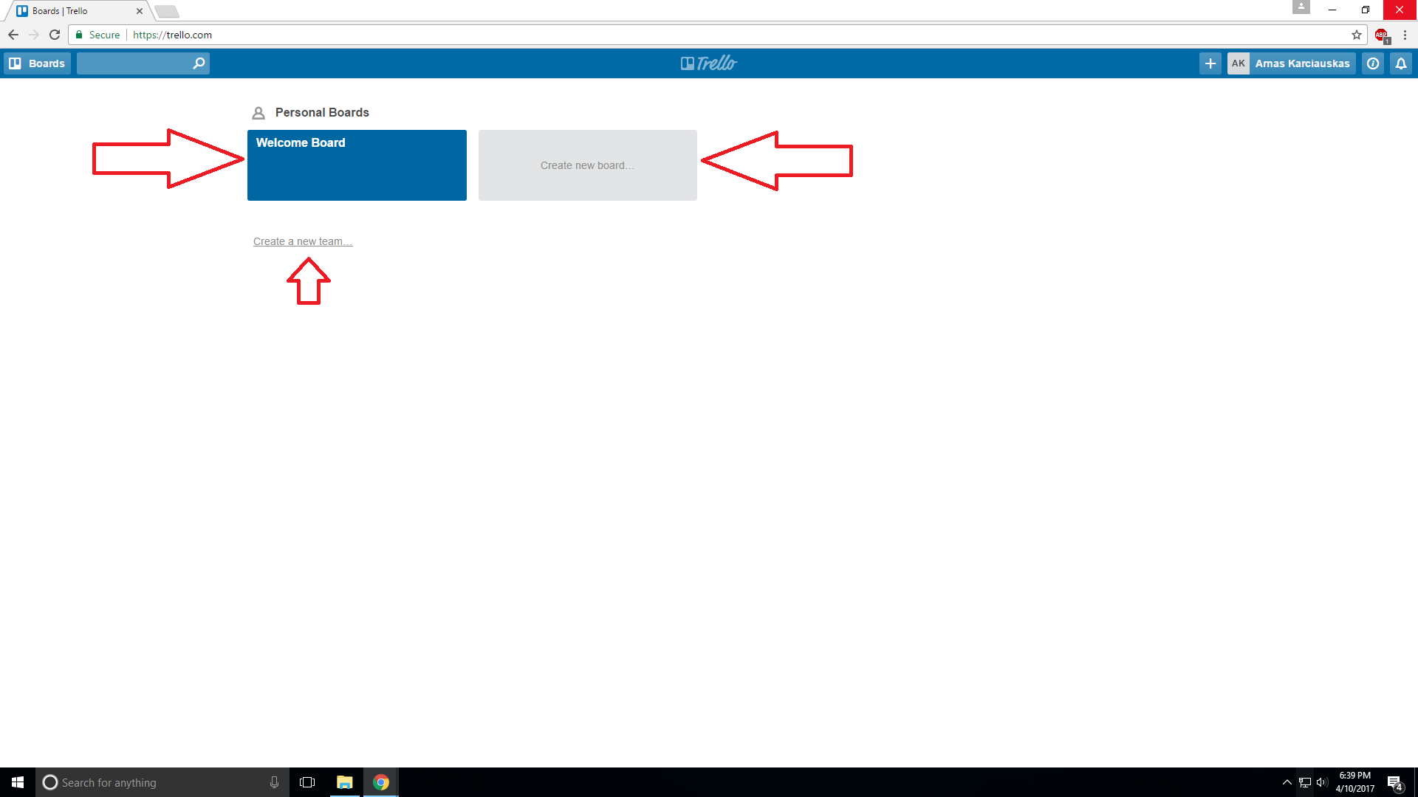

First, I would recommend for you to have a look at Trello’s own “Welcome Board”. It will show you the features of the software package and samples of how it looks like.

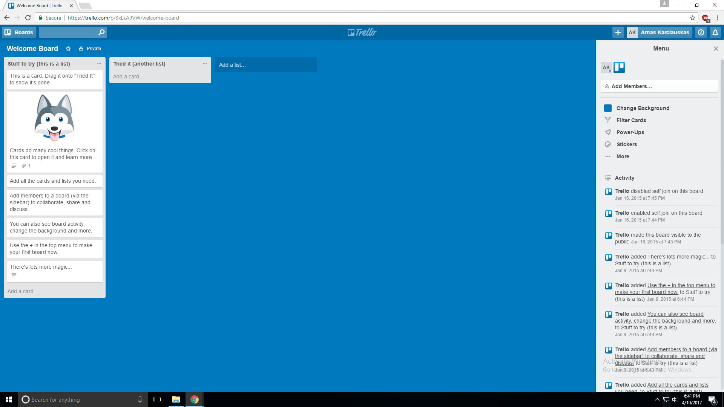

To go back to the main menu press the Trello logo in the middle top of the screen:

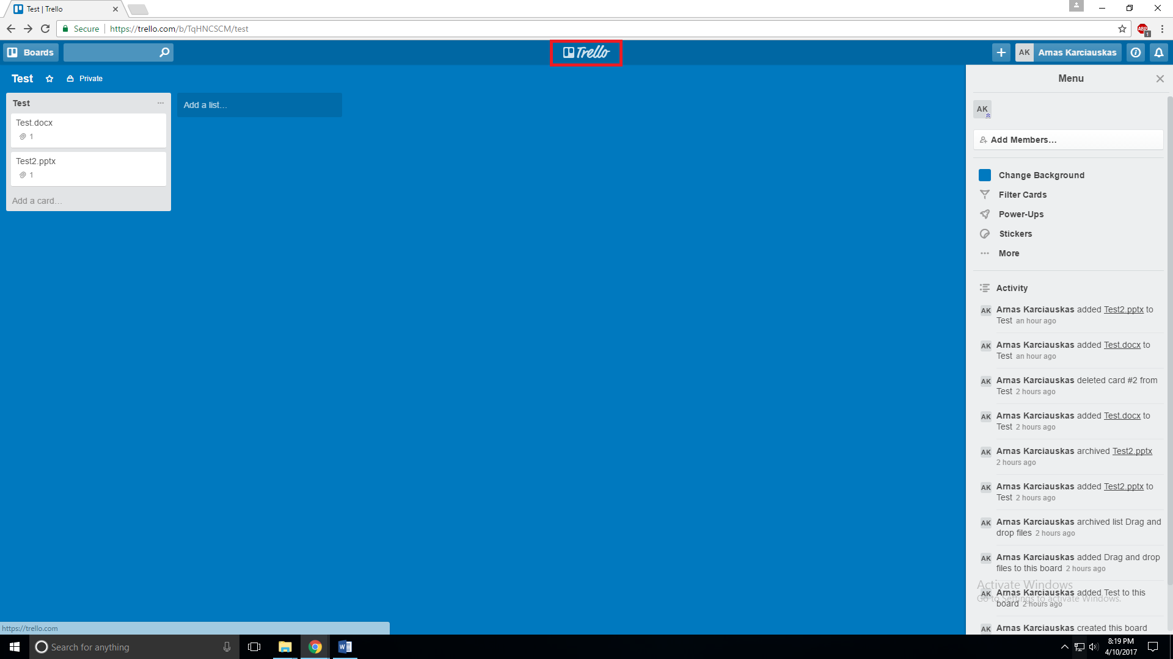

One of the main features of Trello is creating boards, to create a board press the grey box with the words “Create new board…”. After you will see the following box:

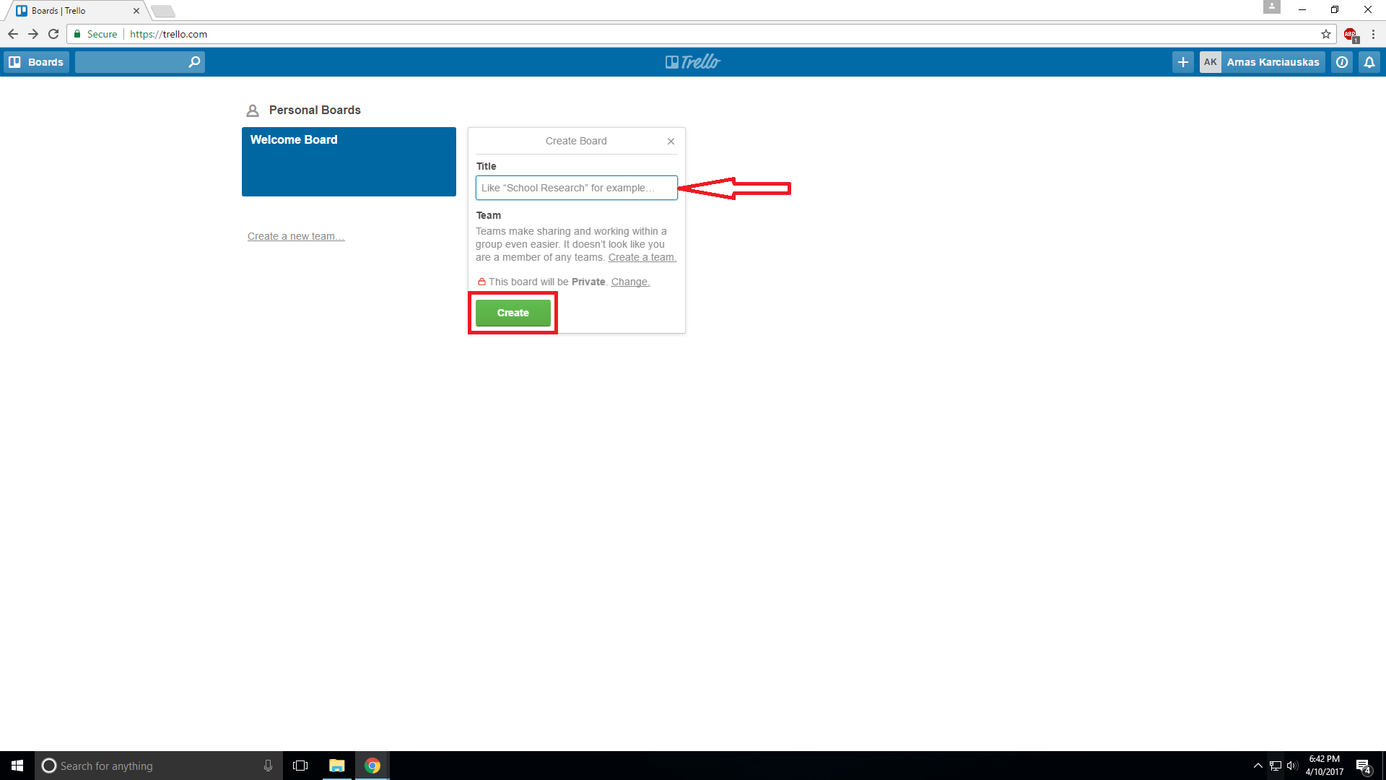

Enter a title and press create.

After you create a board you will be automatically redirected to it.

Here you can make changes to your created board, you can add and download files, add more lists and make changes. Other team members are also able to do the same.

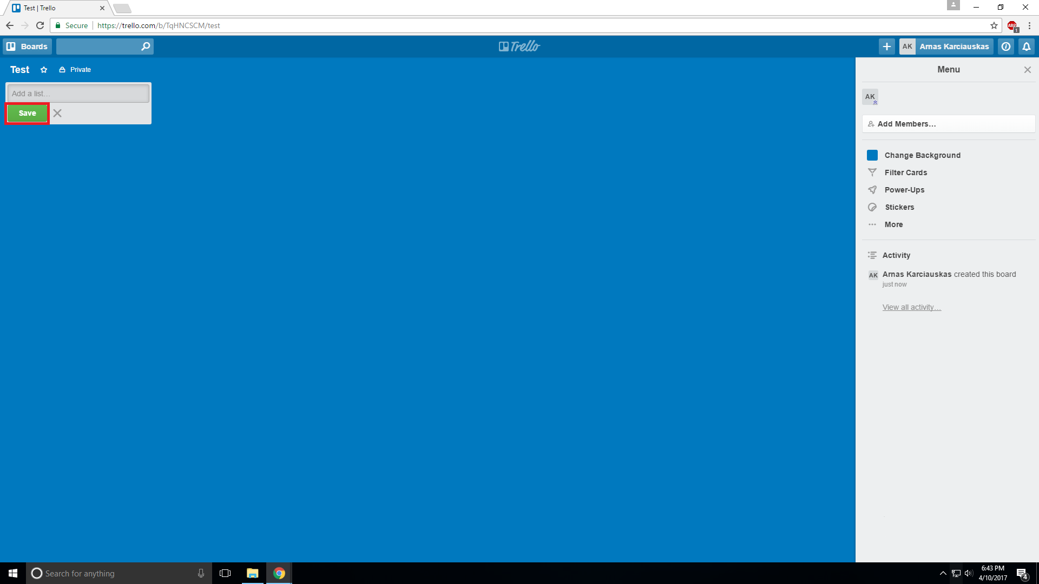

You can add text or add files to your boards. Add files by dragging and dropping.

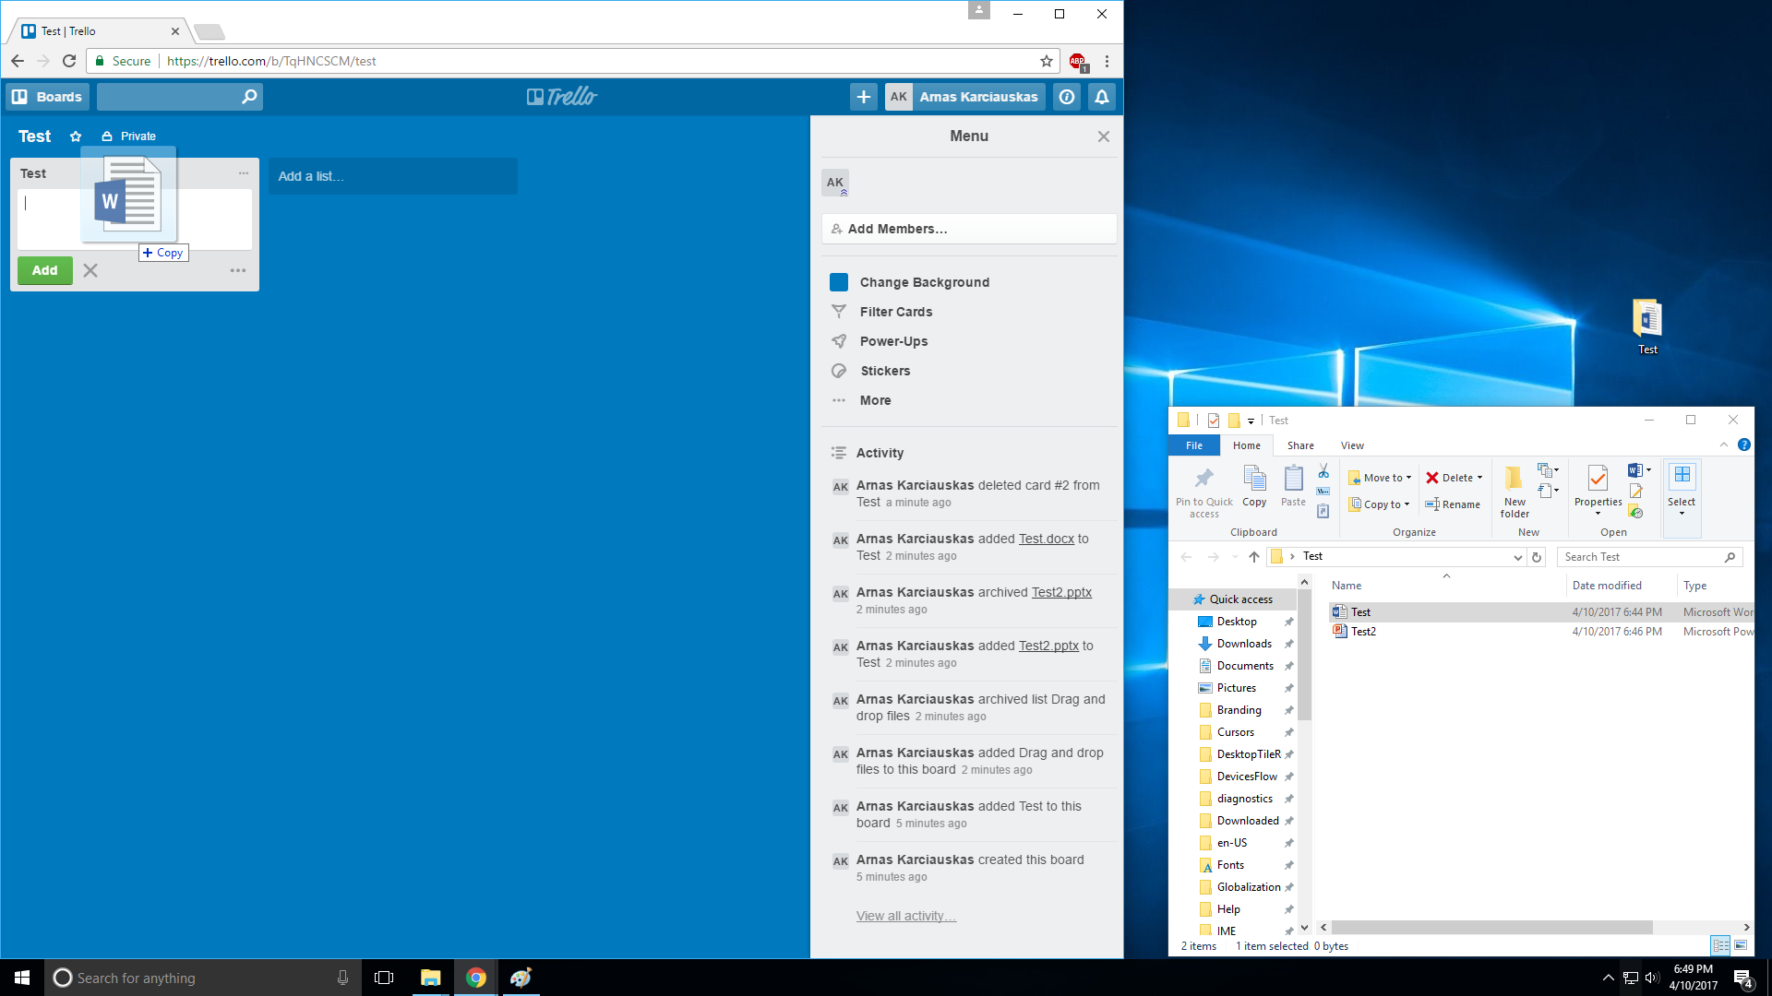

You can see both yours and your team member’s activity on the sidebar.

