A/B Testing Report: Digital Advertising Campaign
Hypothesis testing, confidence intervals, estimated lift, and business recommendation
Dataset: Marketing A/B Testing | Tools: PostgreSQL, Python, pandas, statsmodels

Executive Summary

This report evaluates whether a digital advertising campaign increased user conversion compared with a control experience. Users in the treatment group were exposed to advertisements, while users in the control group were exposed to public service announcements.
The ad group converted at 2.55%, compared with 1.79% for the PSA group. The observed absolute lift was 0.77%, equivalent to a relative lift of 43.09%. The 95% confidence interval for the difference ranged from 0.60% to 0.94%, and the two-proportion z-test returned z = 7.37 with p < 0.001.
Because the confidence interval for the difference is entirely above zero and the p-value is below the 5% significance threshold, the analysis supports rejecting the null hypothesis. The campaign appears to have produced a statistically significant improvement in conversion rate.

Business Problem

Marketing teams need evidence to decide whether an advertising campaign creates enough incremental conversion lift to justify continued spend. The business question for this analysis is: did the ad campaign increase conversion compared with the control group?

Experiment Design

- Treatment group: users exposed to the advertising campaign.
- Control group: users exposed to public service announcements.
- Primary metric: conversion rate, calculated as converted users divided by total users.
- Unit of analysis: user-level records.
- Statistical test: two-proportion z-test comparing ad and PSA conversion rates.
- Significance level: 5%.

Hypotheses

Null hypothesis (H0): there is no difference in conversion rate between the ad group and the PSA group.
Alternative hypothesis (H1): there is a difference in conversion rate between the ad group and the PSA group.
The business expectation is directional: if the campaign is effective, the ad group should convert at a higher rate than the PSA group. The statistical test is reported using a two-sided framework, which is a conservative standard for portfolio reporting.

Dataset Overview

The dataset contains 588,101 user-level records. The key fields used in the analysis are test group, conversion outcome, total ads seen, most active ads day, and most active ads hour.

Key Results

Metric | Ad group | PSA group | Difference
Users | 564,577 | 23,524
Conversions | 14,423 | 420
Conversion rate | 2.55% | 1.79% | 0.77%
95% confidence interval | 2.51% to 2.60% | 1.62% to 1.95% | 0.60% to 0.94%
Standard error | 0.000210 | 0.000863 | 0.0889%

Statistical Methodology

Because the conversion outcome is binary, the conversion rate is a sample proportion. For a binary variable, the standard deviation is calculated as sqrt(p * (1 - p)), where p is the observed conversion rate. The standard error is calculated by dividing the standard deviation by the square root of the sample size.
Confidence intervals were calculated using the normal approximation: conversion rate plus or minus 1.96 times the standard error. The same approach was used for the difference in conversion rates, where the standard error of the difference combines uncertainty from both groups.

Detailed Statistical Summary

Statistic | Ad group |  | PSA group
Standard deviation | 0.1578 |  | 0.1324
Standard error | 0.000210 |  | 0.000863
Conversion rate | 2.55% |  | 1.79%
Margin of error | 0.04% |  | 0.17%
95% confidence interval | 2.51% to 2.60% |  | 1.62% to 1.95%
Difference statistic |  | Value
Absolute lift |  | 0.77%
Relative lift |  | 43.09%
Standard error of difference |  | 0.0889%
95% CI for difference |  | 0.60% to 0.94%
Z-statistic |  | 7.37
P-value |  | p < 0.001

Confidence Intervals and Estimated Difference
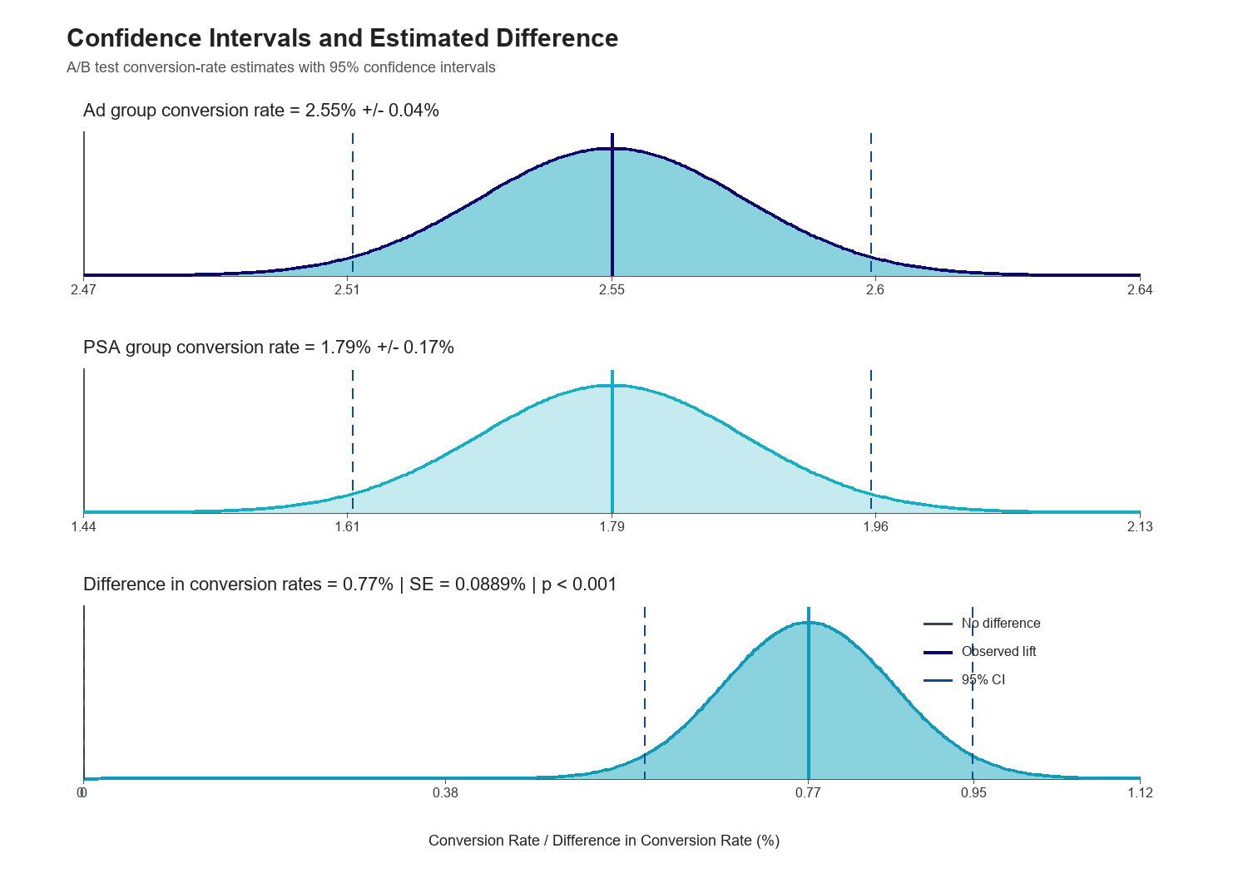
Figure 1. The ad group conversion estimate is higher than the PSA group estimate. The confidence interval for the difference remains above zero.

Interpretation

- The ad group converted at 2.55%, compared with 1.79% for the PSA group.
- The observed lift was 0.77%, with a 95% confidence interval from 0.60% to 0.94%.
- Because the full confidence interval for the difference is above zero, the result supports a positive campaign effect rather than random variation.
- The two-proportion z-test produced z = 7.37 and p < 0.001, which is statistically significant at the 5% level.

Business Recommendation

The campaign should be considered successful based on the available conversion data. The ad group produced a higher conversion rate, the estimated lift was positive, and the confidence interval for the difference stayed above zero. This supports continuing the campaign or using it as a baseline for future creative and targeting tests.
Before increasing budget significantly, the business should also evaluate cost per incremental conversion, revenue per conversion, profit margin, and customer lifetime value. Conversion lift is statistically meaningful, but investment decisions should also consider financial return.

Limitations

- The analysis measures conversion rate but does not include campaign cost, revenue, or profit.
- The groups are imbalanced: the ad group is much larger than the PSA group.
- The analysis does not verify the randomization process used to assign users to groups.
- Higher ad exposure should be interpreted as association, not direct causation, because more active users may naturally see more ads.
- Long-term retention and repeat purchase behavior are not available in this dataset.

Conclusion

The A/B test provides strong evidence that the advertising campaign improved conversion. The ad group converted at 2.55%, while the PSA group converted at 1.79%. The estimated lift was 0.77%, and the 95% confidence interval for the lift ranged from 0.60% to 0.94%. Since the confidence interval is fully positive and the p-value is below 0.001, the result is both statistically significant and business-relevant.

