Ski Project

Logical model

Arnas Gabijunas

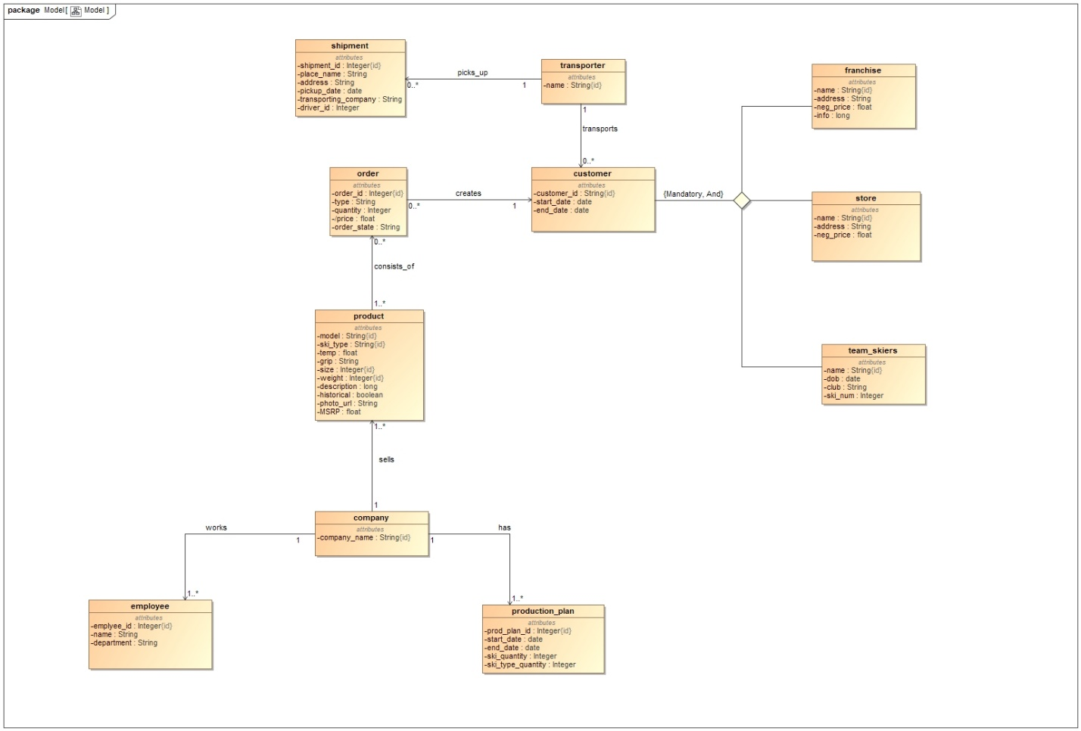

company(company_name)

PK company_name

employee(employee_id, company_name, name, department)

PK employee_id

FK company_name REFERENCES company(company_name)

production_plan(prod_plan_id, start_date, end_date, company_name, ski_quantity, ski_type_quantity)

PK prod_plan_id

FK company_name REFERENCES company(company_name)

product(model, ski_type, company_name, temp, grip, size, weight, description, historical, photo_url, MSRP)

PK model, ski_type, size, weight

FK company_name REFERENCES company(company_name)

transporter(name)

PK name

shipment(shipment_id, place_name, address, pickup_date, transporting_company, driver_id)

PK shipment_id

FK transporting_company REFERENCES transporter(name)

order(order_id, store_id, franchise_id, team_skier_id, type, quantity, order_state)

PK order_id

FK store_id REFERENCES store(customer_id)

FK franchise_id REFERENCES franchise(customer_id)

FK team_skier_id REFERENCES team_skier(customer_id)

product_in_order(order_id, model, ski_type, size, weight)

PK order_id, model, ski_type, size, weight

FK order_id REFERENCES order(order_id)

FK model, ski_type, size, weight REFERENCES product(model, ski_type, size, weight)

franchise(customer_id, start_date, end_date, name, address, neg_price, info, transporter_name)

PK customer_id

FK transporter_name REFERENCES transporter(name)

store(customer_id, start_date, end_date, name, address, neg_price, transporter_name)

PK customer_id

FK transporter_name REFERENCES transporter(name)

team_skiers(customer_id, start_date, end_date, name, dob, club, ski_num, transporter_name)

PK customer_id

FK transporter_name REFERENCES transporter(name)