VILNIUS UNIVERSITY

FACULTY OF MATHEMATICS AND INFORMATICS

INSTITUTE OF COMPUTER SCIENCE

**PRADa**

**Point of Sales System**

Software Design and Architecture

Work done by:

Rokas Ričkus

Danielius Rėkus

Arvydas Venskus

Paulina Januškevičiūtė

Vilnius, 2022

Table of content

1. Introduction 3

2. Actors 3

2.1. Customer 3

2.2. Waiter 3

2.3. Manager 3

2.4. Cook 3

3. User Story Map 3

3.1. Customer 3

3.2. Waiter 4

3.3. Manager 4

3.4. Cook 5

4. User Stories 5

4.1. Customer 5

4.2. Waiter 5

4.3. Manager 5

4.4. Cook 5

5. Data Model 5

# Introduction

The purpose of this system is for it to be applicable to any kind of point-of-sale (POS) enterprise whose main service is the supply of food. The system will support 3 different kinds of orders: On-Site, Take-away and delivery. It will handle all kinds of business and user needs, such as (but not limited to) management of restaurants, orders, products, and employees. The purpose of this document will be to indicate the main functionality of the system, along with key actors and their stories.

# Actors

The proposed point-of-sale (POS) system is designed to selling services and products. It allows clients to make orders online.

## Customer

A system user who uses a part of the system that is provided by the business that owns the POS.

## Cashier

An employee who has a set of permissions depending on what part he partakes in the system’s workflow and uses the system in the workplace.

## Manager

An employee who is a system user that has the rights to change system settings and use more features of the POS.

## Worker

An employee who can only perform a limited number of tasks in the system that are required for a ordinary employee.

# User Story Map

## Customer

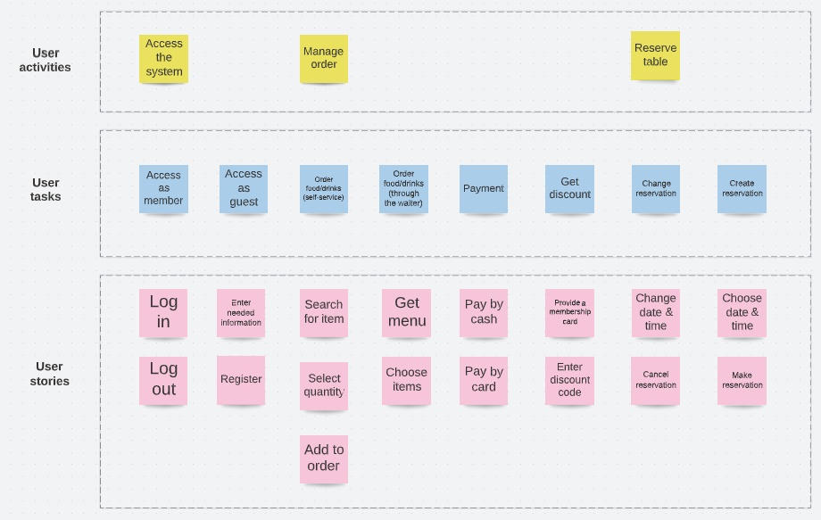

Figure Customer User Story Map

## Cashier

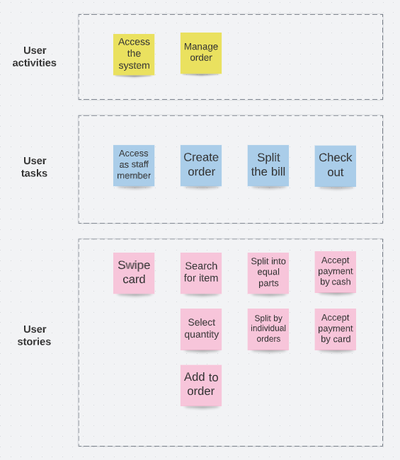

Figure Cashier User Story Map

## Manager

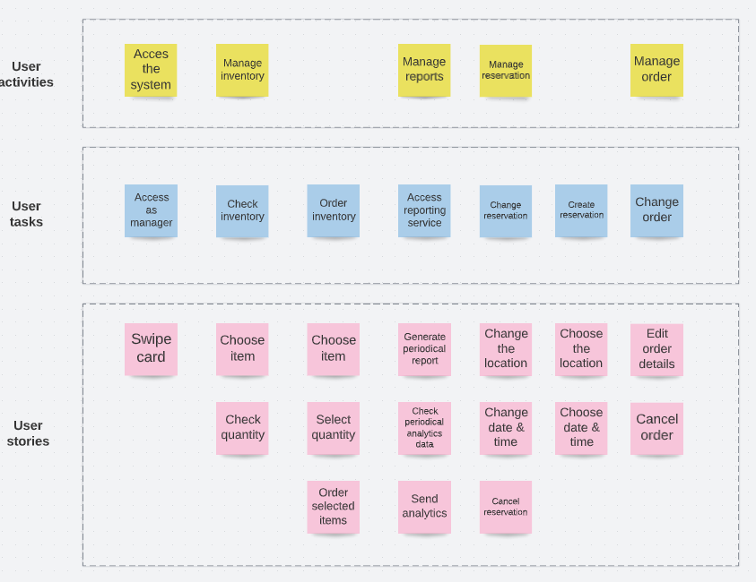

Figure Manager User Story Map

## Worker

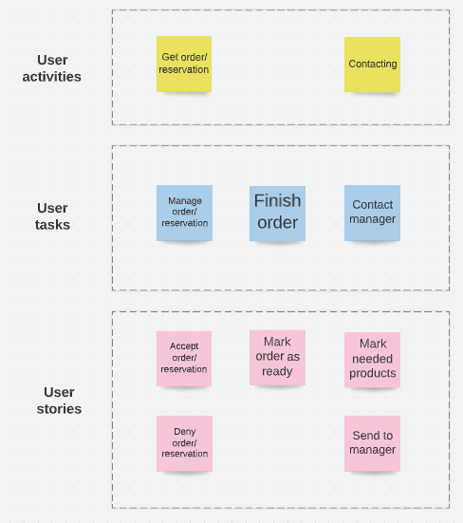

Figure Worker User Story Map

# User Stories

## Customer

**MUST HAVE:**

* As a customer I want to log into the system, so that I could access members' benefits;
* As a customer I want to log out of the system, so that others could log in and use it;
* As a customer I want to enter the needed information, so that I could register and create an account;
* As a customer I want to select an item and its' quantity, so that I could add it to my order;
* As a customer I want to create a reservation, so that I could ensure an available table spot when I arrive at the restaurant;

**SHOULD HAVE:**

* As a customer I want to pay by cash, so that I can still pay even if I don't have my card on me;
* As a customer I want to pay by card, so that I wouldn't have to carry my wallet with cash;
* As a customer I want to change my reservation, so that I could deal with changes in my personal plans;
* As a customer I want to cancel my reservation, so that I could change my plans.

**COULD HAVE:**

* As a customer I want to provide a membership card, so that I could get a discount;
* As a customer I want to enter a discount code, so that I could get a discount;

## Cashier

**MUST HAVE:**

* As a cashier I want to get access as staff member by swiping an access card, so that I could access the system;
* As a cashier I want to search for an item and select its quantity, so that I could add it to the order;
* As a cashier I want to check out, so that the customers can pay for their meals;

**SHOULD HAVE:**

* As a cashier I want to split the bill into equal parts, so that one customer doesn't have to pay for the whole table;
* As a cashier I want to split the bill into individual orders, so that all customers can pay for what they ordered;
* As a cashier I want to create a reservation, so that the customers could ensure a place at the bar and save time without having to make a reservation themselves;
* As a cashier I want to change or cancel a customer's reservation, so that other customers could reserve an unused table.

## Manager

**MUST HAVE:**

* + - As a manager I want to get access by swiping an access card, so that I could access the system as manager;
    - As a manager I want to check inventory, so that I could check its quantity;
    - As a manager I want to order selected items, so that the bar would not have anything out of stock;
    - As a manager I want to change reservation, so that I could change the reservation details in order to make customers happy;
    - As a manager I want to create a reservation, so that I could satisfy customers and consult them;
    - As a manager I want to change order, so that I could edit order details or cancel the whole order;

**SHOULD HAVE:**

* + - As a manager I want to generate a periodical report, so that I could see information about our sales;
    - As a manager I want to check periodical analytics data, so that I could know information about the system's performance;
    - As a manager I want to send analytics to the bar owner, so that he could see the bar’s performance.

## Worker

**MUST HAVE:**

* As a worker I want to accept an order, so that I can start making it;
* As a worker I want to accept a reservation, so that customer knows I have time for his reservation;
* As a worker I want to be able to deny an order, so that the waiters know we cannot prepare that dish;
* As a worker I want to be able to deny a reservation, so that customer knows I am busy at that time of the day;
* As a worker I want to be able to deny an order, so that our manager knows we do not have something in stock;

**SHOULD HAVE:**

* As a worker I want to be able to mark an order as ready, so that our waiter can bring it to the customer;
* As a worker I want to contact the bar manager, so that he knows which products are missing.

# Data Model

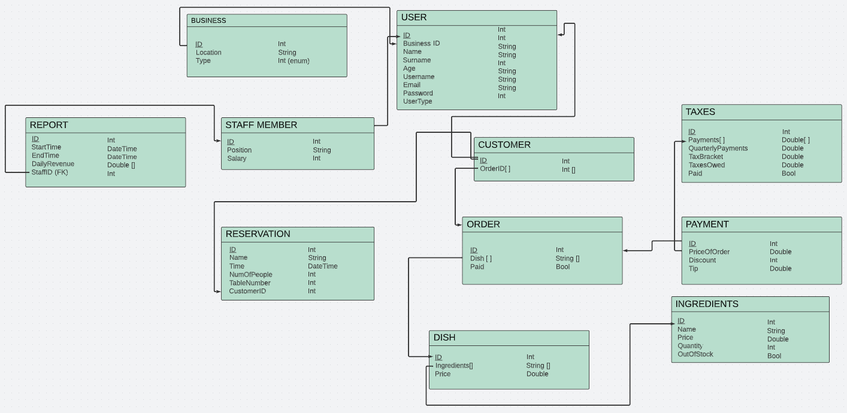

Figure Data Model

* We will keep track of order status using OutOfStock bool type in table ingredients;
* For service reservation we will use business table;
* For taxes from payments, we will use taxes table.