TD : Angular {{}}, @Input, @Output field bindings, [(ngModel)] and ReactiveForm

TD Objectives
Exercises corresponding to course CM3, on dynamic features of Angular: bindings
The goal is to realize how simple it is to use 1-way and even 2-ways (bi-directional) data binding, using the “[()]” (banana-box notation): [(ngModel)]=”field”.
Then we will focus on composing multiple levels of parent-child components, and make then communicate values using @Input (from parent to child field), and @Output (from child to parent callback).
Finally, we will see alternative field bindings with ReactiveForm, and syntax formControlName=”field”, which support validation status.
Pre-requisites =
- TD3-part 1 : angular project already setup (IntelliJ, ng serve, Chrome DevTools)
- TD3-part 2 : ng-bootstrap, for using bootstrap CSS library
- TD3-part 2 : menu navbar already configured in your main page
- TD4-part 1 : @Component and @Service (know to use “ng g c” and “ng g s”)
- TD4-part 1 : fortawesome for using fontawesome icons library
- TD4-part 1 : 3 pages components : lesson-edit-form, lesson-list, lesson-detail

Step 1: reminder on creating component page + exposing Route + nav bar link
Create a component “test-page1”
ng g c test-page1
add (in src/app/app-routing.module.ts) a Route to expose it for path “test-page1”,
import {TestPage1Component} from "./test-page1/test-page1.component";
const routes: Routes = [
{ path:'test-page1', component: TestPage1Component },
and add (in src/app/app.component.html) a menu item with routerLink=”/test-page1”
<a class="dropdown-item" routerLink="/test-page1">Test Page1</a>

Step 2: add {{ }} one-way binding to html text
Add in test-page1.component.html:
<H1>Test Page 1</H1>
numberValue: {{numberValue}}

And corresponding field declaration in test-page1.component.ts:
numberValue = 1;

Step 3: add button callback: (click)=”onClickIncrementValue()”

In src/app/test-page1/test-page1.component.html, add a button with a typescript callback, to increment the value when clicking
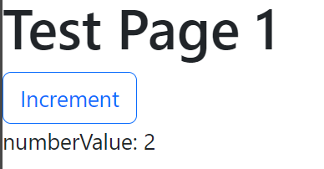

In test-page1.component.html:
<button type="button" class="btn btn-outline-primary" (click)="onClickIncrementValue()">Increment</button>
In test-page1.component.ts:
onClickIncrementValue() {
this.numberValue++;
}

Step 4: using one-way binding [value]

Instead of binding “{{numberValue}}” in plain html text, we want to bind to the “value” attribute of an <input> element. As it is a one-way binding yet, put this element in disabled editing mode.
<input disabled="true" [value]="numberValue">

Step 5: binding output event : (input)=”onInputEvent($event)”

Add another <input>, not disabled, with a handler for the “input” changed event
<input [value]="numberValue" (input)="onInputChanged($event)">

onInputChanged($event: Event) {
console.log("input changed", $event)
}

Check with Chrome debugger that you receive in “$event” parameter, and object with lot of fields, corresponding to the “InputEvent” type:
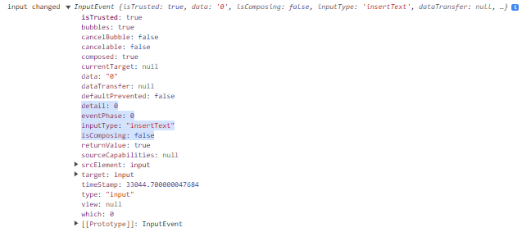

This InputEvent interface inherits from UIEvent, which inherits from Event. Check docs:
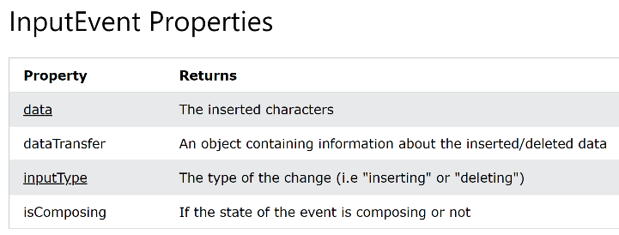
https://www.w3schools.com/jsref/obj_inputevent.asp

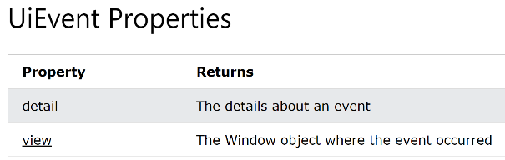
https://www.w3schools.com/jsref/obj_uievent.asp

Step 6 : extract the text value from the input event, convert it to a number
retrieve the edited text value, and convert it to a number
onInputChanged($event: Event) {
console.log("input changed", $event);
const input = <HTMLInputElement> $event.target;
const textValue: string = input.value;
console.log('input text value:', textValue);
const numberValue: number = +textValue;
console.log('input number value:', numberValue);
}

Check in Chrome debugger the console output. Notice the first line show “10” in black (this is a string), and the second line “10” in blue (this is a number).
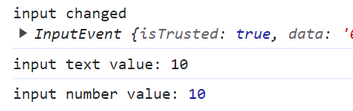
Using such boilerplate code, you could do 2-way data binding, but admittedly, this is not practical
onInputChanged($event: Event) {
this.numberValue = +(<HTMLInputElement> $event.target).value;
}

Check that is works. When editing this input field, value change elsewhere
Also notice that there is a “value” attribute, but unfortunately, there is no “(valueChange)” event emitted. This is why you can’t use the following syntax to do 2-way data binding. Check the compile error code
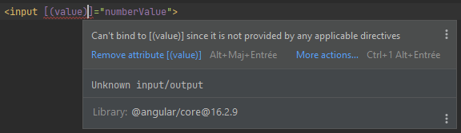

Step 7 : add FormModule to the component (for older angular version <17, add to main app.module.ts)

We will simplify a lot the output binding, and 2-way data binding, by using [(ngModel)], as supported by angular FormModule.
For Angular >=17 (using standolane component), add “FormModule” to your component imports

For older Angular version < 17: add in app.module.ts, add
import { FormsModule } from "@angular/forms";

@NgModule({
… lines ommited

imports: [
BrowserModule,
AppRoutingModule,
FormsModule, // <= for [(ngModel)] supports

Step 8: use [(ngModel)]=field

Now, you can add a third <input> field, with 2-way data binding between ngModel and your field “numberValue”:
<input type="number" [(ngModel)]="numberValue">

summary code for Step 1,2, … 8

<div class="container">
<div class="row">
<label class="col-4">text bind <code ngNonBindable>{{numberValue}}</code></label>
<div class="col-2">numberValue: {{numberValue}}</div>
</div>
<div class="row">
<label class="col-4">button (click)="onClickIncrementValue()"</label>
<button class="col-2 btn btn-outline-primary" type="button" (click)="onClickIncrementValue()">Increment</button>
</div>
<div class="row">
<label class="col-4">input disabled="true" [value]="numberValue"</label>
<input class="col-2" disabled="true" [value]="numberValue">
</div>
<div class="row">
<label class="col-4">input [value]="numberValue" (input)="onInputChanged($event)"</label>
<input class="col-2" [value]="numberValue" (input)="onInputChanged($event)">
</div>
<div class="row">
<label class="col-4">input [(ngModel)]="numberValue"</label>
<input class="col-2" type="number" [(ngModel)]="numberValue">
</div>
</div>

Which renders as:
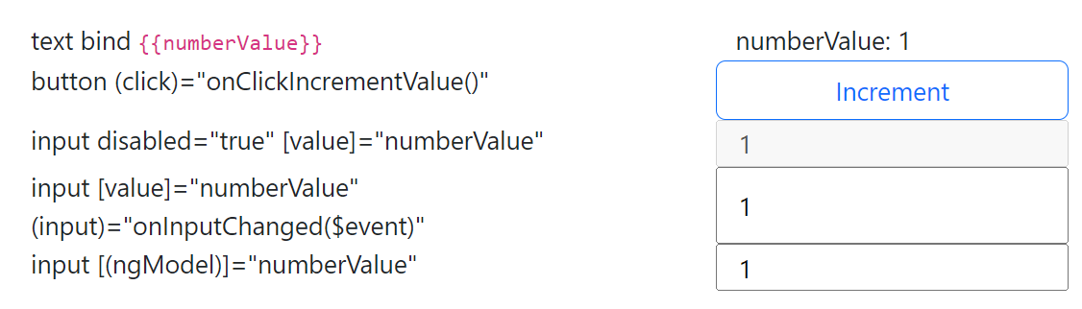

Step 9: bind one-way field from parent to child component, using @Input()

Create 3 new components, called “number-display”, “number-steps” and “number-edit”
ng g c number-display
ng g c number-steps

ng g c number-edit
We will NOT create Route for these components (they are not standalone pages), but we will use them directly as
<app-number-display></app-number-display>
<app-number-steps></app-number-steps>
<app-number-edit></app-number-edit >
Add a value field, annotated with @Input(), and display it in the corresponding html (notice, as it is a 1 line html, no need to externalize in a separate html file, so use template:’…’ instead of templateUrl: ‘file.html’)
@Component({
selector: 'app-number-display',
template: '<div> display value component: {{value}} </div>'
})
export class NumberDisplayComponent {
@Input()
value: number = 0;
}

Use this component in your test-page1. Check that it works.
<app-number-display [value]="numberValue"></app-number-display>

Step 10: bind event from child to parent, using @Output()

In component app-number-steps.component.html, declare 4 buttons, respectively -10, -1, +1, +10.
<div>
<button type="button" class="btn btn-small btn-outline-primary" (click)="onClickDecr10()">-10</button>
<button type="button" class="btn btn-small btn-outline-primary" (click)="onClickDecr1()">-1</button>
<button type="button" class="btn btn-small btn-outline-primary" (click)="onClickIncr1()">+1</button>
<button type="button" class="btn btn-small btn-outline-primary" (click)="onClickIncr10()">+10</button>
</div>

Each button has a handler (click)=”onClickXXX()”, that emit an event to a corresponding @Output Subject.
@Output()
decr10 = new Subject<number>();
@Output()
decr1 = new Subject<number>();
@Output()
incr1 = new Subject<number>();
@Output()
incr10 = new Subject<number>();
onClickDecr10() {
this.decr10.next(-10);
}
onClickDecr1() {
this.decr1.next(-1);
}
onClickIncr1() {
this.incr1.next(+1);
}
onClickIncr10() {
this.incr10.next(+10);
}

In test-page1.html, add app-number-steps component, and bind 4 corresponding @Output to methods
<app-number-steps class="col-3"
(decr10)="onDecr10($event)" (decr1)="onDecr1($event)" (incr1)="onIncr1($event)" (incr10)="onIncr10($event)"
></app-number-steps>

These method expectedly increment by -10,-1,+1,+10 the field numberValue
onDecr10($event: number) {
this.numberValue -= 10;
}
onDecr1($event: number) {
this.numberValue -= 1;
}
onIncr1($event: number) {
this.numberValue += 1;
}
onIncr10($event: number) {
this.numberValue += 10;
}

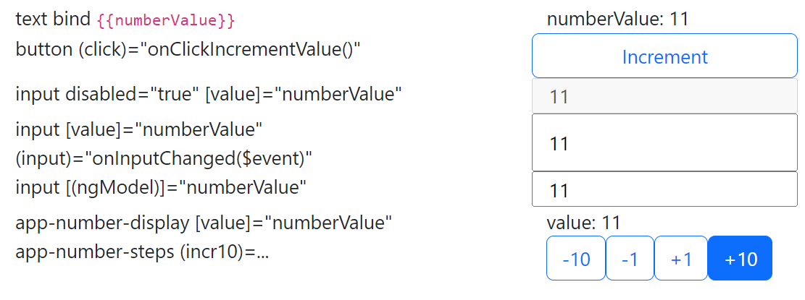
Check that it works

Step 11: combining @Input() field and @Output() fieldChanged: 2-way data binding

In number-edit.component.ts, add both @Input and @Output with name “value” (type number) and corresponding name “valueChange” (event type number)
import {Component, Input, Output} from '@angular/core';
import {Subject} from "rxjs";
@Component({
selector: 'app-number-edit',
template: '<input [(ngModel)]="value" (ngModelChange)="onInputChange()">'
})
export class NumberEditComponent {
@Input()
value: number = 0;
@Output()
valueChange = new Subject<number>();
onInputChange() {
this.valueChange.next(this.value);
}
}

Add it in test-page1, check that it works
<app-number-edit [(value)]="numberValue"></app-number-edit>

Summary code in test-page1.html for Steps 9,10,11 :
<div class="row">
<label class="col-4">app-number-display [value]="numberValue"</label>
<app-number-display class="col-3" [value]="numberValue"></app-number-display>
</div>
<div class="row">
<label class="col-4">app-number-steps (incr10)=...</label>
<app-number-steps class="col-3"
(decr10)="onDecr10($event)" (decr1)="onDecr1($event)" (incr1)="onIncr1($event)" (incr10)="onIncr10($event)"
></app-number-steps>
</div>
<div class="row">
<label class="col-4">app-number-edit [(value)]=numberValue</label>
<app-number-edit class="col-3" [(value)]="numberValue"></app-number-edit>
</div>

Step 12 : working on edit Form: re-open your lesson-edit-form page from TD3

Open file src/app/ lesson-edit-form/lesson-edit-form.component.html
You had defined it using bootstrap class=”container”, class=”row”, class=”col-md-*”.
This form page was for editing object with fields “title”, “description”, “category”, “level”, etc.
export interface LessonPackage {
title: string;
description: string;
category: string;
level: number;
prerequisite: string[];
tags: string[];
copyright: string;
}

Example html code :
<div class="container">
<div class="row mt-2">
<label class="col-md-1" for="title">Title</label>
<input id="title" type="text" class="col-md-5">
</div>
<div class="row mt-2">
<label class="col-md-1" for="description">Description</label>
<textarea id="description" class="col-11" rows="4"></textarea>
</div>
<div class="row mt-2">
<label class="col-md-1" for="category">Category</label>
<input id="category" type="text" class="col-md-2">
<label class="col-md-1" for="level" ngbTooltip="Enter value between 1(basics) to 10(advanced)" placement="top">Level</label>
<input id="level" type="number" class="col-md-1" min="1" max="10">
<label class="col-md-1" for="prerequisites">Prerequisite</label>
<input id="prerequisites" type="text" class="col-md-6">
</div>
<div class="row mt-2">
<label class="col-md-1" for="Tags" ngbTooltip="Enter tags, separated by commas" placement="top">Tags</label>
<input id="tags" type="text" class="col-md-11" placeholder="Enter tags">
</div>
<div class="row mt-1">
<label class="col-md-1" for="license">License</label>
<input id="license" type="text" class="col-md-5">
</div>
<div class="row mt-2">
<div class="col-md-2"></div>
<div class="col-md-2">
<button type="button" class="btn btn-primary">Submit</button>
</div>
</div>
</div>

This renders as :
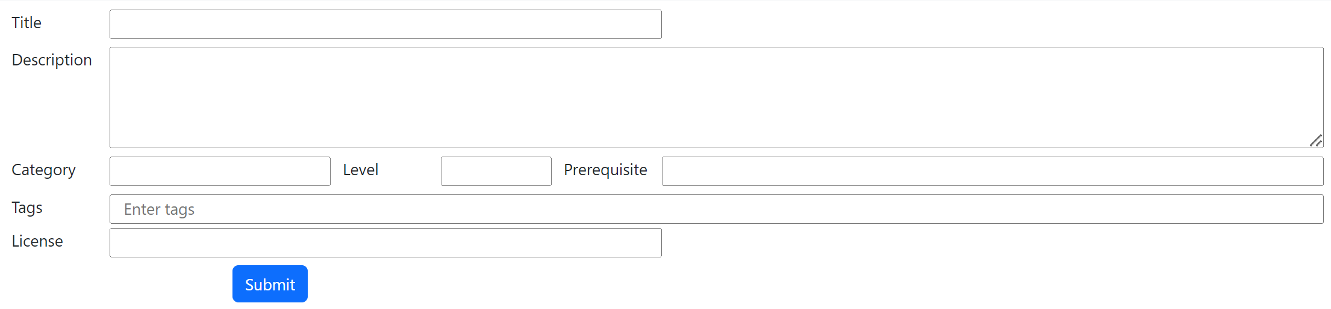

Equivalently you could define it in a flat way using <form> and class=“form-group” and class=”form-control”:
<form>
<div class="form-group">
<label for="titleField">Title</label>
<input type="text" class="form-control" id="titleField" placeholder="Enter title">
</div>
<div class="form-group">
<label for="descriptionField">Description</label>
<textarea class="form-control" id="descriptionField" rows="3" placeholder="Enter description"></textarea>
</div>
<div class="form-group">
<label for="categoryField">Category</label>
<input type="text" class="form-control" id="categoryField" placeholder="Enter category">
</div>
<div class="form-group">
<label for="levelField" ngbTooltip="Enter value between 1(basics) to 10(advanced)">Level</label>
<input type="text" class="form-control" id="levelField" placeholder="Enter level" min="1" max="10">
</div>
<div class="form-group">
<label for="prerequisiteField">Prerequisite</label>
<input type="text" class="form-control" id="prerequisiteField" placeholder="Enter prerequisite">
</div>
<div class="form-group">
<label for="tagsField" ngbTooltip="Enter tags, separated by commas">Tags</label>
<input type="text" class="form-control" id="tagsField" placeholder="Enter tags">
</div>
<div class="form-group">
<label for="copyrightField">Copyright</label>
<input type="text" class="form-control" id="copyrightField" placeholder="Enter copyright">
</div>
<button type="submit" class="btn btn-primary">Export</button>
</form>

This renders as :
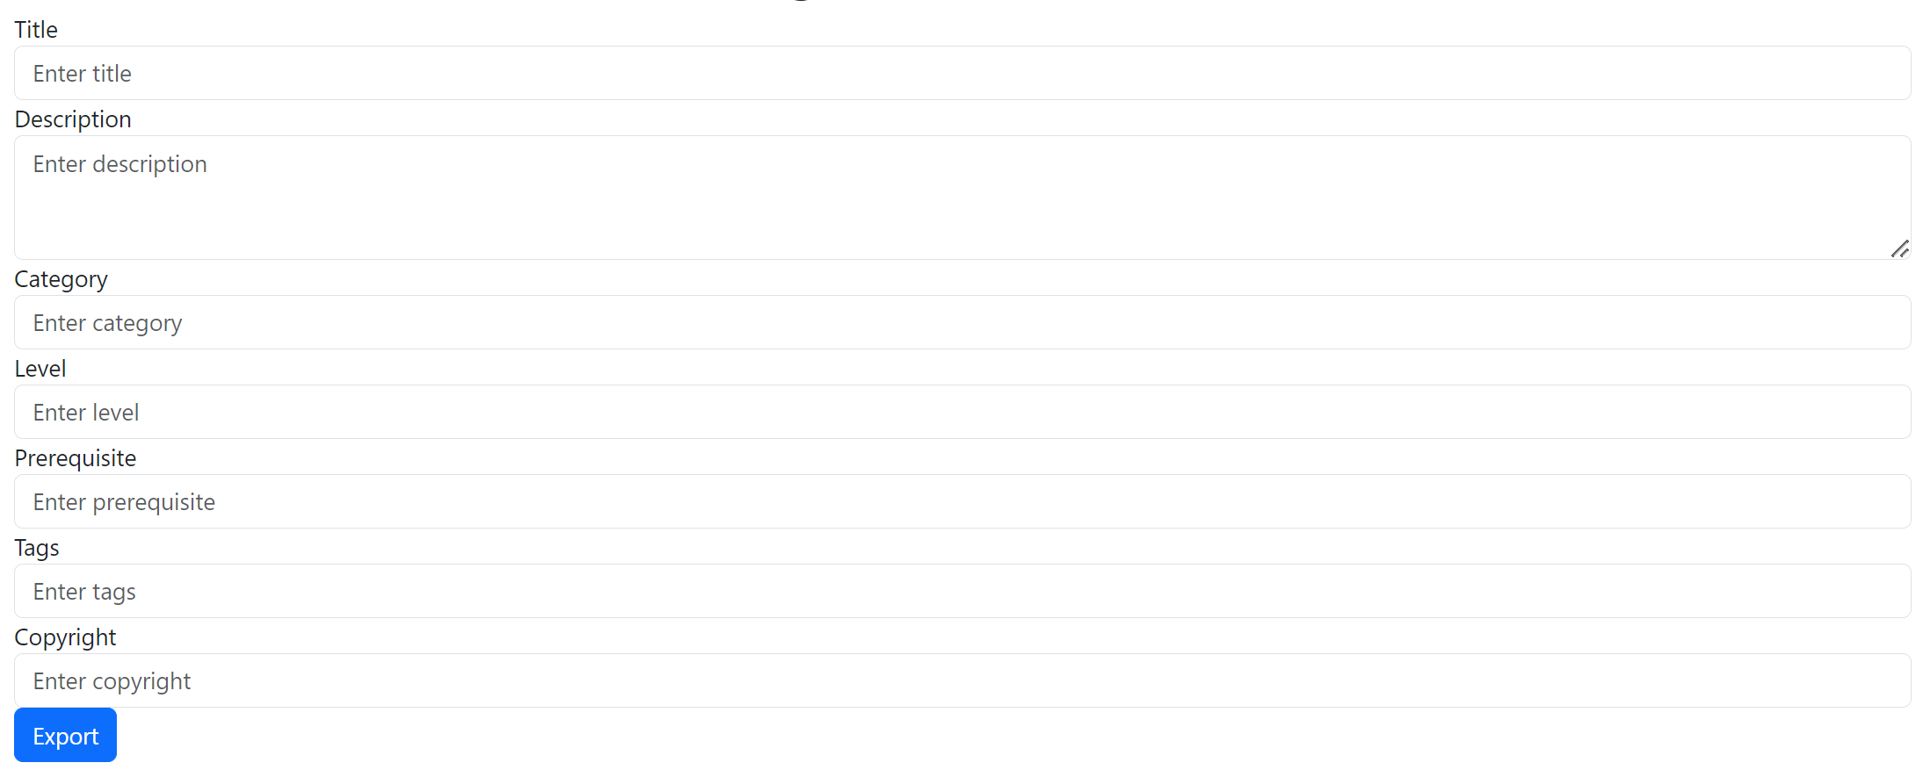
Notice in both form that each <label> has an attribute
<label for=”someFieldId”>
And each <input> or <textarea> has the corresponding id attribute
<input id=”someFieldId”>
There could also be “aria-*” attributes (aria means “Accessible Rich Internet Applications”), to improve accessibility particularly for users with disabilities.
For <input> fields, there can also be placeholder attribute, like
placeholder="Enter tags"
Finally, you could add tooltip text that pop-over on the label, for example:
ngbTooltip="Enter tags, separated by commas" placement="top"
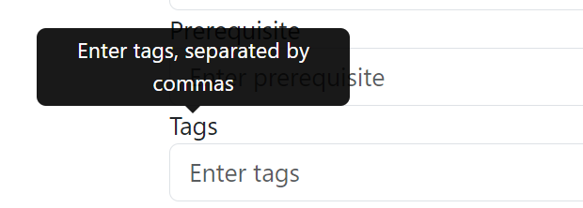

Step 13 : bind simple <input> values to a corresponding object field

Bind field “title: string”, using [(ngModel)]
<input id="title" type="text" class="col-md-5"
[(ngModel)]="title">

Field must be declared in corresponding lesson-edit-form.component.ts (otherwise Angular fails to compile):
title: string = '';

This would force you to declare all fields, then to re-assemble these fields in a json object for saving later (call the server)
title: string = '';
description: string = '';
category: string = '';
level: number = 1;
prerequisite: string[] = [];
tags: string[] = [];
copyright: string = '';
onClickSubmit() {
const formValues: LessonPackage = {
title: this.title,
description: this.description,
category: this.category,
level: this.level,
prerequisite: this.prerequisite,
tags: this.tags,
copyright: this.copyright
};
console.log('form values to save to server', formValues);
}

Alternatively, you could directly declare your target object to be filled,
model: LessonPackage = { title: '', description: '', category: '', level: 1, prerequisite: [], tags: [], copyright: ''};

and bind directly sub-fields of this instance to corresponding <input>s.
<input id="title" type="text" class="col-md-5"
[(ngModel)]="model.title">

The object is ready to be used :
onClickSubmit() {
console.log('form values to save to server', this.model);
}

Step 14: Better way of defining angular form fields, ReactiveForms with validation + dirty/pristine classes

Unfortunately, in previous step, our class did not handle any validation checks. For example, if a field is mandatory, it must be filled, otherwise the label should be displayed in “red”, the submit button greyed, and an error explanation message displayed. If there is a format to respect (a regular expression, a min-max constraint, etc), it must be validated, etc.
For every value that we have, we should add several corresponding boolean values (valid,dirty,pristine,etc…) , and bind them with a lot of boilerplate code.

Change your form to use angular ReactiveForm
In app.module.ts:
import {FormsModule, ReactiveFormsModule} from "@angular/forms";

imports: [
BrowserModule,
AppRoutingModule,
FormsModule,
ReactiveFormsModule, // <= for supports FormGroup/FormBuilder

in lesson-edit-form.ts
import {FormBuilder, FormGroup, Validators} from "@angular/forms";

lessonForm: FormGroup;
constructor(formBuilder: FormBuilder) {
this.lessonForm = formBuilder.group({
title: ['', Validators.required],
description: ['', Validators.required],
category: [''],
level: [''],
prerequisite: [''],
tags: [''],
copyright: ['']
});
}
onSubmit() {
if (this.lessonForm.valid) {
const formData = this.lessonForm.value;
console.log('Form data submitted:', formData);
} else {
console.log('Form is invalid. Please check the required fields.');
}
}

Then change your lesson-edit-form.component.html,
Add [formGroup]=”lessonForm” in the <form> or <div> container,
Then declare formControlName=”..” attributes, instead of binding [(ngModel)]=”..”
<input id="title" type="text" class="col-md-5"
formControlName="title">

<textarea id="description" class="col-11" rows="4"
formControlName="description"></textarea>

Step 15: Debug for VALID / INVALID form

See in Chrome DevTool the content of object “this.lessonForm” when clicking on submit button

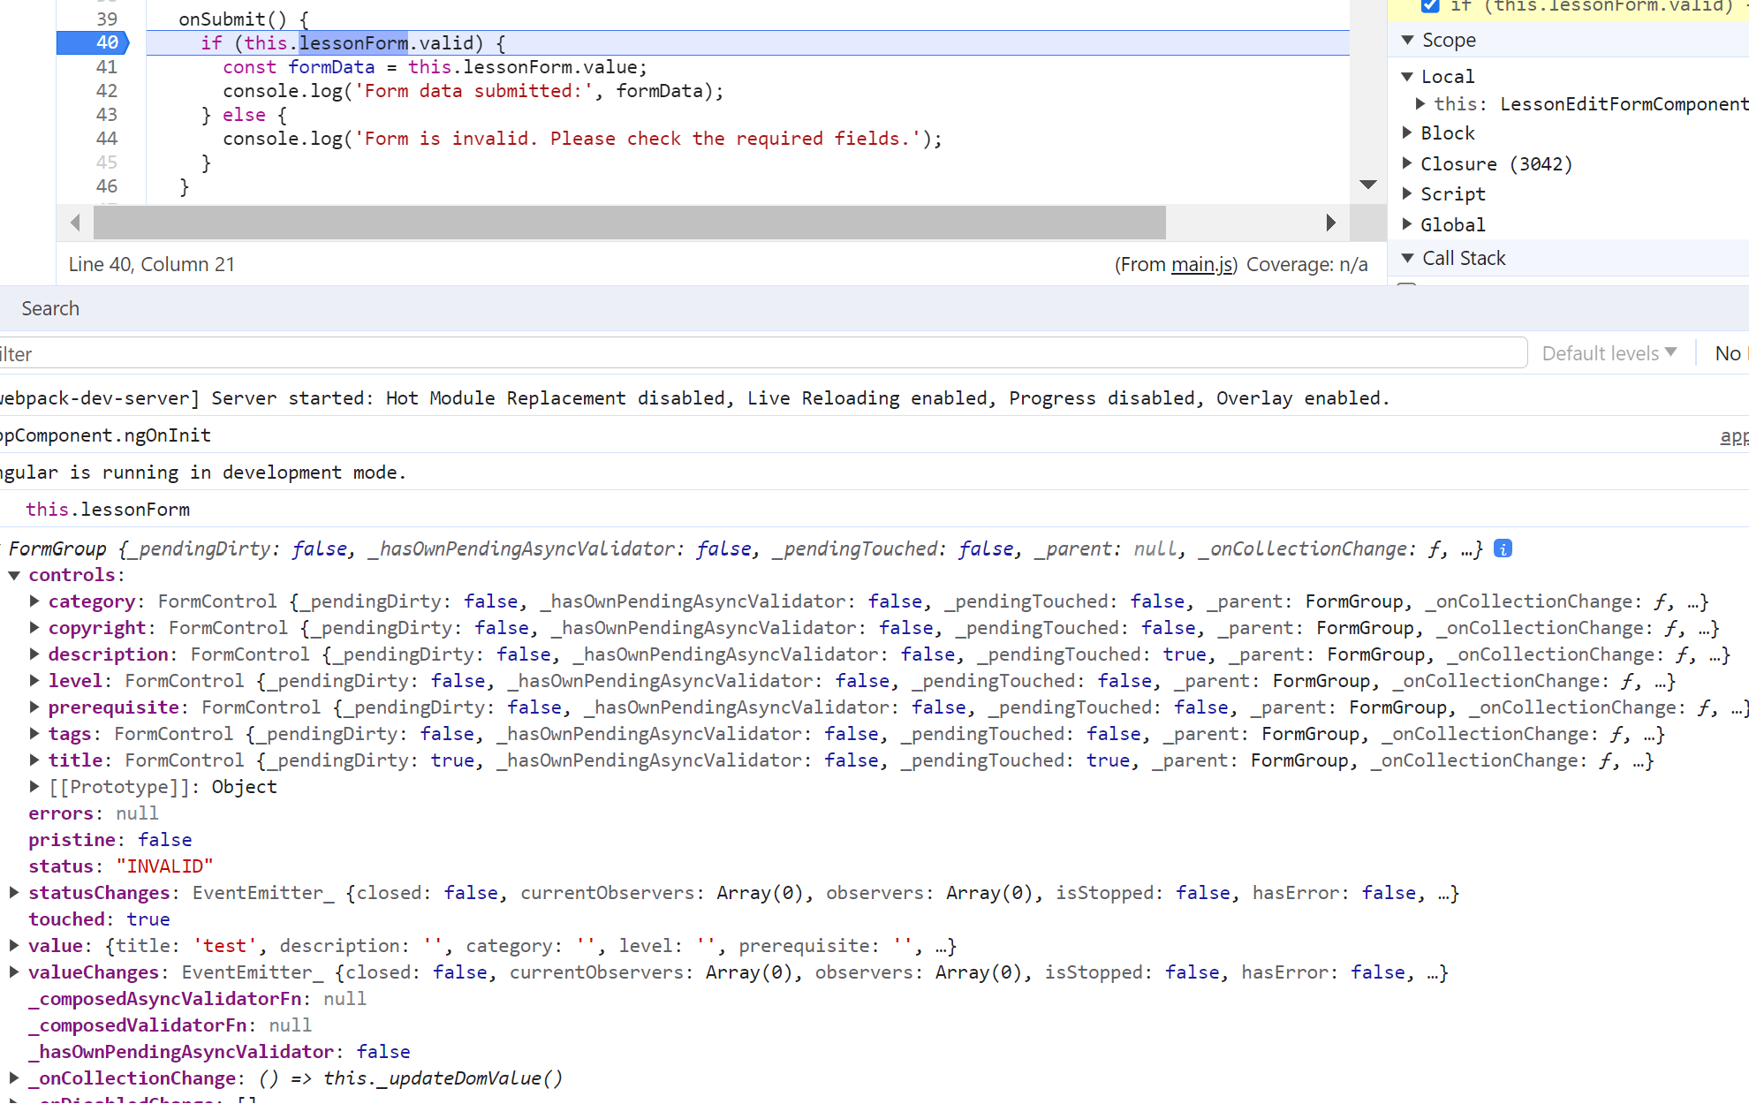

Step 16: Disable the submit button when form is invalid

<button type="button" class="btn btn-primary" (click)="onSubmit()"
[disabled]="!lessonForm.valid"
>Submit</button>

Step 17: add warning message when the form is invalid

<div class="row mt-2">
<label class="col-md-2"></label>
<button type="button" class="btn btn-primary col-md-2" (click)="onSubmit()"
[disabled]="!lessonForm.valid"
>Submit</button>
<span *ngIf="lessonForm.invalid" class="col-md-8 text-danger">
Please fill out all required fields.
</span>
</div>

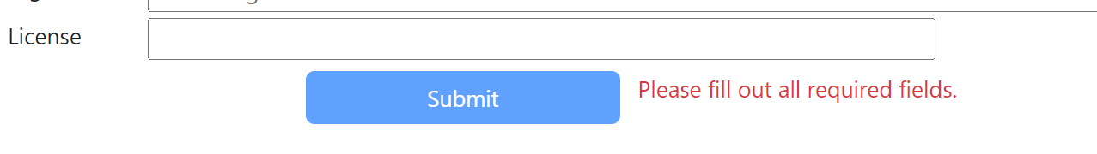
Check that when the form is valid, the message disappears, and the submit button becomes enabled.

Step 18: add classes to each label when corresponding field is invalid, to change it to red

<label class="col-md-1" for="title"
[class]="lessonForm.get('title')?.invalid ? 'text-danger' : ''"
>Title</label>
<label class="col-md-1" for="description"
[class]="lessonForm.get('description')?.invalid ? 'text-danger' : ''"
>Description</label>

