# Catch Up Exam – Web (Angular-React & NodeJS)

Exam during 1 hour.

Students must have their own PC (or borrow teacher’s PC), with the development environment ready to use. Students are NOT allowed to use ChatGPT, or any other coding assistant. Internet connection is not allowed, but students can use their course and their previous TDs and project (be careful, 1 hour is small for searching). You can ask questions to the teacher and request help.

Students are invited to show “live-coding” capabilities, and to explain their code.

Subject: code an angular app as following:

The main page is composed of a header menu (top) and a “router-outlet” (center)

The main menu bar should contain a “router-link” (or bootstrap ngbNavLink) named “Catch-Up-Exam”

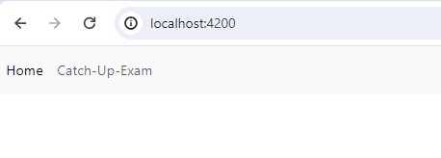

If you don’t have angular-bootstrap installed, this can be a simple “<a>..</a>” routerLink

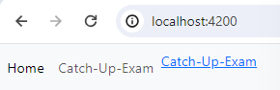

When clicking on the link, the app will display an angular component as follow

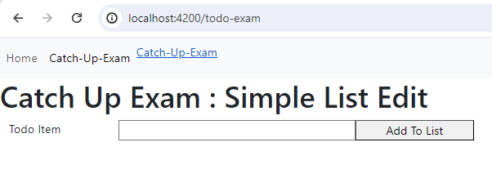

When editing text in the input field, and clicking on the “Add to List” button, it should add element to a list below:

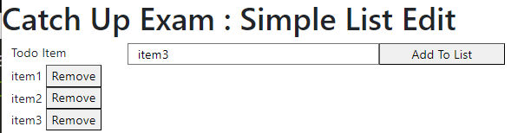

Then, when clicking on the button “Remove” from an item in the list (example on “Item2”), it should remove it.

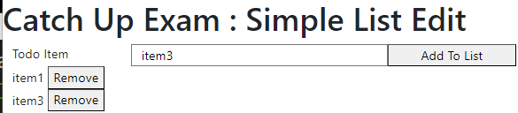

Bonus Exercise:

Refactor the code to put the list of TypeScript object items in an Angular “Service”, so that you can switch between 2 different pages “Catch-Up-Exam” and “Catch-Up-Exam-Bonus”

The second page is similar to the first one, but in read-only mode (no add/remove button, only the list displayed)

