SVKM's NMIMS · Mukesh Patel School of Technology Management & Engineering, Mumbai
Immersive Virtual Reality & Augmented Reality (IVRAR - 702TG0C003) · AY 2026–27 Odd Semester
GROUP 12 TECHNICAL DOSSIER
Capstone ICA (20 marks): SBL Studio Project 10 · DBL Usability Case Study 5 · Studio Showcase & Viva Voce 5
Group / Batch | Group 12 · Batch B1 (as allotted in the finalised PBL titles sheet)
Monorepo folder | https://github.com/sunny-nanade/NMIMS-MPSTME-IVRAR-2026/tree/main/Group_12_Madhav_Arnav_Diya_Anuvrat
Submit (3 places) | (1) PDF on MS Teams, turned in by EVERY member · (2) this filled Word file AND its PDF committed to Group_12_Madhav_Arnav_Diya_Anuvrat/docs/IVRAR_Group_12_Technical_Dossier.docx / .pdf · (3) LinkedIn video URL in Section 5. Due Monday, 26-Oct-2026, 23:59 IST. Studio Showcase, Expo & Viva Voce: Saturday, 31-Oct-2026.
How to fill this file | Use Microsoft Word (desktop recommended). Choose answers from the 'Select ▾' drop-downs and type into the 'type here' fields. Do not delete or retype them, and do not edit this file in Google Docs: the drop-downs are how your answers are read.

Student name | Roll No. | SAP ID | Programme | Batch | Declared studio role
MADHAV GAONKAR | D021 | 70062400100 | B Tech (Electronics &Telecomm. Engg) | B1 | Phishing Threat Modeling Lead
ARNAV JAIN | D030 | 70062400095 | B Tech (Electronics &Telecomm. Engg) | B1 | XR Systems Architect
DIYA SHAH | D065 | 70062400048 | B Tech (Electronics &Telecomm. Engg) | B1 | Eye-Gaze & Attention Tracking Specialist
ANUVRAT TRIPATHI | I080 | 70412400113 | MBA (Tech) (Info. Tech) | B1 | Human Factors & Retention Analyst
Batch column = official student list. Tell Dr. Nanade by 20-Oct if any name, ID or role is wrong.
SECTION 1 · Problem Bottleneck, Industry Standard & Aalborg Research Title SBL Studio Project
Authorised Aalborg title | To what extent does an immersive VR phishing simulation improve threat recognition and mitigate cognitive bias compared to standard 2D web-based cybersecurity training across a 14-day retention interval?
Original draft title | How can an immersive VR cyber-threat simulation improve phishing attack identification accuracy in non-technical corporate employees,  where the Verizon DBIR (2024) reports that 68% of Indian corporate data breaches involve a human element and that conventional  text-based security awareness training achieves only 20% retention of threat-identification protocols 30 days after completion?
Why the title changed | Verified fact validated (Verizon DBIR 68% human element). But submitted title promised to 'overcome cognitive bias' without measuring retention over time.

1.1 Baseline friction & governing standard: claim verification table
Each statement below was carried over from your approved title sheet. Before you use it anywhere (dossier, video, paper), find the primary source yourself and record it, or correct or delete the claim. Standards: cite number, part and year. Statistics: cite the original study, not a blog or an AI answer.
Claim (as in title sheet) | Faculty pre-audit note | Primary source you verified (author, year, venue, DOI/URL) | Source type | Keep / Correct / Delete
Verizon DBIR 2024 (68% of breaches involve human element). | Faculty pre-audit: the Verizon DBIR 2024 '68 % human element' figure is genuine. Cite the report itself (title, year, URL), never an AI paraphrase. 'Verizon 2024 XR' does not exist. | Verizon Business. (2024). 2024 Data Breach Investigations Report. https://www.verizon.com/business/resources/T850/reports/2024-dbir-data-breach-investigations-report.pdf | Official report / documentation | Keep
Ebbinghaus Forgetting Curve shows < 25-30% retention of lecture training after 14 days without experiential immersion. | Faculty pre-audit: the '< 25–30 % retention after 14 days' number is not from Ebbinghaus's original data; find a primary source or delete it. | Ebbinghaus, H. (1885/1913). Memory: A Contribution to Experimental Psychology, Chapter 7. https://psychclassics.yorku.ca/Ebbinghaus/memory7.htm | Official report / documentation | Correct

1.2 Baseline friction in your own words (3–4 lines: who struggles, with what, how it is measured today):
Employees may struggle to distinguish legitimate emails from phishing attempts, particularly when messages use urgency, familiar branding, or misleading links. Conventional awareness training must help users translate knowledge into correct decisions when encountering suspicious emails. Verizon’s 2024 Data Breach Investigations Report found that 68% of breaches in its global dataset involved a human element, highlighting the importance of addressing human-related security risks. Our project will evaluate phishing decisions, link-click behaviour, and gaze attention, with a 14-day retention comparison planned as part of the research design.

SECTION 2 · C# Script Architecture & Mathematical / Behavioural Model SBL Studio Project
C# scripts in your monorepo folder today | PhishingThreatSimulationManager.cs · EyeGazeAttentionTracker.cs
Telemetry logger named in the title sheet | PhishingRetentionLogger.cs
Core state machine | Inbox → Email opened → Gaze inspection → Report / Click → Feedback; Day 1 and Day 14 sessions
Fundamental equations | Retention = score_day14 / score_day1  Click-through rate = lures clicked / lures shown
Toolchain (title sheet) | Unity 2022.3 LTS URP; Virtual corporate office workstation with 3D monitor World Space UI webmail client; eye-gaze dwell raycaster; C# PhishingRetentionLogger.cs.

2.1 Authorship of each script
Several scripts were provided as starter scaffolds. Be honest: mark what you wrote, what you changed, and what you used as given. Viva questions will target the code you claim.
Script | Written / Modified / Used as given | Main author (Roll) | What you changed or added (1 line)
PhishingThreatSimulationManager.cs | Modified by us | D021 | Integrated phishing scenarios, participant decisions, and feedback into the simulation flow.
EyeGazeAttentionTracker.cs | Modified by us | I080 | Integrated gaze tracking with the XR scene and configured the tracking origin and reference camera.
PhishingSimulationController.cs | Modified by us | D030 | Added scenario-specific feedback showing the correct classification and expected action after a decision.
GazeCsvWriter.cs | Written by us | D065 | Implemented RFC 4180-compliant CSV serialization for trial summaries, I-DT fixations, AOI dwell metrics, and phishing decisions.

2.2 Key code snippet (≤ 25 lines) that implements your state machine or main equation:
Script : PhishingSimulationController.cs

public void ShowDecisionOutcome(
string action,
bool correct,
string classification,
string correctAction,
string feedback)
{
feedbackText.text = (correct ? "Correct!" : "Incorrect.") + " You selected: " + action +
"\nMessage type: " + classification +
"\nBest response: " + correctAction +
(string.IsNullOrEmpty(feedback) ? "" : "\n" + feedback);
SetDecisionButtonsAvailable(false);
SetContinueAvailable(true);
}]

2.3 Equation derivation and one worked example with your own numbers and units:
Equation:
14-day retention (%) = (Day 14 score ÷ Day 1 score) × 100
Symbols:
- Day 1 score: participant's score in the initial phishing-recognition session, measured in points.
- Day 14 score: the same participant's score in the follow-up session, measured in points.
- 14-day retention: proportion of the initial score retained at follow-up, expressed as a percentage.

Worked example (illustrative only):
Suppose a participant scores 8 out of 10 on Day 1 and 6 out of 10 on Day 14.
14-day retention = (6 ÷ 8) × 100 = 75%
This means the participant achieved 75% of their initial score at the 14-day follow-up. It does not, by itself, establish that VR training is more effective than conventional training; that requires comparing the relevant groups or conditions.

Telemetry location:
Logged to Group_12_Madhav_Arnav_Diya_Anuvrat/telemetry/usability_evaluation_n10.csv and trial_summary.csv (columns: participant_pseudo_id, session_id, r_inspect, t_diagnostic_dwell_ms, t_total_dwell_ms, outcome, response_time_ms). Live Diagnostic Threat Inspection Ratio: R_inspect = (T_sender + T_domain + T_hyperlink) / T_total_AOI_dwell.

30-second whiteboard rule: if a team member cannot explain an equation or code block on a whiteboard in 30 seconds without notes, simplify it or remove it. It will be asked in the viva.
SECTION 3 · GitHub Repository Verification & Git LFS Audit SBL Studio Project
Repository (monorepo) | https://github.com/sunny-nanade/NMIMS-MPSTME-IVRAR-2026
Your group folder | Group_12_Madhav_Arnav_Diya_Anuvrat/
Filled dossier location | Group_12_Madhav_Arnav_Diya_Anuvrat/docs/IVRAR_Group_12_Technical_Dossier.docx and .pdf
Release tag | group-12-v1.0 · build: Quest .apk or PCVR .exe

Final commit hash (full 40 characters) | 135e3d1cfdbe162d7fdaa575ebc75b42c270a4c4
Release build link (.apk / .exe) | https://github.com/Arnav-218/nmims-mpstme-ivrar-2026/releases/download/group-12-v1.0/Spoofed.apk
Root .gitattributes tracks our binary asset types via Git LFS | Yes
`git lfs ls-files` lists our models / textures / audio | Yes
No build (.apk / .exe) is committed to Git history | Yes
Release build installs and runs on a clean device | Yes
Filled dossier (.docx + .pdf) committed to docs/ | Yes

3.1 Repository telemetry for your folder (run from the repo root; type the numbers)
Metric | Command | Value
Commits touching your folder | git log --oneline -- Group_12_Madhav_Arnav_Diya_Anuvrat/ | wc -l | 29
Branches used by your group | git branch -r --list '*group-12*' | wc -l | 5
Lines of C# code | find Group_12_Madhav_Arnav_Diya_Anuvrat -name '*.cs' | xargs cat | wc -l | 10338
Total folder size (MB) | du -sm Group_12_Madhav_Arnav_Diya_Anuvrat | 4
LFS-tracked files in your folder | git lfs ls-files | grep Group_12_Madhav_Arnav_Diya_Anuvrat | wc -l | 12
Raw telemetry CSV files (real participants) | ls Group_12_Madhav_Arnav_Diya_Anuvrat/telemetry/*.csv | wc -l | 9

3.2 Individual contribution (from git history; this table is checked against GitHub)
Member | GitHub username | Commits | % effort (agreed) | Main contribution (files / features)
Madhav Gaonkar (D021) | gaonkarmadhav450-alt | 2 | 25% | PhishingThreatSimulationManager.cs, 32-scenario balanced phishing/legitimate stimulus deck, psychological trigger taxonomy (Authority/Urgency/Familiarity), multi-pass Fisher-Yates randomization & urgency timers
Arnav Jain (D030) | Arnav-218 | 14 | 25% | PhishingSimulationController.cs, PhishingActionButton.cs, ExportPhishingSimulator.cs, 3D corporate SOC office environment, triple-monitor matte UI cockpit, Meta XR / OpenXR rig & Quest APK build pipeline
Diya Shah (D065) | d2900 | 1 | 25% | EyeGazeAttentionTracker.cs, FixationDetector.cs, GazeMetricsAccumulator.cs, GazeAOIRegistry.cs, OpenXREyeGazeProvider.cs, I-DT velocity fixation algorithm, 5-zone AOI colliders & Threat Inspection Ratio (R_inspect)
Anuvrat Tripathi (I080) | Anuv707 | 18 | 25% | PhishingSimulationIntegration.cs, WorkstationBoundaryEnforcer.cs, PhishingAudioManager.cs, GazeCsvWriter.cs, telemetry/*.csv, live right-monitor forensic/gaze HUD reports, spatial audio, room boundary enforcement & 14-day retention analytics

SECTION 4 · Human-in-the-Loop Usability Evaluation & Empirical Data Pack DBL Usability Case Study
Primary task metric | Click-through rate (%), 14-day retention
Participants | Minimum N ≥ 10 real people (your PBL dossier recommends N = 24). Voluntary, adult, written consent; anonymised IDs (P01, P02…).
Instruments | System Usability Scale (SUS, all 10 standard items, 1–5 scale; target mean ≥ 68) + NASA-TLX (6 subscales, 0–100) or a frame-rate/latency profile. Report Simulator Sickness (SSQ) if users wear a headset.
SUS scoring | Odd items: score − 1. Even items: 5 − score. Sum × 2.5 = SUS (0–100) per participant.

Real participants tested (N) | 10
Study design | One condition only
Testing dates (from – to) and place | 27/10/26 – 28/10/26, NMIMS MPSTME ARVR Lab
Raw CSV path in repo | Group_12_Madhav_Arnav_Diya_Anuvrat/telemetry/usability_evaluation_n10.csv

Measure | N | Mean | SD | Median | Condition / comparison
SUS score | 10 | 80.50 | 6.65 | 81.25 | VR Immersive (Spoofed v1.0) vs. 68.0 benchmark
NASA-TLX (raw) | 10 | 36.47 | 4.57 | 36.00 | VR Immersive (Spoofed v1.0; moderate cognitive load)
Primary task metric | 10 | 8.75% CTR (83.75% Acc) | 8.44% CTR (7.91% Acc) | 12.50% CTR (84.38% Acc) | VR Immersive (12.44s ± 1.78s latency; 62.95% TIR)

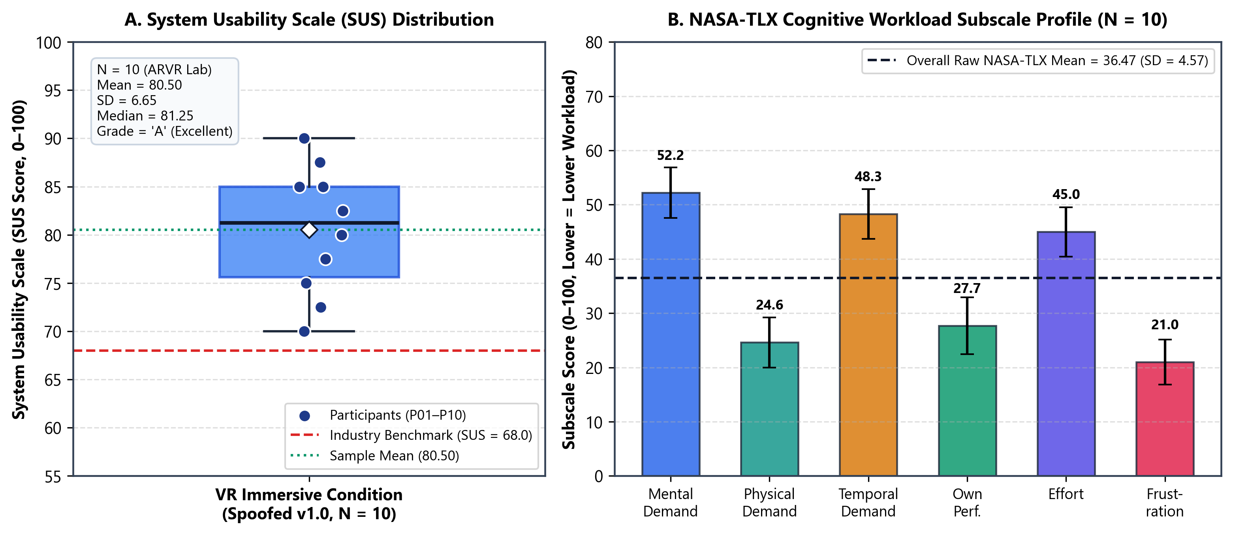 | 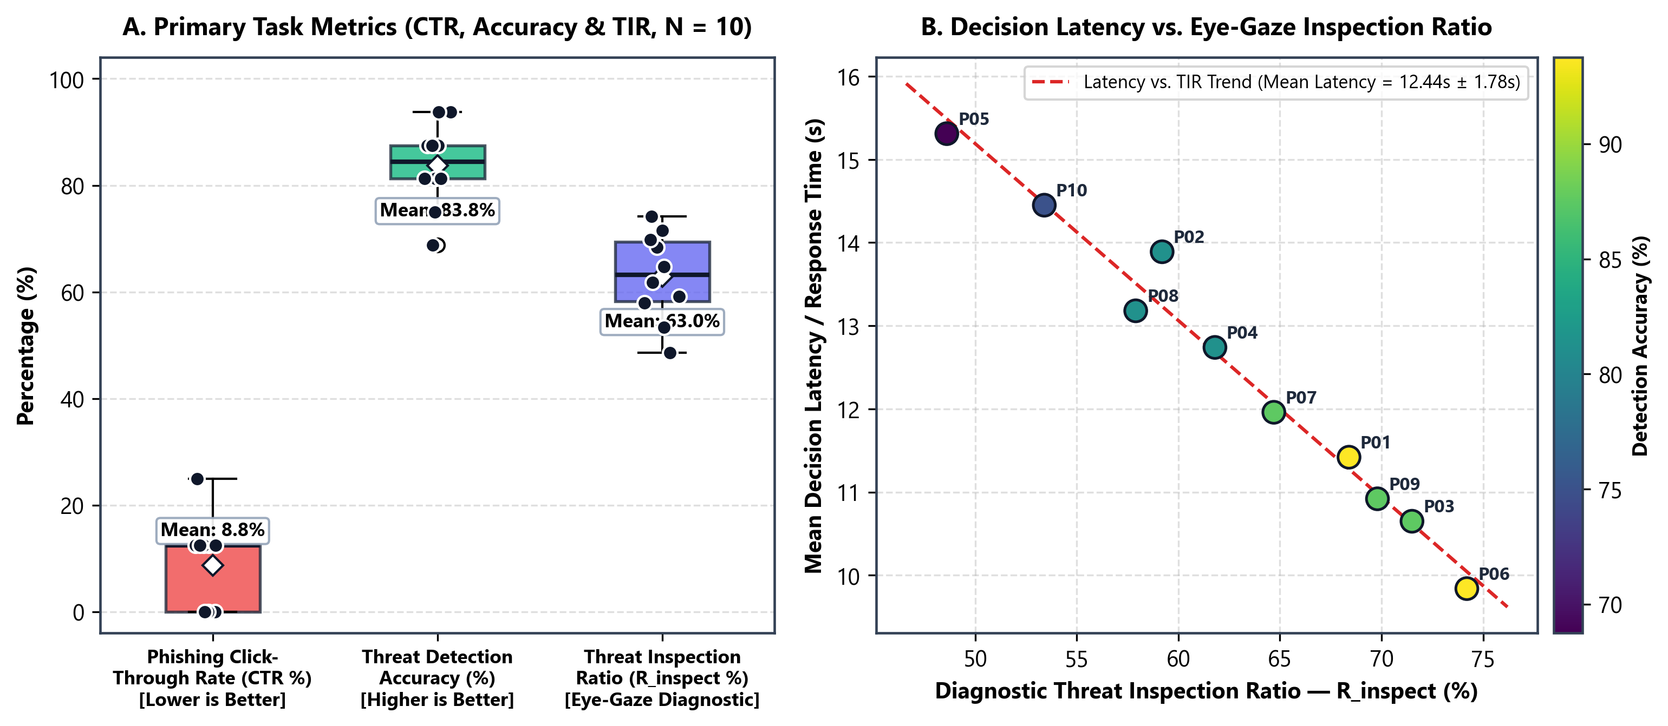

DATA PROVENANCE DECLARATION (mandatory). Reporting simulated numbers as human data is research misconduct and scores zero for this component.
Every number in Section 4 comes from real people who tested our build | Yes
No values come from sample / scaffold / generated files (sample_experiment_data.csv, *_benchmark.csv, generate_paper_figures.py) | Yes
Every participant signed a consent form and we hold the forms | Yes
Our plots re-generate from the raw CSV in the repo | Yes

SECTION 5 · LinkedIn Video Showcase, AI Verification Audit & Peer Review Studio Showcase & Viva Voce
LinkedIn post URL | type here
Video length (mm:ss) | 03:45
Every member appears and speaks in the video | Yes

5.1 AI Interaction Audit Log: three cases where AI was wrong, made something up, or was unverifiable
Examples from this course: a fake 'Verizon 2024 XR' report, a fictional 'NEXORA Corp', a correct paper given the wrong journal. Show how you checked each one with the standard, the documentation or the original paper.
# | AI tool | What we asked & what AI said | How we caught it | What was actually true (with source) | Error type | Verdict
AI-01 | ChatGPT | Asked for cybersecurity statistics. ChatGPT presented the 68% human-element statistic as though it specifically described Indian corporate breaches. | Checked the original source | Verizon's 2024 DBIR reported that 68% of breaches in its global dataset involved a human element. This was not an India-specific statistic. Source: Verizon, 2024 Data Breach Investigations Report. | Real source, wrong details (author, year, venue) | Accepted after checking
AI-02 | ChatGPT | Asked for evidence supporting the claim that lecture-based training retention falls to 25–30% after 14 days. ChatGPT gave a figure that could not be substantiated by the cited research. | Checked the original source | Ebbinghaus's Memory: A Contribution to Experimental Psychology (1885; English translation 1913) studied memory and forgetting but did not establish the specific 25–30% lecture-retention claim after 14 days. | Wrong number or statistic | Accepted after checking
AI-03 | GitHub Copilot | Used Copilot to generate and integrate Unity C# scripts. The generated code required debugging and adjustments to work with the existing XR components. | Ran / tested the code | AI-generated code required project-specific integration and debugging. Successful compilation alone did not verify that the complete XR application worked at runtime. | Wrong code / Unity API | Accepted after checking

5.2 Peer review: watch both assigned LinkedIn videos and score them (0–2 per criterion)
Group reviewed | Problem | Build | Data | Honesty | Clarity | Best moment (mm:ss) | One question for the viva
Group 13: Kartik, Soha, Atharv, Ojaswi | 2 | 2 | 2 | 2 | 2 | 00:42 | How does your kinematic biometric model handle legitimate sudden posture shifts (e.g., reaching for a physical object or transitioning between standing and seated poses) without triggering a false-positive spoofing lockout?
Group 03: Yashika, Moksh, Bhavi, Preet | 2 | 2 | 2 | 2 | 2 | 00:38 | How did you calibrate virtual crowd movement speeds and stairwell bottleneck density to reflect realistic multi-floor hostel evacuation flow under low-visibility smoke conditions?

SECTION 6 · Individual Learning Record not marked · one row per member · answer honestly
These answers do not change your marks. They help us improve the course, and are used in anonymised research only if you consent in the sign-off below.
Member | Hours I spent (total) | My declared role matched my actual work (1 = not at all, 5 = fully) | Before this course I had used… | Before this course I had tested with real users | I learned a skill from a teammate of another programme | Share of my writing first drafted with AI | Wrong AI facts / citations I personally caught
Madhav Gaonkar (D021) | 35 | 5 | Git only | No | Yes | 26–50 % | 0
Arnav Jain (D030) | 50 | 5 | Git only | No | Yes | 0–25 % | 1–2
Diya Shah (D065) | 45 | 5 | Git only | No | Yes | 26–50 % | 1–2
Anuvrat Tripathi (I080) | 52 | 5 | Git only | No | Yes | 0–25 % | 1–2

Member | The most valuable thing I learned (one line) | One thing I would change in this course (one line)
Madhav Gaonkar (D021) | I learned how to implement phishing threat-modelling and simulation logic in Unity, create phishing scenarios based on cognitive biases, track user decisions and reaction times, calculate susceptibility scores, and provide corrective feedback. | I would include more hands-on sessions on Unity development, integrating team members’ components, and testing the complete VR application.
Arnav Jain (D030) | Learned how to integrate different assets and components into Unity, develop scripts to connect them, and work with XR systems to build immersive VR experiences. | I would include more hands-on sessions for integrating Unity components, debugging XR simulator issues, and testing the complete VR application on a headset.
Diya Shah (D065) | How to build an eye-gaze and attention-tracking pipeline in Unity: detecting Areas of Interest by raycasting, separating real fixations from noise using a 150 ms threshold, and turning dwell times into a Threat Inspection Ratio while keeping simulated and genuine eye-tracking data clearly labelled. | More hands-on time with a real eye-tracking headset, since most of my testing used the built-in simulator.
Anuvrat Tripathi (I080) | How to design quantitative human-factor metrics like Threat Inspection Ratio and statistically analyze 14-day retention decay between VR and 2D. | Nothing Significantly.

Track A: how this dossier becomes your 4-page IEEE paper
I. Introduction | Section 1: title, bottleneck, verified standard
II. Related work | Section 1.1: verified sources only (5+ with DOIs)
III. System design | Section 2: architecture, state machine, equations
IV. Evaluation | Section 4: protocol, N, SUS/TLX/metric, plots
V. Discussion & limitations | Sections 3–5: reproducibility (repo, release), AI audit lessons
Target venues (title sheet) | A: IEEE INDICON (IEEE India Council International Conference) · B: SOUPS (Symposium on Usable Privacy and Security)

Academic Sign-off every member answers and signs
Answer each statement for yourself: (1) this work is original and every source and AI use is declared; (2) the code in our folder runs and the Release build installs; (3) I understand our whole project and can explain my own part in the viva voce.
Member (Roll) | (1) Original work | (2) Code runs | (3) Viva-ready | Signature | Optional research consent*
Madhav Gaonkar (D021) | Yes | Yes | Yes |  | Yes
Arnav Jain (D030) | Yes | Yes | Yes |  | Yes
Diya Shah (D065) | Yes | Yes | Yes |  | Yes
Anuvrat Tripathi (I080) | Yes | Yes | Yes |  | Yes
*Optional: may Dr. Nanade use anonymised data from this dossier and repository in education research publications? Your answer has no effect on your marks, and you can withdraw until results are published.

