Experiment 10

Student Name: Arnav Prajapati UID: 24BAI70131
Branch: CSE - AIML Section/Group: 24AIT_KRG-G1
Semester: 4 Date of Performance: 24/04/26
Subject Name: DBMS Subject Code: 24CSH-298

Aim
To design a trigger that automatically implements the functionality of a primary key, ensuring unique identification of records without manual intervention.

Software Requirements
- Database Management System:
  - Oracle Database Express Edition (Oracle XE)
  - PostgreSQL Database
- Database Administration Tool / Client Tool:
  - Oracle SQL Developer (for Oracle XE)
  - pgAdmin (for PostgreSQL)

Objectives
To create a database trigger that automatically enforces primary key constraints or generates unique key values, replicating the functionality of a stored procedure.

Problem Statement
In enterprise databases, primary keys must be unique for every record. Manual assignment of keys can lead to errors.
Design a trigger that:
Automatically generates or enforces a primary key value during record insertion.
Implements the logic similar to a stored procedure.
Demonstrates automated primary key functionality for a table.
(Industry relevance: Amazon, Flipkart, Oracle)

Practical/Experiment Steps
  - Identify the table requiring automated primary key enforcement.

  - Design a trigger that activates before insert operations.

  - Ensure that every new record receives a unique primary key automatically.

  - Validate the trigger by inserting multiple records and verifying unique keys.

Procedure
- Established a connection to the PostgreSQL server and initialized the working environment using a database client such as pgAdmin.
- Created an EMPLOYEES table containing attributes such as employee ID, employee name, gender, and salary.
- Inserted a balanced dataset into the table, ensuring that both male and female employee records were present for meaningful analysis.
- Designed a stored procedure named GET_EMP_COUNT_BY_GENDER with properly defined parameters:
  - An IN parameter to accept the gender input.
  - An OUT parameter to return the total employee count.
  - An INOUT parameter to manage and update the execution status.
- Implemented the procedure logic using PL/pgSQL to perform a COUNT(*) operation, filtering employee records based on the provided gender value.
- Updated the status variable inside the procedure to 'SUCCESS' after successful execution of the query.
- Wrote an anonymous block to test the procedure, where variables were declared and initialized, including setting the gender input (e.g., 'MALE') and initial status as 'PENDING'.
- Executed the procedure using the CALL statement, passing the required parameters and capturing the output values.
- Displayed the results using the RAISE NOTICE statement, printing both the employee count and the updated status to the output console.
- Verified the correctness of the output by comparing the returned count with the actual number of records present in the EMPLOYEES table.

SQL Queries / Code

```
-- DROP TABLE IF EXISTS (SAFE RE-RUN)

DROP TABLE IF EXISTS EMPLOYEES CASCADE;
DROP SEQUENCE IF EXISTS EMP_SEQ;

-- STEP 1: CREATE TABLE
-- CREATE TABLE
CREATE TABLE EMPLOYEES (

EMP_ID INTEGER PRIMARY KEY,
EMP_NAME VARCHAR(100) NOT NULL,
DEPARTMENT VARCHAR(50) NOT NULL,
SALARY NUMERIC(10,2) NOT NULL,
HIRE_DATE DATE DEFAULT CURRENT_DATE

);

-- STEP 2: CREATE SEQUENCE
-- CREATE SEQUENCE FOR PRIMARY KEY GENERATION

CREATE SEQUENCE EMP_SEQ
START WITH 1
INCREMENT BY 1
NO CYCLE;

-- STEP 3: CREATE TRIGGER FUNCTION
-- TRIGGER FUNCTION TO AUTO-GENERATE PRIMARY KEY

CREATE OR REPLACE FUNCTION FN_EMP_PK()
RETURNS TRIGGER AS $$

BEGIN

-- CHECK IF EMP_ID IS NULL

IF NEW.EMP_ID IS NULL THEN
NEW.EMP_ID := NEXTVAL('EMP_SEQ');
END IF;

-- SAFETY CHECK (SHOULD NEVER FAIL)

IF NEW.EMP_ID IS NULL THEN
RAISE EXCEPTION 'EMP_ID CANNOT BE NULL — AUTO GENERATION FAILED';
END IF;

RETURN NEW;

END;

$$ LANGUAGE PLPGSQL;

-- STEP 4: CREATE TRIGGER
-- ATTACH TRIGGER TO TABLE

CREATE TRIGGER TRG_EMP_PK

BEFORE INSERT ON EMPLOYEES

FOR EACH ROW

EXECUTE FUNCTION FN_EMP_PK();

-- STEP 5: INSERT TEST RECORDS

-- INSERT WITHOUT PROVIDING EMP_ID

INSERT INTO EMPLOYEES (EMP_NAME, DEPARTMENT, SALARY)
VALUES ('ALICE JOHNSON', 'ENGINEERING', 85000.00);

INSERT INTO EMPLOYEES (EMP_NAME, DEPARTMENT, SALARY)
VALUES ('BOB SMITH', 'MARKETING', 72000.00);

INSERT INTO EMPLOYEES (EMP_NAME, DEPARTMENT, SALARY)
VALUES ('CAROL DAVIS', 'FINANCE', 91000.00);

INSERT INTO EMPLOYEES (EMP_NAME, DEPARTMENT, SALARY)
VALUES ('DAVID LEE', 'ENGINEERING', 78000.00);

INSERT INTO EMPLOYEES (EMP_NAME, DEPARTMENT, SALARY)
VALUES ('EVA MARTINEZ', 'HR', 65000.00);

SELECT * FROM EMPLOYEES

-- STEP 6: VERIFY RESULTS
-- VERIFY AUTO-GENERATED PRIMARY KEYS

SELECT EMP_ID, EMP_NAME, DEPARTMENT, SALARY, HIRE_DATE
FROM EMPLOYEES
ORDER BY EMP_ID;

-- STEP 7: DUPLICATE KEY TEST

-- ATTEMPT TO INSERT DUPLICATE PRIMARY KEY

INSERT INTO EMPLOYEES (EMP_ID, EMP_NAME, DEPARTMENT, SALARY)
VALUES (1, 'DUPLICATE TEST', 'TEST', 50000);

-- STEP 8: ADMIN / VERIFICATION QUERIES

-- CHECK TRIGGER EXISTS

SELECT TRIGGER_NAME, EVENT_MANIPULATION, ACTION_TIMING
FROM INFORMATION_SCHEMA.TRIGGERS
WHERE EVENT_OBJECT_TABLE = 'EMPLOYEES';

-- CHECK SEQUENCE VALUE

SELECT LAST_VALUE FROM EMP_SEQ;

-- CHECK PRIMARY KEY CONSTRAINT

SELECT CONSTRAINT_NAME, CONSTRAINT_TYPE
FROM INFORMATION_SCHEMA.TABLE_CONSTRAINTS
WHERE TABLE_NAME = 'EMPLOYEES';
```

8.Input/Output Analysis

OUTPUT SCREENSHOTS
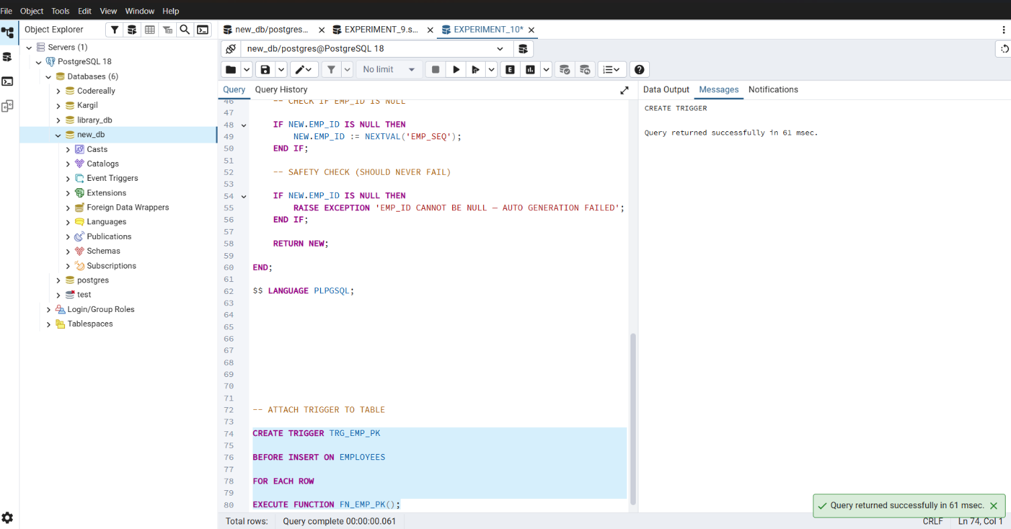
a:

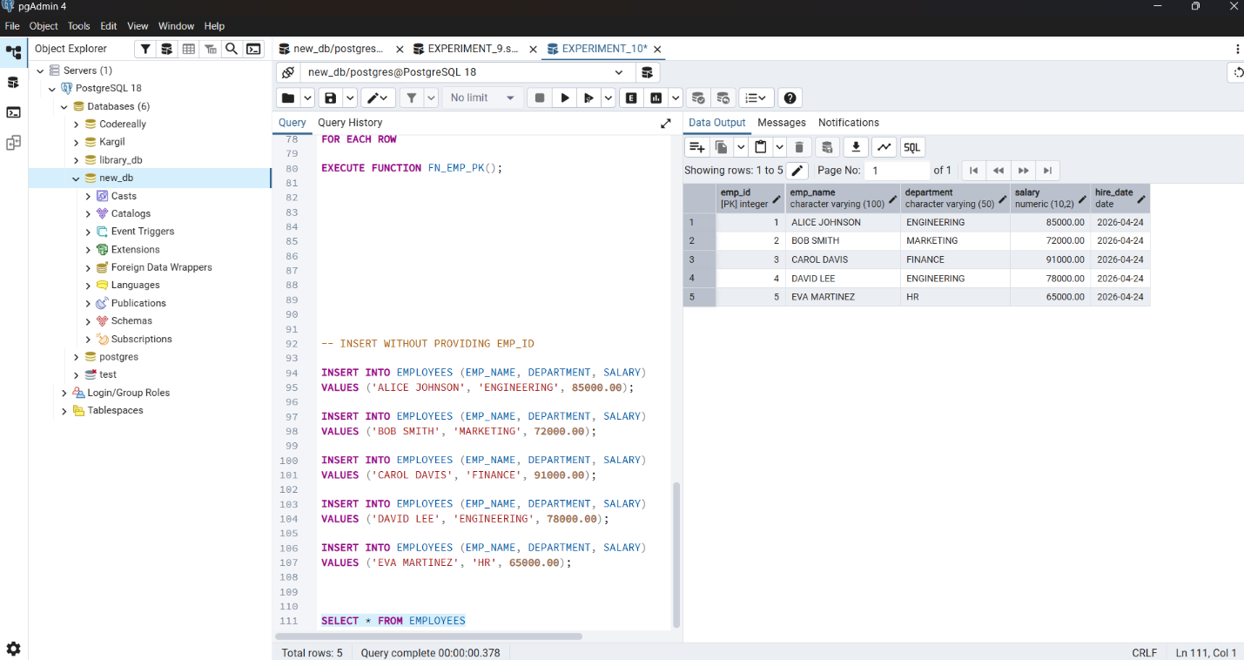
b:

c:
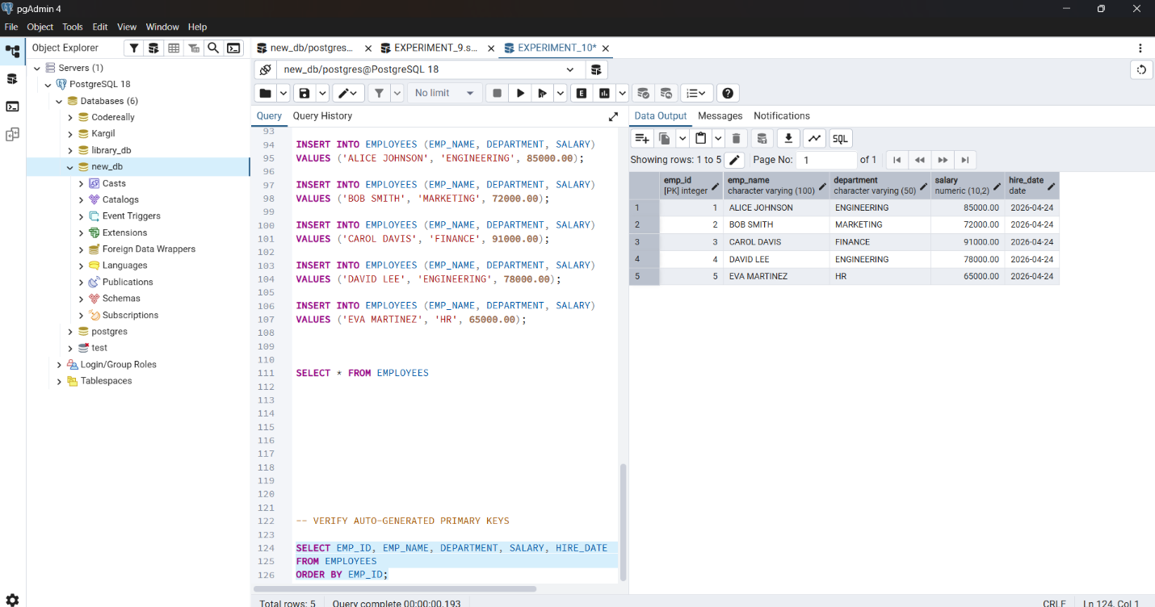

d:

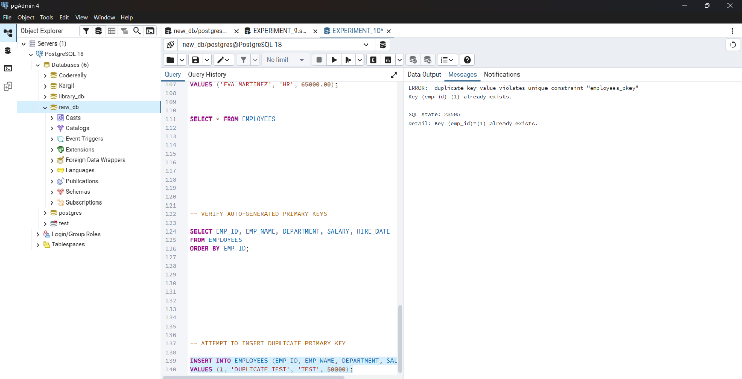

e:
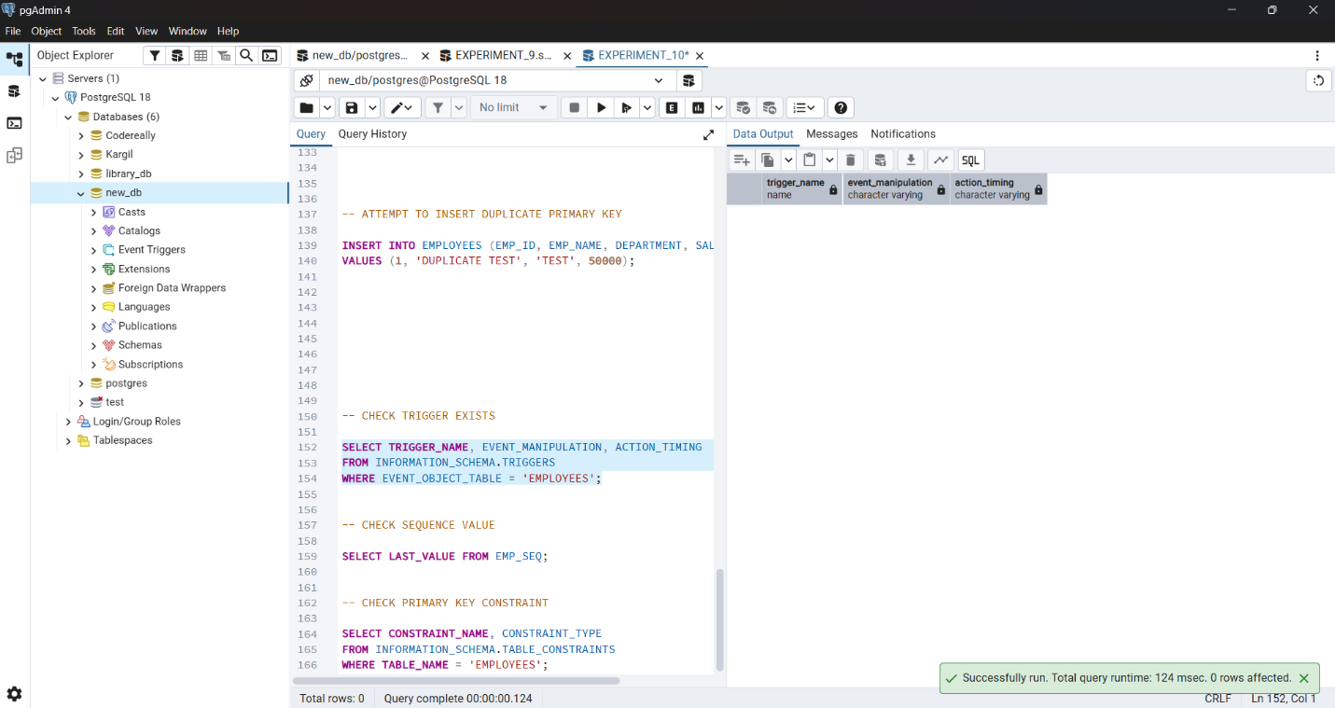

f:
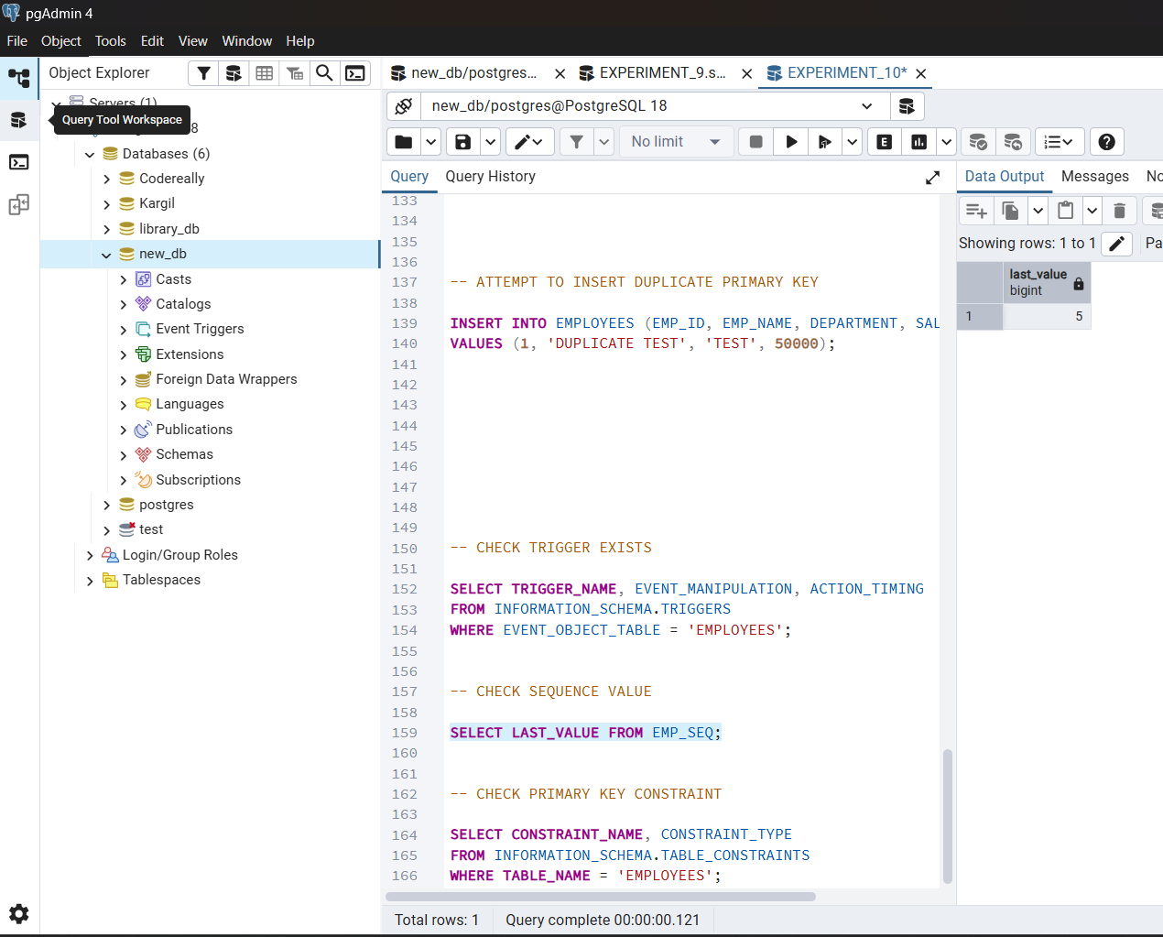

g:
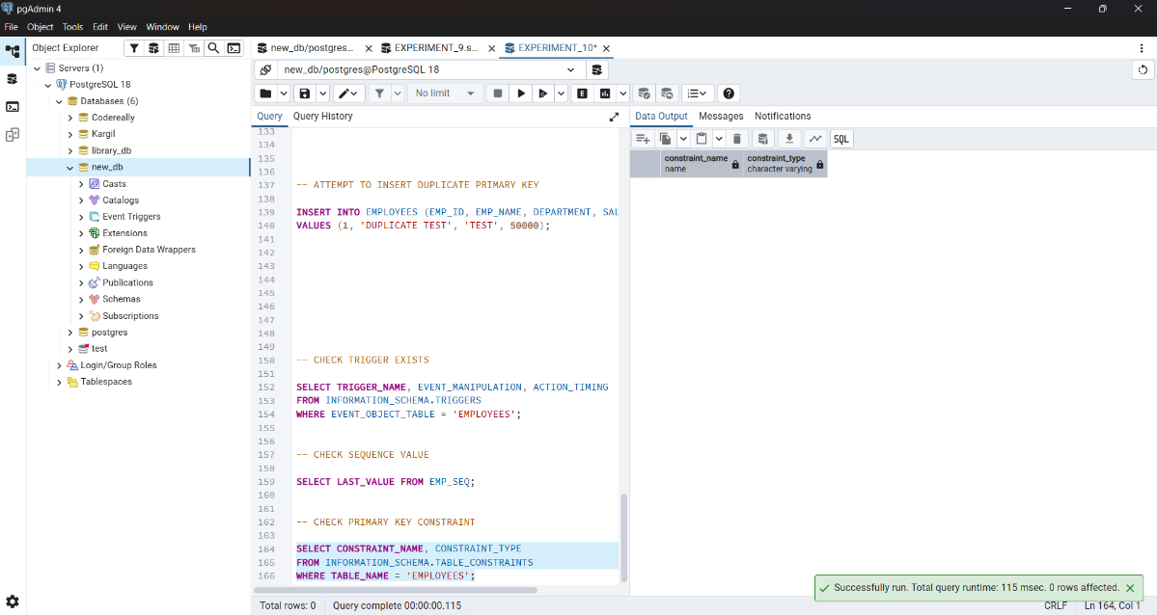

Learning Outcomes
  - After completing this experiment, the learner will be able to:
  - Understand the purpose and working of database triggers.
  - Implement automated primary key functionality using triggers.
  - Ensure data integrity without manual key assignment.
  - Apply trigger-based automation in real-world enterprise applications such as Amazon, Flipkart, and Oracle.

