Experiment 6: DBMS
Name: ARNAV PRAJAPATI
UID: 24BAI70131
Section: 24AIT_KRG_G1

1. Aim of the Session:
To understand the concept and working of cursors for row-by-row data processing, specifically utilizing an explicit cursor to iterate through a dataset and apply a 10% salary increment to each record.

2. Objective of the Session:
- To implement a lifecycle-managed explicit cursor (OPEN, FETCH, CLOSE).
- To differentiate between set-based SQL updates and row-by-row cursor updates.
- To master the use of the FOUND/NOT FOUND status indicators to control loop execution.
- To practice environment cleanup and table management using DROP and CREATE.

3. Practical / Experiment Steps:
The experiment follows this execution logic:
- Initialization: Dropping existing structures and creating a fresh employee table with 5 specific records.
- Direct Update: Performing a standard SQL update on a single record (emp_id = 211) to demonstrate implicit processing.
- Cursor Declaration: Defining emp_cursor to hold the Result Set of IDs and Salaries.
- Row-by-Row Processing:
  - Opening the cursor to establish the context area.
  - Using a LOOP to fetch each employee's ID and current Salary into local variables.
  - Applying a 10% hike ($Salary * 1.10$) individually to every row.
  - Terminating the loop once all rows are processed (EXIT WHEN NOT FOUND).
- Final Verification: Displaying the final state of the table to confirm the cumulative changes.

4. Procedure of the Practical:
- Start the system and log in to the pgAdmin or psql terminal.
- Clean the environment by executing the DROP command to avoid "Table already exists" errors.
- Define the Schema by creating the employee table with ID, Name, and Salary columns.
- Insert the dataset for employees 204, 206, 207, 209, and 211.
- Perform the manual update to observe how direct SQL works without a cursor.
- Write the Anonymous Block (DO $$...$$):
  - Declare variables emp and sal.
  - Define the CURSOR for the selection.
  - Implement the LOOP and FETCH logic.
  - Ensure the CLOSE statement is included to release database resources.
- Execute the script and analyze the output messages.
- Verify the final results using a SELECT * query.

5.Code:

drop table if exists employee;
create table employee
(
emp_id int primary key,
emp_name varchar(50),
salary int
);

insert into employee values(101, 'Arnav', 10000);
insert into employee values(102, 'Anshu', 20000);
insert into employee values(103, 'Anuj', 25000);
insert into employee values(104, 'Akshveer', 32000);
insert into employee values(105, 'Akash', 30000);

select * from employee

-----------------------Implicit cursor----------------------------

update employee
set salary = salary + 3000
where emp_id = 101;

select * from employee

--------------------------Explicit Cursor-----------------------------------
DO $$
DECLARE
emp INT;
sal INT;
emp_cursor CURSOR FOR
SELECT emp_id, salary FROM employee;
BEGIN
OPEN emp_cursor;

LOOP
FETCH emp_cursor INTO emp, sal;
EXIT WHEN NOT FOUND;

UPDATE employee
SET salary = sal * 1.10
WHERE emp_id = emp;

END LOOP;

CLOSE emp_cursor;
END $$;

SELECT * FROM employee;

6. I/O Analysis (Input / Output Analysis)
Input Provided (Initial Data):
emp_id | emp_name | Initial Salary
101 | Arnav | 10000
102 | Anshu | 20000
103 | Anuj | 25000
104 | Akashveer | 32000
105 | Akash | 30000

Intermediate Step (Direct Update):
- Update emp_id 101: $10000 + 3000 = 13000$.
Output Results (Final State after Cursor 10% Hike)
emp_id | emp_name | old_salary | calculation | final_salary
101 | Arnav | 10000 | 10000 * 1.10 | 11000
102 | Anshu | 20000 | 20000 * 1.10 | 22000
103 | Anuj | 25000 | 25000 * 1.10 | 27500
104 | Akshveer | 32000 | 32000 * 1.10 | 35200
105 | Akash | 30000 | 30000 * 1.10 | 33000

7. Output Screenshots:
A:
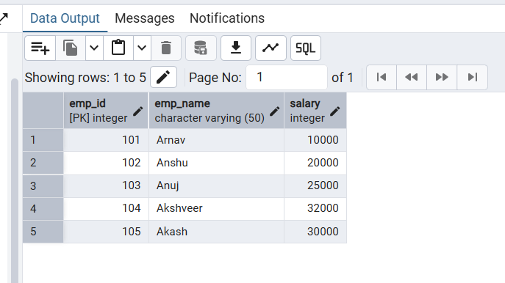

B:
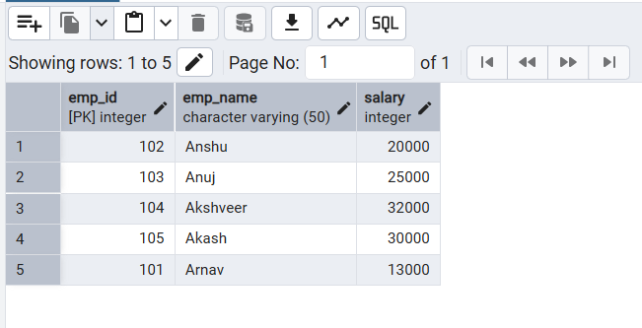

7. Learning Outcome

C:
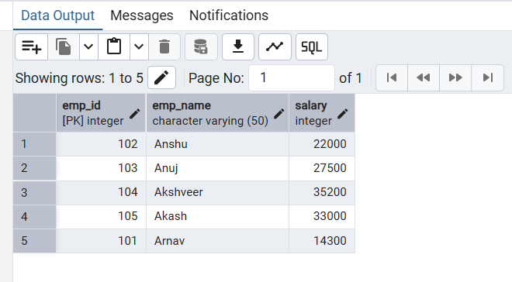

8.Result
By completing this practical, I have learned:
- Concepts Understood: How an explicit cursor acts as a pointer to a result set, allowing the database engine to process rows one at a time.
- Skills Developed: Gained the ability to write procedural SQL blocks in PostgreSQL using DO $$ and managing cursor status via FOUND.
- Practical Exposure: Understood that while cursors offer high control for complex business logic, they are computationally more expensive than bulk updates and should be used specifically for row-dependent processing tasks.

