Name: Arnav Prajapati
UID: 24BAI70131
Course: BE. CSE-(AIML)
Subject: DBMS (24CSH-298)
Date : 28th Jan 2026

Experiment 3 :
1. Aim of the Session-
To understand the basic structure of a PL/SQL program by creating and executing a simple PL/SQL block that includes declaration and execution sections, and to display output using built-in procedures.

2. Objective of the Session
To create a simple PL/SQL program demonstrating Declaration Section and Execution Section.

3 . Problem Statement:
Design and implement a simple PL/SQL program that demonstrates the basic structure of a PL/SQL block. The program should include a declaration section to define variables and an execution section to perform operations using those variables and display the results using appropriate output statements.

4. Theory :
PL/SQL (Procedural Language/SQL) is Oracle’s procedural extension to SQL.
A PL/SQL program is divided into three sections:
- Declaration Section – used to declare variables and constants
- Execution Section – contains executable statements
- Exception Section (optional) – handles runtime errors
In this experiment, a simple PL/SQL block is used to demonstrate variable declaration, computation, and output display.

5.Software Requirements
- Database Management System: Oracle Database
- Database Administration Tool: Oracle Live SQL

6. Experiment Steps
- Open Oracle Live SQL / SQL Developer
- Declare required variables in the declaration section
- Perform calculations in the execution section
- Display output using DBMS_OUTPUT.PUT_LINE
- Execute the PL/SQL block
- Observe the output in the DBMS output window

#Declaration Section (DECLARE)
- Variables are declared and initialized:
  - emp_id → Employee ID
  - emp_name → Employee Name
  - emp_salary → Employee Salary
# Execution Section (BEGIN ... END)
- DBMS_OUTPUT.PUT_LINE is used to display output.
- Procedure of the Practical:
- Start the system and open the Oracle database environment.
- Write a PL/SQL block starting with the DECLARE keyword.
- Declare variables such as employee ID, employee name, and salary.
- Use the BEGIN section to perform calculations like bonus and total salary.
- Display the output using DBMS_OUTPUT.PUT_LINE.
- End the block using END; followed by / to execute it.
- Verify the output displayed in the DBMS output panel.

## Program Code ##
declare
-- declaration of the variables --
emp_id number := 101;
emp_name varchar2(50):= 'Arnav';
emp_salary number := 50000;
bonus number;
total_salary number;

-------------------------------------------
begin
-- calculate bonus --
bonus := emp_salary * 0.10;
-- total salary --
total_salary := emp_salary + bonus;

-------------------------------------------
-- OUTPUT --
dbms_output.put_line('Employee Details');
dbms_output.put_line('----------------------');
dbms_output.put_line('Employee ID :'|| emp_id);
dbms_output.put_line('Employee Name :'|| emp_name);
dbms_output.put_line('Employee Base Salary :'||emp_salary);
dbms_output.put_line('Bonus given (10%) :'|| bonus);
dbms_output.put_line('Total Salary :'||total_salary);
end;

8. Output:
The program successfully displays employee details, bonus amount, and total salary using DBMS output.
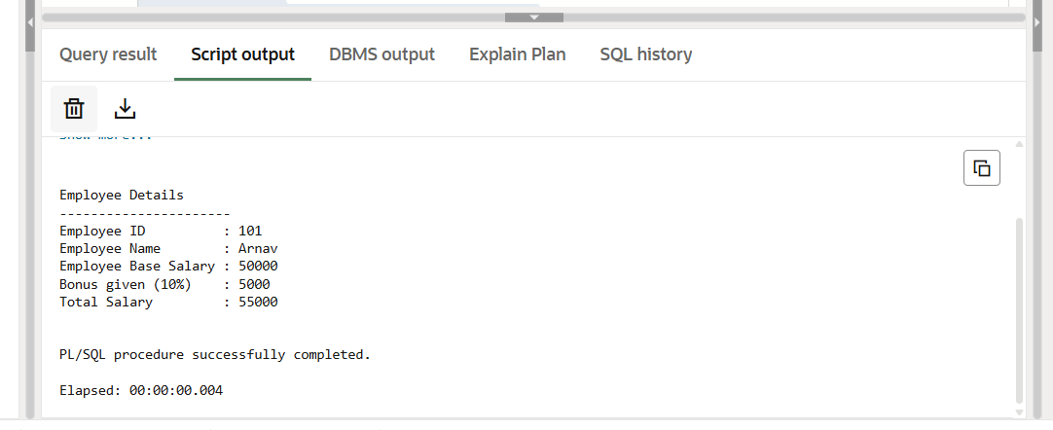

9.Result
The PL/SQL program was executed successfully. Variables were declared in the declaration section, calculations were performed in the execution section, and output was displayed using DBMS_OUTPUT.PUT_LINE.

10.Learning Outcomes
After completing this experiment, the student is able to:
- Understand the basic structure of a PL/SQL program
- Declare and initialize variables in PL/SQL
- Perform arithmetic operations in PL/SQL
- Display output using built-in PL/SQL procedures
- Execute a PL/SQL block successfully in Oracle

