Experiment 1: Database Creation with Constraints, Relationships & User Access Control
1. Aim of the Session
The purpose of this practical is to provide hands-on experience in designing and implementing a comprehensive database system for a library management scenario. Students will learn to create tables with various constraints, establish relationships between tables, and manage user access through roles and permissions in a Database Management System (DBMS).
Purpose of the practical:
- To understand how to create databases and tables with proper structure
- To implement data integrity through constraints and relationships
- To manage user access and permissions in a DBMS

2. Objective of the Session
The specific goals of this session are:
- Learn Table Creation: Understand how to create tables with various data types and constraints
- Implement Data Integrity: Apply PRIMARY KEY, FOREIGN KEY, NOT NULL, UNIQUE, and CHECK constraints to ensure data quality
- Establish Relationships: Create relationships between multiple tables using foreign keys (one-to-many relationships)
- Manage Roles & Permissions: Create user roles and grant/revoke database permissions
- Data Manipulation: Insert, retrieve, and manage data using SQL queries
- Database Security: Understand role-based access control and permission management
Upon completion, students will be able to:
- Design normalized database schemas with proper relationships
- Implement constraints to maintain data integrity
- Manage user access and database security
- Write SQL DDL (Data Definition Language) statements confidently

3. Practical / Experiment Steps
The experiment involves creating a Library Management System database with the following components:
Step 1: Create the BOOKS Table
- Define a table to store book information
- Implement PRIMARY KEY constraint on BOOKS_ID
- Use VARCHAR for text fields and NOT NULL constraint for mandatory fields
Step 2: Create the LIBRARY_VISITORS Table
- Define a table for library members
- Implement PRIMARY KEY on USER_ID
- Apply CHECK constraint to ensure visitors are at least 17 years old
- Apply UNIQUE constraint on EMAIL to prevent duplicate email registrations
- Use NOT NULL constraints for mandatory fields
Step 3: Create the BOOK_ISSUE Table
- Define a table to track which books are issued to which visitors
- Implement PRIMARY KEY on BOOK_ISSUE_ID
- Use FOREIGN KEY constraints to establish relationships with BOOKS and LIBRARY_VISITORS tables
Step 4: Insert Sample Data
- Insert book records into the BOOKS table
- Insert visitor records into the LIBRARY_VISITORS table with valid data
- Insert book issue records linking books to visitors
Step 5: Create Database Roles and Manage Permissions
- Create a LIBRARIAN role with login credentials
- Grant permissions (SELECT, INSERT, UPDATE, DELETE) on specific tables
- Revoke permissions to demonstrate access control

4. Procedure of the Practical
Follow these sequential steps to execute the experiment:
(i) Start the System and Open Database Management System
- Power on the computer and log in
- Open the Database Management System (SQL Server / MySQL / Oracle)
- Ensure you have administrative access to create databases and roles
(ii) Create or Select the Required Database
- Create a new database or select an existing one for the library management system
- Verify the database is active before proceeding
(iii) Drop Existing Tables (Optional)
- Execute DROP TABLE IF EXISTS BOOKS to remove any existing tables and start fresh
- This ensures a clean state for the experiment
(iv) Create the BOOKS Table
CREATE TABLE BOOKS(
BOOKS_ID INT PRIMARY KEY,
BOOK_NAME VARCHAR(50) NOT NULL,
AUTHOR_NAME VARCHAR(50) NOT NULL
)
- Execute the command to create the table
- Verify successful creation
(v) Create the LIBRARY_VISITORS Table
CREATE TABLE LIBRARY_VISITORS(
USER_ID INT PRIMARY KEY,
NAME VARCHAR(50) NOT NULL,
AGE INT CHECK(AGE>=18) NOT NULL,
EMAIL VARCHAR(20) NOT NULL UNIQUE
)
- Execute the command with constraints
- Note the CHECK constraint for age validation
(vi) Create the BOOK_ISSUE Table with Foreign Keys
CREATE TABLE BOOK_ISSUE(
BOOK_ISSUE_ID INT PRIMARY KEY,
USER_ID INT REFERENCES LIBRARY_VISITORS(USER_ID),
BOOK_ID INT NOT NULL,
FOREIGN KEY(BOOK_ID) REFERENCES BOOKS(BOOKS_ID)
)
- Execute to establish relationships between tables
- Verify foreign key constraints are properly set
(vii) Insert Data into BOOKS Table
INSERT INTO BOOKS VALUES(101, 'HARRY POTTER', 'DAVID')
- Execute to insert book records
- Verify insertion using SELECT query
(viii) Insert Data into LIBRARY_VISITORS Table
INSERT INTO LIBRARY_VISITORS(USER_ID,NAME,AGE,EMAIL)
VALUES(501, 'ARNAV PRAJAPATI’, 20, 'arnav@.com')

INSERT INTO LIBRARY_VISITORS VALUES(502, 'Anshu Sharma', 19, 'anshu@gmail.com')
- Execute both insert statements
- Ensure data satisfies all constraints (AGE >= 18, unique EMAIL, etc.)
(ix) Insert Data into BOOK_ISSUE Table
INSERT INTO BOOK_ISSUE VALUES(1001, 501, 101)
- Execute to create an issue record linking visitor to book
- Verify foreign key relationships are maintained
(x) Verify Data Retrieval
- Execute SELECT * FROM BOOKS
- Execute SELECT * FROM LIBRARY_VISITORS
- Execute SELECT * FROM BOOK_ISSUE
- Verify all records are correctly inserted and retrieved
(xi) Create a Database Role
CREATE ROLE LIBRARIAN
WITH LOGIN PASSWORD 'arnav0211'
- Execute to create a new role with login credentials
- Verify role creation
(xii) Grant Permissions to Role
GRANT SELECT,INSERT,DELETE,UPDATE ON BOOKS TO LIBRARIAN
- Execute to grant specific permissions
- Verify permissions are assigned
(xiii) Revoke Permissions from Role
REVOKE SELECT,INSERT,DELETE,UPDATE ON BOOKS FROM LIBRARIAN
- Execute to demonstrate permission revocation
- Verify permissions are removed
(xiv) Document Results
- Note down all outputs and observations
- Take screenshots of each successful execution
- Record any errors and how they were resolved

5. Input / Output Analysis
Inputs Provided:
- BOOKS Table: Book records with ID, name, and author
- LIBRARY_VISITORS Table: Visitor information with ID, name, age (minimum 18), and unique email
- BOOK_ISSUE Table: Issue records linking visitors to books through foreign keys
- User Role: LIBRARIAN role with specific permissions
Expected Outputs:
- Successful Table Creation: All three tables created with proper constraints and relationships
- Data Insertion Success: Records inserted without constraint violations
- SELECT Query Results: All records displayed with proper structure and data types
- Role Management: LIBRARIAN role created and permissions granted/revoked successfully
Sample Screenshots Should Show:
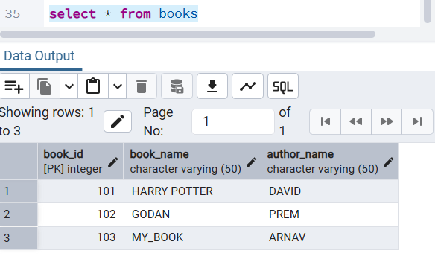
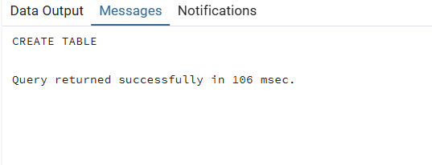

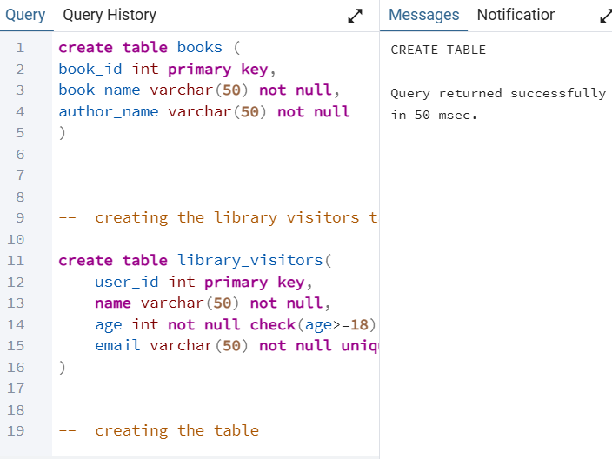

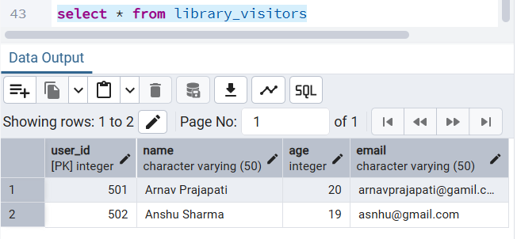

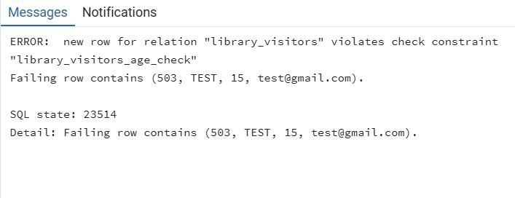

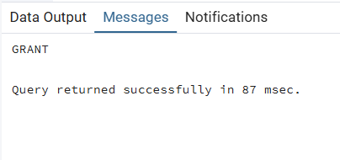

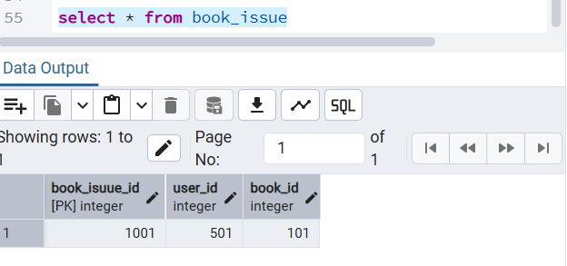

6. Learning Outcomes
Concepts Understood:
- Database Design: How to structure data using normalized tables
- Data Integrity: Implementation of constraints (PRIMARY KEY, FOREIGN KEY, NOT NULL, UNIQUE, CHECK)
- Table Relationships: One-to-many relationships using foreign keys
- Data Manipulation: INSERT and SELECT operations
- Access Control: Role-based security and permission management
- Data Validation: Using CHECK constraints for business rule enforcement
Skills Developed:
- Ability to write DDL (Data Definition Language) statements
- Capability to design relationships between multiple tables
- Understanding of constraint implementation and enforcement
- Proficiency in user role creation and permission management
- Data insertion and retrieval skills
- SQL debugging and error resolution
Practical Exposure Gained:
- Real-world database design for a library management system
- Practical experience with relational database concepts
- Understanding of how DBMS maintains data integrity
- Hands-on experience with SQL DML and DDL operations
- Knowledge of role-based security in enterprise databases
- Appreciation for database normalization and constraint usage
Key Takeaways:
Students will have practical knowledge of building a complete database system with proper structure, integrity, security, and relationships—skills essential for database administration and application development.

