**Web Designing Assignment**

**Term-1**

**Module (HTML) -1**

**Q. Are the HTML tags and elements the same thing?**

- No, the HTML tags and elements are not the same thing.

**Examples of HTML tags :-** <p> Paragraph Tag</p> ,

<h2> Heading Tag </h2>,<b> Bold Tag</b>, <i> Italic Tag</i>,

<u> Underline Tag</u>

**Example of HTML elements :-** <html>,<head>,<title>, <link>, <body>

Here is why because HTML tags represented the root of an HTML

Document. The HTML tag is the container for all HTML elements.

HTML element is defined by a start tag, some content and an end tag.

Example :- <html>

<head>

<title> Heading Example </title>

</head>

<body>

<h1> This is Heading 1</h1>

<h2> This is Heading 2</h2>

<h3> This is Heading 3</h3>

<h4> This is Heading 4</h4>

<h5> This is Heading 5</h5>

<h6> This is Heading 6</h6>

</body>

<body>

<p> This is My First HTML Example </P>

<b> This is My First HTML Example </b>

</body>

</html>

<html> This is HTML element </html>

<head> This is HTML element</head>

<title> This is HTML element</title>

<body> This is HTML element</body>

<h2> This is HTML tag</h2>

<p> This is HTML tags</p>

<b> This is HTML tags </b>

**Q. What are tags and attributes in HTML?**

- HTML tags are the keywords that are used to produce web pages in

various formats. Opening tags and closing tags are found in the

majority of tags. The concluding tags contain a forward slash(/), while

the language of the beginning tags is the same.

**HTML Tags:-**

<p> Paragraph Tag</p>

<h2> Heading Tag </h2>

<b> Bold Tag</b>

<i> Italic Tag</i>

<u> Underline Tag</u>

<body> , <style> , <div>, <span> , <strong>

**Example :-**

<!DOCTYPE html>

<html>

**<!-- head tag -->**

<head>

<title>Welcome to the Example of HTML tags</title>

</head>

**<!-- Body tag -->**

<body>

<h2> HTML Heading Tag</h2>

<p>

HTML tags with example.

</p>

<p>

Please change the code and click the

Run the button to see the changes.

</p>

</body>

</html>

- HTML attributes are additional value that add meaning or adjust the

behaviour of elements. Every element or tag can have attributes.

They always come in pairs. The attribute’s names are case- insensitive.

Attributes should always be used with the start tag. We can add

multiple attributes in one HTML element.

**1) href Attributes :-** We use the <a> tag to define a hyper link. In the

<a> tag, the href attribute specifies the URL of the page the link goes to.

**Example :-** <a href=“home.html”>

**2) src Attributes :-** We use the <img> tag add an image in HTML page.

The src attribute specifies the image path. We can specify the address of the image inside the double quotes.

**Example :-** <img src= “img_tulip.jpg”>

**3) Width and Height Attributes :-** The <img> tag also contains the width and height attributes. As the name suggests, these attributes specify the width and height of the image in pixels.

**Example :-** <img src= “img_tulip.jpg” width= “500” width= “500”>

**4) style attribute :-** The style attribute helps us set the style as font,

size, colour, etc of the HTML element.

**Example :-**

<p style= “background-color:red;”> Style attribute in HTML </p>

**Q. What are void elements in HTML?**

- There is a special group of elements that only have start tags and does

not contain any content within it. Void elements have attributes and

Void elements cannot be nested.

**Void elements :**

<area>, <col>, <command>, <embed>, <link>, <br>, <hr>, <link>, <img>

**Example :-**

<!DOCTYPE html>

<html>

<body>

<h2 style="color:green"> VOID ELEMENTS </h2>

<p>Hi...! <br>Welcome to Example of Void Elements. </p>

<h2 style="color:red"> VOID ELEMENTS </h2>

<p>Hi...! <hr> Welcome to Example of Void Elements. </p>

</body>

</html>

**OUTPUT :-**

## VOID ELEMENTS

Hi...!  
 Welcome to Example of Void Elements.

## VOID ELEMENTS

Hi...!

Welcome to Example of Void Elements.

**Q. What are HTML Entities?**

**-** HTML Provides some method to display reserved characters. Reserved

characters are those characters that are either reserved for HTML or

those which ae not present in the basic Keyboard. For example instance,

‘<’ is reserved in HTML language.

Sometimes this character needs to display on the web page which

creates ambiguity in code. Along with these are the characters which

are normally not present in basic keyboard (£, ¥, €, ©), etc. HTML

Provides some Entity names and Entity numbers to use these symbols.

Entity names are case- sensitive. Entity number is easy to learn.

**Syntax:-** &entity_name; or &#entity_number;

Some useful symbols with their Entity name and Entity Numbers are listed

below:

| Notation | Symbols | Entity name | Entity Number |
| --- | --- | --- | --- |
|  | non-breaking space | &nbsp; |  |
| < | less than | &lt; | < |
| ® | registered trademark | &reg; | ® |
| © | copyright | &copy; | © |
| € | euro | &euro; | € |
| ¥ | yen | &yen; | ¥ |
| £ | pound | &pound; | £ |
| ¢ | cent | &cent; | ¢ |
| “ | double quotation mark | &quot; | “ |
| & | ampersand | &amp; | & |
| > | greater than | &gt; | > |
| ∂ | PARTIAL DIFFERENTIAL | &part; | ∂ |
| ∃ | THERE EXISTS | &exist; | ∃ |
| ∅ | EMPTY SETS | &empty; | ∅ |
| ∇ | NABLA | &nabla; | ∇ |
| ∈ | ELEMENT OF | &isin; | ∈ |
| ∉ | NOT AN ELEMENT OF | &notin; | ∉ |
| + | PLUS SIGN | &plus; | + |
| ∏ | N-ARY PRODUCT | &prod; | ∏ |
| ∑ | N-ARY SUMMATION | &sum; | ∑ |
| Α | Alpha | &Alpha; | Α |
| Β | Beta | &Beta; | Β |
| Γ | Gamma | &Gamma; | Γ |
| Δ | delta | &Delta; | Δ |
| Ε | Epsilon | &Epsilon; | Ε |
| Ζ | Zeta | &Zeta; | Ζ |
| ♥ | BLACK HEART SUIT = valentine | &hearts; | ♥ |
| ♣ | BLACK CLUB SUIT = shamrock | &clubs; | ♣ |
| ♠ | BLACK SPADE SUIT | &spades; | ♠ |
| ↓ | DOWNWARDS ARROW | &darr; | ↓ |
| → | RIGHTWARDS ARROW | &rarr; | → |
| ↑ | UPWARDS ARROW | &uarr; | ↑ |
| ← | LEFTWARDS ARROW | &larr; | ← |
| ™ | TRADEMARK | &trade; | ™ |
| ♦ | BLACK DIAMOND SUIT | ♦ | ♦ |
| ° | degree | &deg; | ° |
| ∞ | infinity | &infin; | ∞ |
| ‰ | per-mille | &permil; | ‰ |
| ⋅ | dot operator | &sdot; | ⋅ |
| ± | plus-minus | &plusmn; | ± |
| † | hermitian | &hercon; | ⊹ |
| – | minus sign | &minus; | − |
| ¬ | – | &not; | ¬ |
| % | percent sign | &percent; | % |
| f | Function | &fnof; | ƒ |
| ∥ | parallel | &parallel; | ∥ |

**Q. What are different types of lists in HTML?**

- There are three types of lists in HTML.

1) Oder list

2) Unorder list

3) Define list

**Example :-**

<!DOCTYPE html>

<html lang="en">

<head>

<meta charset="UTF-8">

<meta name="viewport" content="width=device-width, initial-scale=1.0">

<title> HTML LIST TAG EXAMPLE </title>

</head>

<body>

<H2> HTML LIST TAG WITH EXAMPLE...! </H2>

<b> ODER LIST </b>

<ol>

<li> Apple </li>

<li> Samsung </li>

<li> Sony </li>

<li> Motorola</li>

<li> Oppo</li>

<li> Vivo </li>

<li> One Plus</li>

</ol>

<b> UNORDER LIST </b>

<ul>

<li> Apple </li>

<li> Samsung </li>

<li> Sony </li>

<li> Motorola</li>

<li> Oppo</li>

<li> Vivo </li>

<li> One Plus</li>

</ul>

<b> DEFINE LIST </b>

<dl>

<dt>HTML</dt>

<dd>Hyper-Text Markup Language</dd>

<dt>CSS</dt>

<dd>Cascading StyleSheets</dd>

</dl>

</body>

</html>

**OUTPUT :-**

## HTML LIST TAG WITH EXAMPLE...!

**ODER LIST**

1. Apple
2. Samsung
3. Sony
4. Motorola
5. Oppo
6. Vivo
7. One Plus

**UNORDER LIST**

* Apple
* Samsung
* Sony
* Motorola
* Oppo
* Vivo
* One Plus

**DEFINE LIST**

HTML

Hyper-Text Markup Language

CSS

Cascading StyleSheets

**Q. What is the ‘class’ attribute in HTML?**

**-** The Class is an attribute that specifies one or more class name for

An HTML element. The class attribute can be used on any HTML

element.

**Q. What is the difference between the ‘id’ attribute and the**

**‘class’ attribute of HTML elements?**

- **HTML id Attribute :** The id attribute is a unique identifier that is

used to specify the document. It is used by CSS and JavaScript to

perform a certain task for a unique element. In CSS, the id

attribute is written using the # symbol followed by id.

**- HTML class Attribute :-** The class attribute is used to specify one or more

Class names for an HTML element. The class attribute can be used on any

HTML element. The class name can be used by CSS and JavaScript to

Perform certain tasks for elements with the specified class name. The

Class name in CSS stylesheet using. “.” Symbol.

**Q. What are the various formatting tags in HTML?**

- The formatting tags can be used to set the text styles. Like Bold, italic,

Strong, emphasized, Marked tag, Smaller text, deleted text, sup, sub.

**Example :-**

<!DOCTYPE html>

<html lang="en">

<head>

<meta charset="UTF-8">

<meta name="viewport" content="width=device-width, initial-scale=1.0">

<title> Formatting Tags in HTML..! </title>

</head>

<body>

<h3> Formatting Tags In HTML </h3>

<p> This text is <i> italic.</i></p>

<p> This text is <em> emphasized.</em></p>

<p> This text is <b> bold.</b></p>

<p> This text is <strong> strong. </strong></p>

<p> This text is <u> underlined.</u></p>

<p> This text is <mark> marked.</mark></p>

<p> This text is<sup>superscripted.</sup></p>

<p> This text is <sub> subsripted.</sub></p>

<p> This text is <del> deleted.</del></p>

<p> This text is <ins> inserted.</ins></p>

<p> This text is <big>bigger.</big></p>

<p> This text is <small> smaller </small></p>

</body>

</html>

**OUTPUT :-**

### Formatting Tags In HTML

This text is *italic.*

This text is emphasized.

This text is **bold.**

This text is **strong.**

This text is underlined.

This text is marked.

This text issuperscripted.

This text is subsripted.

This text is inserted.

This text is bigger.

This text is smaller

**Q. How is cell Padding different from Cell Spacing?**

- Cellpadding defines the space between a table cell’s content and its border.

In contrast Cellspacing specifies the space between cells, which means

the whitesspace between the borders of neighbouring cells.

- Cellpadding contains the space within a cell. In contrast, cellspacing refers

to the distance between the cells.

- In cellpadding, the type of attribute is defined as “cellpadding”. In

contrast, in cellspacing, the type of attribute is set to “cellspacing”

- Cellpadding is set to 1 by default. In contrast, the default value of cell-

spacing is 2.

**Example :-**

<!DOCTYPE html>

<html lang="en">

<head>

<meta charset="UTF-8">

<meta name="viewport" content="width=device-width, initial-scale=1.0">

<title> Example of Cellpadding and cellspacing </title>

</head>

<body>

<table border="2" cellspacing="10" cellpadding="40">

<tr>

<td> JAVA</td>

<td> JAVA SCRIPT </td>

<td> C++</td>

</tr>

<tr>

<td> Python </td>

<td> Nodejs</td>

<td> Angular </td>

</tr>

</table>

</body>

</html>

**OUTPUT :-**

**Q. How can we club two or more rows or columns into a**

**Single Row or Column in an HTML table?**

- We use the colspan and rowspan attribute, to merge cells in HTML. The

rowspan attribute is for the number of rows a cell should merge,

whereas the colspan attribute is for the number of columns a cell

should merge. The attribute should be placed inside the <td> tag.

**Example :-**

<!DOCTYPE html>

<html lang="en">

<head>

<meta charset="UTF-8">

<meta name="viewport" content="width=device-width, initial-scale=1.0">

<title>Document</title>

</head>

<body>

<table border="2" cellspacing="10" cellpadding="10">

<tr>

<th rowspan="3">DAY</th>

<th colspan="3">SEMINAR</th>

</tr>

<tr>

<th colspan="2">SCHEDULE</th>

<th rowspan="2">TOPIC</th>

</tr>

<tr>

<th>BEGIN</th>

<th>END</th>

</tr>

<tr>

<td rowspan="2">MONDAY</td>

<td rowspan="2">8:00 AM</td>

<td rowspan="2">5:00 PM</td>

<td>INTRODUCTION TO XML</td>

</tr>

<tr>

<td>VALIDITY : DTD</td>

</tr>

<tr>

<td rowspan="3">TUESDAY</td>

<td>8:00AM</td>

<td>11:00 AM</td>

<td>X PATH</td>

</tr>

<tr>

<td>11:00 AM</td>

<td>2:00 PM</td>

<td rowspan="2">XSL TRANSFORMATION</td>

</tr>

<tr>

<td>2:00 PM</td>

<td>11:00 AM</td>

</tr>

<tr>

<td>WEDNESDAY</td>

<td>8:00 AM</td>

<td>12:00 PM</td>

<td> XLS FORMATING</td>

</tr>

</table>

</body>

</html>

**OUTPUT :-**

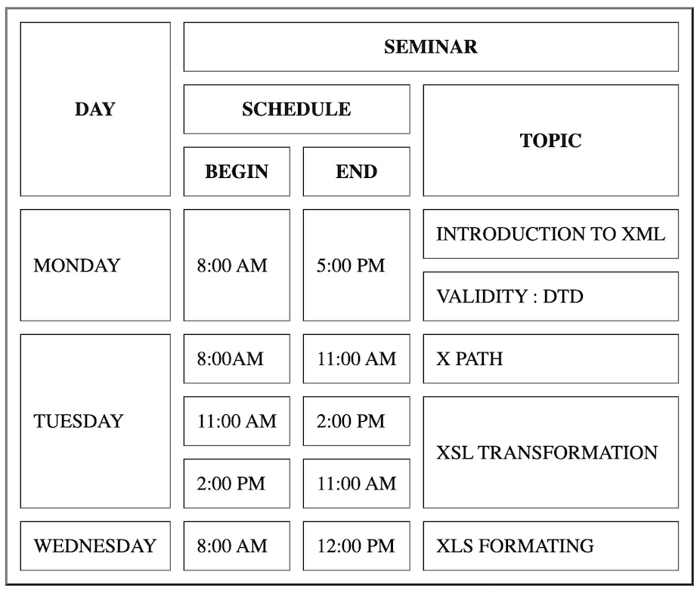

**Q. What is the difference between a block level element and**

**inline element?**

-Block elements always start from a new line and inline elements

never start from a new line.

- Block elements always cover space from left to right as far as it can go

and Inline elements cover space as bounded by the tags in the Html

element.

**Example :-**

<!DOCTYPE html>

<html>

<title>Block-level Element</title>

<body>

<h1>TOPS Technologies</h1>

<h3>Block-level Element</h3>

<h3>

You can give reviews as well as

contribute posts on this portal.

</h3>

<h3>In-line level Element</h3>

<span> You can give reviews as well as

contribute posts on this portal.</span>

<strong> You can give reviews as well as

contribute posts on this portal.</strong>

<p> <span style="border: 1px solid black;"> You can give reviews as well as

contribute posts</span> on this portal. </p>

<p style=" border: 1px solid red;"> You can give reviews as well as

contribute posts on this portal</p>

</body>

</html>

**OUTPUT :-**

**Q. How to create a Hyperlink in HTML?**

We can create a Hyperlink using Anchor Tag in HTML.

**Example :-**

<!DOCTYPE html>

<html lang="en">

<head>

<meta charset="UTF-8">

<meta name="viewport" content="width=device-width, initial-scale=1.0">

<title>Document</title>

</head>

<body>

<a href="home.html"> HOME </a>

<a href="Aboutus.html"> ABOUT US </a>

<a href="Contactus.html"> CONTACT US </a>

<a href="Image.html"> IMAGES</a>

<H1> WELLCOME TO THE HOME PAGE....! </H1>

</body>

</html>

**OUTPUT :-**

[HOME](home.html)[ABOUT US](Aboutus.html)[CONTACT US](Contactus.html)[IMAGES](Image.html)

**WELLCOME TO THE HOME PAGE....!**

**Q. What is the use of an iframe tag?**

**-** An iframe, also knowns as inline Frame, is an element that loads another

HTML element inside of a webpage. They are commonly used to embed

Specific content like external ads, videos, tags or other interactive

Elements into the page.

**Example :-**

<!DOCTYPE html>

<html lang="en">

<head>

<meta charset="UTF-8">

<meta name="viewport" content="width=device-width, initial-scale=1.0">

<title>Document</title>

</head>

<body>

<a href="Iframec.html"> </a>

<iframe width="560" height="315" src="https://www.youtube.com/embed/hlkijvnMQkM?si=PZFHtSpbmoYSZC_F"

title="YouTube video player" frameborder="0" allow="accelerometer; autoplay; clipboard-write; encrypted-media; gyroscope; picture-in-picture; web-share" allowfullscreen></iframe>

</body>

</html>

**OUTPUT :-**

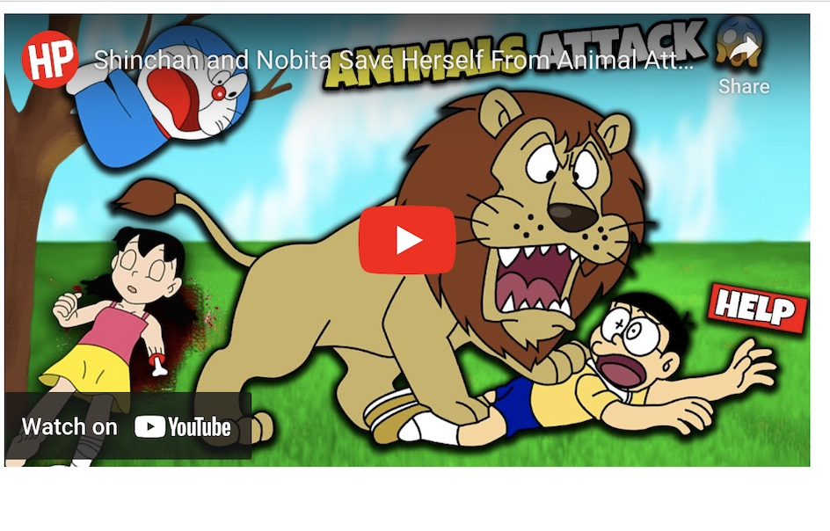

**Q. What is the use of Span tag? Explain With Example?**

- Span tag is an line container to wrap section of text for styling, to add

attributes to a section of text without creating a new line content.

**Example :-**

<!DOCTYPE html>

<html lang="en">

<head>

<meta charset="UTF-8">

<meta name="viewport" content="width=device-width, initial-scale=1.0">

<title>Document</title>

</head>

<body>

<p> My Name is <span style="color: blue; font-weight: bolder;"> ARNAV </span> And

I am living in <span style="color: darkgreen; font-weight: bolder;">

DEHGAM. </span></p>

</body>

</html>

**OUTPUT:-**

My Name is **ARNAV**And I am living in **DEHGAM.**

**Q. How to insert a picture into a background image of a**

**webpage?**

- The most common and simple way to add background image is using the

Background image attribute inside the <body> tag.

**Syntax**

<body background = “ URL or Path of Image” > Body of the Webpage

</body>

**Example :-**

<!DOCTYPE html>

<html lang="en">

<head>

<meta charset="UTF-8">

<meta name="viewport" content="width=device-width, initial-scale=1.0">

<title> Example Of background Image </title>

</head>

<body style="background-image: url('/Users/arnavpandav/Desktop/ARNAV PANDAV/Lecture Practice/Sp.jpg' );">

</body>

</html>

**OUTPUT:-**

**Q. What are the different tags to separate sections of text?**

- <br>, <p>, <blockquote> these tags are used to separate sections of text.

**Example :-**

<!DOCTYPE html>

<html lang="en">

<head>

<meta charset="UTF-8">

<meta name="viewport" content="width=device-width, initial-scale=1.0">

<title> Example of Sepratiion Tags in HTML </title>

</head>

<body>

<h3> Example of Sepration Tags in HTML..! </h3>

<blockquote> Blockquote Tag , P and br Tags

<p> HTML stands for HyperText Markup Language. It

is used to design web pages using a markup language.<br>

HTML is the combination of Hypertext and Markup language.

Hypertext defines the link between the web pages.<br> A

markup language is used to define the text document within

tag which defines the structure of web pages. </p>

</blockquote>

</body>

</html>

**OUTPUT :-**

**Q. How are active links different from normal links?**

- The default colour for normal and active links is blue. Some browsers

recognize an active link when the mouse cursor is placed over that link.

Whereas, others recognize active links when the link has the focus. Those

don’t have a mouse cursor over that link is considered a normal link.

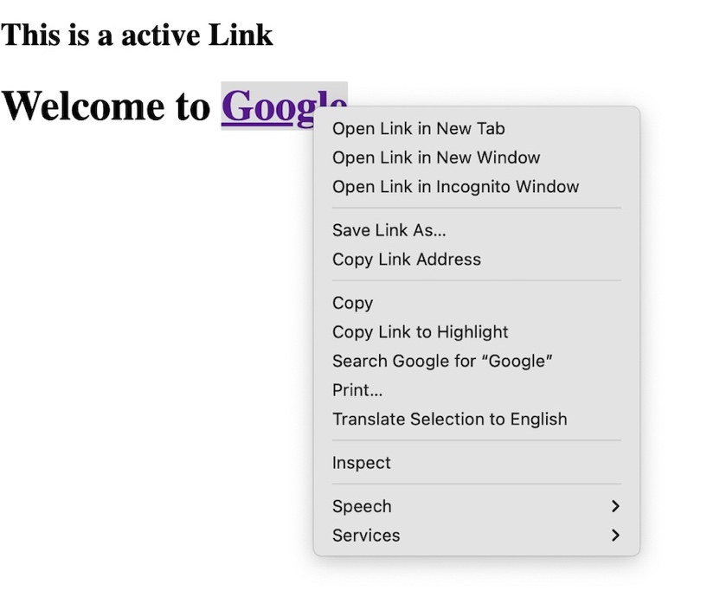

**Q. What is SVG?**

- SVG stands for scalable vector Graphics. SVG is used to define graphics for

The Web. SVG images can be created and edited with any text editor. SVG

images can be searched, indexed, scripted, and compressed. SVG images are

scalable. SVG images can be printed with high quality at any resolution.

**Example :-**

<!DOCTYPE html>

<html lang="en">

<head>

<meta charset="UTF-8">

<meta name="viewport" content="width=device-width, initial-scale=1.0">

<title> SVG Example </title>

</head>

<body>

<svg>

<circle cx="70" cy="70" r="60" fill="red" stroke="black" stroke-width="5">

</svg> <br><br>

<svg>

<rect height="50" width="50" fill="blue" stroke="black">

</svg>

</body>

</html>

**OUTPUT:-**

**Q. What is the different between HTML and XHTML?**

- HTML stands for Hypertext Markup language, whereas XHTML stands for

Extensible Hypertext Markup language. In HTML you cannot make your

own tags but in XTML you can.

- HTML was developed by Tim Berners Lee, Whereas XHTML was

developed by W3C (World wide web Consortium)

- It was developed in 1991, Whereas XHTML was released in 2000.

- The format is a document file format in HTML, whereas in XHTML the

format is markup language.

**Q. What are logical and Physical tags in HTML?**

**- Logical Tags :-** These tags are used to add some logical or semantic value

to the text.

<em>,<cite>,<strong>,<code>,<abbr>,<blockquote> these tags are example of Logical Tags.

**- Physical Tags :-** These tags are used to provide the visual appearance to the

text.

<b>,<big>,<i>,<u>, <small>,<strike>,<sub>,<sup> these tags are example of Physical tags.

**Example :-**

<!DOCTYPE html>

<html>

<head>

<title>Page Title</title>

</head>

<body>

<h3> Logical Tags </h3>

Welcome to <abbr title="TopsTechnologies"> TOPS </abbr>

<address> 401 Amruta Arcade Lala Lajpat Rai Marg Char Rasta Maninagar Ahmedabad 380008 Gujarat </address> <br>

<cite> TOPS Technologies</cite> is my favourite website. <br>

<code> TOPS Technologies is my favourite. </code>

<blockquote>

TOPS Technologies, a leading IT training institute in India, has announced signing a Memorandum of understanding with Gujarat Technological University <br>

for better skill and training development, placement, R & D, and other related services. Through this agreement, TOPS Technologies aims to provide<br>

enthusiastic learners with value-added programs and an industry-ready curriculum. This strategic alliance will help Indian students to become skilled <br>

professionals through access to the best educational resources for rewarding career opportunities.

</blockquote>

<ins> Newly inserted content.</ins>

<p>

<dfn>TOPS</dfn> TOPS organizes a JobFest where 50+ Companies interview Candidates for their Job Openings.

This event is organized at a Convention center Maximum salary offered by companies during JobFest for a

fresher has been 7.2 lacs Each student interviews with maximum companies in 1 day

Companies get to interact with multiple candidates and offer maximum salaries

Candidates select the best Job Offers

</p>

<h3> Physical Tags </h3>

Text without formatting<br>

<b> Tops Technologies </b> <br>

<big> Tops Technologies </big><br>

<i> Tops Technologies </i><br>

<small>Tops Technologies</small><br>

1<sup>st</sup><br>

H<sub>2</sub>O<br>

<u> Tops Technologies</u><br>

<tt> TopsTechnologies</tt>

</body>

</html>

**OUTPUT :-**

**Software Engineering Assignment**

MODULE: 2 (HTML)

**Q. Define the terms**

**Website :-** A Website is a collection off files accessed through a web address,

covering a particular theme or subject and managed by a particular person

or organization.

**Webpage :-** A Webpage is a hypertext document on the world wide web.

Webpages are delivered by a web server to the user and displayed in a web

Browser.

**Web browser :-** A software application used to access information on the world

Wide web is called a Web browser. When a user requests some information, the web browser fetches the data from a web server and then displays the web

Page on the user’s screen.

**Web Server :-** A Web server is software and hardware that uses HTTTP (Hypertext transfer protocol) and other protocols to respond to client

Requests made over the world wide web.

The main job of a web server is to display website content through storing, processing and delivering web pages to users.

**HTML :-** HTML stands for hypertext Markup language. HTML is the standard

Markup language for creating web pages. HTML describe the structure of a

Web page.

**Q. Create a webpage to show “ This is my first HTML page”**

<!DOCTYPE html>

<html lang="en">

<head>

<meta charset="UTF-8">

<meta name="viewport" content="width=device-width, initial-scale=1.0">

<title> First HTML Page</title>

</head>

<body>

<p> " This is My First HTML Page."</p>

</body>

</html>

**OUTPUT :-**

" This is My First HTML Page."

**Q. Display top 10 IT companies list in HTML webpage.**

<!DOCTYPE html>

<html lang="en">

<head>

<meta charset="UTF-8">

<meta name="viewport" content="width=device-width, initial-scale=1.0">

<title> Top 10 IT companies </title>

</head>

<body>

<h3> <u> LIST OF TOP 10 IT COMPANIES.</u></h3>

<ol>

<li> MICROSOFT</li>

<li> ORACLE</li>

<li> ACCENTURE</li>

<li> COGNIZANT</li>

<li>INFOSYS </li>

<li> TCS</li>

<li> SAP</li>

<li> IBM</li>

<li> DXC</li>

<li> DELLOITE CONSULTIING</li>

</ol>

</body>

</html>

**OUTPUT :-**

### LIST OF TOP 10 IT COMPANIES.

1. MICROSOFT
2. ORACLE
3. ACCENTURE
4. COGNIZANT
5. INFOSYS
6. TCS
7. SAP
8. IBM
9. DXC
10. DELLOITE CONSULTIING

**Q. Create a dropdown list.**

<!DOCTYPE html>

<html lang="en">

<head>

<meta charset="UTF-8">

<meta name="viewport" content="width=device-width, initial-scale=1.0">

<title> Dropdown List </title>

</head>

<body>

<h3> Example Of Dropdown List in HTML.</h3>

<form>

<label> CHOOSE A CAR : </label>

<select style="width: 100px; height: 30px;">

<option> VOLVO </option>

<option> MERCEDES</option>

<option> AUDI</option>

<option> HONDA</option>

<option> MARUTI</option>

<option> TOYATO</option>

</select>

</form>

</body>

</html>

**OUTPUT:-**

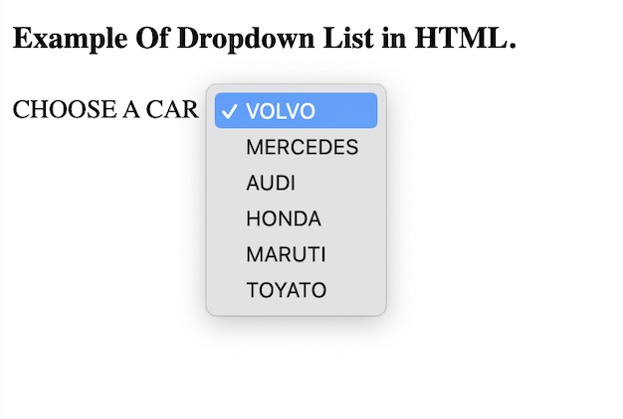

**Q. Create a Table Of college Management system using row span**

**& Col span.**

<!DOCTYPE html>

<html lang="en">

<head>

<meta charset="UTF-8">

<meta name="viewport" content="width=device-width, initial-scale=1.0">

<title> College Management System. </title>

</head>

<body>

<table border="2" cellspacing="10x" cellpadding="10px">

<tr>

<th colspan="2" rowspan="3"> Subject Code and Subject Name </th>

<th colspan="2" rowspan="2"> Internal Assesment </th>

<th colspan="2" rowspan="2"> External Assesment </th>

<th colspan="2"> Grand Total </th>

<th rowspan="3"> Remarks</th>

</tr>

<tr>

<th rowspan="2"> MM </th>

<th rowspan="2"> MO </th>

</tr>

<tr>

<th> MM</th>

<th> MO</th>

<th> MM</th>

<th> MO</th>

</tr>

<tr>

<td colspan="2"> Economics Theory </td>

<td> 40 </td>

<td> 32 </td>

<td> 60 </td>

<td> 43 </td>

<td> 100</td>

<td> 75 </td>

<td> P </td>

</tr>

<tr>

<td colspan="2"> Elements of Statistic </td>

<td> 40 </td>

<td> 31 </td>

<td> 60 </td>

<td> 38 </td>

<td> 100</td>

<td> 69 </td>

<td> P </td>

</tr>

<tr>

<td colspan="2"> Company Law</td>

<td> 40 </td>

<td> 32 </td>

<td> 60 </td>

<td> 47 </td>

<td> 100 </td>

<td> 79 </td>

<td> P </td>

</tr>

<tr>

<td colspan="2"> Money, Banking, Financial Management</td>

<td> 40 </td>

<td> 31 </td>

<td> 60 </td>

<td> 36 </td>

<td> 100 </td>

<td> 67 </td>

<td> P </td>

</tr>

<tr>

<td colspan="2"> Elements of Coding </td>

<td> 40 </td>

<td> 32 </td>

<td> 60 </td>

<td> 47 </td>

<td> 100 </td>

<td> 79 </td>

<td> P </td>

</tr>

</table>

</body>

</html>

**OUTPUT:-**

Bottom of Form