RAMDEOBABA UNIVERSITY
SCHOOL OF COMPUTER SCIENCE AND ENGINEERING

B. TECH PROJECT REPORT
B.Tech. in Computer Science and Engineering (CSE)
Idea Lab
ON
Smart Parking Space Detection
using YOLO and OpenCV
Submitted by
Arinjay Sawai (Roll No. 3)
Arnav Nawade (Roll No. 42)
Aryan Jumde (Roll No. 34)
Under the Guidance of
Abhishek Sahu
Academic Year: 2026 – 27
RAMDEOBABA UNIVERSITY, NAGPUR
Department of Computer Science and Engineering

CERTIFICATE
This is to certify that the project report entitled “Smart Parking Space Detection using YOLO and OpenCV” is a bonafide work of Arinjay Sawai (Roll No. 3), Arnav Nawade (Roll No. 42) and Aryan Jumde (Roll No. 34), submitted to Ramdeobaba University, Nagpur, in partial fulfilment of the requirements for the award of the degree of Bachelor of Technology (B.Tech) in Computer Science and Engineering (CSE). The project was carried out in the Department of Computer Science and Engineering during the academic year 2026–27.
Date: ____________________
Place: Nagpur
________________________  Abhishek Sahu  Project Guide  Department of Computer Science & Engineering | ________________________  Name: __________________  Associate Head  Department of Computer Science & Engineering
________________________
Name: __________________
Dean, School of Computer Science and Engineering

STUDENT DECLARATION
We hereby declare that the project report entitled “Smart Parking Space Detection using YOLO and OpenCV” is submitted as part of the requirements for the B.Tech programme in Computer Science and Engineering (CSE) at Ramdeobaba University, Nagpur.
The report documents our project work under the guidance of Abhishek Sahu and acknowledges the software, research and other external sources used. Published results are identified separately from measurements made on the local prototype. Detection accuracy is not claimed where independent ground-truth labels are unavailable. We understand that this declaration is to be signed after reviewing the final report.
Arinjay Sawai — Roll No. 3
Signature: ____________________
Arnav Nawade — Roll No. 42
Signature: ____________________
Aryan Jumde — Roll No. 34
Signature: ____________________
Date: ____________________

APPROVAL SHEET
This report entitled “Smart Parking Space Detection using YOLO and OpenCV” by Arinjay Sawai (Roll No. 3), Arnav Nawade (Roll No. 42) and Aryan Jumde (Roll No. 34) is submitted for approval for the degree of Bachelor of Technology (B.Tech) in Computer Science and Engineering (CSE).
________________________  Abhishek Sahu  Project Guide  Department of Computer Science & Engineering | ________________________  External Examiner  Name: __________________  Date: __________________
________________________
Name: __________________
Dean, School of Computer Science and Engineering

ACKNOWLEDGEMENT
We express our sincere gratitude to Ramdeobaba University and the School of Computer Science and Engineering for providing the academic environment and facilities required to complete this project.
We are grateful to our project guide, Abhishek Sahu, for guidance, technical suggestions and feedback. We also thank the Project In-Charge, Associate Head and Dean, School of Computer Science and Engineering, for their support.
We acknowledge the support of our classmates, laboratory staff, friends and family members who contributed directly or indirectly to the completion of this work.

ABSTRACT
Parking-space monitoring requires both reliable vehicle detection and a consistent interpretation of occupancy over time. This project develops a local browser application that estimates available parking spaces from recorded video using YOLOv8n and OpenCV. Users can upload footage, define parking zones directly in the browser and configure temporal filtering to reduce short-lived state changes.
The system associates vehicle-box centres with normalized four-corner parking polygons. A separate state machine for each space confirms occupancy changes from consecutive observations. A Flask and Waitress backend serves annotated video, live counts and controls through a shared inference worker. Video identities, zone coordinates and stability settings persist across restarts. New sources require calibration before availability is reported.
Evaluation combines code inspection, automated regression tests and a CPU timing experiment on the supplied video. Across 100 warmed analysis calls, mean latency was 40.58 ms, corresponding to 24.65 analyzed frames per second; 29 automated tests passed. A synthetic sequence reduced six raw transitions to two stable transitions. Seven recent papers and five detector models are reviewed separately. Parking precision, recall and F1 remain unmeasured because the project clip lacks verified occupancy labels.
Keywords: Smart Parking, YOLOv8n, OpenCV, Zone Editing, Temporal Filtering, Flask, Computer Vision
TABLE OF CONTENTS
CERTIFICATE 2
STUDENT DECLARATION 3
APPROVAL SHEET 4
ACKNOWLEDGEMENT 5
ABSTRACT 6
LIST OF FIGURES 8
LIST OF TABLES 9
LIST OF ABBREVIATIONS 10
1. TITLE OF THE PROJECT 11
2. OBJECTIVES 12
3. ALGORITHM FLOWCHART BLOCK DIAGRAM 13
4. METHODOLOGY 14
5. RESULTS 18
6. CONCLUSION 20
7. FUTURE SCOPE 21
REFERENCES 22
ANNEXURE A: PUBLICATIONS AND INTELLECTUAL PROPERTY 23
ANNEXURE B: STUDENT CONTRIBUTION STATEMENT 24
ANNEXURE C: PROJECT OUTPUTS 25

LIST OF FIGURES
Figure 3.1: Processing flowchart and block diagram 14
Figure 4.1: Dashboard and browser zone editor 17
Figure 5.1: Measured analysis latency 18
Figure 5.2: Published nano-model comparison 19
Figure 5.3: Temporal-filter behavior 19
Figure 6.1: Annotated project output 20

LIST OF TABLES
Table 4.1: Methodology stages 14
Table 4.2: Stability presets 15
Table 4.3: Input validation and preprocessing 16
Table 5.1: Local runtime and test results 18
Table 5.2: State-of-the-art model metrics 19
Table B.1: Student contribution record 24

LIST OF ABBREVIATIONS
Abbreviation | Meaning
AI | Artificial Intelligence
AP | Average Precision
API | Application Programming Interface
COCO | Common Objects in Context
CPU | Central Processing Unit
CSE | Computer Science and Engineering
FLOPs | Floating-point Operations
FPS | Frames per Second
GPU | Graphics Processing Unit
IoU | Intersection over Union
JSON | JavaScript Object Notation
MAE | Mean Absolute Error
MJPEG | Motion JPEG
NMS | Non-Maximum Suppression
ROI | Region of Interest
UI | User Interface
YOLO | You Only Look Once

1. TITLE OF THE PROJECT

Smart Parking Space Detection using YOLO and OpenCV
Parking availability is a spatial and temporal problem. Detecting a vehicle does not by itself identify its parking space, and a missed detection in one frame does not prove that a vehicle has departed. A useful system must combine detection, calibrated parking regions and stable state reporting. Camera-based monitoring can observe several spaces in one view, but perspective, shadows, occlusion and illumination changes complicate interpretation [1]–[3].
The project converts a YOLO and OpenCV parking detector into an interactive local application. The supplied demonstration contains 18 spaces. Users can upload a different video, define its zones over a browser preview and choose how quickly occupancy changes are accepted. Each video retains its own calibration, avoiding manual editing of coordinate arrays in Python.

2. OBJECTIVES
• Accept supported video uploads with validation and persistent source selection.
• Provide browser-based drawing, resizing, movement and saving of parking zones.
• Reduce transient occupancy changes through independent temporal state per space.
• Display annotated video, available/occupied/checking counts and playback controls.
• Evaluate functional behavior and runtime, and distinguish measured evidence from published research.

Project Scope
This is a recorded-video prototype using pretrained YOLOv8n weights. It does not identify drivers, book spaces or train a new detector. The report describes the algorithm and block diagram, methodology, results, conclusion and future scope. References and annexures document provenance and submission details. Accuracy claims require a labeled evaluation dataset that is not currently supplied.

3. ALGORITHM FLOWCHART BLOCK DIAGRAM
The system processes one selected video through a shared worker. It validates the video and metadata, decodes frames at a controlled stride, predicts permitted vehicle classes, maps box centres to parking zones, filters each zone state over time and publishes the latest annotated frame and occupancy status to the browser.

3.1 Algorithm Steps
• Select or upload a video and validate its extension, file size, dimensions, frame count and first decodable frame.
• Load the saved polygon zones and stability preset for that video; otherwise present a calibration preview.
• Decode a frame at the selected stride and run YOLOv8n with confidence threshold 0.35.
• Keep car, motorcycle, bus and truck detections, then test each box centre against every parking polygon.
• Update each zone using consecutive-frame evidence and compute available, occupied and checking counts.
• Draw the annotated result, stream it through MJPEG, return JSON status and preserve revised zone settings atomically.

3.2 Flowchart Interpretation
The block diagram in Section 4 shows the same sequence. Validation precedes inference, spatial association follows vehicle detection and temporal filtering precedes the browser display. The order prevents the dashboard from showing parking availability for unconfigured scenes or from treating one missed detection as an immediate departure.

4. METHODOLOGY

4.1 Methodology Stages
Table 4.1: Methodology stages
Stage | Input and operation | Output
Video intake | Upload or choose a saved video; validate metadata and decode the first frame. | A usable source or a clear validation error.
Zone calibration | Draw, edit and save normalized four-corner parking polygons in the browser. | Per-video parking-space geometry.
Vehicle detection | Run YOLOv8n on sampled frames and retain permitted vehicle classes. | Vehicle bounding boxes.
Spatial association | Test every vehicle-box centre against configured polygon boundaries. | Raw occupied or available observation per zone.
Temporal filtering | Confirm a candidate state using the selected consecutive-frame thresholds. | Stable occupied, available or checking state.
Presentation and storage | Annotate the frame; stream MJPEG and JSON; persist source settings atomically. | Local dashboard and reusable configuration.

4.2 Processing Flowchart and Block Diagram
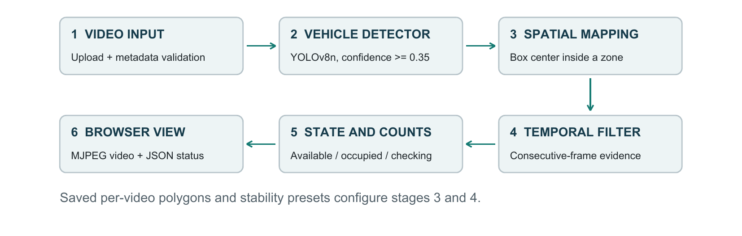
Figure 3.1: Processing flowchart and block diagram; one shared inference worker serves browser clients.

4.3 Detection and Zone Association
OpenCV decodes the selected video. YOLOv8n uses a 640-pixel input setting and confidence threshold 0.35. Allowed COCO classes are car (2), motorcycle (3), bus (5) and truck (7). A zone is observed as occupied if at least one vehicle-box centre lies inside or on its polygon boundary. Multiple detections in one zone count once; unintended overlapping zones can count the same vehicle twice.

4.4 Stable Occupancy Estimation
Each zone begins in a checking state. Consecutive observations confirm a candidate state before it replaces the stable state; agreeing evidence resets the opposing streak. The longer departure threshold tolerates brief missed detections. Initial confirmation uses the shorter threshold for both available and occupied states.
Table 4.2: Stability presets (thresholds count processed observations)
Preset | Occupied / initial | Available after departure
Responsive | 2 | 4
Balanced (default) | 3 | 8
Steady | 5 | 12
At the sample cadence of about 12.47 observations/s, balanced thresholds represent evidence windows of approximately 0.24 s and 0.64 s. Actual response also depends on sampling and display polling. Source changes, restarts, loops and zone saves reset state. Available + occupied + checking must equal the configured zone count.
4. METHODOLOGY (continued)

4.5 Data Cleaning and Preprocessing
Table 4.3: Input audit and implemented validation
Item | Observed data / processing rule
Sample video | 1214 × 640 pixels; 1,214 frames; 24.938 FPS; 48.68 s; 18 zones.
Upload validation | MP4/MOV/AVI/MKV/WebM; at most 500 MiB; first frame must decode.
Metadata | Dimensions ≤4096 px; finite FPS in (0, 240]; positive frame count.
Deduplication | SHA-256 identity reuses existing footage and settings.
Zone validation | Up to 200 convex, non-crossing quadrilaterals; normalized finite coordinates within [0, 1].
Frame selection | Stride = max(1, round(FPS/10)); the sample retains every second frame.
The predictor performs resizing, padding and tensor normalization internally. The project adds no histogram equalization, denoising or training augmentation. Browser coordinates are stored as fractions of frame width and height, then mapped back to pixels for analysis. Resizing a display preserves calibration; moving a camera does not. First-frame validation cannot guarantee that every subsequent frame is intact.

4.6 Data Preparation for Future Accuracy Evaluation
A labeled corpus should include daylight, night, rain, glare, occlusion and different views. Review corrupt or duplicate captures, document exclusions and flag ambiguous zones as unscorable. Annotate vehicle boxes and time-aligned per-space occupancy, with a second reviewer checking a subset. Split by camera and recording day before frame sampling to prevent near-duplicate leakage [4].
Tune detection confidence, association rules and filter thresholds only on validation data. Freeze them before testing. Report vehicle AP, per-space precision/recall/F1, count MAE, unknown-state coverage and transition delay. This is a proposed evaluation protocol: the current project uses pretrained weights and has no cleaned training corpus or held-out accuracy result.

4.7 User Interface Development and Deployment
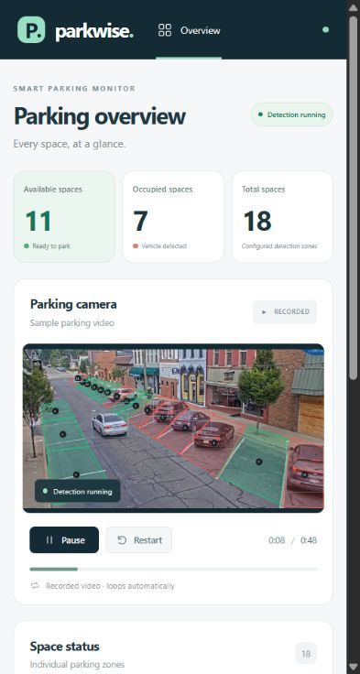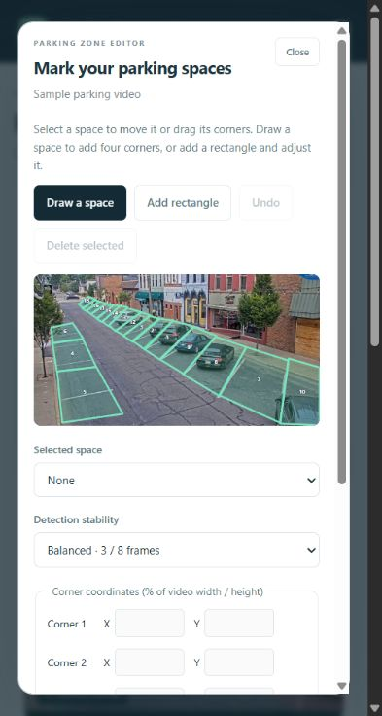
Figure 4.1: Actual dashboard (left) and browser zone editor (right), captured during project testing on 21 October 2026.

4.7.1 Browser Workflow
Users upload a video with progress feedback and select saved sources. New footage opens in preview until calibrated. The SVG editor supports four-point drawing, rectangles, drag handles, whole-zone movement, percentage-coordinate fields, deletion and undo. Saving validates the revision and geometry, stores the settings and restarts analysis. Playback controls provide pause, resume and restart.

4.7.2 Local Deployment
Flask and Waitress serve the dashboard at http://localhost:5000 with eight server threads and one shared detector worker. MJPEG supplies video; JSON status is polled once per second. Atomic files under data/ retain sources, previews, zones and the selected source. Run .\.venv\Scripts\python.exe app.py from the project folder after installing requirements into that virtual environment; using another Python can cause the missing-cv2 error.
The local service supports one active video and has no authentication. Remote deployment would require access control, TLS, storage quotas and load testing; multiple cameras would require separate workers and resource management.

5. RESULTS

5.1 Experimental Setup and Discussion
The benchmark ran on 22 October 2026 on Windows with an AMD Ryzen 7 7840HS (16 logical processors), Python 3.13.9, CPU-only PyTorch 2.14.1 and Ultralytics 8.4.183. Eight PyTorch threads were reported after initialization. The first 200 source frames were decoded, every second frame retained, and six warm-up predictions excluded before timing 100 analysis calls.
Table 5.1: Measured local runtime and functional results
Metric | Measured value | Interpretation
Mean / median latency | 40.58 / 40.51 ms | Warmed analysis, n=100
95th percentile / maximum | 43.11 / 48.20 ms | Observed tail in one run
Analysis throughput | 24.65 frames/s | 1,000 / mean milliseconds
Cold first prediction | 4.47 s | Excluded from warmed timings
State-count invariant | 100 / 100 frames | Counts sum to 18
Regression suite | 29 / 29 passed | 2.506 s test-runner time
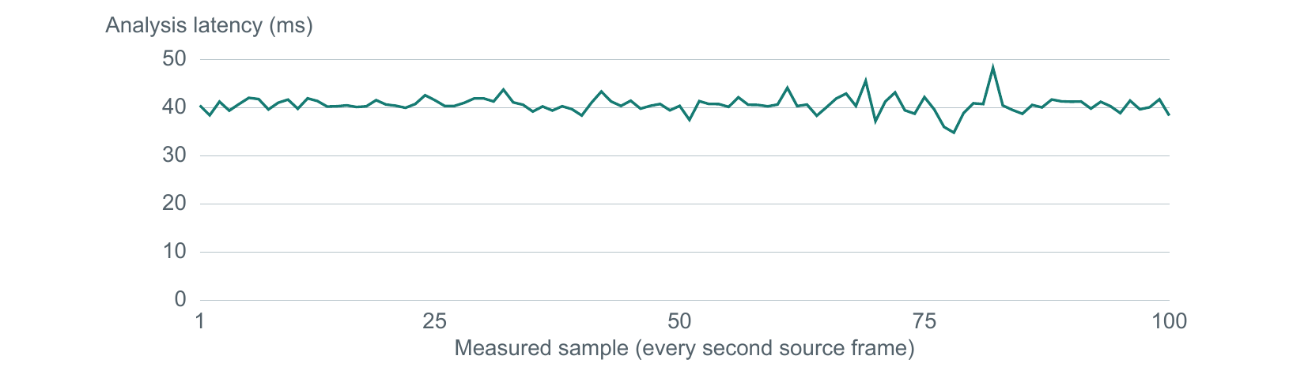
Figure 5.1: Per-frame analysis latency for the 100 measured calls; vertical scale begins at zero.

5.2 Interpretation and Measurement Boundary
Timing includes predictor preprocessing, detection, post-processing, zone association, filtering and annotation. It excludes decoding, JPEG encoding, HTTP and browser rendering. The rate exceeds the configured sample cadence, suggesting headroom on this machine, but is not browser FPS. This is a single short run, not a multi-run endurance study. Test pass rate describes checked software behavior, not detection accuracy.
5. RESULTS (continued)

5.3 State-of-the-Art Model Comparison
Table 5.2: Source-reported nano models at 640-pixel input
Model | COCO AP (%) | Params (M) | FLOPs (B) | Source
YOLOv8n | 37.3 | 3.2 | 8.7 | [8]
YOLO11n | 39.5 | 2.6 | 6.5 | [9]
YOLO12n | 40.6 | 2.6 | 7.5 | [10]
YOLOv13-N | 41.6 | 2.5 | 6.4 | [6]
YOLO26n | 40.9 / 40.1* | 2.4 | 5.5 | [11]
*YOLO26: standard / end-to-end AP. AP is COCO AP50–95, not parking accuracy.
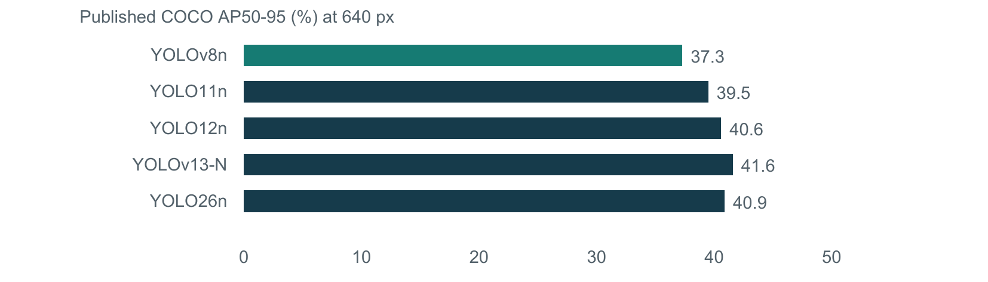
Figure 5.2: Published COCO AP; YOLO26 uses standard-head AP.
Training and evaluation protocols differ across sources; even the reported YOLO11 baseline varies. Only YOLOv8n was tested locally. The other four are candidates. Published AP cannot identify the best parking detector or predict its CPU latency.

5.4 Detection Stability
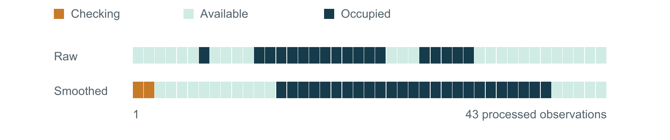
Figure 5.3: Controlled 43-observation sequence using the balanced filter.
The synthetic sequence reduces six raw transitions to two stable transitions, suppressing a one-frame spike and three-observation dropout. Confirmation delays real changes and can preserve persistent errors. Reduced flicker does not prove accuracy: parking precision, recall, F1 and count MAE remain unmeasured without verified labels.

6. CONCLUSION
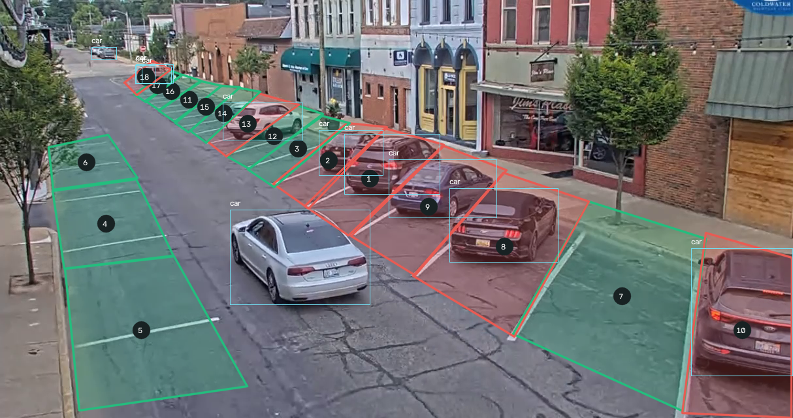
Figure 6.1: Actual output at source frame 198 (about 7.94 s): 7 occupied and 11 available predictions, not ground-truth counts.

6.1 Project Conclusion
The project integrates video upload, browser zone editing and stable occupancy display. Persistent per-video geometry supports new fixed views. A shared worker avoids repeating inference for each browser; the checking state prevents availability claims before confirmation or calibration.
The measured YOLOv8n pipeline averaged 40.58 ms per warmed analysis call on the tested CPU. Functional tests and state-count checks passed, and a controlled sequence demonstrated suppression of transient state changes. These findings support the implemented workflow and its short-run responsiveness. They do not establish parking accuracy, generalization across cameras or long-duration reliability.

7. FUTURE SCOPE
Occlusion, darkness, camera motion, small vehicles and box-centre mismatch can cause incorrect assignment. The next priority is a labeled, camera-separated dataset and controlled comparison of the five models using identical conditions. Measure occupancy F1, count error, false transitions, unknown coverage and confirmation delay together with end-to-end latency.
Further development can add overlap-based association or segmentation, camera-motion warnings, multi-camera workers, authenticated remote access and occupancy history. Model replacement should follow parking-specific evidence rather than a published COCO score alone.

REFERENCES
Primary research and official model documentation; sources checked 22–23 October 2026.
[1] G. P. C. P. da Luz, G. M. Sato, L. F. G. Gonzalez, and J. F. Borin, “Smart parking with pixel-wise ROI selection for vehicle detection using YOLOv8, YOLOv9, YOLOv10, and YOLOv11,” Internet of Things, vol. 36, art. 101858, 2026. doi: 10.1016/j.iot.2025.101858.
[2] K. Kim, J. Lee, I. Jeong, J. Jung, and J. Cho, “Real-Time Parking Space Management System Based on a Low-Power Embedded Platform,” Sensors, vol. 25, no. 22, art. 7009, 2025. doi: 10.3390/s25227009.
[3] JS Jefflin Deno, S Karthi Sree, S Maheswari, and P Sasikumar, “Smart mobility infrastructure: improving campus parking efficiency in real time,” Scientific Reports, vol. 16, art. 15186, 2026. doi: 10.1038/s41598-026-46053-4.
[4] P. L. de Almeida, J. H. Alves, L. M. Kujavski, P. L. Alves, and L. E. Oliveira, “MetaPKLot – new challenges and protocols for vision-based parking lot management,” Neural Computing and Applications, vol. 38, art. 704, 2026. doi: 10.1007/s00521-026-12398-0.
[5] Y. Tian, Q. Ye, and D. Doermann, “YOLOv12: Attention-Centric Real-Time Object Detectors,” NeurIPS, 2025; arXiv:2502.12524. https://arxiv.org/abs/2502.12524
[6] M. Lei et al., “YOLOv13: Real-Time Object Detection with Hypergraph-Enhanced Adaptive Visual Perception,” arXiv:2506.17733, 2025 (preprint). Model metrics: https://github.com/iMoonLab/yolov13
[7] G. Jocher et al., “Ultralytics YOLO26: Unified Real-Time End-to-End Vision Models,” arXiv:2606.03748, 2026 (preprint). https://arxiv.org/abs/2606.03748
[8] Ultralytics, “Explore Ultralytics YOLOv8,” official model documentation. https://docs.ultralytics.com/models/yolov8/
[9] Ultralytics, “Ultralytics YOLO11,” official model documentation. https://docs.ultralytics.com/models/yolo11/
[10] Ultralytics, “YOLO12: Attention-Centric Object Detection,” official model documentation. https://docs.ultralytics.com/models/yolo12/
[11] Ultralytics, “Ultralytics YOLO26,” official model documentation. https://docs.ultralytics.com/models/yolo26/
Project evidence: app.py, detector.py, sources.py, browser assets and tests; local measurements in tmp/pdfs/measurements.json dated 22 October 2026. Original repository: github.com/prajesdas/Smart-Parking-Space-Detector-using-YOLO-and-OpenCV.

ANNEXURE A: PUBLICATIONS AND INTELLECTUAL PROPERTY
No publication, conference acceptance, patent filing, design registration or copyright registration has been supplied for this project. No such outcome is claimed in this report.
The research papers listed in the references are external works reviewed for technical context. They are not publications by the student team.
If a project-related submission or registration is completed later, its title, authors, venue or authority, date, identifier and documentary evidence can be added here.

ANNEXURE B: STUDENT CONTRIBUTION STATEMENT
The names and roll numbers below are provided by the team. Individual responsibilities have not been supplied; the contribution cells are intentionally editable and should be completed and confirmed by each student before submission.
Table B.1: Student contribution record
Student name | Roll No. | Contribution to be confirmed
Arinjay Sawai | 3 | ________________________________  ________________________________
Arnav Nawade | 42 | ________________________________  ________________________________
Aryan Jumde | 34 | ________________________________  ________________________________
Arinjay Sawai — Signature: ____________________
Arnav Nawade — Signature: ____________________
Aryan Jumde — Signature: ____________________
Guide verification: Abhishek Sahu
Signature: ____________________ Date: ____________________

ANNEXURE C: PROJECT OUTPUTS

C.1 Software and Demonstration
The project outputs include the local web dashboard, YOLOv8n/OpenCV detection pipeline, browser zone editor, video upload and source library, persistent configuration, temporal occupancy filter and automated regression tests. The application demonstrates the sample video and supports calibration of additional recorded footage.

C.2 Reproducibility Record
The software requirements pin Flask 3.1.3, NumPy 2.5.4, OpenCV 5.0.0.93, PyTorch 2.14.1, torchvision 0.29.1, Ultralytics 8.4.183 and Waitress 3.0.2. The tested environment used Python 3.13.9 on Windows. Model weights and the sample assets must remain available to the application.
Runtime data and chart inputs are retained in tmp/pdfs/measurements.json; the benchmark script is tmp/pdfs/benchmark_report.py. The test-output directory contains application captures. Local benchmark values in this report date from 22 October 2026; screen captures date from 21 October 2026.

C.3 Launch and Verification
From the project directory, run .\.venv\Scripts\python.exe app.py and open http://localhost:5000 after initialization. Verify the sample stream, select a source, upload a supported video, draw and save zones, then inspect counts and playback controls. Uploaded videos and per-source settings are stored under data/.
A Python interpreter without the project dependencies will raise ModuleNotFoundError for cv2. Use the virtual-environment interpreter and install requirements there. The cv2 import is supplied by the opencv-python distribution.

