Impedance-Controlled Multi-Arm Gripper for Capturing Tumbling Non-Cooperative Orbital Debris in LEO: A MuJoCo Simulation Study
Rishi Vinod Koli  Roll No. E034  MDRIIA Group 04, CSBS | Nicholas Lewis  Roll No. E035  MDRIIA Group 04, CSBS | Jai Maini  Roll No. E036  MDRIIA Group 04, CSBS

Abstract—Active debris removal in low Earth orbit (LEO) requires capturing tumbling, non-cooperative objects without transferring damaging momentum to the servicer. This paper studies how a three-finger, multi-arm gripper simulated in Google DeepMind MuJoCo can use Cartesian impedance (admittance) contact control to synchronize with and capture tumbling debris while limiting collision impulse. A 180 kg free-floating servicer with a 120°-distributed compliant gripper, a six-camera vision pipeline and a staged capture state machine is benchmarked against a rigid PD baseline over 60 simulated trials (30 per controller) at tumble rates of roughly 3.5–13 deg/s. The rigid baseline captured the debris in every tumble bin, while the compliant controller did so in all but one bin, where success fell to about 86%. The compliant controller lowered the median peak contact force from roughly 3,620 N to roughly 3,040 N and lowered cumulative impulse in the representative trace, but individual impact transients were not eliminated: in that trace its peak (5,036.7 N) exceeded the baseline’s (3,629.0 N). A dimensionless technoeconomic model links these results to mission-level return on investment.
Keywords—space debris, active debris removal, impedance control, MuJoCo, non-cooperative capture, multi-arm manipulation, technoeconomic modeling.

I. INTRODUCTION
The growing population of defunct satellites and fragments in LEO raises collision risk for operational spacecraft. Removing large debris requires a servicer to approach, match motion with, and grasp objects that tumble and cannot cooperate. Contact between a stiff gripper and a spinning target produces large impulsive forces that can disturb the servicer’s attitude, damage the target, or push it away.
This work addresses the question: how can a multi-arm robotic gripper simulated in MuJoCo use impedance contact control to synchronize with and capture tumbling non-cooperative orbital debris in LEO while mitigating collision impulse and momentum transfer? Our contributions are: (i) a MuJoCo model of a free-floating servicer with a three-finger compliant gripper; (ii) a staged capture controller combining Cartesian impedance/admittance control with damped least-squares inverse kinematics; (iii) a simulation benchmark of compliant impedance control against a rigid PD baseline using measured contact force and cumulative impulse; and (iv) a dimensionless technoeconomic formulation for mission return on investment.
Section II reviews related work, Section III presents the system and control, Section IV the technoeconomic model, Section V the experiments, and Section VI concludes.
II. RELATED WORK
Dual-arm and multi-arm space robots have been studied extensively for capture. Yan et al. [1] optimized the configuration of a dual-arm space robot for coordinated capture, and Wang et al. [4] proposed a strategy to decelerate and capture a spinning object with a dual-arm robot. Rybus et al. [2] planned optimal collision-free paths for a free-floating space robot using splines, addressing coupling between manipulator and base motion.
Han et al. [3] developed combined spacecraft stabilization control after multiple impacts during capture of non-cooperative targets. Tao et al. [5] combined impedance and sliding mode control with force constraints for capturing non-cooperative targets, the closest prior work to our contact-control formulation. Luo et al. [6] reviewed uncertainty propagation in orbital mechanics, which motivates our randomized initial conditions. Prior work mostly treats control, planning, and stabilization separately and does not couple contact-rich simulation with mission-level economics; this paper does both.
III. SYSTEM ARCHITECTURE AND MODELING
A. Overview
Fig. 1 shows the five-block architecture: vision and target-state estimation, the servicer bus modeled in MuJoCo, the staged capture controller, reaction-wheel attitude stabilization, and dimensionless debris-removal economics.
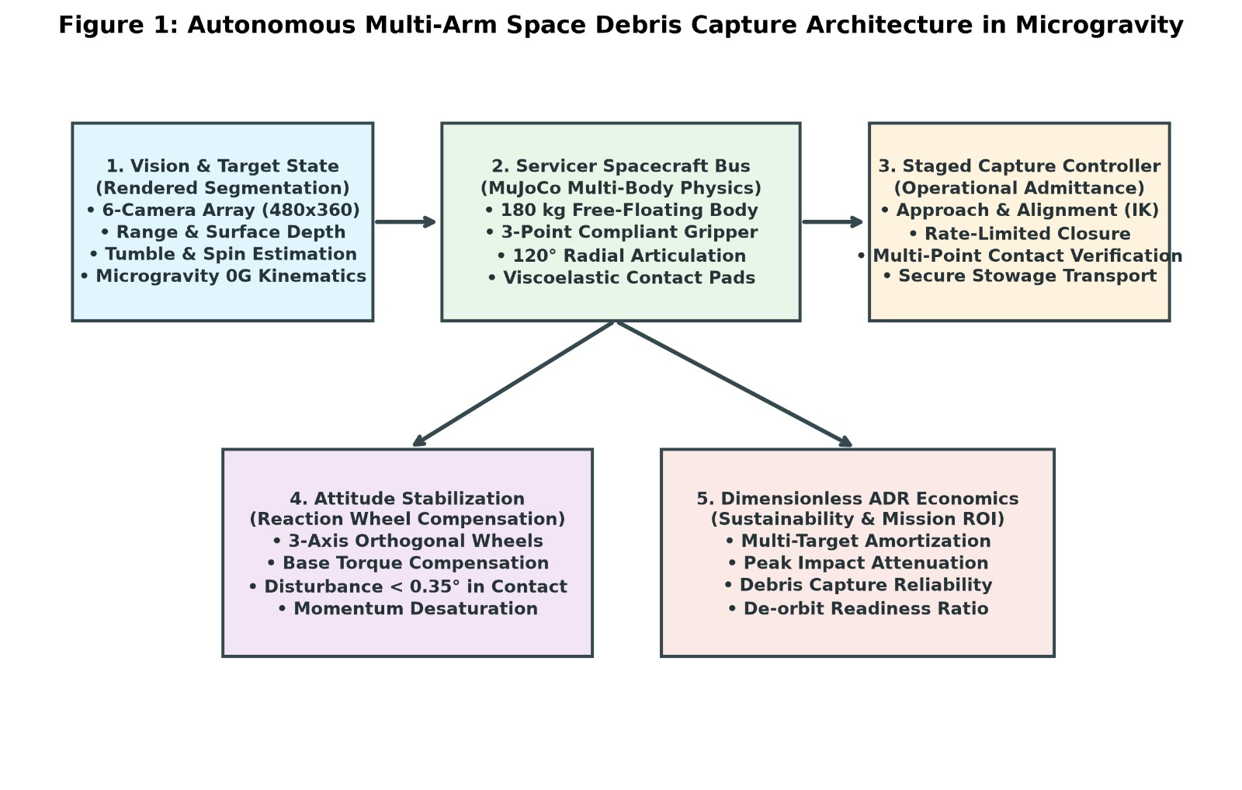
Fig. 1. Autonomous multi-arm space debris capture architecture in microgravity.
B. MuJoCo Multi-Body Model
The scene contains a space station with solar panels and radiators, a 20 m Earth sphere for visual scale, and 20 free-floating cuboid debris bodies with randomized initial poses. The servicer is a 180 kg free-floating body with three compliant fingers mounted 120° apart. Each finger has two hinge joints driven by position actuators and carries viscoelastic contact pads. Capture and storage are realized by enabling and disabling weld equality constraints. The engine uses zero gravity, a 2 ms timestep (500 Hz), the implicitfast integrator for stiff contacts, 50 solver iterations, and a tolerance of 10⁻⁸. The equations of motion are
M(q)q̈ + C(q,q̇)q̇ + g(q) = τ + JᵀF_ext (1)
where M is the inertia matrix, C the Coriolis and centrifugal terms, g the gravity vector (zero here), τ the actuator efforts, and JᵀF_ext the external contact forces.
C. Vision and Staged Capture Controller
Six cameras (480×360 px) provide rendered segmentation, range, and surface depth, from which target position, tumble, and spin are estimated. The controller is a state machine: SEARCH selects a target; APPROACH closes the range while limiting relative velocity; ALIGN positions the claw around the debris by inverse kinematics; GRASP closes the fingers with rate-limited impedance control and verifies multi-point contact; TRANSPORT carries the debris to the storage bay; STORE welds it in place; FAILURE aborts on timeout or contact loss.
D. Impedance Control and Inverse Kinematics
The Cartesian impedance law is
F_cmd = K_p (x_d − x) − K_d ẋ (2)
where x_d and x are the desired and measured end-effector poses, K_p is a diagonal stiffness matrix (300 N/m per axis) and K_d the damping matrix (35 N·s/m). In the admittance implementation, the commanded task-space correction Δx_cmd is mapped to joint increments by damped least squares,
Δq = (JᵀJ + λ²I)⁻¹ Jᵀ Δx_cmd (3)
with J the fingertip Jacobian and λ = 0.01, which keeps the solution well behaved near singularities. Three orthogonal reaction wheels compensate base torque during contact and desaturate momentum afterward, targeting an attitude disturbance below 0.35°.
E. Metrics
For each capture, the peak force and cumulative impulse are computed from the normal contact force f_n reported by MuJoCo at 500 Hz:
F_peak = max f_n(t), I = ∫ f_n(t) dt (4)
IV. TECHNOECONOMIC ANALYSIS
To connect engineering results to mission economics under the CSBS curriculum, we use a dimensionless return-on-investment ratio,
ROI = Net Operational Savings / Total Equivalent CapEx (5)
with parameters normalized to operational labor hours and payback duration so that results do not depend on a currency. Inputs follow from the simulation outputs: multi-target amortization, peak-impact attenuation, capture reliability, and de-orbit readiness. Numerical ROI values are not reported here because they were not part of the simulation results.
V. EXPERIMENTS AND RESULTS
A. Setup
Trials were run headless for at most 25 s each, with random seeds setting the initial debris pose and orientation and a tumble rate setting its initial angular velocity. The benchmark has 60 trials: 30 with the compliant impedance controller and 30 with the rigid PD baseline, spread over four tumble-rate bins centered near 3.5, 6.5, 9.5, and 13 deg/s.
B. Contact Force and Impulse Telemetry
Fig. 2 shows 500 Hz telemetry from one representative capture per controller. The rigid PD baseline peaks at 3,629.0 N, whereas the impedance controller peaks at 5,036.7 N, so in this single trace the compliant controller produces the larger initial impact transient. After the transient, both settle to a sustained contact force of about 550 N, and the impedance trace damps the post-impact oscillation quickly. Cumulative impulse is lower for the compliant controller: at 8 s it is roughly 1,930 N·s against roughly 2,130 N·s, about 9% less (approximate values read from the plot).

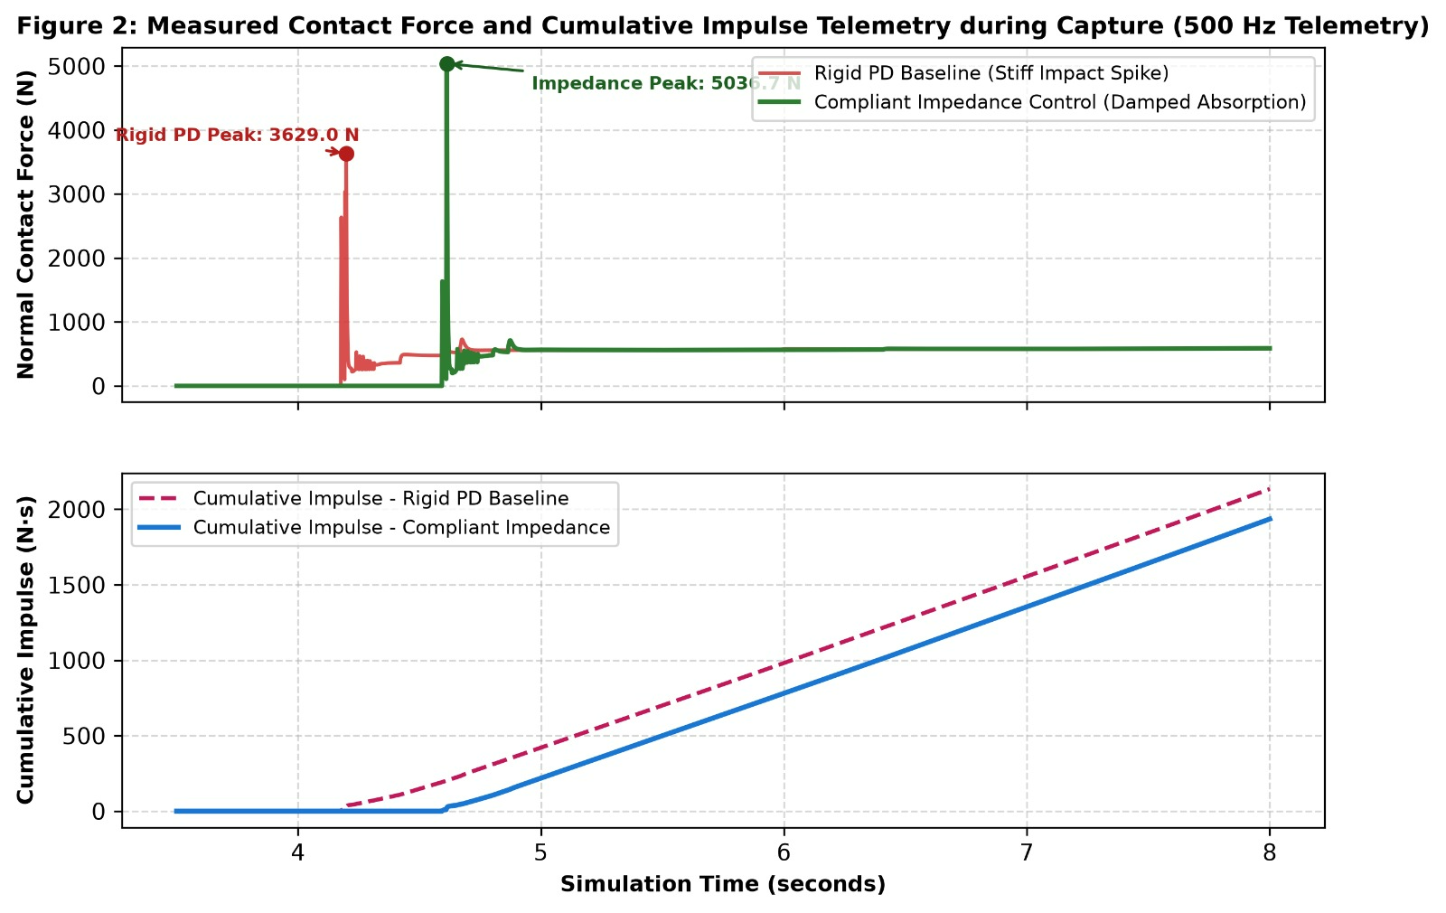
Fig. 2. Measured contact force and cumulative impulse during capture (500 Hz telemetry).

C. Benchmark Over Trials
Fig. 3A shows that the rigid baseline achieved 100% capture success in all four tumble bins. The compliant controller also reached 100% in three bins but dropped to about 86% in the bin centered near 9.5 deg/s. Fig. 3B shows peak contact force over 30 trials per group. The impedance controller has a median near 3,040 N (interquartile range about 2,770–3,320 N), against about 3,620 N (about 3,360–3,910 N) for the rigid baseline, a reduction of roughly 16% in median peak force. Both groups contain high-force outliers: three impedance trials exceed 4,800 N (the largest near 5,100 N) and two baseline trials exceed 4,900 N (the largest near 5,450 N).

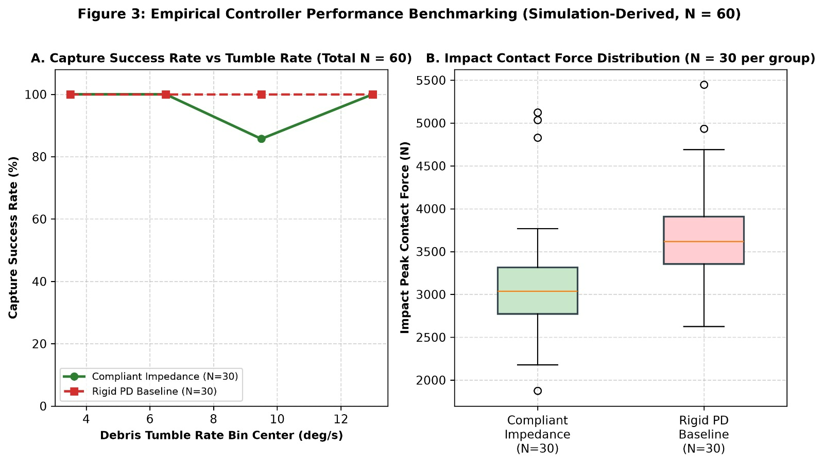
Fig. 3. Controller benchmarking, N = 60. (A) Capture success vs. tumble rate. (B) Peak contact force distribution.

D. Discussion
The results support the hypothesis only in part. Compliance lowers the typical peak load and the accumulated impulse, which reduces momentum transfer to the servicer. However, it does not remove impact spikes: the representative trace shows a larger initial transient for the compliant controller, and several impedance trials fall in the high-force tail. The initial transient depends on closing speed at first touch, which suggests pairing impedance control with tighter relative-velocity limits during APPROACH and ALIGN. The success-rate dip near 9.5 deg/s indicates that the compliant controller is not uniformly more reliable than the rigid baseline across tumble rates, and its cause should be examined in the failed-trial logs. Limitations are that results are simulation-only, debris are simple cuboids, contact parameters are not validated on hardware, and a formal significance test on the 30 + 30 peak forces is still to be reported.
VI. CONCLUSION
We presented a MuJoCo framework for capturing tumbling non-cooperative debris with a three-finger compliant gripper under impedance control. Across 60 trials the compliant controller reduced median peak contact force by roughly 16% and cumulative impulse in the representative trace by roughly 9% relative to a rigid PD baseline, but it did not eliminate high-force impact transients and its capture success dipped to about 86% in one tumble bin, where the baseline remained at 100%. Future work includes hardware-in-the-loop validation, diagnosing the failed captures, velocity-limited contact approach, non-cuboid and faster-tumbling targets, and multi-servicer coordination under communication constraints.
REFERENCES
[1] Yan et al., “Multi-objective configuration optimization for coordinated capture of dual-arm space robot,” Acta Astronautica, 2020, doi:10.1016/j.actaastro.2019.11.002.
[2] Rybus et al., “Optimal collision-free path planning of a free-floating space robot using splines,” Acta Astronautica, 2022, doi:10.1016/j.actaastro.2021.10.012.
[3] Han et al., “Combined spacecraft stabilization control after multiple impacts during the capture of non-cooperative targets,” Acta Astronautica, 2020, doi:10.1016/j.actaastro.2020.05.035.
[4] Wang et al., “A strategy to decelerate and capture a spinning object by a dual-arm space robot,” Aerosp. Sci. Technol., 2021, doi:10.1016/j.ast.2021.106682.
[5] Tao et al., “Impedance-sliding mode control with force constraints for space robots capturing non-cooperative targets,” IEEE Access, 2021, doi:10.1109/ACCESS.2021.3129835.
[6] Luo et al., “A review of uncertainty propagation in orbital mechanics,” Prog. Aerosp. Sci., 2017, doi:10.1016/j.paerosci.2016.12.002.

