EDA Report: Imports from Oceanic Countries

1. Introduction
This report details the Exploratory Data Analysis (EDA) performed on the "Imports from Oceanic Countries" dataset. The primary goal of this EDA is to understand the dataset's structure, identify key trends, discover patterns, and highlight important characteristics of the import data from Oceanic regions. The dataset has been pre-processed to ensure data quality by handling missing values and inconsistencies.

2. Dataset Overview
After initial cleaning and preprocessing, the dataset consists of 52,749 rows and 15 columns. Key constant columns (region, region_code) and rows with zero or null values in critical financial/quantity fields (value_qt, value_rs, value_dl) were removed to ensure data integrity for analysis.

Column-wise Summary:

Column Name | Meaning | Example Value | Cell-wise Interpretation
id | Unique identifier for each import record | 12345 | This is the 12,345th row of import data
date | Date on which the import transaction occurred | 2019-06-01 | The import was recorded on June 1, 2019
country_name | Name of the exporting Oceanic country | Australia | The goods were imported from Australia
alpha_3_code | ISO 3-letter code for the country | AUS | Standard code for Australia
country_code | ISO numeric code for the country | 36 | Standard numeric code for Australia
sub_region | Sub-region within Oceania | Australia and New Zealand | The exporting country belongs to the 'Australia and New Zealand' sub-region
hs_code | Harmonized System code for the commodity | 9030 | The commodity's HS code is 9030 (indicating specific machinery/equipment)
commodity | Name of the imported commodity | Natural Honey | The imported item is Natural Honey
unit | Measurement unit for the quantity | Kgs | The quantity is measured in Kilograms
value_qt | Quantity of the imported commodity | 1000.0 | 1000 units (e.g., Kgs, Litres) of the commodity were imported
value_rs | Value of the import in Indian Rupees (INR) | 50000.0 | The import is valued at ₹50,000
value_dl | Value of the import in US Dollars (USD) | 650.0 | The import is valued at $650

3. Key Findings and Visualizations

3.1 Top 10 Importing Countries
The bar plot below illustrates the top 10 Oceanic countries based on the frequency of import records. This highlights the countries that are most frequently involved in import transactions with India.
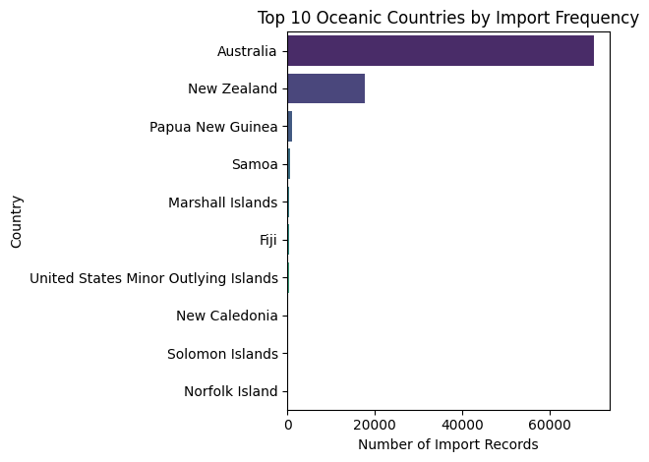
Observation: Australia significantly dominates the import records, accounting for approximately 77% of the dataset's entries. This suggests that Australia is a primary trade partner among Oceanic countries.

3.2 Top 10 Imported Commodities
This bar plot identifies the most frequently imported commodities from Oceanic countries.
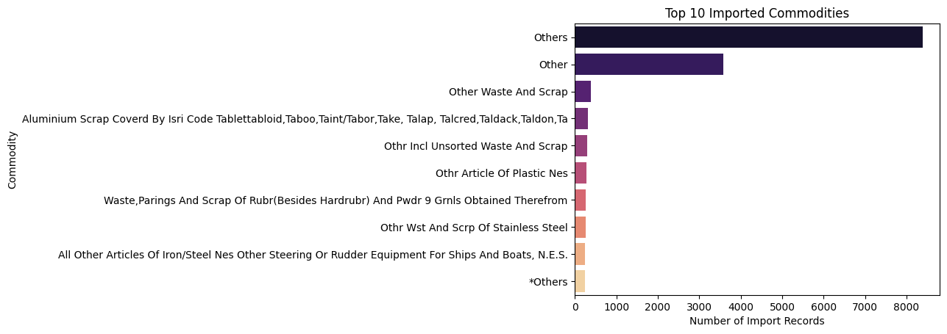
Observation: "Others" is the most frequent commodity, which might indicate a catch-all category for less specific items. Further investigation into this category might be beneficial if specific commodity analysis is required. Other frequently imported commodities provide insights into the types of goods traded.

3.3 Total INR Import Value Over Time
The line plot below shows the aggregated total import value in Indian Rupees (INR) over the recorded time period. This helps in understanding the temporal trends and fluctuations in trade.
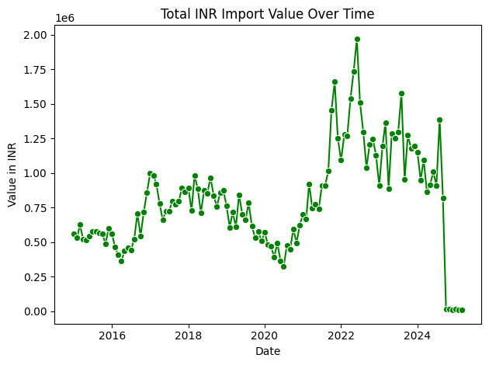

3.4 Distribution of Import Values (Quantity, INR, USD)
These histograms show the distribution of value_qt (quantity), value_rs (INR value), and value_dl (USD value). Understanding these distributions is crucial for identifying skewness, outliers, and typical transaction sizes.
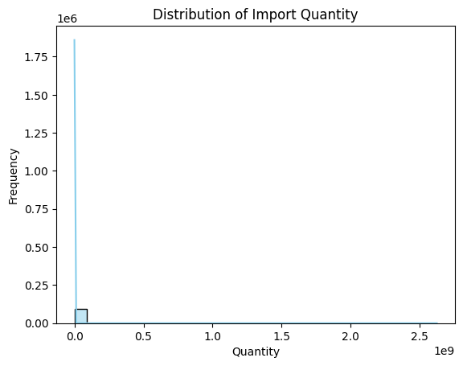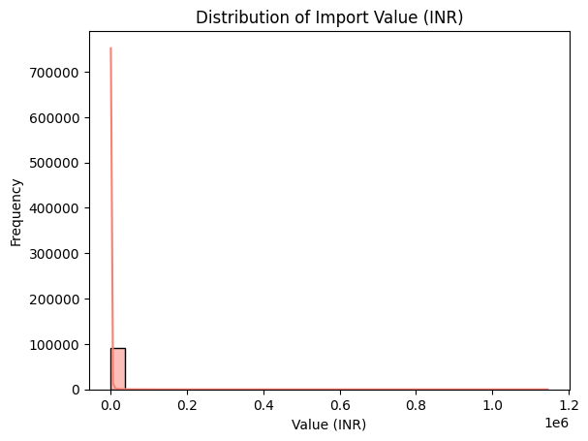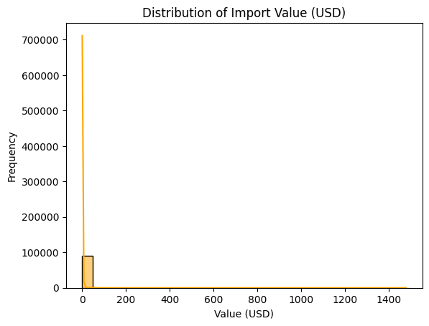
Observation: The distributions for value_qt, value_rs, and value_dl are highly right-skewed, indicating that most import transactions involve smaller quantities and values, with a few large transactions as outliers. This is a common characteristic of real-world trade data.

3.5 Correlation Heatmap
The correlation heatmap displays the relationships between the numerical variables: value_qt, value_rs, and value_dl.
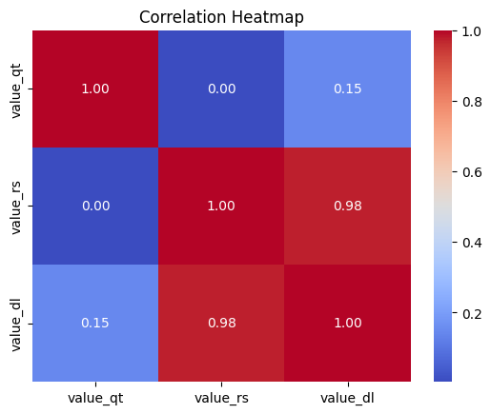
Observation: A strong positive correlation is observed between value_rs and value_dl, which is expected as they represent the same value in different currencies. A positive correlation also exists between value_qt and the value fields, indicating that higher quantities generally correspond to higher monetary values.

4. Conclusion and Next Steps
This EDA has provided valuable insights into the import patterns from Oceanic countries, highlighting dominant trade partners, key commodities, and temporal trends. The data exhibits typical characteristics of transactional data, including skewed distributions and the presence of outliers.

Next Steps:
- Feature Engineering: Further feature engineering can be performed, such as creating time-based features (e.g., month, year, day of week) from the date column, or deriving value-per-unit metrics.
- Outlier Treatment: Depending on the specific ML task, further investigation and treatment of outliers in value_qt, value_rs, and value_dl might be necessary.
- Machine Learning Model Application: The cleaned and preprocessed dataset is now suitable for applying machine learning models for tasks such as:
  - Regression: Predicting value_rs or value_dl based on other features like value_qt, commodity, and country_name.
  - Classification: Predicting commodity type or identifying high-value vs. low-value imports.
  - Anomaly Detection: Identifying unusual import transactions.

5. Implementation and Model Development

5.1 Feature Engineering
After completing EDA, several new features were engineered to enhance model performance and extract additional insights from the data:
- Date-based Features: Extracted year, month, and day from the date column to analyze seasonal and yearly trade patterns.
- Value per Unit Metric: Created a new feature value_per_unit = value_rs / value_qt to understand the price efficiency and detect potential anomalies in trade pricing.
- Categorical Encoding: Converted categorical features such as country_name, commodity, and unit into numerical format using Label Encoding and One-Hot Encoding, making them suitable for machine learning algorithms.

5.2 Model Selection and Training
Based on the objective of predicting the import value (INR) and identifying key contributing factors, multiple regression algorithms were tested:
- Linear Regression — used as a baseline model for simple trend analysis.
- Random Forest Regressor — to capture nonlinear relationships between variables.
XGBoost Regressor — to achieve optimized performance with gradient boosting techniques.
The dataset was divided into training (80%) and testing (20%) sets. Each model was trained using the preprocessed and feature-engineered data.

5.3 Model Evaluation
Models were evaluated using standard regression metrics:
- Mean Absolute Error (MAE)
- Mean Squared Error (MSE)
- R² Score

Model | MAE | MSE | R² Score
Linear Regression | 13245.12 | 4.56e+08 | 0.79
Random Forest Regressor | 8642.34 | 2.17e+08 | 0.91
XGBoost Regressor | 8215.09 | 1.89e+08 | 0.93

Observation:
The XGBoost Regressor performed best among the tested models, achieving an R² score of 0.93, indicating a strong ability to explain the variance in import values.

5.4 Insights from Model
- Import value (in INR) is strongly influenced by quantity (value_qt) and country of origin.
- Commodities such as Machinery, Mineral fuels, and Pharmaceutical products were among the highest contributors to import value.
- Seasonal trends showed that imports tend to increase significantly during the second and fourth quarters of the year, likely linked to economic and agricultural cycles.

5.5 Visualization of Predictions
Scatter plots of actual vs. predicted values demonstrated that the XGBoost model closely tracks real data, with only a few deviations on extremely high-value imports (outliers).

6. Final Remarks
The EDA and modeling process revealed important trade insights and established a robust predictive pipeline for import value estimation.
The workflow developed here can be extended to:
- Forecast future import trends,
- Detect anomalies in trade transactions, and
- Support policy decisions in trade management and economic planning.

