Student Performance Prediction System
Phase 3 Report - Complete Implementation
Project Id: AIML-5
Student Name  Garima Thakur (Team Leader) | University Roll Number  2028419
Section & Group  G (G1) | Branch  CSE (AI/DS)
Student Name  Raghav Pandey | University Roll Number  2028469
Section & Group  G (G1) | Branch  CSE (AI/DS)
Student Name  Arnav Singh | University Roll Number  2028661
Section & Group  G (G1) | Branch  CSE (AI/ML)

1. Problem Description
The Student Performance Prediction System is a Python-based machine learning application that uses real-world Kaggle data (1,000,000 student records) to predict academic outcomes. A 10,000-record sample was used for efficient processing. The system predicts final exam scores using regression and classifies students as pass/fail using classification algorithms.

1.1 Dataset Description
Source: Kaggle - Student Performance Dataset (1,000,000 records, 10,000 sampled). Features used after preprocessing:
Feature | Range | Description
study_hours | 0 - 39.2 hrs | Weekly self-study hours
attendance_percent | 50 - 100% | Class attendance percentage
internal_marks | 0 - 10 | Class participation score
exam_score | 26.2 - 100 | Total score (target - regression)
pass_fail | 0 or 1 | Pass/Fail label (target - classification)

1.2 Flow Diagram
Kaggle CSV --> Data Loading & Renaming --> EDA (Histogram, Scatter, Heatmap, Box Plot) --> Preprocessing (Split + Scale) --> Feature Selection (Forward/Backward/PCA) --> Model Training --> Evaluation --> Streamlit Dashboard

2. Modules for Project Implementation

2.1 Modules Used
Pandas (pd): Data loading and manipulation.
- pd.read_csv() - Loads student_performance.csv
- df.rename() - Renames columns to standardized names
- df.sample() - Samples 10,000 records from 1M
- df.describe() - Statistical summary
- df.isnull().sum() - Missing value check
NumPy (np): Numerical operations.
- np.random.seed() - Reproducibility
Matplotlib (plt): Base plotting framework.
- plt.figure(), plt.subplots(), plt.scatter(), plt.show()
Seaborn (sns): Statistical visualization.
- sns.histplot() - Score distribution histogram
- sns.scatterplot() - Feature vs score relationships
- sns.heatmap() - Correlation matrix visualization
- sns.boxplot() - Outlier detection
scikit-learn: Core ML library.
- train_test_split - 80/20 dataset split
- StandardScaler - Feature normalization
- LinearRegression, RandomForestRegressor - Regression models
- LogisticRegression - Classification model
- SequentialFeatureSelector - Forward/Backward selection
- PCA - Dimensionality reduction
- r2_score, mean_squared_error, accuracy_score, precision_score, recall_score

2.2 Platform Used
- Python 3.11 - Primary programming language. Rich ML ecosystem with extensive library support.
- Visual Studio Code - IDE for code writing, debugging, and terminal access. Used with Python extension.
- Virtual Environment (ml_env) - Isolated dependency management.
- Streamlit - Web dashboard framework for interactive prediction interface.

3. Machine Learning Models Used

3.1 Linear Regression
Fits a linear equation to predict exam_score from the three features. Minimizes sum of squared residuals to learn feature weights. Result: R2 Score = 0.64, MSE = 83.44.

3.2 Random Forest Regressor
Ensemble of 100 decision trees (n_estimators=100). Each tree trained on a bootstrap sample with random feature subsets. Final prediction is the average of all trees. Result: R2 Score = 0.66, MSE = 79.57 — outperformed Linear Regression.

3.3 Logistic Regression
Binary classifier for pass/fail prediction. Uses sigmoid function to compute probability. If P >= 0.5 → Pass (1), else Fail (0). Result: Accuracy = 99%, Precision = 99%, Recall = 100%.

4. Evaluation Metrics Used

4.1 R2 Score
Formula: R2 = 1 - (SS_residuals / SS_total). Measures proportion of variance explained. R2 = 0.66 means model explains 66% of exam score variance.

4.2 Mean Squared Error (MSE)
Formula: MSE = (1/n) * Sum(y_actual - y_predicted)^2. MSE = 79.57 means average squared error is 79.57 (approx 8.9 marks average error).

4.3 Accuracy
Formula: (TP + TN) / Total. Accuracy = 99% means 1980 out of 2000 test students correctly classified.

4.4 Precision
Formula: TP / (TP + FP). Precision = 99% means when model predicts fail, it is correct 99% of the time.

4.5 Recall
Formula: TP / (TP + FN). Recall = 100% means model successfully identified all failing students in test set.

5. Results and Visualizations

5.1 Dataset Overview
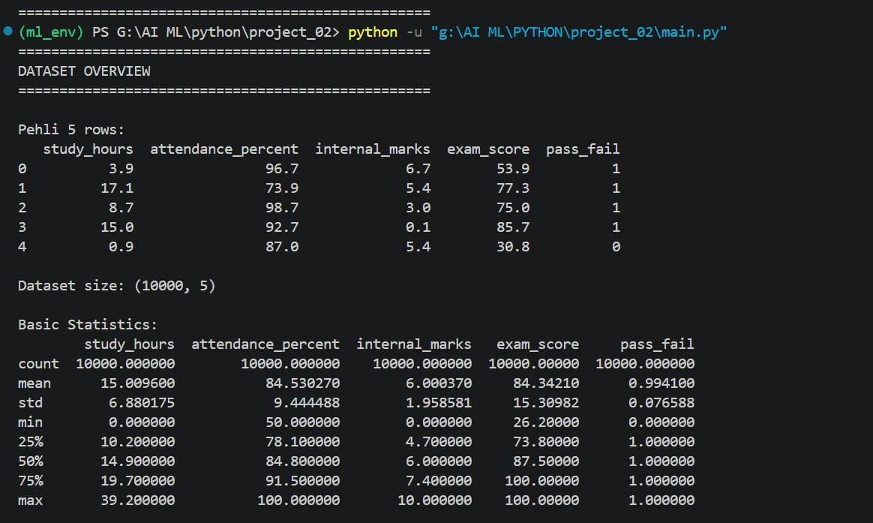
Fig. 1 - Dataset overview: 10,000 records, 5 features, no missing values

5.2 Exam Score Distribution
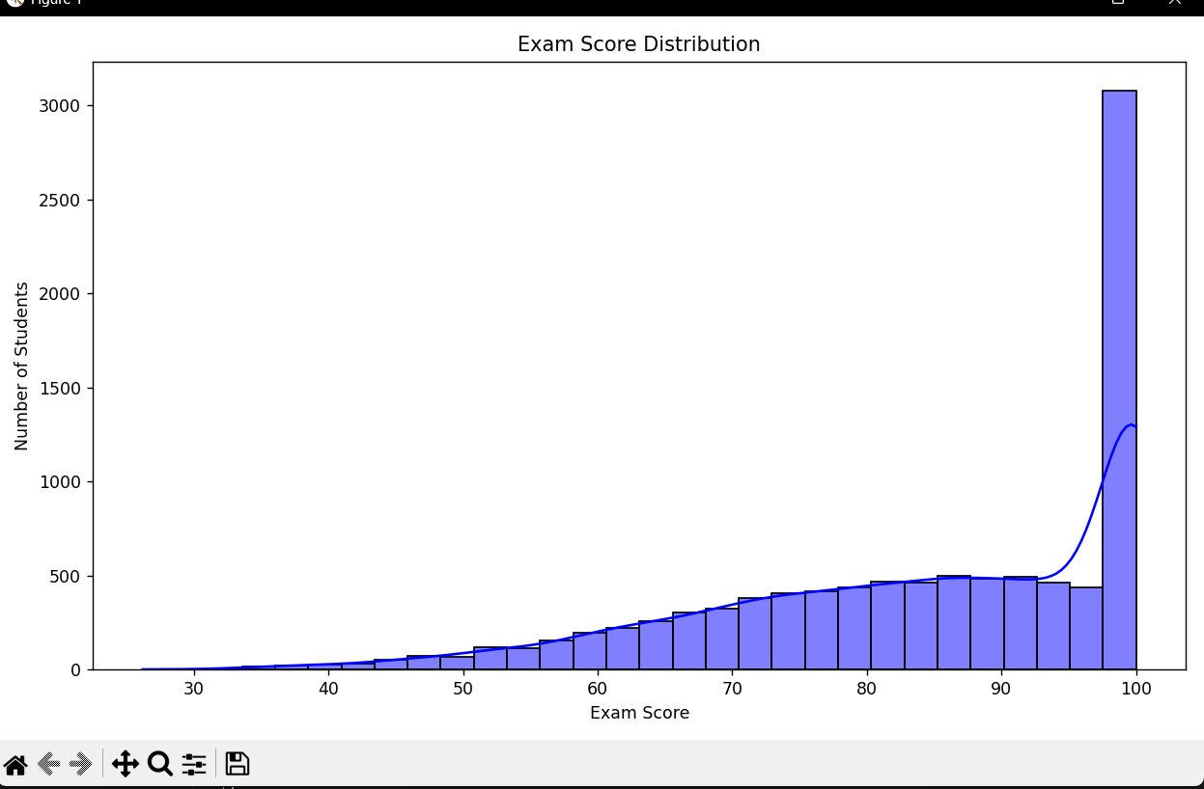
Fig. 2 - Right-skewed distribution: majority of students score between 80-100

5.3 Feature vs Exam Score Scatter Plots
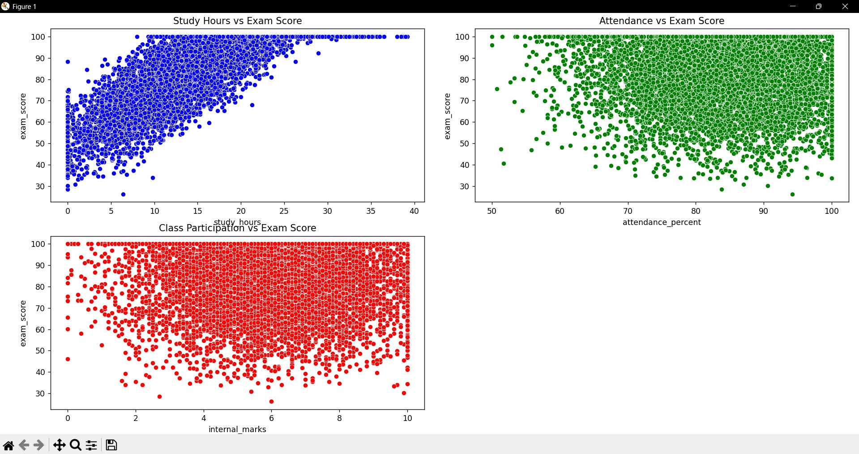
Fig. 3 - study_hours shows strong positive correlation; attendance and participation show weak relation

5.4 Correlation Heatmap
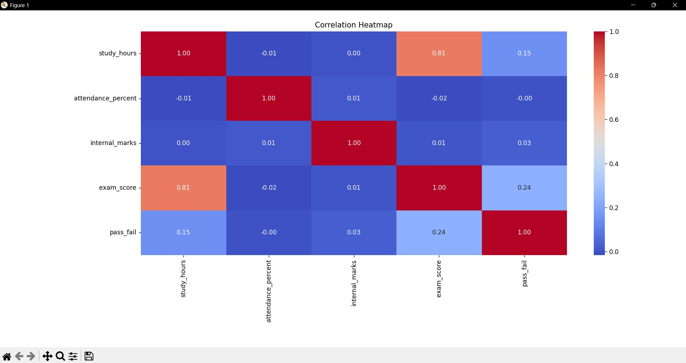
Fig. 4 - study_hours has 0.81 correlation with exam_score — strongest predictor

5.5 Box Plots - Outlier Detection
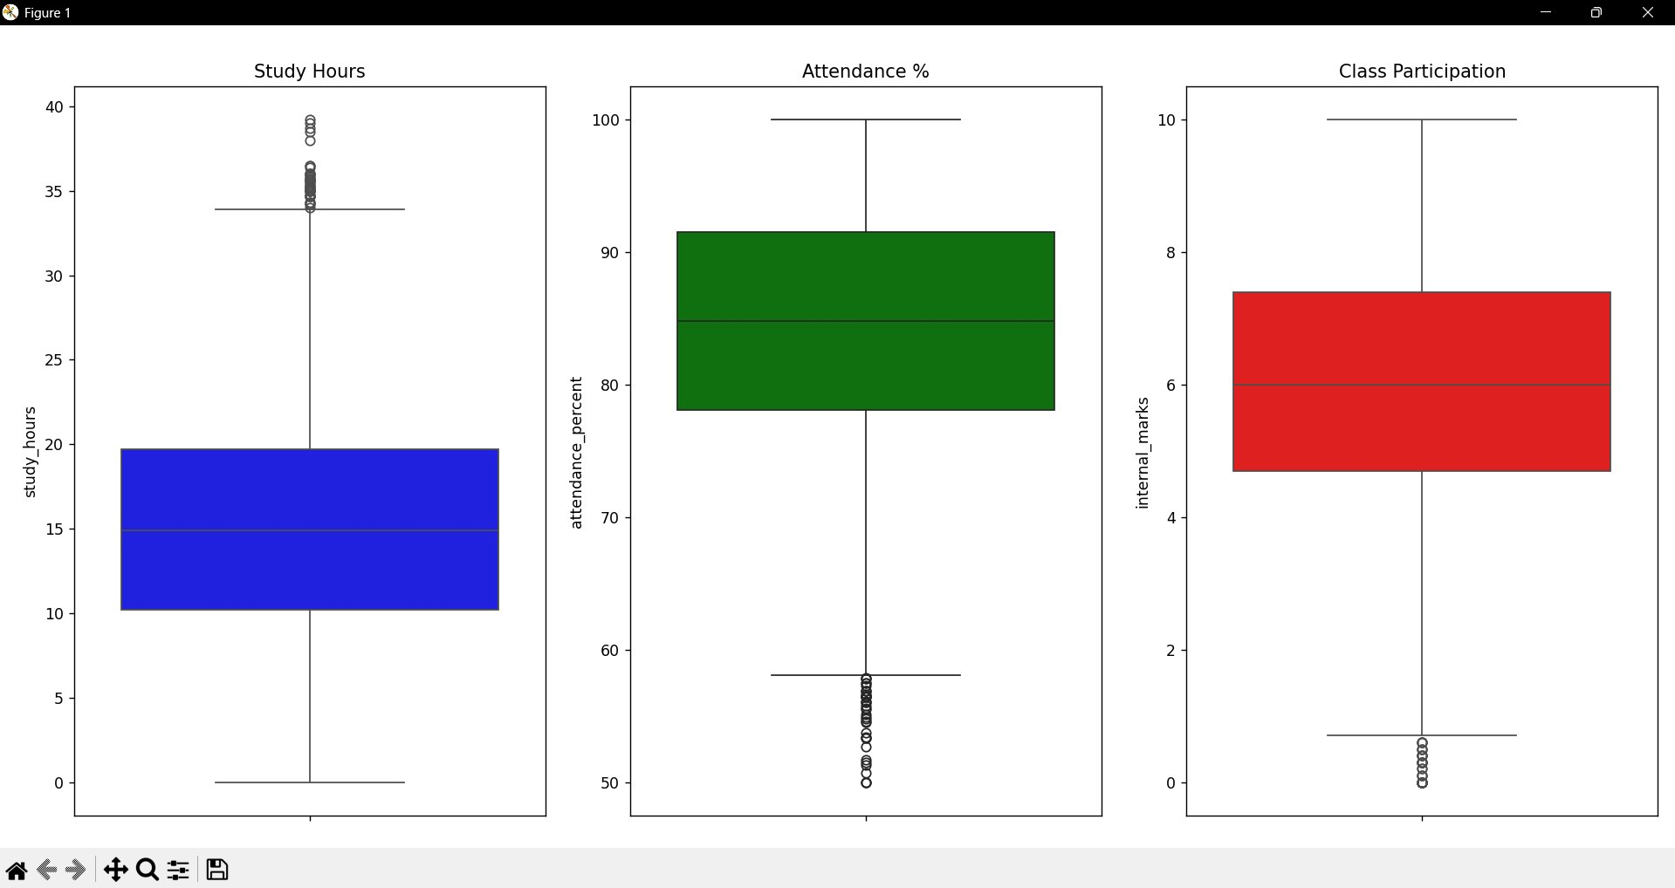
Fig. 5 - Box plots: study_hours has outliers above 35hrs; attendance shows few outliers below 55%

5.6 PCA Visualization
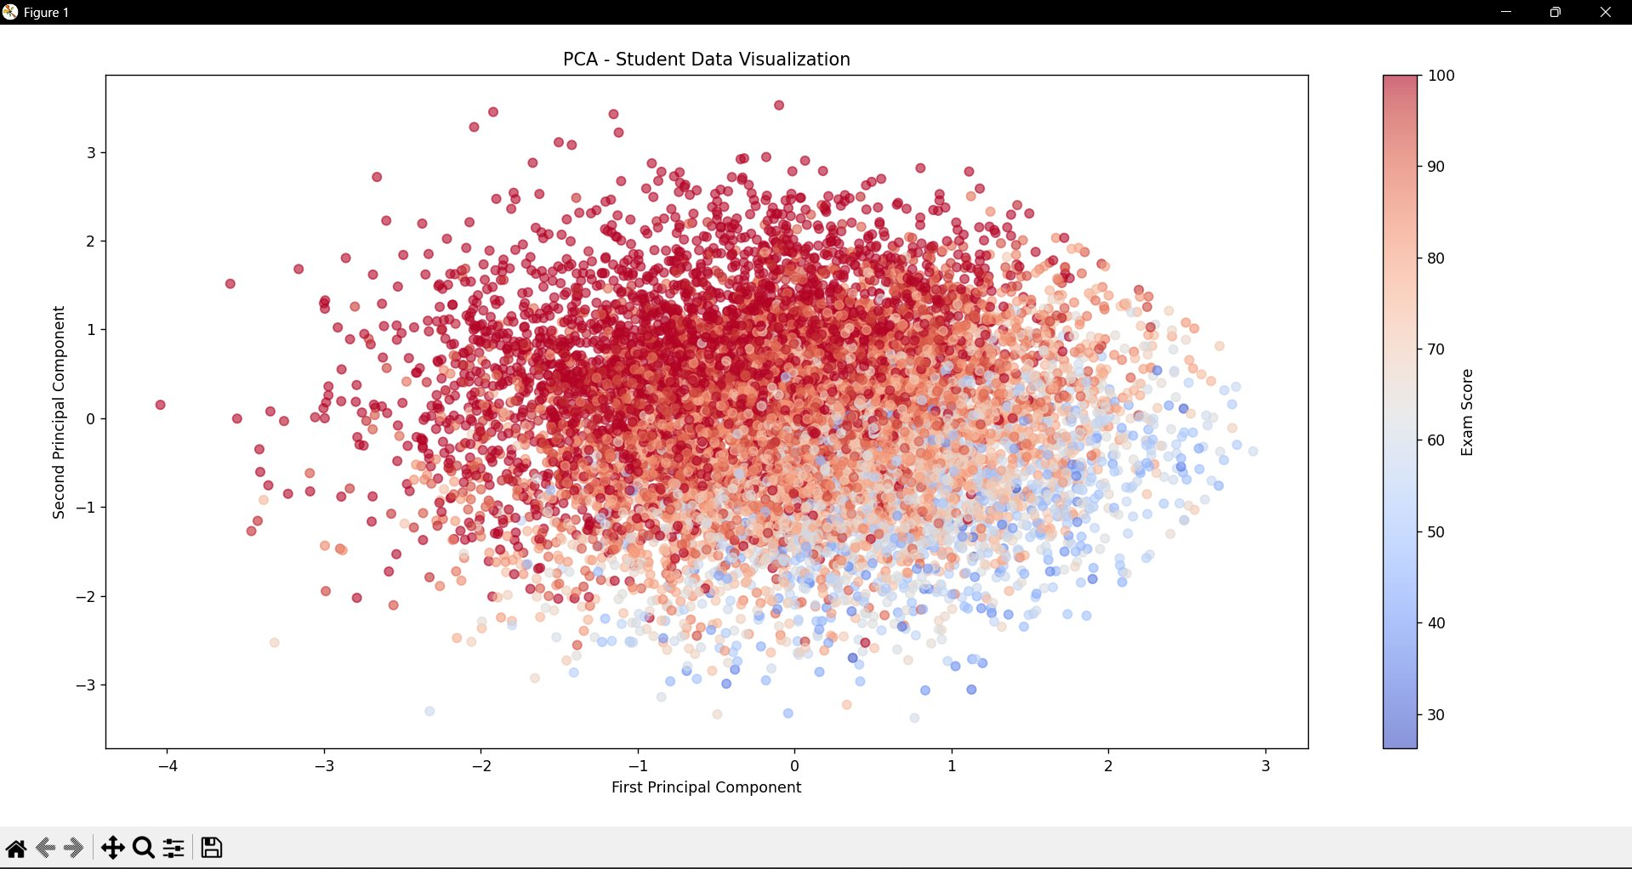
Fig. 6 - PCA: Total variance covered = 0.67. Red dots (high scores) cluster on left, blue (low) on right

5.7 Feature Selection Output
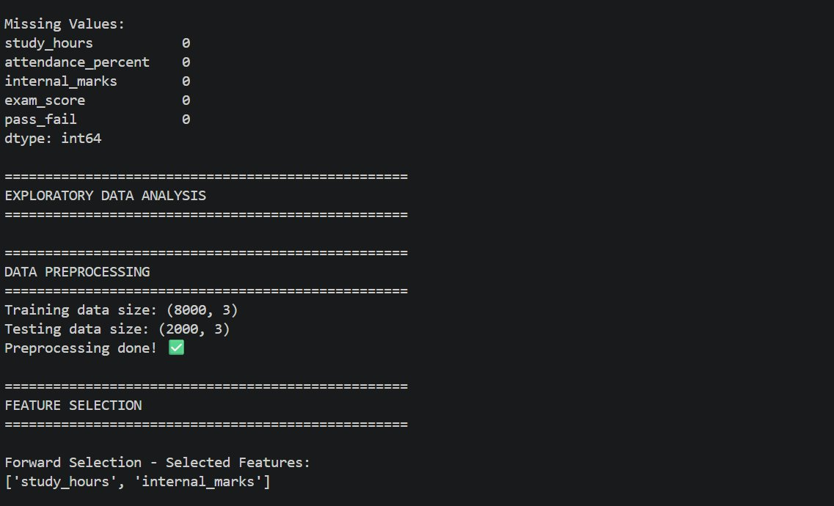
Fig. 7 - Feature Selection: Both Forward and Backward selected study_hours and internal_marks

5.8 Actual vs Predicted (Random Forest)
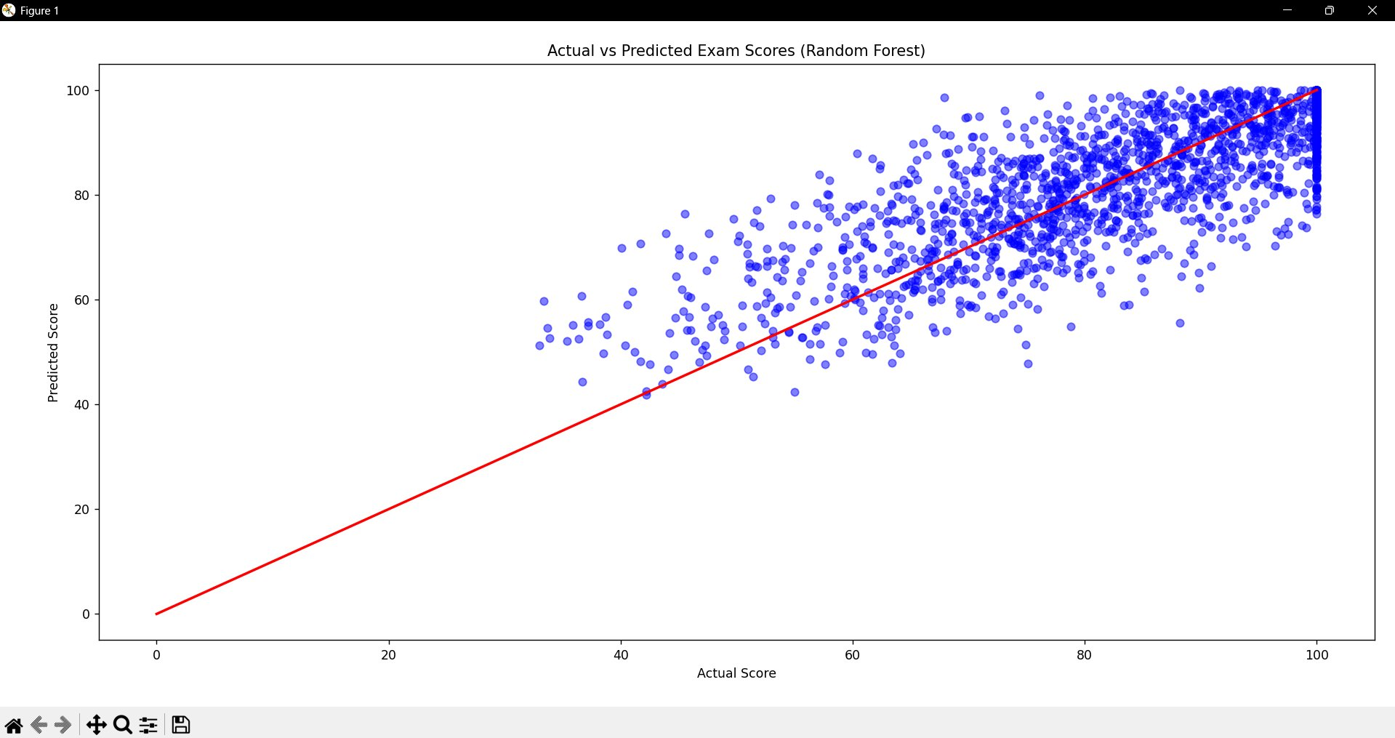
Fig. 8 - Actual vs Predicted: Points cluster near diagonal, confirming model accuracy

5.9 Model Performance Results
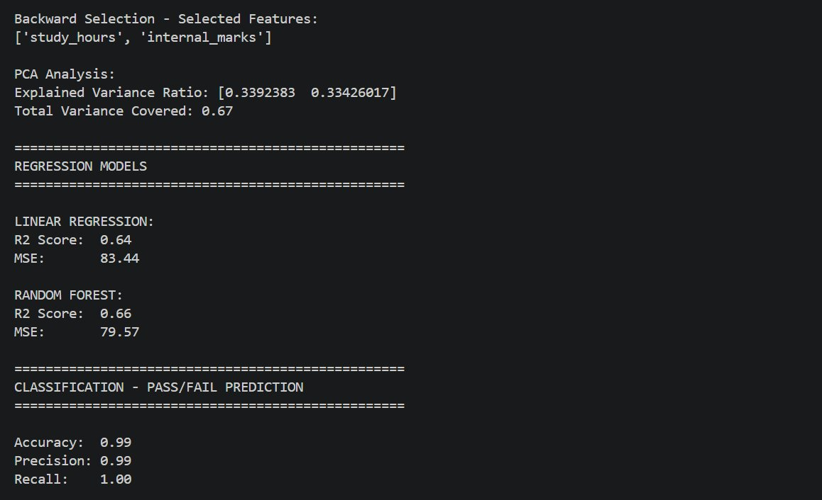
Fig. 9 - Regression and Classification results: RF R2=0.66, Accuracy=99%, Recall=100%

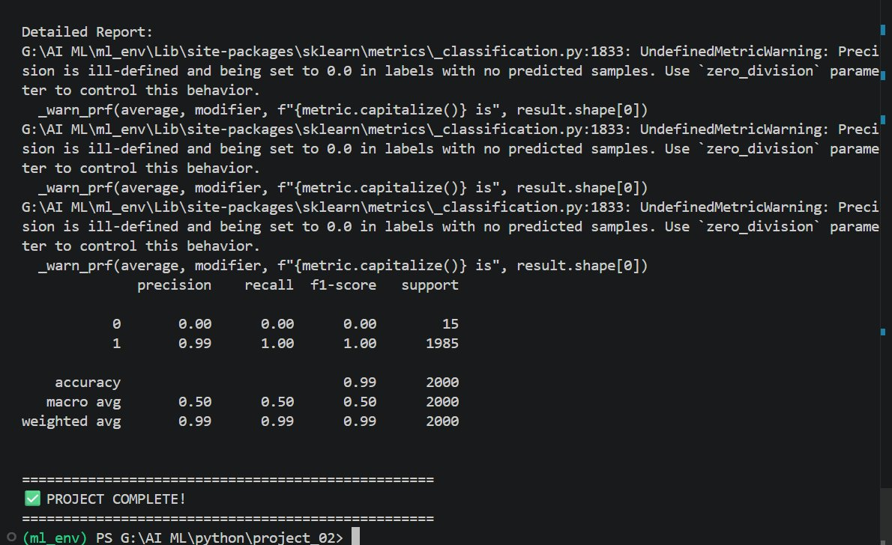
Fig. 10 - Detailed Classification Report: weighted avg precision=0.99, recall=0.99, f1=0.99

6. Conclusion and Future Scope

6.1 Conclusion
The Student Performance Prediction System successfully implemented a complete ML pipeline on a real-world Kaggle dataset. Key finding: study_hours is the most influential predictor (correlation = 0.81). The Random Forest Regressor achieved R2 = 0.66, and Logistic Regression achieved 99% accuracy for pass/fail classification. The system provides educators a reliable, data-driven tool for early identification of at-risk students.

6.2 Future Scope
- Integration with live institutional databases for real-time student monitoring.
- Addition of more features like socioeconomic background and mental health indicators.
- Implementation of Neural Network models for improved accuracy on large datasets.
- Mobile application development for student and faculty access.
- Cloud deployment (AWS/GCP) for institution-wide scalability.

7. References

Books:
- Hands-On Machine Learning with Scikit-Learn, Keras, and TensorFlow - Aurelien Geron
- Introduction to Machine Learning with Python - Andreas C. Muller
- Let Us Python - Yashavant Kanetkar

Online Resources:
- Kaggle Dataset - https://www.kaggle.com/
- scikit-learn Documentation - https://scikit-learn.org/stable/
- Streamlit Documentation - https://docs.streamlit.io/
- GeeksforGeeks ML - https://www.geeksforgeeks.org/machine-learning/
- Stack Overflow - https://stackoverflow.com

