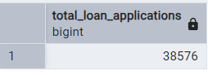

select COUNT(id) AS Total_Loan_Applications From bankloan1

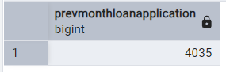

SELECT COUNT(id) AS prevMonthLoanApplication FROM bankloan1 WHERE EXTRACT(MONTH FROM issue_date) = 11 AND EXTRACT(YEAR FROM issue_date) = 2021

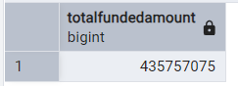

SELECT SUM(loan_amount) AS TotalFundedAmount FROM bankloan1

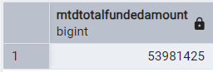

SELECT SUM(loan_amount) AS MTDTotalFundedAmount FROM bankloan1 WHERE EXTRACT(MONTH FROM issue_date) = 12 AND EXTRACT(YEAR FROM issue_date) = 2021

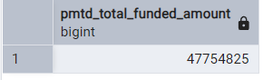

SELECT SUM(loan_amount) AS PMTD_Total_Funded_Amount FROM bankloan1 WHERE EXTRACT(MONTH FROM issue_date)= 11 AND EXTRACT(YEAR FROM issue_date) = 2021

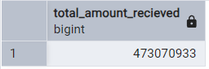

SELECT SUM(total_payment) AS Total_Amount_Recieved FROM bankloan1

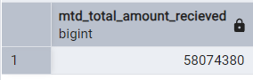

SELECT SUM(total_payment) AS MTD_Total_Amount_Recieved FROM bankloan1 WHERE EXTRACT(MONTH FROM issue_date)=12 AND EXTRACT(YEAR FROM issue_date)=2021

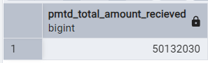

SELECT SUM(total_payment) AS PMTD_Total_Amount_Recieved FROM bankloan1 WHERE EXTRACT(MONTH FROM issue_date)=11 AND EXTRACT(YEAR FROM issue_date)=2021

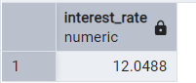

SELECT ROUND(CAST(AVG(int_rate*100)AS NUMERIC),4) AS Interest_Rate FROM bankloan1

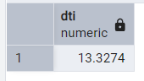

SELECT ROUND(CAST(AVG(dti*100)AS NUMERIC),4) AS DTI FROM bankloan1

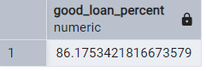

SELECT (COUNT(CASE WHEN loan_status = 'Fully Paid' OR loan_status = 'Current' THEN id END) * 100.0) / COUNT(id) AS good_loan_percent FROM bankloan1;

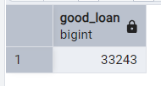

SELECT COUNT(id) AS Good_Loan FROM bankloan1 WHERE loan_status = 'Fully Paid' OR loan_status = 'Current'

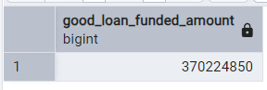

SELECT COUNT(id) AS Good_Loan FROM bankloan1 WHERE loan_status = 'Fully Paid' OR loan_status = 'Current'

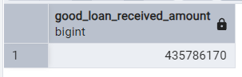

SELECT SUM(loan_amount) AS Good_Loan_Funded_Amount FROM bankloan1 WHERE loan_status = 'Fully Paid' OR loan_status = 'Current'

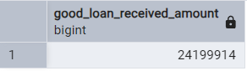

SELECT SUM(total_payment) AS Good_Loan_Received_Amount FROM bankloan1 WHERE loan_status = 'FULLY PAID' OR loan_status = 'Current'

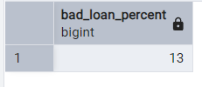

SELECT (COUNT(CASE WHEN loan_status = 'Charged Off' THEN id END)*100)/COUNT(id) AS Bad_Loan_Percent FROM bankloan1

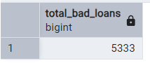

SELECT COUNT(id) AS Total_Bad_Loans FROM bankloan1 WHERE loan_status = 'Charged Off'

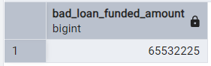

SELECT SUM(loan_amount) AS Bad_Loan_Funded_Amount FROM bankloan1 WHERE loan_status = 'Charged Off'

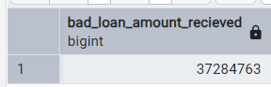

SELECT SUM(total_payment) AS Bad_Loan_Amount_Recieved FROM bankloan1 WHERE loan_status = 'Charged Off'

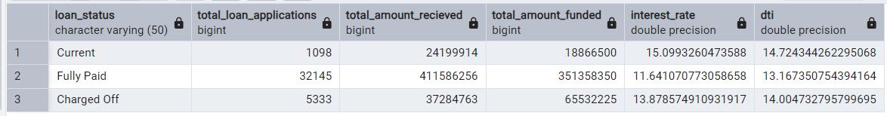

SELECT loan_status, COUNT(id) AS total_loan_applications, SUM(total_payment) AS total_amount_Recieved, SUM(loan_amount) AS total_amount_funded, AVG(int_rate*100) AS Interest_rate, AVG(dti*100) AS DTI FROM bankloan1 GROUP BY loan_status

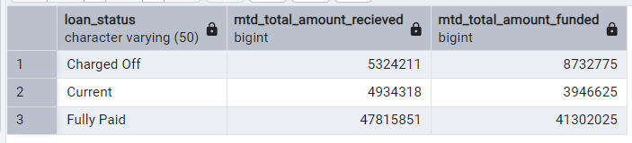SELECT loan_status, SUM(total_payment) AS MTD_total_amount_Recieved, SUM(loan_amount) AS MTD_total_amount_funded FROM bankloan1 WHERE EXTRACT(MONTH FROM issue_date)=12 GROUP BY loan_status

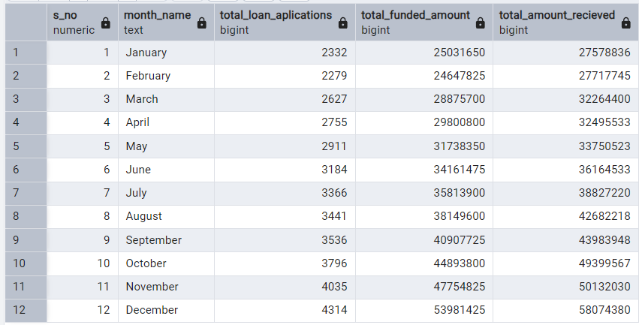

SELECT Extract(Month FROM issue_date) AS S_no, TO_CHAR(issue_date, 'Month') AS Month_Name, COUNT(id) AS total_loan_aplications, SUM(loan_amount) AS total_funded_amount, SUM(total_payment) AS Total_Amount_Recieved FROM bankloan1 GROUP BY Extract(Month FROM issue_date),TO_CHAR(issue_date, 'Month') ORDER BY Extract(Month FROM issue_date)

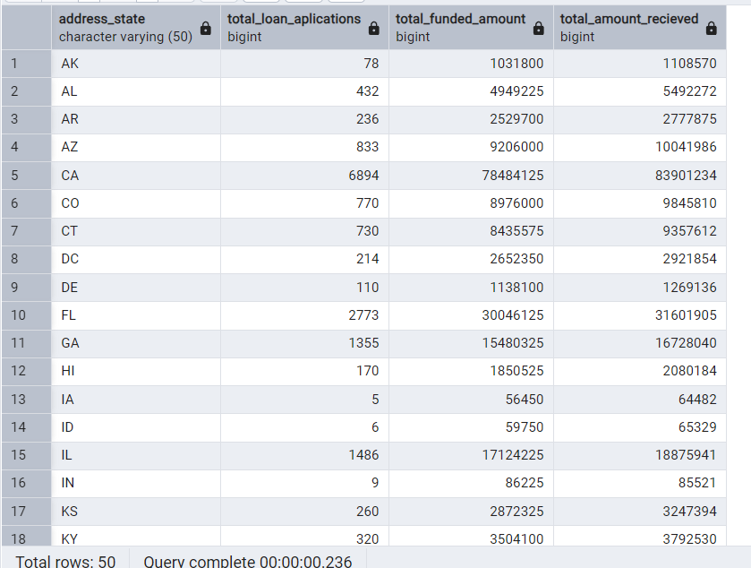SELECT address_state, COUNT(id) AS total_loan_aplications, SUM(loan_amount) AS total_funded_amount, SUM(total_payment) AS Total_Amount_Recieved FROM bankloan1 GROUP BY address_state ORDER BY address_state

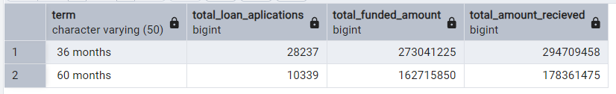

SELECT term, COUNT(id) AS total_loan_aplications, SUM(loan_amount) AS total_funded_amount, SUM(total_payment) AS Total_Amount_Recieved FROM bankloan1 GROUP BY term ORDER BY term

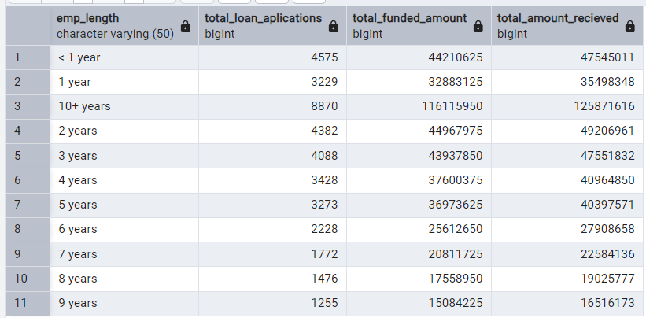SELECT emp_length, COUNT(id) AS total_loan_aplications, SUM(loan_amount) AS total_funded_amount, SUM(total_payment) AS Total_Amount_Recieved FROM bankloan1 GROUP BY emp_length ORDER BY emp_length

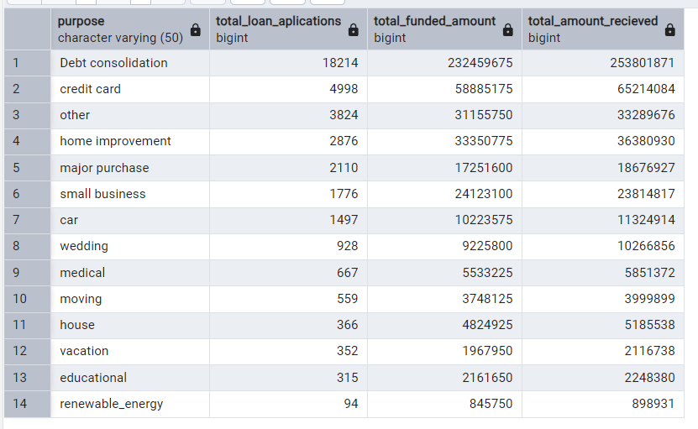

SELECT purpose, COUNT(id) AS total_loan_aplications, SUM(loan_amount) AS total_funded_amount, SUM(total_payment) AS Total_Amount_Recieved FROM bankloan1 GROUP BY purpose ORDER BY Count(id) DESC

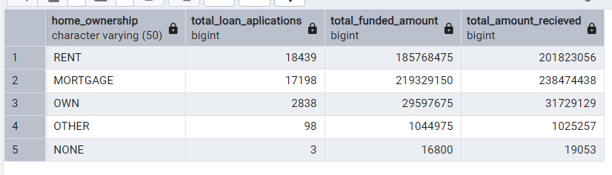

SELECT home_ownership, COUNT(id) AS total_loan_aplications, SUM(loan_amount) AS total_funded_amount, SUM(total_payment) AS Total_Amount_Recieved FROM bankloan1 GROUP BY home_ownership ORDER BY Count(id) DESC

**ALL QUERIES USED**

CREATE TABLE bankloan1 ( id SERIAL PRIMARY KEY, address_state VARCHAR(50), application_type VARCHAR(50), emp_length VARCHAR(50), emp_title VARCHAR(100), grade VARCHAR(50), home_ownership VARCHAR(50), issue_date DATE, last_credit_pull_date DATE, last_payment_date DATE, loan_status VARCHAR(50), next_payment_date DATE, member_id INT, purpose VARCHAR(50), sub_grade VARCHAR(50), term VARCHAR(50), verification_status VARCHAR(50), annual_income FLOAT, dti FLOAT, installment FLOAT, int_rate FLOAT, loan_amount INT, total_acc INT, total_payment INT ); select * from bankloan1

select COUNT(id) AS Total_Loan_Applications From bankloan1

SELECT COUNT(id) AS prevMonthLoanApplication FROM bankloan1 WHERE EXTRACT(MONTH FROM issue_date) = 11 AND EXTRACT(YEAR FROM issue_date) = 2021

SELECT SUM(loan_amount) AS TotalFundedAmount FROM bankloan1

SELECT SUM(loan_amount) AS MTDTotalFundedAmount FROM bankloan1 WHERE EXTRACT(MONTH FROM issue_date) = 12 AND EXTRACT(YEAR FROM issue_date) = 2021

SELECT SUM(loan_amount) AS PMTD_Total_Funded_Amount FROM bankloan1 WHERE EXTRACT(MONTH FROM issue_date)= 11 AND EXTRACT(YEAR FROM issue_date) = 2021

SELECT SUM(total_payment) AS MTD_Total_Amount_Recieved FROM bankloan1 WHERE EXTRACT(MONTH FROM issue_date)=12 AND EXTRACT(YEAR FROM issue_date)=2021

SELECT SUM(total_payment) AS PMTD_Total_Amount_Recieved FROM bankloan1 WHERE EXTRACT(MONTH FROM issue_date)=11 AND EXTRACT(YEAR FROM issue_date)=

SELECT ROUND(CAST(AVG(int_rate*100)AS NUMERIC),4) AS Interest_Rate FROM bankloan1

SELECT ROUND(CAST(AVG(dti*100)AS NUMERIC),4) AS DTI FROM bankloan1

SELECT (COUNT(CASE WHEN loan_status = 'Fully Paid' OR loan_status = 'Current' THEN id END) * 100.0) / COUNT(id) AS good_loan_percent FROM bankloan1;

SELECT COUNT(id) AS Good_Loan FROM bankloan1 WHERE loan_status = 'Fully Paid' OR loan_status = 'Current'

SELECT SUM(loan_amount) AS Good_Loan_Funded_Amount FROM bankloan1 WHERE loan_status = 'Fully Paid' OR loan_status = 'Current'

SELECT SUM(total_payment) AS Good_Loan_Received_Amount FROM bankloan1 WHERE loan_status = 'Fully Paid' OR loan_status = 'Current'

SELECT (COUNT(CASE WHEN loan_status = 'Charged Off' THEN id END)*100)/COUNT(id) AS Bad_Loan_Percent FROM bankloan1

SELECT COUNT(id) AS Total_Bad_Loans FROM bankloan1 WHERE loan_status = 'Charged Off'

SELECT SUM(loan_amount) AS Bad_Loan_Funded_Amount FROM bankloan1 WHERE loan_status = 'Charged Off'

SELECT SUM(total_payment) AS Bad_Loan_Amount_Recieved FROM bankloan1 WHERE loan_status = 'Charged Off'

SELECT loan_status, COUNT(id) AS total_loan_applications, SUM(total_payment) AS total_amount_Recieved, SUM(loan_amount) AS total_amount_funded, AVG(int_rate*100) AS Interest_rate, AVG(dti*100) AS DTI FROM bankloan1 GROUP BY loan_status

SELECT loan_status, SUM(total_payment) AS MTD_total_amount_Recieved, SUM(loan_amount) AS MTD_total_amount_funded FROM bankloan1 WHERE EXTRACT(MONTH FROM issue_date)=12 GROUP BY loan_status

SELECT address_state, COUNT(id) AS total_loan_aplications, SUM(loan_amount) AS total_funded_amount, SUM(total_payment) AS Total_Amount_Recieved FROM bankloan1 GROUP BY address_state ORDER BY address_state

SELECT emp_length, COUNT(id) AS total_loan_aplications, SUM(loan_amount) AS total_funded_amount, SUM(total_payment) AS Total_Amount_Recieved FROM bankloan1 GROUP BY emp_length ORDER BY emp_length

SELECT purpose, COUNT(id) AS total_loan_aplications, SUM(loan_amount) AS total_funded_amount, SUM(total_payment) AS Total_Amount_Recieved FROM bankloan1 GROUP BY purpose ORDER BY Count(id) DESC

SELECT home_ownership, COUNT(id) AS total_loan_aplications, SUM(loan_amount) AS total_funded_amount, SUM(total_payment) AS Total_Amount_Recieved FROM bankloan1 GROUP BY home_ownership ORDER BY Count(id) DESC