KISS Vocational Training Management Portal — Business Requirements Document
Oct 9, 2026 · @Shashank Singh

1. Document control
This BRD (v1.0, draft for review) states what the business needs from the portal; the companion Project Documentation v2.1 states how it will be built.
Item | Detail
Document | Business Requirements Document (BRD)
Version | 1.0 — draft for team and guide review
Source documents | KISS VTMP Project Planning, System Design & SE Documentation v2.1; Feature List (features 1–20)
Project type | Group software engineering project, 2 members, one semester
Sponsor / approver | Project guide (to be named)
Users covered | Students, Trainers, Administration, Public Verifier, Employers / Placement Cell

Version | Change
1.0 | First BRD: core workflow from v2.1 plus business case and requirements for unique features 10–20

2. Executive summary
KISS needs one rule-driven portal that takes every vocational student from enrollment to a verifiable certificate, and then shows what that student can actually do.
Today training runs on spreadsheets, paper registers and informal messages. Eligibility is checked by hand, students cannot see their own progress, and certificates cannot be verified. The portal replaces this with a single workflow shared by Students, Trainers and Administration, where the system — not individuals — decides completion eligibility.
The core workflow (features 1–9) is the minimum the institution needs. Four unique features turn it from a record-keeping tool into an outcomes tool:
- Skill Passport (F10) — a verified record of competencies each student has demonstrated, shareable with employers.
- Early Intervention System (F11) — flags students whose attendance or marks are declining while there is still time to act.
- Competency Gap Analyzer (F12) — compares required skills with demonstrated ones and recommends remedial practice.
- QR-Based Certificate Verification (F15) — lets any employer confirm a certificate is genuine in seconds.
The remaining innovations (F13, F14, F16–F20) are planned as later enhancements. Section 9 analyses each unique feature; Section 15 sets the release order for a two-person team.

3. Business background and problem statement
The institution's vocational programme has no system of record, so seat allocation, eligibility and certification depend on manual work that is slow, inconsistent and unverifiable.
# | Business problem | Business impact | Addressed by
P1 | Enrollment and batch allocation done by hand with no view of seat availability | Over-filled batches, unfair placement, admin hours lost each cycle | F3, F4, F14
P2 | Attendance and marks scattered across registers | Eligibility checks are slow and inconsistent between trainers | F5, F6, F7
P3 | Students cannot see their attendance, progress or results in real time | Problems are discovered only at the end of the course | F5, F6, F11
P4 | Certificates issued without a consistent eligibility check or authenticity check | Certificates carry little weight with employers; forgery risk | F7, F15
P5 | No record of who changed attendance or marks | Disputes cannot be resolved; no accountability | F19
P6 | Certificates state a course name, not the skills a student can perform | Employers cannot judge job readiness; placement is harder | F10, F12, F13, F18
P7 | Struggling students are identified late or not at all | Avoidable drop-outs and non-completions | F11, F12
P8 | Many students and families are more comfortable in Odia or Hindi, often on slow connections | Low adoption; reliance on staff to relay information | F16
Problems P1–P5 come from the v2.1 documentation. P6–P8 are the business gaps that justify the unique features; they should be confirmed with the training office.

4. Business objectives and success metrics
Success means one student can travel the whole path from enrollment to a verified certificate and Skill Passport with no offline step.
ID | Business objective | KPI / success measure | Target (prototype)
BO-1 | Digitize the full training workflow | Workflow stages completed without an offline step | 12 of 12 stages
BO-2 | Give each role its own interface and permissions | Unauthorized role or ownership requests rejected by the server | 100% of security test cases pass
BO-3 | Reduce manual allocation and tracking effort | Allocation and attendance % computed by the system | Allocation preview for 500 students in under 5 s
BO-4 | Give students transparent, real-time progress | Time from trainer entry to student visibility | Immediate (next page load)
BO-5 | Issue trustworthy, verifiable certificates | Certificates issued only to eligible students; verifiable by QR | 100% carry a unique ID and QR; verification in under 3 s
BO-6 | Identify at-risk students early | Students flagged before the final assessment | Flags raised within 1 day of a trigger
BO-7 | Show employers what students can do | Completed students with a verified Skill Passport | 100% of certified students
BO-8 | Make every sensitive change accountable | Changes to attendance, marks, approvals and certificates logged | 100% logged with old and new value
BO-9 | Demonstrate a complete SE lifecycle | SRS, UML, ER, test plan, WBS, schedule, risk register delivered | All delivered by final submission
BO-1–BO-5, BO-8 and BO-9 restate OBJ-1–OBJ-7 from v2.1; BO-6 and BO-7 are added by the unique features. Targets are prototype targets and should be reviewed with the guide.

5. Scope
Release 1 delivers the core workflow; Release 2 adds the four high-impact innovations; Release 3 holds the remaining enhancements as stretch goals.

5.1 In scope
Release | Features | Notes
R1 — Core MVP | F1–F9: authentication and RBAC, courses and electives, enrollment, batch and trainer allocation, attendance, progress and assessment, certificate generation, performance reports, admin dashboard | Includes the audit log for attendance, marks and approvals (BR-12) because the core business rules depend on it
R2 — Differentiators | F10 Skill Passport, F11 Early Intervention, F12 Competency Gap Analyzer, F15 QR verification | Requires a competency model per course (Section 9.1)
R3 — Enhancements | F13 Career Matcher, F14 Smart Allocation, F16 Multilingual, F17 AI Assistant, F18 Practical Evidence, F19 full Audit Trail viewer, F20 Outcome Analytics | Built only if R2 is complete and tested

5.2 Out of scope
- Payroll or trainer salary management.
- Hosting full course content (videos, LMS material) — F17 reads only approved documents uploaded by admins.
- Biometric or hardware attendance.
- Multi-campus or enterprise deployment.
- Online fee payment.
- Native mobile apps (the web app is responsive instead).

5.3 Changes from v2.1 scope
Item | v2.1 position | BRD position | Reason
QR certificate verification | Could | Should (R2) | High business value for employers; low build cost on top of unique certificate IDs
At-risk student list (FR-26) | Should | Extended into F11 Early Intervention | Adds trend detection and tracked remedial actions
AI recommendations | Won't | Could (R3), limited to F17 over approved materials | Kept out of the critical path; fully optional
Competency / skill tracking | Not covered | Should (R2) | Needed by F10 and F12

6. Stakeholders and user roles
Three roles log in and do the work; two external parties only consume verified outputs.
Stakeholder | Type | Business need | Key capabilities
Student | Primary user | Enroll fairly, see progress, get a credible certificate and job leads | Catalogue, enrollment, my training, Skill Passport, gap report, AI assistant, opportunities, documents
Trainer | Primary user | Record attendance and marks quickly; know who needs help | My batches, attendance, assessments, rubric evaluation with evidence, intervention list
Administration (training office) | Primary user | Run cycles, allocate seats, approve completion, report outcomes | Master data, enrollment review, allocation, completion queue, certificates, dashboards, audit log
Public Verifier / Employer | External | Confirm a certificate or skill profile is genuine | Public verification page, shared Skill Passport link (no login)
Placement cell / Industry partner | External (via Admin) | Reach students whose skills fit open roles | Opportunities published by Admin; matched candidate lists (R3)
Project guide / Institution management | Sponsor | A working, well-documented prototype; outcome evidence | Approves this BRD; reviews analytics
Development team (2 members) | Delivery | Clear, prioritized, testable requirements | Owns build, test and documentation
Open question: whether employers get their own login in R3 or continue to work only through Admin-published opportunities and public links.

7. Current state vs future state
The future process replaces five manual hand-offs with system-enforced steps and adds three outcome steps the current process lacks.
Activity | Current state | Future state
Enrollment | Paper or spreadsheet forms; no seat visibility | Online ranked preferences inside an open window; one per cycle
Allocation | Manual placement by staff | System allocation with preview, capacity and clash checks
Attendance and marks | Registers kept by each trainer | Recorded per session, validated, audit-logged
Struggling students | Noticed at the end, if at all | Flagged automatically with tracked remedial action
Completion | Judged by hand | Eligibility computed from BR-09, then approved
Certificate | Printed; cannot be verified | PDF with unique ID and QR, verifiable online
Skills record | None | Verified Skill Passport, shareable with employers
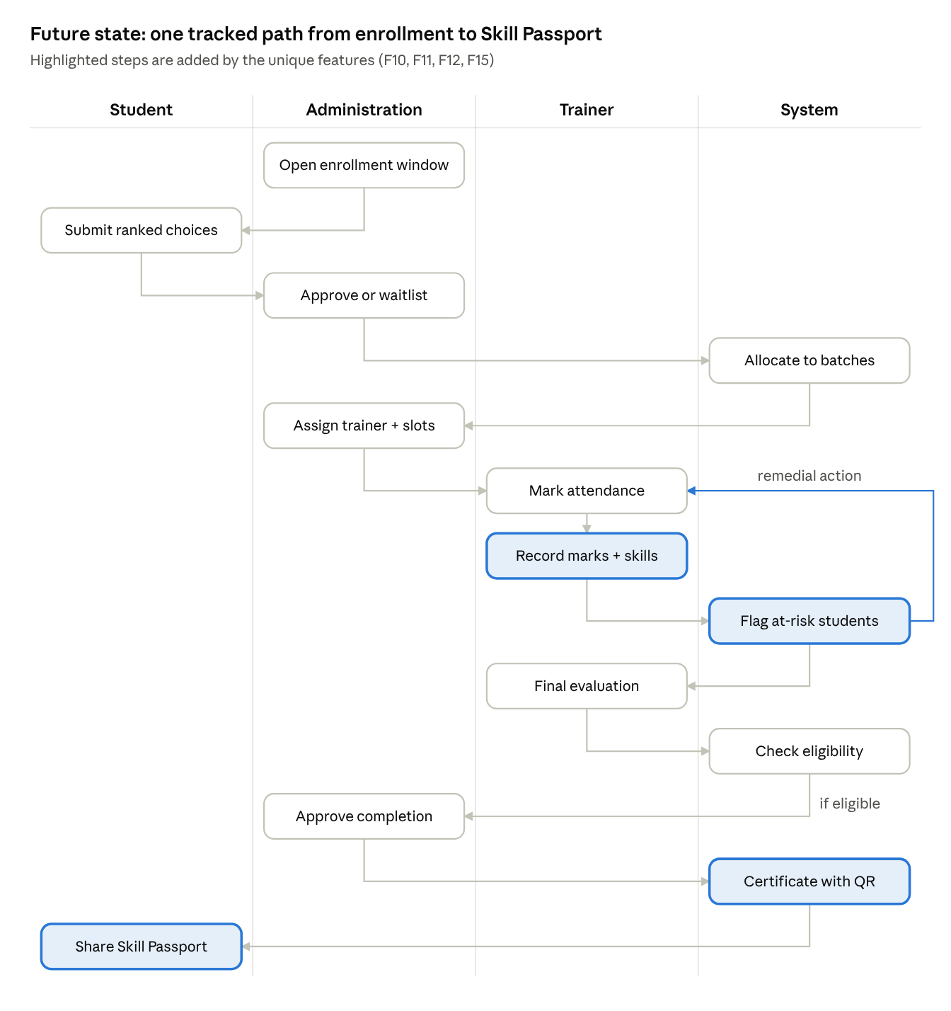
future-state process · 4 roles, 13 steps
The highlighted loop is the main change in the training phase: an at-risk flag sends the student back through remedial work before final evaluation. Students who fail the eligibility check are marked Not Completed with a reason.

8. Core business requirements (F1–F9)
All 30 core requirements are Must for Release 1 unless marked Should; each traces to the v2.1 functional requirements (FR) and business rules (BR).
ID | Feature | Business requirement | Priority | Traces to
BRQ-1.1 | F1 Auth | Users log in and out securely with email and password | Must | FR-01, NFR-01
BRQ-1.2 | F1 Auth | Each role (Student, Trainer, Admin) sees only its own dashboard and permitted actions, enforced on the server | Must | FR-02, FR-03
BRQ-1.3 | F1 Auth | Users can manage their profile and change their password | Should | FR-04
BRQ-2.1 | F2 Courses | Admin can create, update and deactivate vocational courses | Must | FR-30
BRQ-2.2 | F2 Courses | Each course shows description, duration, prerequisites, seat capacity and enrollment window | Must | FR-10
BRQ-2.3 | F2 Courses | Admin can open and close elective availability per course and cycle | Must | FR-31, BR-02
BRQ-3.1 | F3 Enrollment | Students browse courses and submit up to three ranked preferences | Must | FR-11
BRQ-3.2 | F3 Enrollment | Only one active enrollment per student per cycle, only inside the open window | Must | BR-01, BR-02
BRQ-3.3 | F3 Enrollment | Admin approves, rejects (with reason) or waitlists requests, singly or in bulk | Must | FR-32
BRQ-3.4 | F3 Enrollment | Students track their enrollment status and reasons | Must | FR-12
BRQ-4.1 | F4 Batches | Admin creates batches with capacity, dates and venue | Must | FR-33
BRQ-4.2 | F4 Batches | System allocates approved students by preference and priority rule, with a preview before confirming | Must | FR-34, BR-03, BR-04
BRQ-4.3 | F4 Batches | Admin assigns trainers and schedules sessions | Must | FR-35
BRQ-4.4 | F4 Batches | No batch exceeds capacity; overflow is waitlisted | Must | BR-03
BRQ-5.1 | F5 Attendance | Trainers mark present / absent / late per session for their own batches only | Must | FR-22, BR-05
BRQ-5.2 | F5 Attendance | Attendance edits allowed for 48 hours; later edits by Admin only, logged | Must | BR-06, BR-12
BRQ-5.3 | F5 Attendance | System calculates attendance % and shows absenteeism per student and batch | Must | FR-14, BR-08
BRQ-6.1 | F6 Assessment | Trainers create assessments (theory or practical) with max marks, weightage and mandatory flag | Must | FR-24
BRQ-6.2 | F6 Assessment | Marks validated between 0 and max marks | Must | BR-07
BRQ-6.3 | F6 Assessment | Trainers record progress milestones and a final evaluation with completion recommendation | Must | FR-23, FR-25
BRQ-6.4 | F6 Assessment | System calculates weighted aggregate score and grade band | Must | BR-11
BRQ-7.1 | F7 Certificates | System checks completion eligibility (attendance, mandatory assessments, aggregate, recommendation) | Must | BR-09
BRQ-7.2 | F7 Certificates | Certificate generated only after Admin approval, with a unique non-guessable ID, as a downloadable PDF | Must | BR-10, FR-38
BRQ-7.3 | F7 Certificates | A record of every certificate issued is kept | Must | FR-38, BR-12
BRQ-8.1 | F8 Reports | Individual student performance report (PDF) | Must | FR-38
BRQ-8.2 | F8 Reports | Batch-wise and course-wise reports with completion rates and results, exportable as CSV / PDF | Should | FR-39
BRQ-9.1 | F9 Dashboard | Admin dashboard shows counts of students, courses, trainers and batches | Must | FR-36
BRQ-9.2 | F9 Dashboard | Dashboard shows enrollment, completion and performance statistics with charts | Should | FR-36, FR-39
BRQ-9.3 | F9 Dashboard | Students and trainers see role dashboards with their own key figures | Must | FR-02
BRQ-9.4 | F9 Dashboard | Admin views the completion queue with the system's eligibility result | Must | FR-37

9. Unique features: analysis and business requirements (F10–F20)
The four recommended differentiators (F10, F11, F12, F15) share one foundation — a competency model per course — so building it once unlocks all four at low extra cost.
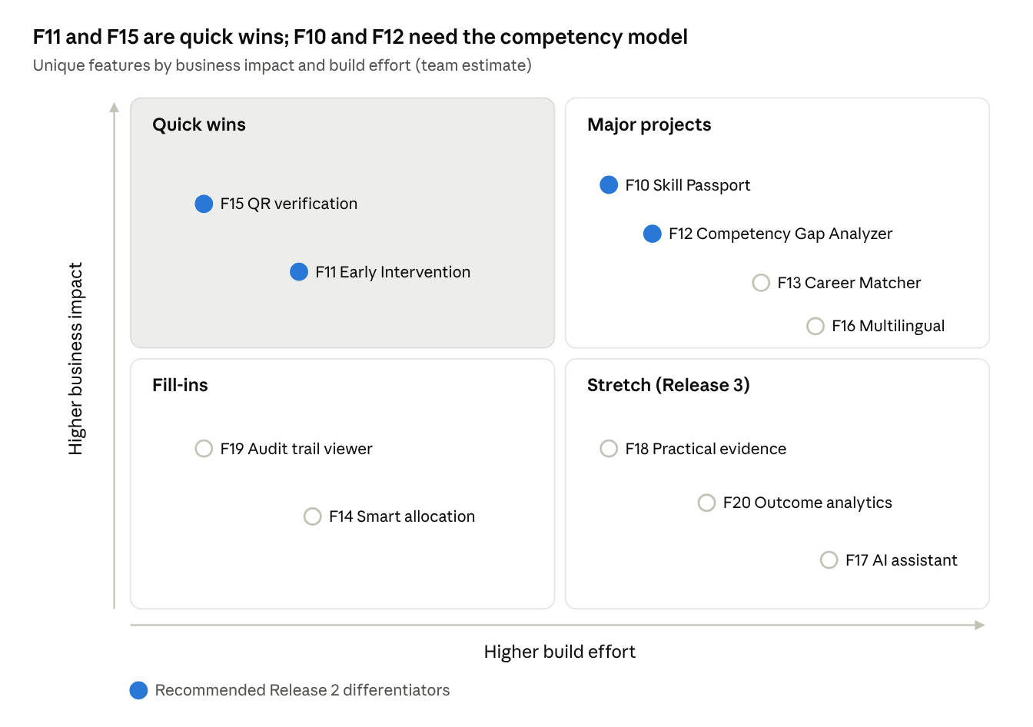
unique features · impact vs effort
F11 and F15 reuse data the core already collects, so they are cheap. F10 and F12 cost more, but only because of the competency model, which F13 and F18 then reuse. F17 carries the most effort and risk for its value.

9.1 Shared foundation: the competency model
Every course defines a list of competencies (for example "Wire a single-phase distribution board"). Each competency has a code, a type (theory or practical), a required proficiency level (1–4) and the assessments that evidence it. Assessment results and rubric evaluations then roll up into a per-student competency score.
ID | Requirement | Priority
BRQ-C.1 | Admin defines competencies per course with code, title, type, required level and linked assessments | Should
BRQ-C.2 | Trainers rate each student on each competency (level 1–4) using a rubric | Should
BRQ-C.3 | Job roles (for F13) are defined as a list of required competencies and levels | Could
Proficiency levels: 1 Aware, 2 Assisted, 3 Independent, 4 Can teach others. A competency is verified when the student reaches the required level and a trainer confirms it.

9.2 F10 Skill Passport
Business value. Certificates say which course was finished; employers want to know which tasks the student can do. A passport of trainer-verified competencies answers that and addresses P6.
ID | Requirement | Priority
BRQ-10.1 | Each student has one Skill Passport listing every verified competency, its level, date verified and verifying trainer | Should
BRQ-10.2 | Practical skills are tracked separately from theory, with links to evidence (F18) when present | Should
BRQ-10.3 | Students generate a shareable link or QR to a read-only passport, and can revoke it | Should
BRQ-10.4 | The passport spans training cycles, so skills from earlier courses remain | Should
Rules. Only a trainer assigned to the student's batch can verify a competency (extends BR-05). A verified entry cannot be deleted, only revoked by Admin with a reason, and every change is logged (BR-12). Shared links show name, photo (optional), competencies and certificates only — never marks or attendance.
Acceptance criteria. A certified student opens their passport and sees each verified competency with level and date. A shared link opened without login shows the read-only profile; after revocation it shows "Link no longer active".

9.3 F11 Early Intervention System
Business value. Today students fall below 75% attendance or 40% aggregate before anyone notices. Flagging them early protects completion rates (P7) and extends v2.1 FR-26 from a list into a tracked process.
ID | Requirement | Priority
BRQ-11.1 | System calculates a daily risk level (Low / Medium / High) for every student in an Active batch | Should
BRQ-11.2 | Trainers and Admin see a flagged-students list with the reason for each flag | Should
BRQ-11.3 | Trainers record a remedial action (counselling, extra session, practice task) with owner and due date | Should
BRQ-11.4 | System tracks whether the student improves after the action and closes or escalates the flag | Should
BRQ-11.5 | Students see their own flag with a supportive message and the agreed action | Should
Rules (defaults, all configurable). Medium risk: attendance below 80%, or 3 consecutive absences, or an assessment below 50%. High risk: attendance below 75% (the BR-09 threshold), or projected aggregate below 40%, or a drop of 15 points between consecutive assessments. A flag closes automatically when all triggers clear for 7 days; an unresolved High flag after 14 days escalates to Admin.
Acceptance criteria. A student with 74.99% attendance is High risk within one day of the session being marked. Recording an action and the student returning above thresholds closes the flag and keeps its history.

9.4 F12 Competency Gap Analyzer
Business value. Turns marks into a clear next step: which skills are missing and what to practise. Helps students improve before final assessment and gives trainers a batch-level view of weak topics.
ID | Requirement | Priority
BRQ-12.1 | For each student, compare required level with demonstrated level for every course competency | Should
BRQ-12.2 | Show gaps ranked by size, separating not-yet-assessed from assessed-but-below-level | Should
BRQ-12.3 | Recommend a remedial session, practice task or resource mapped to each gap competency | Should
BRQ-12.4 | Trainers see a batch heatmap of competencies by student to plan remedial sessions | Should
BRQ-12.5 | Against a target job role (F13), show the gap between the student's passport and the role's requirements | Could
Rules. Gap = required level − demonstrated level, floored at 0. Recommendations come only from a resource list curated by trainers or Admin. A large gap on a mandatory competency also raises an F11 flag.
Acceptance criteria. A student with level 1 on a level-3 competency sees a gap of 2 and at least one recommended action. The batch heatmap shows that competency highlighted for every student below level.

9.5 F15 QR-Based Certificate Verification
Business value. Employers can confirm authenticity in seconds without contacting the institution (P4). Builds directly on the unique certificate ID already required by BR-10.
ID | Requirement | Priority
BRQ-15.1 | Each certificate PDF carries its unique ID and a QR code pointing to the public verification page | Should
BRQ-15.2 | Anyone can verify by scanning the QR or typing the ID, without logging in | Should
BRQ-15.3 | The page shows only name, course, grade, issue date and status: Valid, Revoked or Not found | Should
BRQ-15.4 | Admin can revoke a certificate with a reason; status changes immediately and is logged | Should
BRQ-15.5 | Verification attempts are counted per certificate and rate-limited per IP | Could
Rules. IDs are random and at least 12 characters, never sequential. Revoked certificates stay in the record and show "Revoked" with the date, not the reason. Reissue creates a new ID and marks the old one Superseded.
Acceptance criteria. Scanning a valid certificate's QR on a phone shows "Valid" with matching details. An invalid ID shows "Certificate not found" (v2.1 TC-18). A revoked certificate shows "Revoked".

9.6 Additional enhancements (Release 3)
These seven features add value but each needs extra data, content or effort, so they follow once R2 is stable.
Feature | Business value | Key business requirements | Depends on | Priority
F13 Career and Opportunity Matcher | Connects training to placement; shows students why skills matter | BRQ-13.1 Admin publishes internships, apprenticeships and jobs with required competencies. BRQ-13.2 System ranks opportunities by match % against the student's passport. BRQ-13.3 Student sees missing skills for a target role (via F12). BRQ-13.4 Student can mark interest; Admin sees interested, matched students | F10, F12, BRQ-C.3 | Could
F14 Smart Batch and Resource Allocation | Prevents clashes and over-filled batches before they happen | BRQ-14.1 Warn when a batch nears or exceeds capacity. BRQ-14.2 Detect trainer double-booking and venue or timetable clashes when scheduling. BRQ-14.3 Suggest feasible batch, trainer and slot options in the allocation preview | F4 allocation (BR-03, BR-04) | Could
F16 Multilingual and low-bandwidth interface | Wider adoption by students and families more at ease in Odia or Hindi | BRQ-16.1 All UI text in English, Odia and Hindi, switchable per user. BRQ-16.2 Certificates remain in English, with optional Odia name line. BRQ-16.3 Pages usable on 3G: core pages under 500 KB, images lazy-loaded. BRQ-16.4 Keyboard navigation and screen-reader labels (WCAG 2.1 AA as goal) | Translation of UI strings (needs native reviewers) | Could
F17 AI Training Assistant | 24×7 help with concepts and practice outside class | BRQ-17.1 Answers only from course materials approved by Admin, citing the source. BRQ-17.2 Generates practice questions per competency. BRQ-17.3 Explains concepts at a simpler level on request. BRQ-17.4 Recommends resources tied to F12 gaps. BRQ-17.5 Declines out-of-scope questions; usage logged | Approved material library; an LLM API with cost limit | Could
F18 Practical Assessment Evidence | Makes practical marks defensible and supports passport verification | BRQ-18.1 Trainers attach photo, video link or document evidence to a practical assessment. BRQ-18.2 Rubric-based scoring with named criteria and levels. BRQ-18.3 Evidence linked to the competency it verifies | Competency model; file storage (size limit e.g. 10 MB) | Could
F19 Audit Trail and Change History | Accountability and dispute resolution | BRQ-19.1 Log changes to attendance, marks, enrollment, completion, certificates and passport entries (who, what, when, old, new). BRQ-19.2 Admin views and filters the log by user, entity and date. BRQ-19.3 Log entries cannot be edited or deleted | Logging itself is R1 (BR-12); the viewer is R3 | Must (logging) / Should (viewer)
F20 Training Outcome Analytics | Evidence for management on which courses and batches work | BRQ-20.1 Compare completion rate, average score and attendance across courses and batches. BRQ-20.2 Track competency achievement rates per course. BRQ-20.3 Record and report employment / placement outcomes per course | F8 reports, F10, F13 for placement data | Could
Analysis notes.
- F17 is the highest-risk feature: it adds external cost, content preparation and answer-quality testing. Keep it strictly to approved materials and treat it as optional.
- F19 logging is not optional — the core business rules (BR-06, BR-12) already require it in R1. Only the viewer screen is an enhancement.
- F16 is cheap to prepare for (externalize all UI strings from day one) but costly to complete (translation and review). Prepare in R1, translate in R3.

10. Business rules
The system, not individual users, enforces these rules; every threshold below is a configurable setting, not hard-coded.

10.1 Core rules (from v2.1)
ID | Rule
BR-01 | One active enrollment per student per training cycle; duplicates rejected
BR-02 | Enrollment accepted only while the course's window is open
BR-03 | A batch never exceeds capacity; excess approved students are waitlisted
BR-04 | Allocation honours preference rank first, then the priority rule (submission time or CGPA)
BR-05 | Trainers act only on batches assigned to them
BR-06 | Attendance only for scheduled sessions; editable for 48 hours, then Admin only and logged
BR-07 | Marks between 0 and the assessment's maximum
BR-08 | Attendance % = sessions attended ÷ sessions conducted × 100, two decimals
BR-09 | Completion requires attendance ≥ 75%, all mandatory assessments recorded, aggregate ≥ 40% and a trainer recommendation
BR-10 | Certificate only after Admin approval; unique, non-guessable ID
BR-11 | Grades: A ≥ 85%, B 70–84.99%, C 55–69.99%, D 40–54.99%, Not Completed < 40%
BR-12 | Every change to attendance, marks, enrollment or completion status is audit-logged (who, what, when, old, new)

10.2 New rules for unique features
ID | Rule | Feature
BR-13 | A competency is verified only when the student reaches the required level and an assigned trainer confirms it | F10, F12
BR-14 | Verified passport entries are never deleted; Admin may revoke with a reason, logged | F10, F19
BR-15 | Public passport and certificate pages show no marks, attendance or contact details | F10, F15
BR-16 | Risk flags: Medium if attendance < 80%, 3 consecutive absences or any assessment < 50%; High if attendance < 75%, projected aggregate < 40% or a 15-point drop between assessments | F11
BR-17 | A flag closes after triggers clear for 7 days; an unresolved High flag escalates to Admin after 14 days | F11
BR-18 | Competency gap = required level − demonstrated level, minimum 0; a gap on a mandatory competency raises an F11 flag | F12
BR-19 | Certificate IDs are random, at least 12 characters; revoked or superseded certificates keep their record and show their status | F15
BR-20 | No trainer or venue may be booked into two overlapping sessions | F14
BR-21 | The AI assistant answers only from approved materials and cites the source; otherwise it declines | F17
BR-22 | Opportunity match % = verified required competencies ÷ total required competencies × 100 | F13

11. Non-functional requirements
NFR-01 to NFR-08 carry over from v2.1; NFR-09 to NFR-14 are added by the unique features.
ID | Category | Requirement
NFR-01 | Security | Passwords hashed (bcrypt); JWT tokens with expiry; authorization checked on the server for every request
NFR-02 | Security | Server-side input validation; parameterized queries / ORM; output escaped against XSS
NFR-03 | Performance | Common pages and APIs respond within 2 s for 100 concurrent users
NFR-04 | Usability | Responsive on desktop and mobile; each core task within three clicks of the dashboard
NFR-05 | Reliability | Status-changing operations run in database transactions
NFR-06 | Auditability | Sensitive changes logged immutably (BR-12)
NFR-07 | Maintainability | Modular code per module; README and API documentation kept current
NFR-08 | Privacy | Users see only authorized data; public pages expose minimal details
NFR-09 | Public access | Verification and shared passport pages load within 3 s on mobile, need no login, and are rate-limited
NFR-10 | Low bandwidth | Core student pages under 500 KB on first load; usable on a 3G connection
NFR-11 | Localization | All UI strings stored outside code from R1 so Odia and Hindi can be added without code changes; Unicode fonts for Odia script
NFR-12 | Accessibility | Keyboard navigation, labelled form fields and sufficient contrast (WCAG 2.1 AA as goal)
NFR-13 | AI safety and cost | AI assistant limited to approved materials, monthly usage cap, no student personal data sent to the AI provider
NFR-14 | Storage | Evidence uploads limited to images, PDF and video links; maximum 10 MB per file; stored outside the database

12. Data and reporting requirements
The 17 entities in v2.1 cover the core workflow; the unique features need 9 more, all linked to existing Student, Course, Batch and Assessment records.

12.1 New business data
Entity | Holds | Used by
Competency | Course, code, title, type (theory / practical), required level, mandatory flag | F10, F12, F13
AssessmentCompetency | Which assessments evidence which competency | F12
CompetencyRating | Student, competency, level achieved, trainer, date, verified flag | F10, F12
PassportShare | Student, share token, created, expires, revoked | F10
RiskFlag | Student, batch, level, trigger reasons, opened, closed, escalated | F11
InterventionAction | Flag, action type, owner, due date, outcome | F11
LearningResource | Competency, title, type, link, approved by | F12, F17
Opportunity / JobRole | Title, type (internship, apprenticeship, job), partner, required competencies, closing date | F13
PracticalEvidence | Assessment result, file or link, rubric criteria scores, uploaded by | F18
The Certificate entity gains status (Valid, Revoked, Superseded), revoked_reason and verification_count for F15.

12.2 Reports
Report | Audience | Contents | Release
Student performance report (PDF) | Student, Admin | Attendance %, assessment results, aggregate, grade, trainer remarks | R1
Batch report | Trainer, Admin | Attendance and results per student, completion status | R1
Course report | Admin | Completion rate, grade distribution across batches | R1
Skill Passport (web + PDF) | Student, employer | Verified competencies, levels, certificates | R2
At-risk students | Trainer, Admin | Open flags by level, reason, action and age | R2
Competency gap / heatmap | Student, Trainer | Gaps per student; batch competency coverage | R2
Outcome analytics | Admin, management | Cross-course comparison, competency achievement, placement outcomes | R3
All tabular reports export to CSV; student-facing documents export to PDF.

13. Assumptions, constraints and dependencies
Assumptions
- Student, trainer and course master data can be seeded or entered by Administration.
- Each student is enrolled in only one vocational course per training cycle.
- One institution, one deployment.
- In-app notifications are enough; email and SMS are optional.
- Trainers will define 8–15 competencies per course and rate students against them (needed for F10–F12).
- Admin will curate the learning resources and materials that F12 and F17 draw on.
Constraints
- Two developers, one academic semester (about 12 weeks).
- Free-tier hosting and database; limited budget for any paid AI API.
- Stack fixed in v2.1: React, Node.js / Express, PostgreSQL, Prisma, PDFKit / Puppeteer, qrcode.
Dependencies
Dependency | Needed for | Owner
Competency lists for at least 2 demo courses | F10, F12, F13 | Team with a trainer or guide
Public URL for the deployed app | F15 QR codes, shared passports | Team
Native Odia and Hindi reviewers | F16 | Team (volunteers)
LLM API key with spending cap | F17 | Guide approval
File storage (cloud bucket or server disk) | F18 evidence | Team
Sample opportunities from the placement cell | F13 | Admin / placement cell

14. Risks and mitigations
Scope growth is the biggest risk: 20 features for two people in 12 weeks only works if the core workflow is finished before any innovation starts.
Risk | Prob. | Impact | Mitigation
Scope grows past what two people can deliver | High | High | Freeze R1 scope after week 2; R2 starts only after one student completes the full workflow; R3 is stretch only
Competency model not defined in time | Med | High | Define competencies for 2 demo courses in weeks 1–2; use seed data
Risk-flag rules produce too many false alarms | Med | Med | Make thresholds configurable; tune with demo data; show the reason for every flag
Shared passport or verification page leaks personal data | Low | High | Show minimal fields only (BR-15); random tokens; rate limiting; security test cases
QR links break when the server URL changes | Med | Med | Use a stable configured base URL; deploy early in week 3
AI assistant gives wrong or off-topic answers | Med | High | Restrict to approved materials with citations; decline otherwise; keep F17 optional
AI API cost exceeds budget | Low | Med | Monthly cap; cache common answers; disable when the cap is reached
Translations incomplete or inaccurate | Med | Low | Externalize strings early; translate student-facing pages first; native review
Evidence uploads exhaust free storage | Med | Med | 10 MB limit; links for videos; compress images
Frontend / backend integration problems | Med | High | API contract first; integrate weekly
Insufficient testing time | High | High | Write tests with each feature; boundary tests for every threshold rule

15. Prioritisation and roadmap
Build the full core workflow first (weeks 1–8), then the four differentiators (weeks 9–10); everything else is stretch.
MoSCoW | Features
Must | F1–F9 core workflow; audit logging (F19 / BR-12)
Should | F10 Skill Passport, F11 Early Intervention, F12 Competency Gap Analyzer, F15 QR verification, F19 audit log viewer
Could | F13 Career Matcher, F14 Smart Allocation, F16 Multilingual, F17 AI Assistant, F18 Practical Evidence, F20 Outcome Analytics
Won't (this version) | Payroll, LMS content hosting, biometric attendance, fee payment, native mobile apps
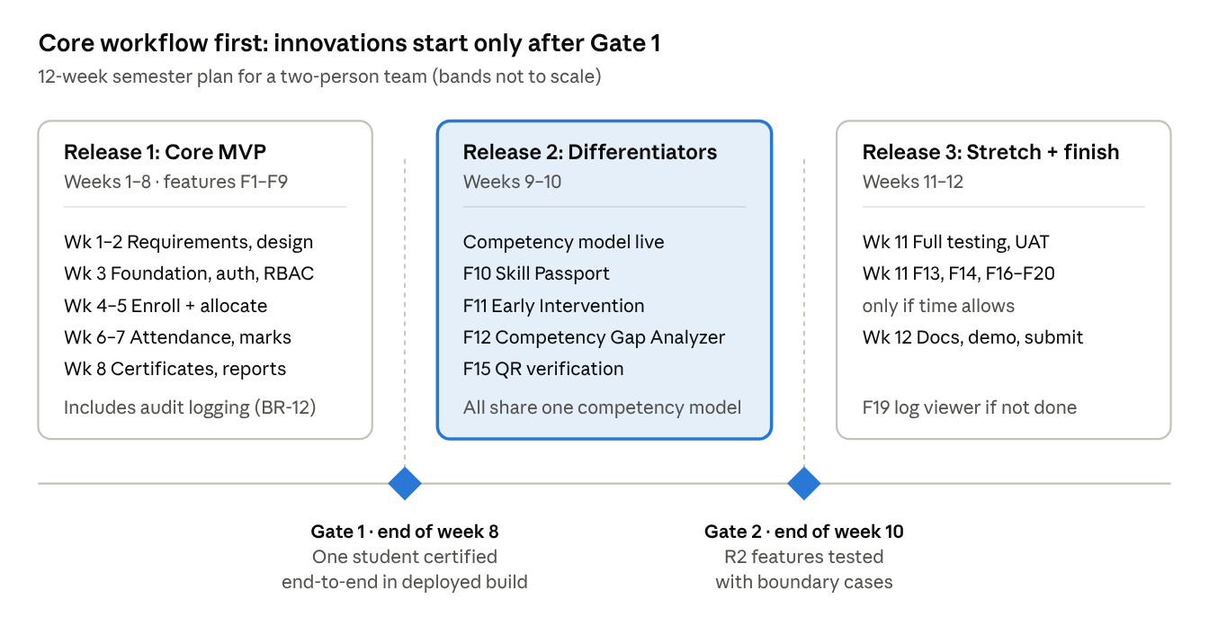
release roadmap · 3 releases, 2 gates
Gate 1 keeps the v2.1 rule of thumb: no Should or Could work starts until one student travels the full Must workflow in the deployed build. To make R2 fit in two weeks, the competency tables (Section 12.1) are created in week 3 with the rest of the schema, and UI strings are externalized from the start for F16.

16. Traceability and sign-off
Each business problem maps to an objective, the requirements that meet it and the tests that prove it; existing TC IDs come from v2.1 and new TCs are to be written.
Problem | Objective | Business requirements | Rules | Test cases
P1 Manual allocation | BO-3 | BRQ-3.1–3.4, BRQ-4.1–4.4, BRQ-14.x | BR-01–BR-04, BR-20 | TC-03–TC-07
P2 Scattered records | BO-1 | BRQ-5.1–5.3, BRQ-6.1–6.4 | BR-05–BR-08, BR-11 | TC-08–TC-12
P3 No student visibility | BO-4 | BRQ-5.3, BRQ-9.3 | BR-08 | TC-09
P4 Unverifiable certificates | BO-5 | BRQ-7.1–7.3, BRQ-15.1–15.5 | BR-09, BR-10, BR-19 | TC-13, TC-14, TC-16–TC-18, new TC-20–22
P5 No change history | BO-8 | BRQ-19.1–19.3 | BR-12, BR-14 | TC-19
P6 Skills not visible to employers | BO-7 | BRQ-C.1–C.2, BRQ-10.1–10.4, BRQ-13.x, BRQ-18.x | BR-13–BR-15, BR-22 | new TC-23–26
P7 Late identification of struggling students | BO-6 | BRQ-11.1–11.5, BRQ-12.1–12.4 | BR-16–BR-18 | new TC-27–31
P8 Language and bandwidth barriers | BO-1 | BRQ-16.1–16.4 | — | new TC-32–33
Role security | BO-2 | BRQ-1.1–1.3 | BR-05 | TC-01, TC-02, TC-15
Suggested new boundary tests. Attendance 79.99% / 80.00% (Medium flag), 74.99% / 75.00% (High flag); competency level equal to required (no gap) and one below (gap 1); revoked certificate shows "Revoked"; expired passport link shows "Link no longer active".

Sign-off
Role | Name | Decision | Date
Project guide
Team member 1
Team member 2

