KISS Vocational Training Management Portal — Technical Architecture Document
Oct 9, 2026 · @Shashank Singh

1. Document control and purpose
This TAD (v1.0, draft) describes how the portal is built to meet the BRD: one modular monolith on React, Node.js / Express and PostgreSQL, extended with competency, risk, passport, verification and AI modules.
Item | Detail
Document | Technical Architecture Document (TAD)
Version | 1.0 — draft for team and guide review
Inputs | KISS VTMP BRD v1.0; Project Documentation v2.1 (Sections 9–13, 23)
Audience | Development team (2 members), project guide, examiners
Scope | Releases R1 (core F1–F9), R2 (F10, F11, F12, F15) and R3 (F13, F14, F16–F20)
Where this TAD and v2.1 differ, this TAD wins for architecture; the BRD wins for business rules.

2. Architecture overview
The portal is a modular monolith: one React frontend, one Express API and one PostgreSQL database, with business rules held in a service layer split by module.
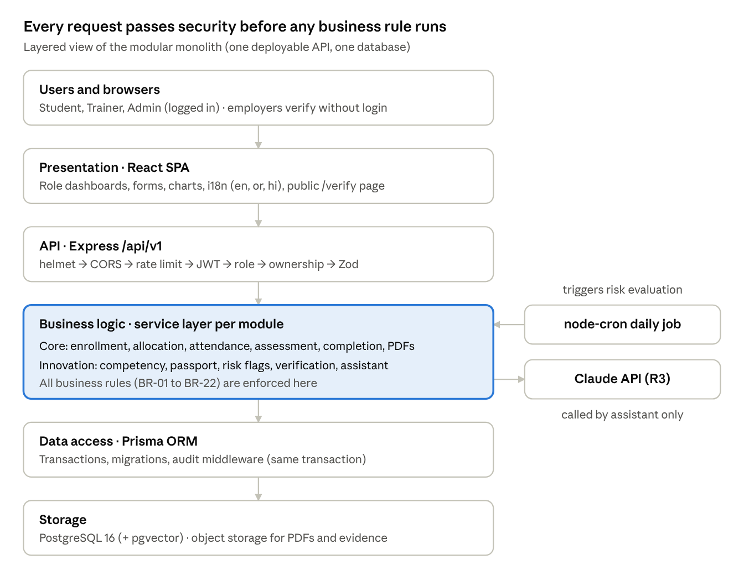
layered architecture · 6 layers
Requests flow top to bottom; nothing reaches the service layer without passing authentication, role, ownership and validation checks. The daily job and the AI provider are the only parts outside the request path.

3. Architecture principles and key decisions
The design favours one simple deployable app with strict module boundaries, because two developers must build, test and demo it in 12 weeks.
Principles
- Business rules live in the service layer, never in controllers or the UI.
- Authorization is enforced on the server for every request (role + ownership).
- Every status change runs in a database transaction and writes an audit entry.
- Thresholds (75%, 40%, 48 h, risk levels) are configuration rows, not constants.
- Innovation modules read core data; core modules never depend on innovation modules.
- Public endpoints expose the minimum data and are rate-limited.
Architecture decision records
ADR | Decision | Alternatives considered | Rationale
ADR-01 | Modular monolith | Microservices | One deploy, one DB, simple testing; modules still separable later
ADR-02 | PostgreSQL | MySQL, MongoDB | Strong constraints, transactions, JSONB for rubric data, pgvector for F17
ADR-03 | Prisma ORM with migrations | Sequelize, raw SQL | Type-safe queries, versioned schema shared by both members
ADR-04 | REST + JSON, OpenAPI contract | GraphQL | Simple, easy to test with Supertest and Postman
ADR-05 | JWT access token (15 min) + refresh token in httpOnly cookie | Server sessions | Stateless API; refresh cookie limits token theft via XSS
ADR-06 | Server-side PDF generation (PDFKit) with QR (qrcode) | Client-side PDF | Tamper-resistant documents; one template
ADR-07 | In-process scheduler (node-cron) for risk flags | Separate worker, message queue | Daily batch volume is small; no extra infrastructure
ADR-08 | i18next with JSON resource files (en, or, hi) | Hard-coded strings | Odia and Hindi added without code change (NFR-11)
ADR-09 | Retrieval-augmented AI over approved materials only, behind a feature flag | Open-ended chatbot | Grounded answers with citations; can be switched off (BR-21)
ADR-10 | Object storage for evidence files; DB stores metadata only | Files in DB | Keeps DB small; signed URLs control access

4. Technology stack
The stack is the v2.1 choice plus five libraries for the unique features; all are free and open source except the optional AI API.
Layer | Technology | Used for
Frontend | React 18, Vite, React Router, Tailwind CSS | Role-based SPA, responsive layouts
Frontend data | TanStack Query, React Hook Form + Zod | Caching, forms with shared validation
Charts | Recharts | Dashboards, gap heatmap, analytics (F9, F12, F20)
Localization | i18next, react-i18next, Noto Sans Oriya / Devanagari fonts | English, Odia, Hindi (F16)
API | Node.js 20 LTS, Express, Zod | REST endpoints, validation
Auth | jsonwebtoken, bcrypt, helmet, express-rate-limit, cors | Login, RBAC, security headers, throttling
Data access | Prisma ORM | Schema, migrations, transactions
Database | PostgreSQL 16 (+ pgvector extension for R3) | Relational store; embeddings for F17
Documents | PDFKit, qrcode | Certificates, reports, QR codes (F7, F15)
Scheduling | node-cron | Daily risk evaluation, flag escalation (F11)
File storage | S3-compatible bucket (e.g. Cloudflare R2 / Supabase Storage) | Evidence uploads (F18), stored PDFs
AI (R3, optional) | Claude API (claude-haiku-5-5 for cost), embeddings from an open-source model (e.g. bge-m3, 1024 dimensions) stored in pgvector | AI Training Assistant (F17)
Testing | Jest, Supertest, Playwright | Unit, API, end-to-end
Tooling | GitHub, GitHub Actions, ESLint, Prettier | Version control, CI, code quality
Hosting | Vercel / Netlify (frontend), Render / Railway (API), Neon / Supabase (PostgreSQL) | Free-tier deployment

5. Module design
The backend has 12 core modules (auth, audit and settings form a shared kernel) and 9 innovation modules; each module owns its routes, controller, service, validation schema and tests.
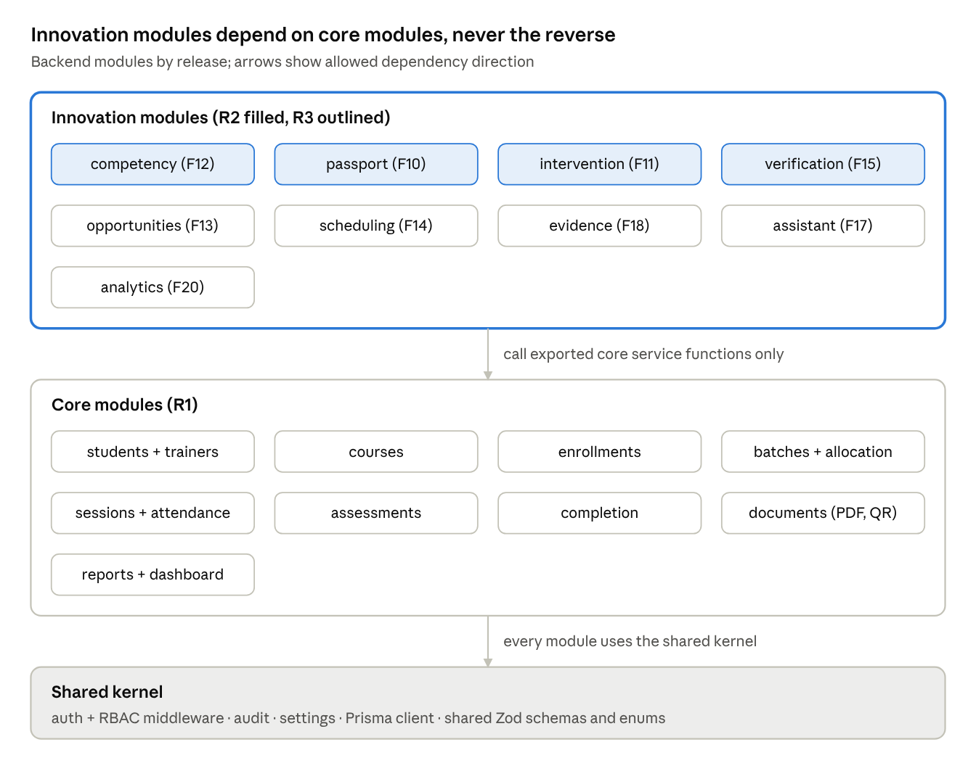
module dependency map · 9 core, 9 innovation
Because dependencies run one way, any innovation module can be switched off or cut from scope without breaking the core workflow.
Module | Responsibility | Owns tables | Release | Owner
auth | Login, refresh, logout, password change, RBAC + ownership middleware | User, RefreshToken | R1 | P1
students / trainers | Profiles and master data | Student, Trainer | R1 | P2
courses | Courses, enrollment windows, prerequisites | Course | R1 | P2
enrollments | Ranked preferences, review, waitlist (BR-01, BR-02) | Enrollment | R1 | P1 / P2
batches + allocation | Batches, allocation preview and confirm (BR-03, BR-04) | Batch, BatchStudent, TrainerAssignment | R1 | P2
sessions + attendance | Scheduling, attendance, 48 h edit window (BR-05, BR-06, BR-08) | TrainingSession, Attendance | R1 | P1
assessments | Assessments, results, progress, evaluations (BR-07, BR-11) | Assessment, AssessmentResult, Progress, Evaluation | R1 | P1
completion | Eligibility engine (BR-09), completion queue | — (reads others; writes Enrollment status) | R1 | P2
documents | Certificate and report PDFs, QR codes | Certificate, PerformanceReport | R1 / R2 | P2
reports + dashboard | Aggregates, CSV / PDF export | Read-only views | R1 | P2
audit | Append-only change log, viewer | AuditLog | R1 / R3 | P2
settings | Configurable thresholds | Setting | R1 | P2
competency | Competency model, ratings, gap calculation (F12) | Competency, AssessmentCompetency, CompetencyRating, LearningResource | R2 | P1
passport | Skill Passport view, share tokens (F10) | PassportShare | R2 | P1
intervention | Daily risk evaluation, flags, actions, escalation (F11) | RiskFlag, InterventionAction | R2 | P1
verification | Public certificate and passport lookup (F15) | — (reads Certificate, PassportShare) | R2 | P2
opportunities | Job roles, opportunities, matching (F13) | JobRole, Opportunity, OpportunityInterest | R3 | P2
scheduling-advisor | Capacity and clash detection, suggestions (F14) | — (reads batches, sessions) | R3 | P2
evidence | Uploads and rubric scores (F18) | PracticalEvidence, Rubric | R3 | P1
assistant | Retrieval and answer generation (F17) | Material, MaterialChunk, AssistantLog | R3 | P1
analytics | Outcome analytics (F20) | Read-only materialized views | R3 | P2
Modules call each other only through exported service functions, never another module's tables directly. Innovation modules (bold) may read core services; core modules never import them.

6. Data architecture
One PostgreSQL database in 3NF holds the 17 v2.1 entities plus 18 new tables; integrity is enforced with keys, unique constraints and check constraints, not only in code.

6.1 Core entities (from v2.1, unchanged)
User, Student, Trainer, Course, Enrollment, Batch, BatchStudent, TrainerAssignment, TrainingSession, Attendance, Progress, Assessment, AssessmentResult, Evaluation, Certificate, PerformanceReport, AuditLog.
Additions to existing tables: Certificate.status (VALID, REVOKED, SUPERSEDED), Certificate.public_code (12+ char random, unique), Certificate.revoked_reason, Certificate.verification_count; Assessment.mode (THEORY, PRACTICAL); User.locale (en, or, hi).

6.2 New tables
Table | Key columns | Constraints | Release
Setting | key (PK), value, updated_by, updated_at | Typed values validated by Zod | R1
RefreshToken | token_id (PK), user_id (FK), hash, expires_at, revoked_at | Hash only, never raw token | R1
Competency | competency_id (PK), course_id (FK), code, title, mode, required_level, is_mandatory | unique (course_id, code); required_level 1–4 | R2
AssessmentCompetency | assessment_id (FK), competency_id (FK) | PK (assessment_id, competency_id) | R2
CompetencyRating | rating_id (PK), student_id, competency_id, batch_id, level, rated_by, verified_at | level 1–4; unique (student, competency, batch) | R2
LearningResource | resource_id (PK), competency_id (FK), title, type, url, approved_by | url required | R2
PassportShare | share_id (PK), student_id (FK), token_hash, expires_at, revoked_at | unique token_hash | R2
RiskFlag | flag_id (PK), student_id, batch_id, level, reasons (JSONB), opened_at, closed_at, escalated_at | one open flag per (student, batch) via partial unique index | R2
InterventionAction | action_id (PK), flag_id (FK), type, owner_id, due_on, outcome, completed_at | due_on ≥ created date | R2
JobRole, JobRoleCompetency | role_id, title; (role_id, competency_code, level) | composite PK | R3
Opportunity, OpportunityInterest | opportunity_id, role_id, type, partner, closes_on; (opportunity_id, student_id) | composite PK on interest | R3
Rubric, PracticalEvidence | rubric criteria (JSONB); evidence_id, result_id, object_key, mime, size_bytes, scores (JSONB) | size ≤ 10 MB; allowed mime list | R3
Material, MaterialChunk, AssistantLog | material_id, course_id, approved_by; chunk text + embedding vector(1024); question, sources, tokens | approved_by NOT NULL | R3

6.3 Data rules in the database
- AuditLog is insert-only: the app's DB role has no UPDATE or DELETE on it.
- Check constraints enforce BR-07 (0 ≤ marks ≤ max_marks) and level ranges.
- Partial unique index enforces BR-01: one active enrollment per student per cycle.
- Derived values (attendance %, aggregate, gap, match %) are computed on read or in SQL views, not stored, except snapshots on PerformanceReport and Certificate.

7. API design
All endpoints sit under /api/v1, return JSON and share one error format; the v2.1 endpoint list (Section 23) stays, and the table below adds the unique-feature endpoints.
Conventions
- Error body: { "error": { "code": "ENROLLMENT_WINDOW_CLOSED", "message": "…" } } with HTTP 400, 401, 403, 404, 409 or 422.
- Pagination: ?page=&pageSize= (max 100); filtering by query parameters.
- Every mutating request validated by a Zod schema shared with the frontend.
- Idempotent actions (approve, allocate confirm, issue certificate) accept an Idempotency-Key header.
- Contract kept in openapi.yaml; Postman collection generated from it.
New endpoints
Method & path | Purpose | Role | Feature
GET/POST/PUT /courses/:id/competencies | Manage course competencies | Admin | F12
PUT /batches/:id/competency-ratings | Rate students on competencies | Trainer (own batch) | F10, F12
GET /students/:id/passport | View Skill Passport | Student (own), Trainer, Admin | F10
POST /students/me/passport/shares · DELETE /passport/shares/:id | Create or revoke share link | Student | F10
GET /students/:id/gaps · GET /batches/:id/competency-heatmap | Gap report, batch heatmap | Student (own), Trainer, Admin | F12
GET /risk-flags?batchId=&level= | At-risk list | Trainer (own), Admin | F11
POST /risk-flags/:id/actions · PATCH /risk-actions/:id | Record or update remedial action | Trainer, Admin | F11
POST /certificates/:id/revoke | Revoke certificate | Admin | F15
GET /public/verify/:code | Verify certificate (no login) | Public | F15
GET /public/passport/:token | View shared passport (no login) | Public | F10
GET/POST /opportunities · GET /students/me/matches | Publish opportunities, see matches | Admin / Student | F13
POST /scheduling/check | Detect capacity and clash conflicts | Admin | F14
POST /evidence/upload-url · POST /results/:id/evidence | Get signed upload URL, attach evidence | Trainer | F18
POST /assistant/ask | Ask the AI assistant | Student | F17
GET /analytics/outcomes | Outcome analytics | Admin | F20
GET/PUT /settings | Read or change thresholds | Admin | All

8. Key runtime flows
Three flows carry most of the new logic; each runs inside one transaction and ends with an audit entry.

8.1 Completion approval to certificate with QR (F7, F15)
- Admin calls POST /completions/:studentId/approve with an Idempotency-Key.
- Auth middleware checks role = Admin.
- Completion service recomputes eligibility (BR-09) from Attendance, AssessmentResult and Evaluation; if not eligible → 409, nothing saved.
- In one transaction: Enrollment → Completed; Certificate row created with a 12-character random public_code (crypto.randomBytes, base32); AuditLog entries written.
- After commit, documents service renders the PDF with PDFKit, embeds a QR of https://<base-url>/verify/<public_code>, uploads to storage and sets Enrollment → Certified.
- If PDF rendering fails, status stays Completed and Admin can retry (v2.1 UC-04 4a).

8.2 Daily risk evaluation job (F11, F12)
- node-cron runs at 02:00 server time; a DB advisory lock stops two instances running at once.
- For each student in an Active batch, one SQL query computes attendance %, consecutive absences, latest and previous assessment %, projected aggregate and mandatory competency gaps.
- The intervention service applies BR-16 thresholds from Setting and derives Low / Medium / High.
- Opens a RiskFlag if none is open, updates level and reasons if one is, closes it after 7 clear days (BR-17).
- Escalates High flags open longer than 14 days and creates an in-app notification for Admin.
- The same evaluation also runs on demand after attendance or marks are saved for that batch, so flags appear within one day at most.

8.3 Public certificate verification (F15)
- Employer scans the QR; browser opens /verify/<code> (a lightweight public page, no login).
- Page calls GET /public/verify/:code; rate limiter allows 30 requests per minute per IP.
- Verification service looks up the code; returns only name, course, grade, issue date and status, or 404.
- verification_count increments asynchronously; response is cacheable for 5 minutes (except after revocation, which purges the cache key).

9. Security architecture
Every request passes the same middleware chain; public endpoints are a separate router with its own limits and a minimal response shape.
Request pipeline: helmet (security headers) → CORS allow-list → rate limiter → authenticate (verify JWT) → authorize(roles) → requireOwnership(resolver) → Zod validation → controller → service.
Concern | Design
Passwords | bcrypt, cost 12; minimum 8 characters; generic error on failed login
Tokens | Access JWT 15 min in memory; refresh token 7 days in httpOnly, Secure, SameSite=Strict cookie, rotated on use, stored as a hash
Brute force | 5 failed logins per account per 15 min → temporary lock; per-IP limit on /auth
Ownership | Resolvers check the trainer is assigned to the batch (BR-05) and that students read only their own records; violations return 403
Input | Zod on every body and query; Prisma parameterized queries; React escaping; no dangerouslySetInnerHTML
Public endpoints | /public/* router: no auth, 30 req/min/IP, fields whitelisted (BR-15), random non-sequential codes and tokens
Share tokens | 32-byte random, stored hashed, expiry and revocation checked on every view
File uploads | Pre-signed URLs, 10 MB limit, MIME allow-list, private bucket; downloads through short-lived signed URLs
AI assistant | No student personal data in prompts; per-user daily question limit; prompt includes only retrieved approved text
Secrets | .env locally, platform secret store in production; never committed
Transport | HTTPS only (platform TLS); HSTS via helmet
Security tests (v2.1 TC-08, TC-15 plus new ones) cover role escalation, other users' records, expired tokens, revoked share links and public field leakage.

10. AI assistant architecture (F17, Release 3)
The assistant is retrieval-augmented: it answers only from course materials an Admin has approved, cites them, and declines anything else (BR-21).
Ingestion (Admin uploads a material)
- Admin uploads a PDF or text file for a course and approves it.
- Text is extracted and split into ~500-token chunks with 50-token overlap.
- Each chunk is embedded and stored in MaterialChunk.embedding (pgvector, cosine index).
Answering (POST /assistant/ask)
- Check the feature flag, the student's daily limit and the monthly cost cap.
- Embed the question; fetch the top 5 chunks for the student's own course(s).
- If the best similarity is below the threshold (e.g. 0.75), return a polite refusal with no model call.
- Otherwise call the Claude API (claude-haiku-5-5) with a fixed system prompt: answer only from the given excerpts, cite them, reply in the student's locale, refuse off-topic requests.
- Return the answer with source titles; log question, chunk IDs, token counts and latency to AssistantLog.
Other modes: practice questions (prompt seeded with a competency's chunks, returns MCQs as JSON validated by Zod); simpler explanation (same retrieval, "explain at a beginner level" instruction); resource recommendations come from LearningResource rows linked to F12 gaps, not from the model.
The module sits behind an interface (AssistantProvider) so a mock provider runs in tests and the feature can be disabled without touching other modules.

11. Deployment architecture
The prototype runs on three free-tier services (static host, API host, managed PostgreSQL) plus object storage; the AI API is called only when F17 is enabled.
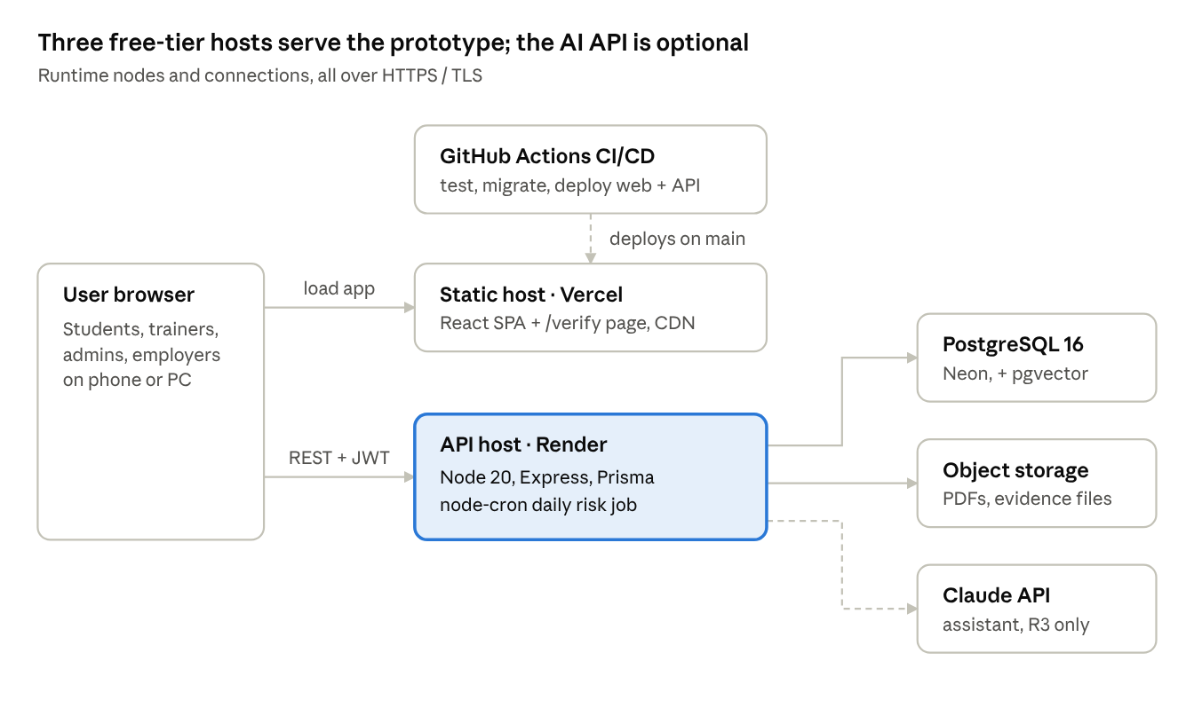
deployment · 6 nodes
Environment | Purpose | Database | Deploys from
Local | Development | PostgreSQL in Docker, seeded | Developer machine
Test (CI) | Automated tests | PostgreSQL service container, reset per run | Every pull request
Production / demo | Guide review and final demo | Managed PostgreSQL with daily backup | main branch
Configuration comes only from environment variables: DATABASE_URL, JWT_SECRET, REFRESH_SECRET, PUBLIC_BASE_URL, STORAGE_*, AI_ENABLED, ANTHROPIC_API_KEY, AI_MONTHLY_CAP. Hosting names are examples; any equivalent free tier works.

12. Non-functional design
Each BRD non-functional requirement maps to a concrete design choice and a way to check it.
NFR | Design choice | How verified
NFR-03 Performance (2 s, 100 users) | Indexes on all FKs and filter columns; aggregates in SQL; TanStack Query caching; pagination | k6 load test, 100 virtual users
BO-3 Allocation (500 students < 5 s) | Single sorted in-memory pass, O(n log n + n·p); one bulk insert in a transaction | Jest timing test with 500 seeded students
NFR-05 Reliability | prisma.$transaction for status changes; idempotency keys; PDF generation retried outside the transaction | Integration tests that force a failure mid-operation
NFR-09 Public pages (3 s mobile) | Separate lightweight verify page (no SPA bundle), cache headers | Lighthouse on throttled mobile
NFR-10 Low bandwidth (< 500 KB) | Route-based code splitting, gzip/brotli, WebP images, lazy-loaded charts, system fonts except Odia/Devanagari subsets | Bundle analyzer; Lighthouse on Slow 3G
NFR-11 Localization | i18next namespaces per module; locale stored on User; dates and numbers via Intl; certificates in English with optional Odia name | Missing-key check in CI
NFR-12 Accessibility | Semantic HTML, labelled inputs, focus states, 4.5:1 contrast, keyboard-only flows | axe-core in Playwright tests
NFR-13 AI cost and safety | Daily per-user limit, monthly cap, retrieval threshold, no personal data in prompts | Unit tests on guard logic; log review
NFR-14 Storage | 10 MB limit, MIME allow-list, video as links only | API tests with oversized and wrong-type files

13. Logging, audit and monitoring
Business changes go to the audit log in the database; technical events go to structured application logs.
Stream | What | Where | Retention
Audit log | Changes to attendance, marks, enrollment, completion, certificates, passport entries, settings: user, action, entity, id, old value, new value, timestamp | AuditLog table (insert-only) | Life of the system
Application log | Requests (method, path, status, latency, user id), errors with stack traces, cron job runs | pino JSON logs → hosting platform log viewer | 7–30 days (platform default)
AI log | Question, retrieved chunk IDs, tokens, latency, refusals | AssistantLog table | 90 days
Health | GET /health (app + DB check) | Uptime monitor (e.g. UptimeRobot free tier) | —
Audit entries are written by a Prisma middleware in the same transaction as the change, so a change cannot commit without its audit record. Personal data (passwords, tokens) is never written to any log.

14. Development, testing and CI/CD
Every pull request runs lint, type checks and tests; main deploys automatically, so the demo build is always current.
Repository layout (monorepo)
- apps/web — React frontend, src/features/<module> per module, src/locales/{en,or,hi}
- apps/api — Express backend, src/modules/<module>/{routes,controller,service,schema,tests}
- packages/shared — Zod schemas, enums (status values), types shared by both apps
- prisma/ — schema, migrations, seed script covering every role and status
Test levels
Level | Tool | Focus
Unit | Jest | Rule functions: attendance %, eligibility, grade, allocation, risk level, gap, match % — with boundary values
Integration | Supertest + test PostgreSQL | Endpoints, middleware, ownership, transactions
End-to-end | Playwright | One student from enrollment to certificate and passport; public verify page
Security | Supertest | Role escalation, cross-user access, public field leakage
Accessibility / performance | axe-core, Lighthouse, k6 | NFR-03, NFR-09, NFR-10, NFR-12
Pipeline (GitHub Actions): install → lint + typecheck → unit → integration (PostgreSQL service container) → build → on main: run migrations and deploy API and web → Playwright smoke test against the deployed URL.
Branching: main (deployed) and dev; one feature branch per task; pull requests reviewed by the other member.

15. Technical risks and traceability

15.1 Technical risks
Risk | Impact | Mitigation
Free-tier API host sleeps when idle; first request slow and cron may not fire | Demo delay; missed risk evaluation | Uptime pinger keeps it awake; on-demand evaluation after attendance save; run a catch-up job at startup
Free-tier DB connection limits | Errors under load | Prisma connection pool size 5; pooled connection string (PgBouncer)
Schema drift between members | Broken builds | Migrations only through Prisma; schema changes reviewed by P2
QR base URL changes after printing | Old QR codes break | Fixed PUBLIC_BASE_URL from week 3; /verify route kept permanently
Odia font rendering in PDFs | Broken glyphs on certificates | Embed Noto Sans Oriya in PDFKit; English-only certificate as fallback
AI answers drift from materials | Wrong guidance to students | Similarity threshold, citations, refusal path, feature flag off by default
Daily job slow as data grows | Late flags | One set-based SQL query per run; index on Attendance(student_id, session_id)

15.2 Traceability: BRD requirements to modules
BRD requirements | Modules | Key endpoints / jobs
BRQ-1.x (F1) | auth | /auth/*
BRQ-2.x, 3.x (F2, F3) | courses, enrollments | /courses, /enrollments
BRQ-4.x (F4), BRQ-14.x (F14) | batches + allocation, scheduling-advisor | /allocations/*, /scheduling/check
BRQ-5.x (F5) | sessions + attendance | /sessions/:id/attendance
BRQ-6.x (F6) | assessments | /assessments, /evaluations
BRQ-7.x (F7), BRQ-15.x (F15) | completion, documents, verification | /completions/*, /certificates/:id/revoke, /public/verify/:code
BRQ-8.x, 9.x (F8, F9), BRQ-20.x (F20) | reports + dashboard, analytics | /reports/*, /analytics/outcomes
BRQ-C.x, BRQ-10.x (F10) | competency, passport | /courses/:id/competencies, /students/:id/passport, /public/passport/:token
BRQ-11.x (F11) | intervention | daily cron, /risk-flags
BRQ-12.x (F12) | competency | /students/:id/gaps, /batches/:id/competency-heatmap
BRQ-13.x (F13) | opportunities | /opportunities, /students/me/matches
BRQ-16.x (F16) | web (i18n), all modules | locale on User
BRQ-17.x (F17) | assistant | /assistant/ask
BRQ-18.x (F18) | evidence | /evidence/upload-url
BRQ-19.x (F19) | audit | Prisma audit middleware, /audit-logs

