KISS VOCATIONAL TRAINING
MANAGEMENT PORTAL
Project Planning, System Design & Software Engineering Documentation
An end-to-end web-based system for managing vocational training, from enrollment to certification
Item | Details
Project Type | Group Software Engineering Project (Working Prototype + SE Documentation)
Team Size | 2 Members
Users | Students, Trainers, Administration
Document Version | 2.1 (refined draft with diagrams)
Status | Planning & Design

1. Project Overview
The KISS Vocational Training Management Portal is a web-based system that manages the complete vocational training lifecycle. It connects Students, Trainers and Administration through a single, rule-driven workflow covering elective enrollment, batch allocation, training delivery, attendance, progress tracking, assessment, evaluation, course completion and certificate/performance report generation.
The goal is a working end-to-end prototype rather than a collection of disconnected CRUD screens. The system's depth comes from enforced business rules, explicit status transitions, role- and ownership-based access control, and verifiable outputs (certificates and reports), backed by complete Software Engineering documentation.

1.1 Problem Statement
Vocational training is typically managed through spreadsheets, paper registers and informal communication. This causes:
- Manual, error-prone enrollment and batch allocation with no visibility into seat availability.
- Attendance and marks scattered across registers, making eligibility checks slow and inconsistent.
- Students lacking real-time visibility into their attendance, progress and results.
- Certificates issued without a consistent eligibility check or a way to verify authenticity.
- No audit trail when attendance or marks are changed.

1.2 Proposed Solution
A centralized portal where each role works on the same data, every workflow step changes a well-defined status, and the system (not individual users) decides eligibility for completion and certification.

2. Project Objectives
ID | Objective | Success Measure
OBJ-1 | Digitize the full training workflow from enrollment to certification. | One student can be taken through every stage in the demo without any offline step.
OBJ-2 | Provide separate role-based interfaces. | Each role sees only its own dashboard and permitted actions.
OBJ-3 | Centralize training data. | All entities stored in one relational database with enforced keys and constraints.
OBJ-4 | Reduce manual effort in allocation and tracking. | Batch allocation and attendance percentage are computed by the system.
OBJ-5 | Give students transparent progress information. | Attendance, marks and feedback are visible to the student immediately after entry.
OBJ-6 | Issue trustworthy completion documents. | Certificates are generated only for eligible students and carry a verifiable unique ID.
OBJ-7 | Demonstrate a complete SE lifecycle. | SRS, UML, ER, test plan, test cases, WBS, schedule and risk register delivered.

3. Project Scope

3.1 In Scope
- Authentication and role-based, ownership-aware authorization.
- Course/elective management and student enrollment with ranked preferences.
- Enrollment review (approve, reject, waitlist).
- Batch creation, student allocation and trainer assignment.
- Training session scheduling.
- Attendance recording and attendance percentage calculation.
- Progress tracking, assessments, results and trainer feedback/evaluation.
- Rule-based completion verification.
- Certificate and performance report generation with public certificate verification.
- Audit logging of sensitive changes (attendance, marks, approvals).
- Role dashboards and basic analytics.
- Testing and Software Engineering documentation.

3.2 Out of Scope (First Prototype)
- Payroll or trainer salary management.
- Full learning-management content hosting (videos, course material).
- Biometric or hardware-based attendance integration.
- Multi-campus or large-scale enterprise deployment.
- AI-based recommendations (possible future enhancement).

3.3 Assumptions and Constraints
- Student, trainer and course master data can be seeded or entered by Administration.
- Each student may be enrolled in only one vocational course per training cycle.
- The prototype runs as a single deployment serving a single institution.
- Development is limited to a two-member team within one academic semester.
- Email/SMS notifications are optional; in-app status updates are sufficient for the MVP.

4. Stakeholders and User Roles
Role | Primary Responsibilities | Key Screens
Student | Browse courses, submit ranked preferences, view batch, trainer and schedule, track attendance, progress, results and feedback, download certificate and performance report. | Dashboard, Course Catalogue, My Enrollment, My Training, Documents
Trainer | View assigned batches and students, manage sessions, mark attendance, update progress, record assessment marks, give feedback, recommend completion. | Dashboard, My Batches, Session Attendance, Assessments, Evaluations
Administration | Manage students, trainers, courses, batches and schedules; review enrollments; run allocation; monitor performance; approve completion; issue certificates; view reports. | Dashboard, Master Data, Enrollments, Allocation, Completion Queue, Reports
Public Verifier (optional) | Verify a certificate using its certificate ID or QR code, without logging in. | Certificate Verification Page

5. End-to-End System Workflow
Each step is performed by a specific actor and moves the student's enrollment into a defined status (see Section 7).
Step | Actor | Action | Resulting Status
1 | Admin | Creates courses, sets seat limits and opens the enrollment window. | Course: Open
2 | Student | Browses courses and submits ranked preferences. | Enrollment: Pending
3 | Admin | Reviews requests: approves, rejects or waitlists. | Approved / Rejected / Waitlisted
4 | Admin / System | Creates batches and runs allocation for approved students. | Allocated
5 | Admin | Assigns trainers and schedules sessions; activates the batch. | In Training
6 | Trainer | Conducts sessions and marks attendance. | In Training
7 | Trainer | Records progress, assessment marks and feedback. | In Training
8 | Trainer | Submits final evaluation and completion recommendation. | Completion Pending
9 | System | Checks completion rules (attendance, assessments, aggregate score). | Eligible / Not Eligible
10 | Admin | Verifies and approves completion. | Completed / Not Completed
11 | System | Generates certificate (with unique ID) and performance report. | Certified
12 | Student | Views and downloads completion documents. | Certified

6. Business Rules
These rules are enforced by the backend. They are the main difference between this system and a basic CRUD application, and they directly drive the boundary-value test cases.
ID | Rule
BR-01 | A student may hold only one active enrollment per training cycle; duplicate requests are rejected.
BR-02 | Enrollment requests are accepted only while the course's enrollment window is open.
BR-03 | A batch cannot exceed its seat capacity; excess approved students are waitlisted.
BR-04 | Allocation honours student preference rank first, then the configured priority rule (submission time or CGPA).
BR-05 | A trainer may mark attendance, enter marks and evaluate students only for batches assigned to them.
BR-06 | Attendance can be marked only for scheduled sessions and edited within 48 hours; later edits require Admin and are audit-logged.
BR-07 | Assessment marks must be between 0 and the assessment's maximum marks.
BR-08 | Attendance % = sessions attended ÷ sessions conducted × 100, rounded to two decimals.
BR-09 | Completion eligibility requires: attendance ≥ 75%, all mandatory assessments recorded, aggregate score ≥ 40%, and a trainer completion recommendation.
BR-10 | A certificate is generated only after Admin approves completion; each certificate has a unique, non-guessable ID.
BR-11 | Performance grade bands: A (≥ 85%), B (70–84.99%), C (55–69.99%), D (40–54.99%), Not Completed (< 40%).
BR-12 | Every change to attendance, marks, enrollment status or completion status is written to the audit log (who, what, when, old and new value).
Threshold values (75%, 40%, 48 hours, grade bands) should be stored as configurable settings so they can be changed without code changes.

7. Status Lifecycles
These lifecycles form the basis of the State Diagrams and keep all modules consistent about what each status means.

7.1 Enrollment / Student Training Status
From | To | Trigger | Actor
— | Pending | Student submits enrollment request | Student
Pending | Approved | Request approved | Admin
Pending | Rejected | Request rejected with reason | Admin
Pending / Approved | Waitlisted | No seat available | Admin / System
Waitlisted | Approved | Seat becomes available | Admin / System
Approved | Allocated | Student placed in a batch | Admin / System
Allocated | In Training | Batch activated | Admin
In Training | Completion Pending | Trainer submits final evaluation | Trainer
Completion Pending | Completed | Rules satisfied and Admin approves | System + Admin
Completion Pending | Not Completed | Rules not satisfied or Admin rejects | System + Admin
Completed | Certified | Certificate and report generated | System

7.2 Batch Status
Status | Meaning
Planned | Batch created; students and trainer can be assigned; no sessions conducted yet.
Active | Training in progress; attendance and assessments can be recorded.
Closed | Training finished; attendance and marks locked; completion processing begins.

8. Functional Requirements
Priority uses MoSCoW: M = Must (MVP), S = Should, C = Could. Requirement IDs are reused in the SRS, test cases and traceability matrix.

8.1 Authentication & Access
ID | Requirement | Priority
FR-01 | Users log in with email and password; passwords are stored hashed. | M
FR-02 | The system routes each user to a role-specific dashboard. | M
FR-03 | Every API checks role and resource ownership before acting. | M
FR-04 | Users can update their profile and change their password. | S

8.2 Student Module
ID | Requirement | Priority
FR-10 | View the course catalogue with description, duration, seats and enrollment window. | M
FR-11 | Submit an enrollment request with up to three ranked preferences. | M
FR-12 | Track enrollment status and see rejection or waitlist reasons. | M
FR-13 | View allocated batch, trainer and session schedule. | M
FR-14 | View attendance history and current attendance percentage. | M
FR-15 | View progress updates, assessment results and trainer feedback. | M
FR-16 | View completion status and download certificate and performance report. | M

8.3 Trainer Module
ID | Requirement | Priority
FR-20 | View assigned batches and their enrolled students. | M
FR-21 | View and manage sessions for assigned batches. | S
FR-22 | Mark attendance per session (present/absent/late) and edit within the allowed window. | M
FR-23 | Record progress updates for students. | M
FR-24 | Create assessments and enter marks with validation. | M
FR-25 | Submit final evaluation with remarks and a completion recommendation. | M
FR-26 | View students at risk (attendance below threshold). | S

8.4 Administration Module
ID | Requirement | Priority
FR-30 | Manage students, trainers and courses (create, update, deactivate). | M
FR-31 | Open and close enrollment windows per course. | M
FR-32 | Approve, reject or waitlist enrollment requests (single and bulk). | M
FR-33 | Create batches with capacity, dates and venue. | M
FR-34 | Run automatic allocation and manually adjust allocations. | M
FR-35 | Assign trainers and schedule sessions for batches. | M
FR-36 | Monitor attendance and performance across batches. | S
FR-37 | Review the completion queue with the system's eligibility result and approve or reject. | M
FR-38 | Generate certificates and performance reports (PDF). | M
FR-39 | View dashboards and export reports (CSV/PDF). | S
FR-40 | View the audit log with filters by user, entity and date. | S

8.5 Public
ID | Requirement | Priority
FR-50 | Verify a certificate by ID or QR code, showing name, course, date and validity only. | C

9. Non-Functional Requirements
ID | Category | Requirement
NFR-01 | Security | Passwords hashed with bcrypt; JWT access tokens with expiry; authorization enforced on the server for every request.
NFR-02 | Security | All input validated server-side; parameterized queries/ORM to prevent SQL injection; output escaped to prevent XSS.
NFR-03 | Performance | Common pages and API calls respond within 2 seconds for up to 100 concurrent users in the demo environment.
NFR-04 | Usability | Responsive interface usable on desktop and mobile; each core task reachable within three clicks from the dashboard.
NFR-05 | Reliability | Status-changing operations run in database transactions so partial updates cannot occur.
NFR-06 | Auditability | Sensitive changes are logged immutably as defined in BR-12.
NFR-07 | Maintainability | Modular code structure per module; consistent naming; README and API documentation kept current.
NFR-08 | Privacy | Users see only data they are authorized for; public verification exposes minimal certificate details.

10. Proposed System Architecture
A modular monolith is recommended for a two-person project: one deployable application, internally split into modules with clear boundaries. It is simpler to build, test and deploy than microservices while still showing clean separation of concerns.
Layer | Responsibility | Technology
Presentation | Role-based UI, forms, dashboards, client-side routing | React, Tailwind CSS, Recharts
API | REST endpoints, request validation, error handling | Node.js, Express.js, Zod/Joi
Security | Authentication, role and ownership checks | JWT, bcrypt, middleware
Business Logic | Business rules, status transitions, allocation, eligibility checks | Service layer per module
Data Access | Queries, transactions, migrations | Prisma or Sequelize ORM
Database | Persistent relational storage | PostgreSQL (recommended) or MySQL
Documents | Certificate and report PDFs with QR codes | PDFKit / Puppeteer, qrcode
Decision: PostgreSQL is recommended for its strong constraint support and free hosting options. Finalize this in Phase 1 so both members build against the same schema.

10.1 Suggested Project Structure
Organize the backend by module so each member owns clear folders: auth, students, trainers, courses, enrollments, batches, sessions, attendance, assessments, evaluations, completion, documents, reports and audit. Each module contains its routes, controller, service (business rules) and validation schema.

11. Database Design

11.1 Entities and Key Attributes
Entity | Key Attributes
User | user_id (PK), name, email (unique), password_hash, role, is_active, created_at
Student | student_id (PK), user_id (FK), roll_no (unique), program, year, cgpa, phone
Trainer | trainer_id (PK), user_id (FK), specialization, phone
Course | course_id (PK), code (unique), title, description, duration_weeks, total_seats, enroll_start, enroll_end, status
Enrollment | enrollment_id (PK), student_id (FK), course_id (FK), preference_rank, status, remarks, submitted_at
Batch | batch_id (PK), course_id (FK), name, capacity, start_date, end_date, venue, status
BatchStudent | batch_id (FK), student_id (FK), allocated_at; PK (batch_id, student_id)
TrainerAssignment | batch_id (FK), trainer_id (FK), assigned_at; PK (batch_id, trainer_id)
TrainingSession | session_id (PK), batch_id (FK), session_date, start_time, end_time, topic
Attendance | attendance_id (PK), session_id (FK), student_id (FK), status, marked_by, marked_at; unique (session_id, student_id)
Progress | progress_id (PK), student_id (FK), batch_id (FK), milestone, percent_complete, note, updated_at
Assessment | assessment_id (PK), batch_id (FK), title, type, max_marks, weightage, is_mandatory, held_on
AssessmentResult | result_id (PK), assessment_id (FK), student_id (FK), marks_obtained; unique (assessment_id, student_id)
Evaluation | evaluation_id (PK), student_id (FK), batch_id (FK), trainer_id (FK), skill_rating, remarks, recommendation
Certificate | certificate_id (PK, unique code), student_id (FK), course_id (FK), grade, issued_on, approved_by
PerformanceReport | report_id (PK), student_id (FK), batch_id (FK), attendance_pct, aggregate_score, grade, file_path
AuditLog | log_id (PK), user_id (FK), action, entity, entity_id, old_value, new_value, timestamp

11.2 Key Relationships
Relationship | Cardinality | Meaning
User – Student / Trainer | 1 : 0..1 | Each login account belongs to at most one student or trainer profile.
Student – Enrollment | 1 : N | A student can submit several ranked preference records.
Course – Enrollment | 1 : N | A course receives many enrollment requests.
Course – Batch | 1 : N | A course can run in multiple batches.
Batch – Student | M : N via BatchStudent | A batch has many students; a student may join batches across training cycles.
Batch – Trainer | M : N via TrainerAssignment | A trainer can handle several batches; a batch may have a co-trainer.
Batch – TrainingSession | 1 : N | A batch has many scheduled sessions.
TrainingSession – Attendance | 1 : N | One attendance record per student per session.
Batch – Assessment | 1 : N | Assessments are defined per batch.
Assessment – AssessmentResult | 1 : N | One result per student per assessment.
Student – Evaluation | 1 : N | A student receives a final evaluation per batch.
Student – Certificate | 1 : 0..N | At most one certificate per completed course.
User – AuditLog | 1 : N | Every logged change is linked to the user who made it.
Refinement from v1: Batch–Student and Trainer–Batch are many-to-many through junction tables, attendance links to sessions rather than directly to students, and marks are stored in a separate AssessmentResult entity.

12. Role-Based Access Control
Authorization is enforced in backend middleware, never only by hiding frontend buttons. Each request checks the user's role and, where required, ownership (a trainer's own batches, a student's own records).
Capability | Student | Trainer | Admin
View own profile and dashboard | Yes | Yes | Yes
Browse course catalogue | Yes | Yes (read) | Yes
Submit enrollment request | Yes (self) | No | Yes (on behalf)
Approve / reject / waitlist enrollment | No | No | Yes
Create and manage courses | No | No | Yes
Create batches and run allocation | No | No | Yes
View batch students | No | Own batches | Yes
Mark / edit attendance | No | Own batches, 48 h | Yes (logged)
Record progress and marks | No | Own batches | Yes (logged)
View attendance, progress, results | Own only | Own batches | Yes
Submit evaluation / recommend completion | No | Own batches | No
Approve completion and issue certificate | No | No | Yes
View reports and audit log | No | Own batch reports | Yes
Verify certificate (public page) | Yes | Yes | Yes

13. Batch Allocation Approach
Allocation is the most algorithmic part of the system and should be documented clearly in the SRS and an Activity Diagram.
- Collect all Approved enrollment preferences for the training cycle.
- Sort students by the priority rule (earliest submission time, or CGPA when configured).
- For each student in order, try their preferences from rank 1 to rank 3.
- For the preferred course, place the student in the batch with the most free seats.
- If every batch of every preferred course is full, mark the student Waitlisted.
- Run the whole allocation in one database transaction and write a summary to the audit log.
- Show Admin a preview (allocated, waitlisted, seats remaining) before confirming.
Complexity is roughly O(n log n) for sorting plus O(n × p) for placement, where p is the number of preferences (3). This is easily explained in viva and fast enough for thousands of students.

14. Two-Person Team Division
With two members, work is split by complete workflows rather than scattered features, so each person owns a vertical slice (UI, API, business rules and tests) and integration points stay few and explicit.
Work Area | Person 1 | Person 2
Requirements, SRS, architecture, database schema | Shared | Shared
Authentication and RBAC middleware | Lead | Support
Student module (catalogue, enrollment, my training) | Lead | Support
Trainer module (sessions, attendance, progress) | Lead | Support
Assessments, results and evaluations | Lead | Support
Admin module and master data (students, trainers, courses) | Support | Lead
Enrollment review and batch allocation | Support | Lead
Trainer assignment and scheduling | Support | Lead
Completion engine, certificates and reports | Support | Lead
Audit log and certificate verification | Support | Lead
Frontend integration, testing, final documentation | Shared | Shared

14.1 Person 1 – Student & Training Workflow
Owns: Authentication → Course Catalogue → Enrollment Submission → My Batch → Sessions → Attendance → Progress → Assessments → Evaluation.

14.2 Person 2 – Administration & Management Workflow
Owns: Master Data → Enrollment Review → Batch Creation → Allocation → Trainer Assignment → Completion Queue → Certificates & Reports → Audit Log.

14.3 Documentation Ownership
Artifact | Owner
SRS (introduction, scope, NFRs) | Shared
Use Case Diagram and use case specifications | Person 1
Sequence Diagrams: login, enrollment, attendance, assessment | Person 1
Sequence Diagrams: allocation, completion, certificate | Person 2
Activity Diagrams: training and assessment flows | Person 1
Activity Diagram: allocation; State Diagrams (Section 7) | Person 2
Class Diagram, ER Diagram, relational schema, data dictionary | Person 2
Component and Deployment Diagrams | Person 1
Test plan and test cases | Each for own modules
WBS, Gantt chart, risk register | Shared
User manual and technical documentation | Each for own modules

14.4 Integration Points
The two slices meet at a small number of contracts that must be agreed before parallel coding begins:
- Enrollment status values and transitions (Section 7).
- Batch and BatchStudent structure used by trainer screens.
- Attendance and assessment data consumed by the completion engine.
- Shared authentication middleware and error response format.

15. Minimum Viable Product (MVP)
Priority | Features
Must (MVP) | Login with three roles and RBAC; course creation and catalogue; enrollment with preferences; admin approval; batch creation and allocation; trainer assignment; session scheduling; attendance; progress; assessment marks; evaluation; completion check and approval; certificate and performance report generation; student document download.
Should | Audit log viewer; at-risk student list; bulk approval; report export (CSV/PDF); dashboard charts; waitlist promotion.
Could | Public certificate verification with QR; email notifications; profile photos; dark mode.
Won't (this version) | Payroll, LMS content hosting, biometric attendance, AI recommendations.
Rule of thumb: no Should or Could feature starts until one student can travel the full Must workflow end-to-end in the deployed build.

16. Key Use Case Specifications

UC-01: Submit Enrollment Request
Field | Description
Primary Actor | Student
Preconditions | Student is logged in; at least one course has an open enrollment window.
Main Flow | 1. Student opens the course catalogue.  2. Student selects up to three courses and ranks them.  3. Student submits the request.  4. System validates BR-01 and BR-02.  5. System saves the preferences with status Pending and confirms.
Alternate Flows | 4a. Student already has an active enrollment: system rejects with a message.  4b. Window closed: system blocks submission.
Postconditions | Enrollment records exist with status Pending and are visible to Admin.

UC-02: Allocate Students to Batches
Field | Description
Primary Actor | Admin
Preconditions | Enrollments are approved; batches exist with capacity.
Main Flow | 1. Admin opens Allocation for a training cycle.  2. System runs the allocation algorithm (Section 13).  3. System shows a preview of allocated and waitlisted students.  4. Admin confirms.  5. System saves BatchStudent records in one transaction and logs the action.
Alternate Flows | 3a. Admin manually moves a student before confirming, within capacity.  5a. Transaction fails: no changes are saved and an error is shown.
Postconditions | Students are Allocated or Waitlisted; students can see their batch.

UC-03: Mark Session Attendance
Field | Description
Primary Actor | Trainer
Preconditions | Trainer is assigned to the batch; the session is scheduled; batch is Active.
Main Flow | 1. Trainer opens today's session for an assigned batch.  2. System lists allocated students.  3. Trainer marks each student present, absent or late.  4. Trainer saves.  5. System stores records and recalculates attendance percentages.
Alternate Flows | 1a. Trainer is not assigned to the batch: access denied (BR-05).  4a. Editing after 48 hours: blocked for trainers (BR-06).
Postconditions | Attendance saved; students see updated percentages.

UC-04: Approve Completion and Issue Certificate
Field | Description
Primary Actor | Admin (System supports)
Preconditions | Batch is Closed; trainer has submitted evaluations.
Main Flow | 1. Admin opens the completion queue.  2. System shows each student's attendance %, aggregate score, mandatory assessment status and eligibility (BR-09).  3. Admin approves eligible students.  4. System generates a certificate with a unique ID and a performance report.  5. Student is notified in-app and can download both documents.
Alternate Flows | 2a. Student not eligible: Admin can only mark Not Completed with a reason.  4a. PDF generation fails: status stays Completed and Admin can retry.
Postconditions | Status is Certified; documents are stored and downloadable.

17. Software Engineering Documentation Plan
Artifact | Contents | Phase
SRS (IEEE 830 style) | Purpose, scope, definitions, users, functional (FR) and non-functional (NFR) requirements, business rules, constraints, assumptions, interfaces. | 1
Use Case Diagram + Specs | Actors, use cases, include/extend relations; UC specifications as in Section 16. | 1
Class Diagram | Classes, attributes, methods, associations and multiplicities. | 1
ER Diagram + Relational Schema | Entities, keys, relationships, normalized tables (3NF). | 1
Data Dictionary | Field names, types, constraints and descriptions. | 1–2
Sequence Diagrams | Login, enrollment, allocation, attendance, assessment, completion and certificate. | 2–3
Activity Diagrams | Allocation algorithm, training flow, completion flow. | 2–3
State Diagrams | Enrollment and batch lifecycles (Section 7). | 2
Component and Deployment Diagrams | Modules, APIs and database; client, server, database and file storage nodes. | 2
Test Plan and Test Cases | Approach, environment, entry/exit criteria, test cases, results. | 3–7
Traceability Matrix | FR → Use Case → Test Case mapping. | 7
WBS, Gantt, Risk Register | Work decomposition, schedule, risks and mitigation. | 1, updated weekly
User Manual | Step-by-step guide per role with screenshots. | 8
Technical Documentation | Setup, environment variables, API reference, architecture and schema. | 8
The initial versions of the use case, class, ER, sequence, activity, state, component and deployment diagrams are provided in Section 27.

18. Testing Strategy
Level / Technique | Application in this Project
Unit Testing | Business rule functions: attendance %, eligibility check, grade calculation, allocation (Jest).
Integration Testing | API endpoints with a test database, including auth middleware (Supertest).
System Testing | Full workflows end-to-end through the UI in a deployed environment.
User Acceptance Testing | Walkthroughs by classmates acting as Student, Trainer and Admin.
Boundary Value Analysis | Attendance at 74.99% / 75%, marks at 0 / max / max+1, batch at capacity / capacity+1.
Equivalence Partitioning | Valid/invalid login, open/closed enrollment window, assigned/unassigned trainer.
Security Testing | Accessing other users' records, role escalation, missing or expired tokens, SQL injection inputs.

18.1 Sample Test Cases
TC ID | Req. | Scenario / Input | Expected Result
TC-01 | FR-01 | Student logs in with valid credentials | Student dashboard is shown
TC-02 | FR-01 | Login with wrong password | Generic error; no token issued
TC-03 | FR-11 | Student submits valid ranked preferences | Enrollment saved as Pending
TC-04 | BR-01 | Student submits a second enrollment in the same cycle | Request rejected with message
TC-05 | BR-02 | Enrollment after window closes | Submission blocked
TC-06 | FR-32 | Admin approves a pending enrollment | Status becomes Approved
TC-07 | BR-03 | Allocation when batch is at full capacity | Extra student is Waitlisted
TC-08 | BR-05 | Trainer opens a batch not assigned to them | 403 Forbidden
TC-09 | FR-22 | Trainer marks attendance for a session | One record per student saved
TC-10 | BR-06 | Trainer edits attendance after 48 hours | Edit blocked
TC-11 | BR-07 | Marks entered as max_marks + 1 | Validation error
TC-12 | BR-07 | Marks entered as 0 and as max_marks | Both accepted
TC-13 | BR-09 | Attendance 74.99%, other criteria met | Not eligible
TC-14 | BR-09 | Attendance 75.00%, other criteria met | Eligible
TC-15 | FR-03 | Student calls an admin-only API | 403 Forbidden
TC-16 | FR-38 | Admin approves an eligible student | Certificate with unique ID generated
TC-17 | FR-16 | Student downloads certificate | Correct PDF for that student only
TC-18 | FR-50 | Verify with an invalid certificate ID | Shows 'Certificate not found'
TC-19 | BR-12 | Admin edits marks after lock | Change applied and audit log entry created
Each test case in the final document should also include preconditions, test data, actual result and pass/fail status.

19. Requirements Traceability (Sample)
Requirement | Use Case | Test Cases
FR-01, FR-03 | Login / all | TC-01, TC-02, TC-15
FR-11, BR-01, BR-02 | UC-01 | TC-03, TC-04, TC-05
FR-32, FR-34, BR-03 | UC-02 | TC-06, TC-07
FR-22, BR-05, BR-06 | UC-03 | TC-08, TC-09, TC-10
FR-24, BR-07 | Assessment workflow | TC-11, TC-12
FR-37, FR-38, BR-09 | UC-04 | TC-13, TC-14, TC-16, TC-17
FR-50, BR-12 | Verification / audit | TC-18, TC-19

20. Work Breakdown Structure (WBS)
WBS ID | Component / Task | Owner
1.0 | KISS Vocational Training Management Portal | Team
1.1 | Requirements Engineering | Shared
1.1.1–1.1.4 | Stakeholders, functional and non-functional requirements, business rules | Shared
1.1.5 | SRS preparation and review | Shared
1.2 | System Design | Shared
1.2.1 | Architecture, component and deployment design | Person 1
1.2.2 | ER diagram, schema, data dictionary | Person 2
1.2.3 | UML diagrams (use case, class, sequence, activity, state) | Split per 14.3
1.2.4 | API contract | Shared
1.3 | Student & Training Component | Person 1
1.3.1–1.3.3 | Auth/RBAC, catalogue and enrollment, my-batch views | Person 1
1.3.4–1.3.6 | Sessions and attendance, progress, assessments and evaluations | Person 1
1.4 | Administration Component | Person 2
1.4.1–1.4.3 | Dashboard, master data, enrollment review | Person 2
1.4.4–1.4.5 | Batches, allocation, trainer assignment, scheduling | Person 2
1.4.6–1.4.8 | Completion engine, certificates and reports, audit log | Person 2
1.5 | Testing | Shared
1.5.1–1.5.4 | Unit, integration, system and UAT | Each for own modules; shared system testing
1.6 | Deployment & Documentation | Shared
1.6.1–1.6.4 | Deployment, user manual, technical docs, final report and presentation | Shared

21. Risk Register
Risk | Prob. | Impact | Mitigation | Owner
Scope grows too large | High | High | Freeze MVP (Section 15) after Phase 1; new ideas go to a backlog. | Shared
Frontend/backend integration problems | Med | High | Agree API contract and response formats before parallel coding; integrate weekly. | Shared
Schema conflicts between members | Med | High | Design schema together; use ORM migrations; one member reviews schema changes. | Person 2
Uneven workload | Med | Med | Track tasks on a shared board (GitHub Projects/Trello); review weekly. | Shared
Security gaps in authorization | Med | High | Central RBAC middleware; dedicated security test cases (TC-08, TC-15). | Person 1
Allocation logic bugs | Med | High | Unit-test allocation with edge cases (full batches, ties, empty preferences). | Person 2
PDF generation takes too long | Low | Med | Start with a simple template; polish only after MVP works. | Person 2
Deployment issues close to demo | Med | High | Deploy early in Phase 2 and redeploy continuously. | Shared
Insufficient testing time | High | High | Write tests alongside features, not at the end. | Shared
Documentation left to the last minute | High | Med | Update diagrams and SRS at the end of each phase. | Shared

22. Development Schedule
Indicative 12-week plan; adjust week numbers to the semester calendar.
Phase | Weeks | Focus | Deliverables / Milestone
1 | 1–2 | Requirements & Design | SRS draft, use cases, ER model, class diagram, API contract. M1: Design sign-off
2 | 3 | Foundation | Repository, CI, database migrations, authentication, RBAC, base layouts, first deployment
3 | 4–5 | Core Workflows | Courses, enrollment, approval, batches, allocation, trainer assignment. M2: Student allocated end-to-end
4 | 6–7 | Training Operations | Sessions, attendance, progress, assessments, evaluations
5 | 8 | Completion | Eligibility engine, completion queue, certificates, reports. M3: Full MVP workflow
6 | 9 | Integration & Enhancements | Dashboards, audit log, verification page, UI polish
7 | 10–11 | Testing | Unit, integration, system, security and UAT; bug fixing; traceability matrix
8 | 12 | Finalization | Final documentation, user manual, demo data, presentation. M4: Submission

23. API Outline
All endpoints are prefixed with /api, return JSON, and use a consistent error format: { "error": { "code", "message" } }.
Method & Endpoint | Purpose | Role
POST /auth/login | Log in and receive a JWT | Public
GET /auth/me | Current user profile | All
GET /courses | List courses | All
POST /courses · PUT /courses/:id | Create or update a course | Admin
POST /enrollments | Submit ranked preferences | Student
GET /enrollments?status= | List enrollments (own for student) | Student, Admin
PATCH /enrollments/:id/status | Approve, reject or waitlist | Admin
POST /batches · GET /batches | Create or list batches | Admin (Trainer: own)
POST /allocations/preview · POST /allocations/confirm | Run and confirm allocation | Admin
POST /batches/:id/trainers | Assign trainer | Admin
POST /batches/:id/sessions · GET /batches/:id/sessions | Schedule or list sessions | Admin, Trainer
PUT /sessions/:id/attendance | Mark or edit attendance for a session | Trainer, Admin
GET /students/:id/attendance | Attendance history and % | Student (own), Trainer, Admin
POST /progress · GET /students/:id/progress | Record or view progress | Trainer / Student, Admin
POST /assessments · PUT /assessments/:id/results | Create assessment and enter marks | Trainer
POST /evaluations | Final evaluation and recommendation | Trainer
GET /completions?batchId= · POST /completions/:studentId/approve | Completion queue and approval | Admin
GET /students/:id/certificate · GET /students/:id/report | Download documents | Student (own), Admin
GET /verify/:certificateId | Public certificate verification | Public
GET /audit-logs | View audit trail | Admin

24. Collaboration and Development Practices
- Version control: GitHub repository with main (stable, deployed) and dev branches; one feature branch per task, merged through pull requests reviewed by the other member.
- Commits: small, descriptive commits (for example "feat(attendance): add 48h edit rule").
- Task tracking: GitHub Projects or Trello board with To Do, In Progress, Review and Done columns, linked to WBS IDs.
- API contract first: endpoints, request and response shapes documented (Postman collection or OpenAPI) before implementation.
- Environments: .env files for secrets (never committed); seed script for demo data covering every role and status.
- Weekly sync: a short review of progress, blockers, risks and documentation updates.

25. Definition of Done
A feature is done when it is implemented, validated on the server, covered by tests, merged after review, deployed and reflected in the documentation. The prototype is done when:
- All three roles log in and see role-appropriate dashboards.
- A student can enroll, be approved, allocated, trained, assessed, evaluated and certified in the deployed build.
- All business rules in Section 6 are enforced by the backend.
- Unauthorized role and ownership violations are rejected by the backend.
- Certificates and performance reports are generated correctly and are downloadable.
- All Must test cases pass, with results recorded.
- SRS, UML, ER, test documentation, WBS, schedule, risk register and user manual are complete.

26. Recommended Project Strategy
Build a thin but complete vertical slice first: Authentication → Course → Enrollment → Approval → Allocation → Session → Attendance → Assessment → Evaluation → Completion → Certificate. Once one student can move through this path reliably in the deployed build, add dashboards, the audit log viewer, verification and other enhancements.
Present the project as an integrated management system. The business rules, status lifecycles, allocation algorithm, ownership-based access control, verifiable certificates and complete SE artifacts are what demonstrate its depth, far more than the number of screens.

27. System Design Diagrams
This section contains the initial UML and database diagrams, derived from the requirements, business rules and lifecycles defined above. Editable PlantUML source files are provided separately so both members can update the diagrams as the design evolves.

27.1 Use Case Diagram
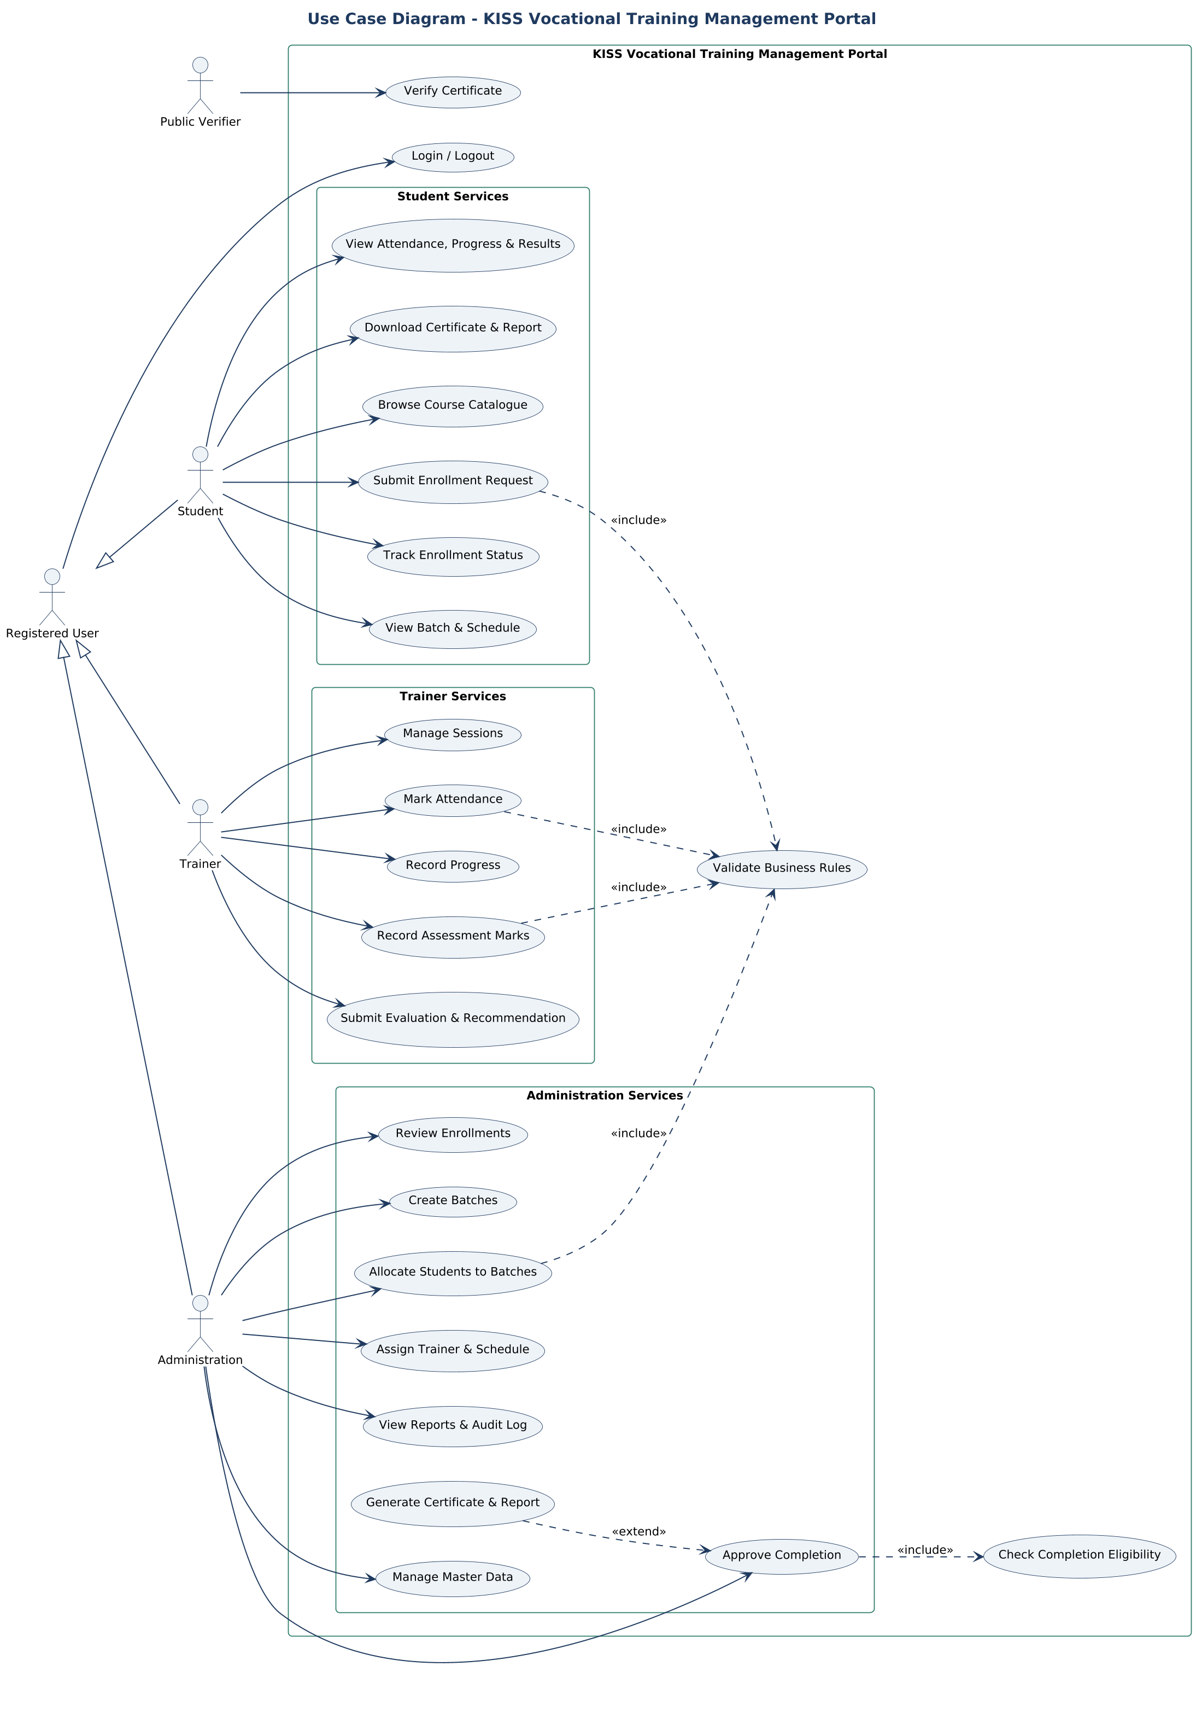
Figure 1: Actors and use cases. All registered users inherit Login; business-rule validation and eligibility checks are included use cases.

27.2 Class Diagram
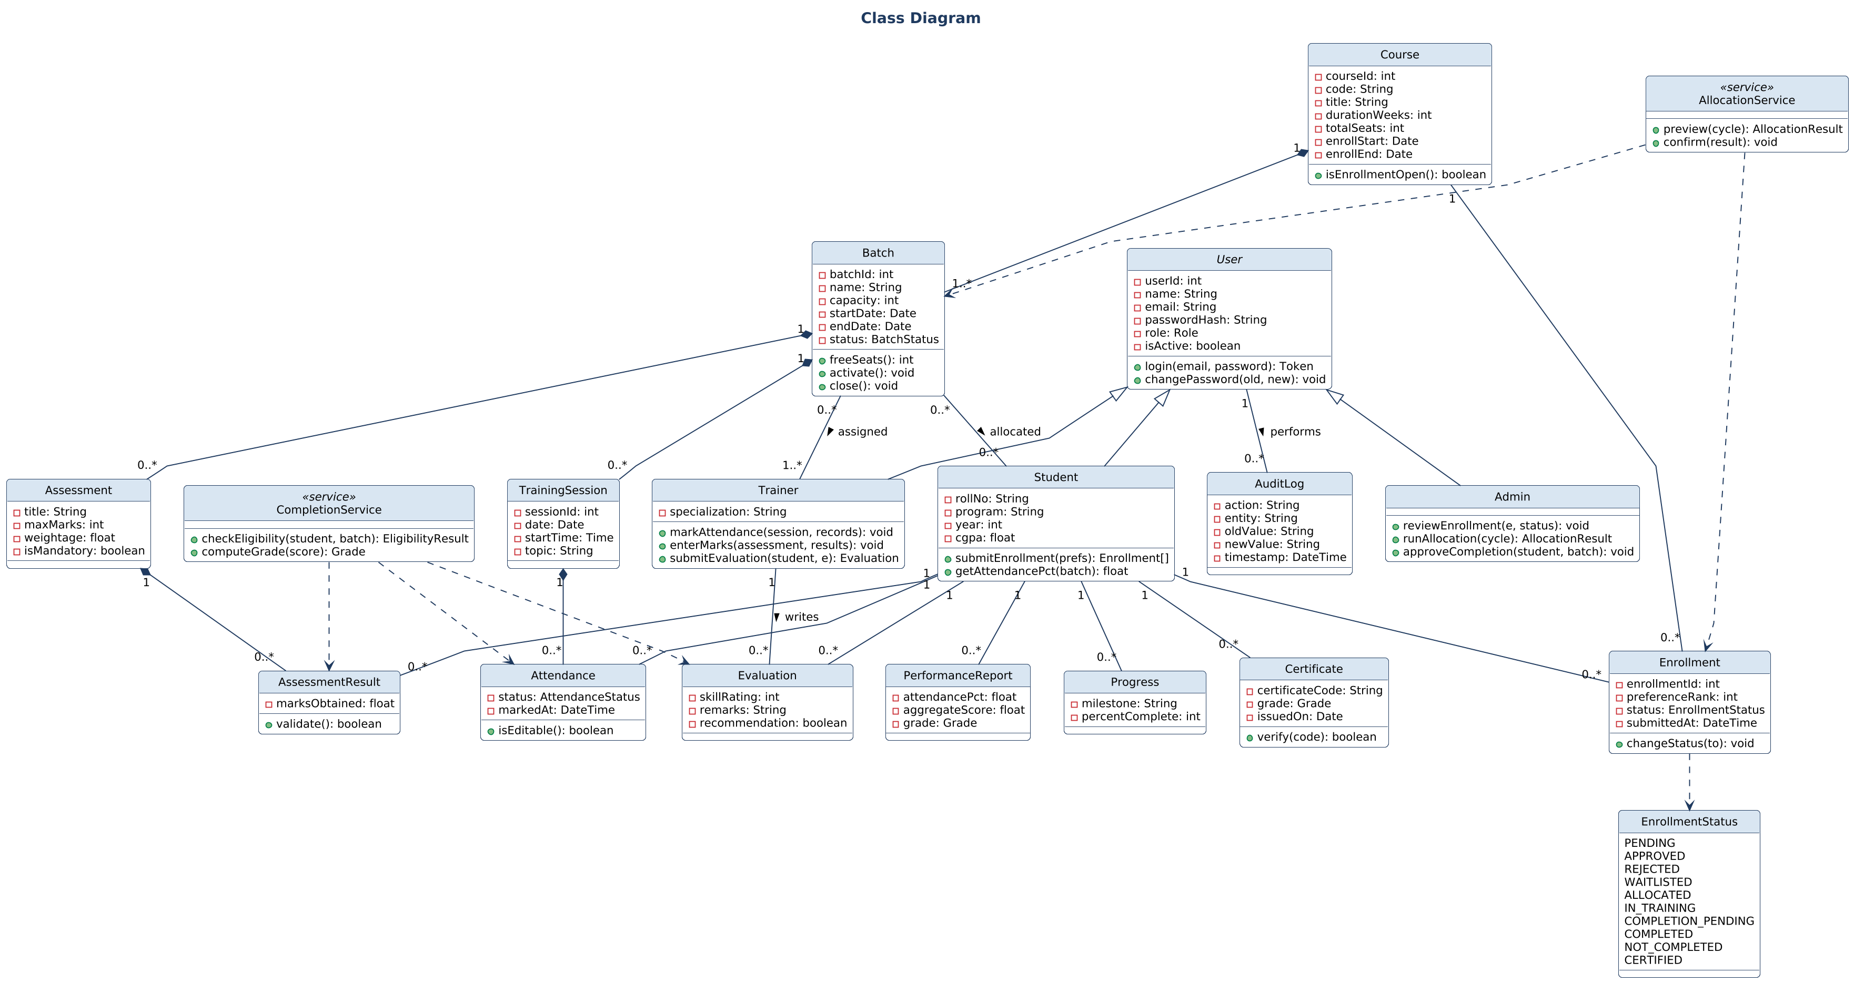
Figure 2: Domain classes, services, associations and multiplicities.

27.3 Entity-Relationship Diagram
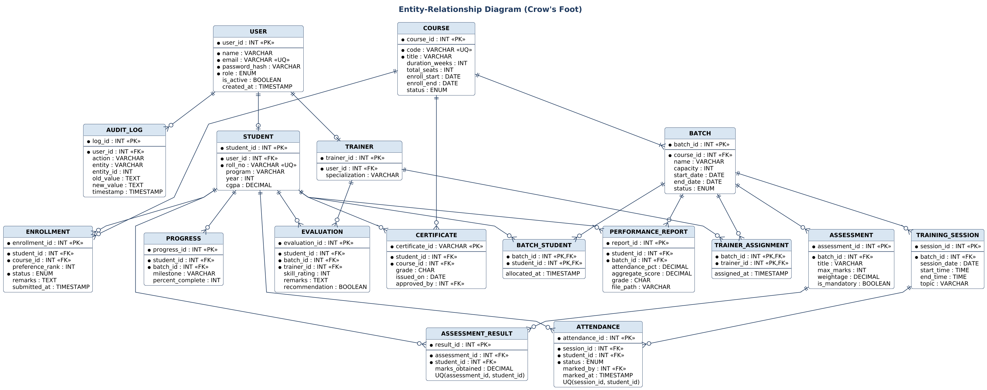
Figure 3: Database entities with primary, foreign and unique keys in crow's foot notation.

27.4 Sequence Diagram – Login & Role-Based Access
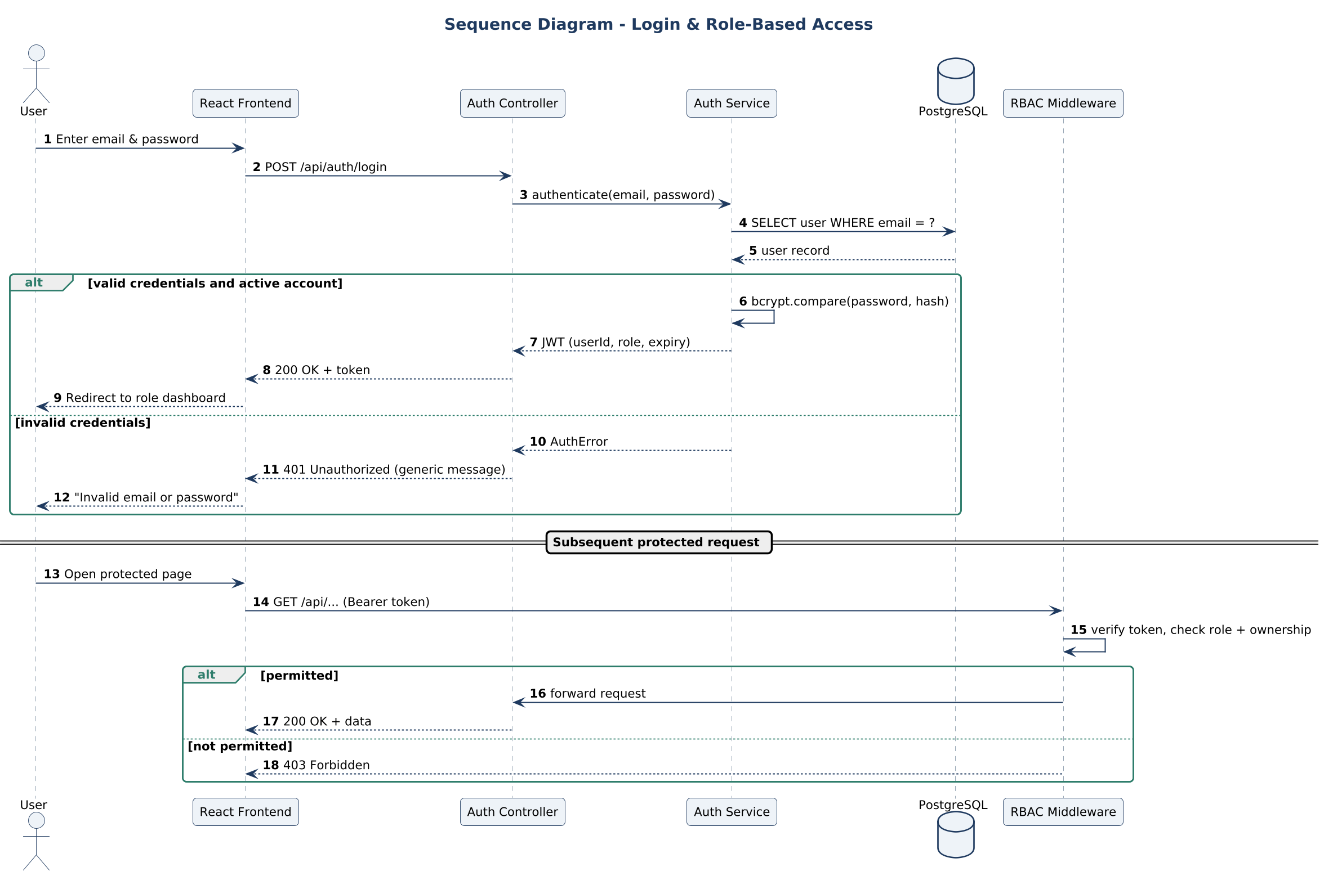
Figure 4: Authentication and RBAC middleware flow.

27.5 Sequence Diagram – Enrollment Submission & Review
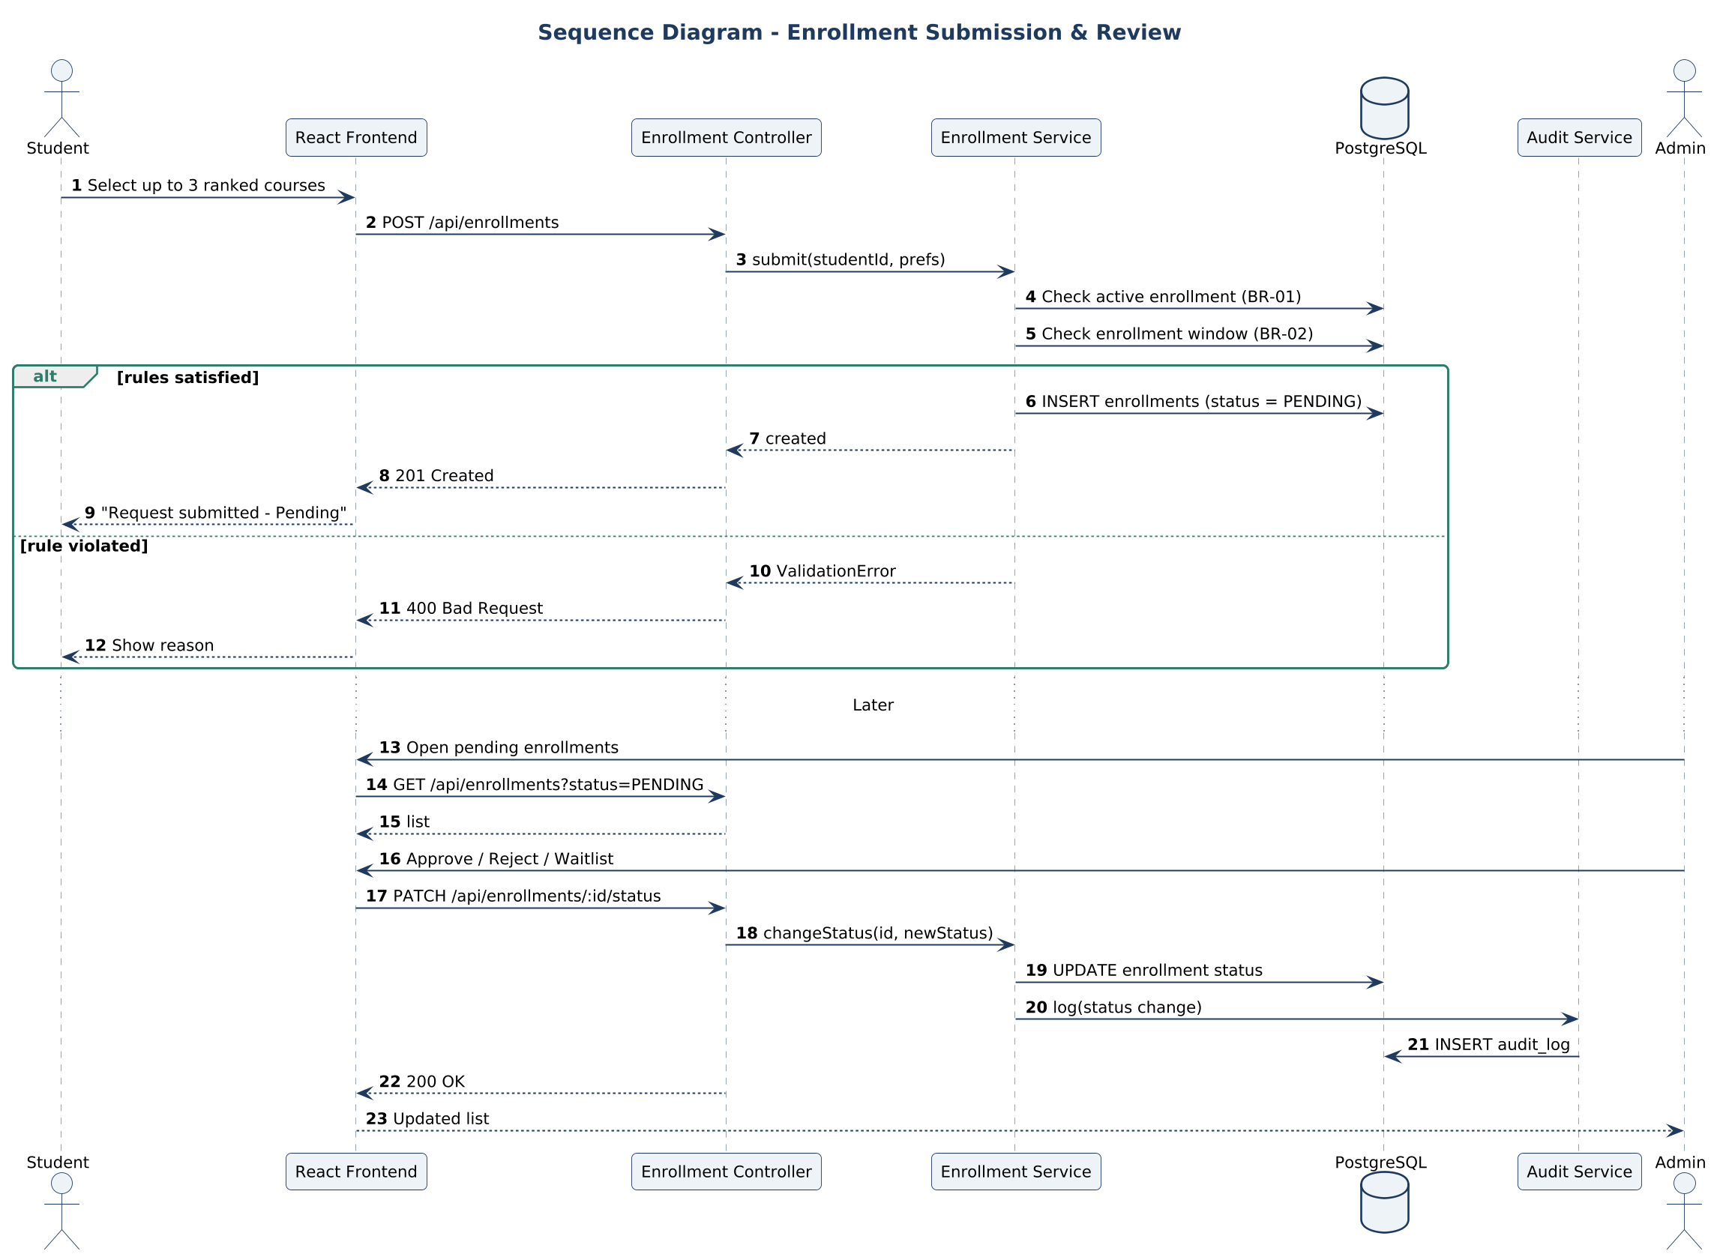
Figure 5: Enrollment with BR-01/BR-02 validation and admin review.

27.6 Sequence Diagram – Batch Allocation
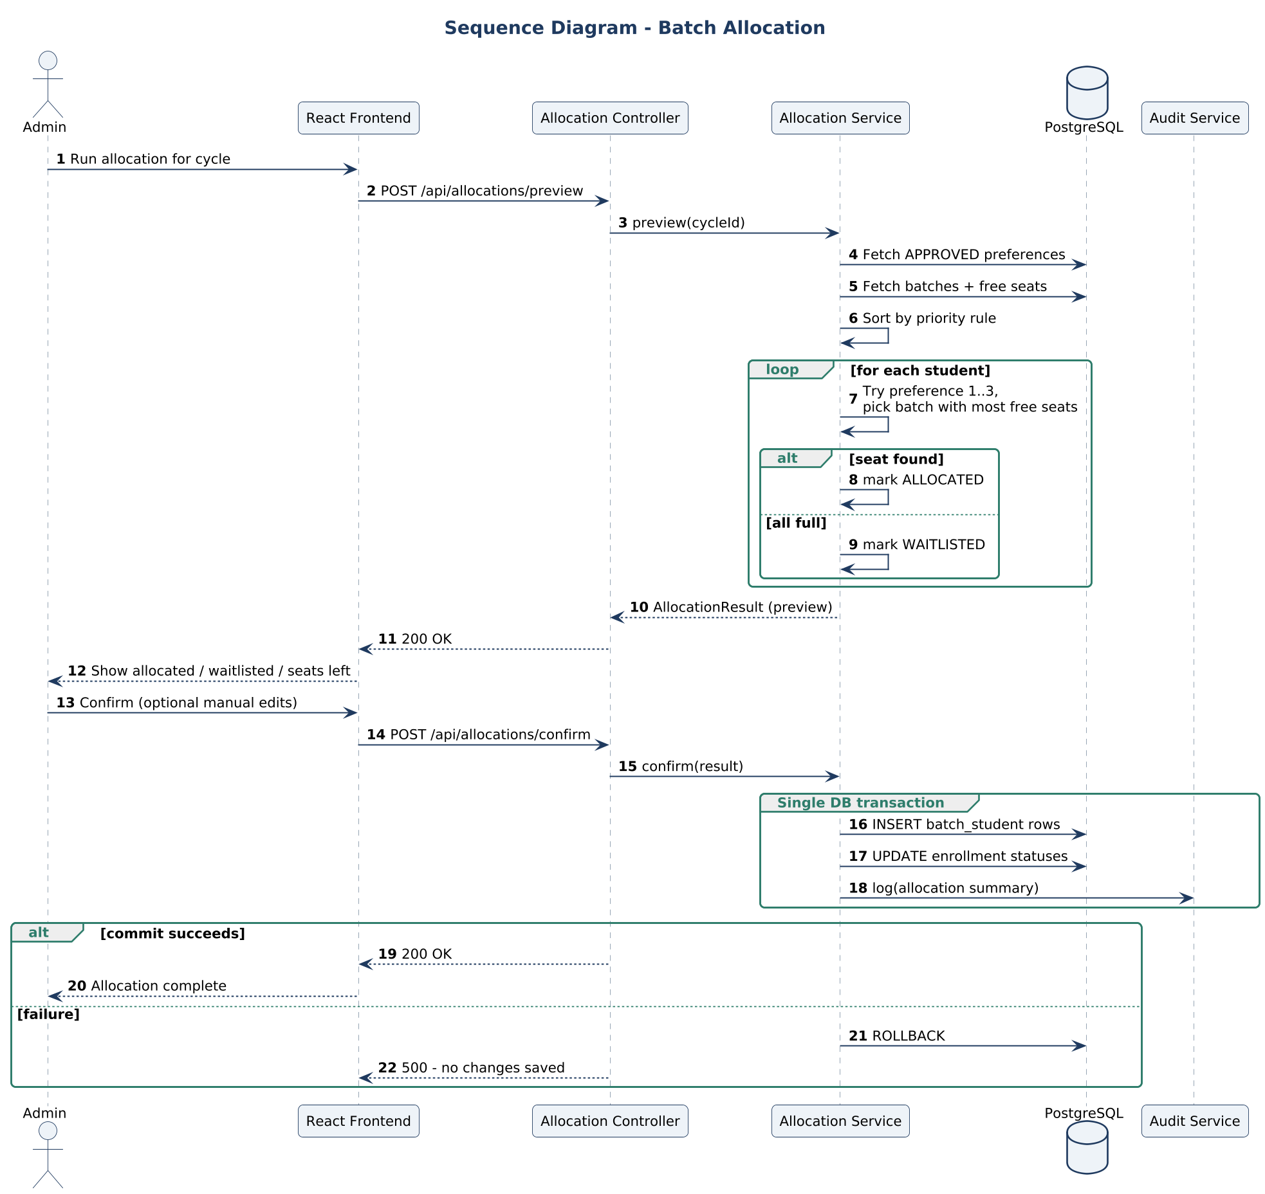
Figure 6: Preview-then-confirm allocation within one transaction.

27.7 Sequence Diagram – Mark Session Attendance
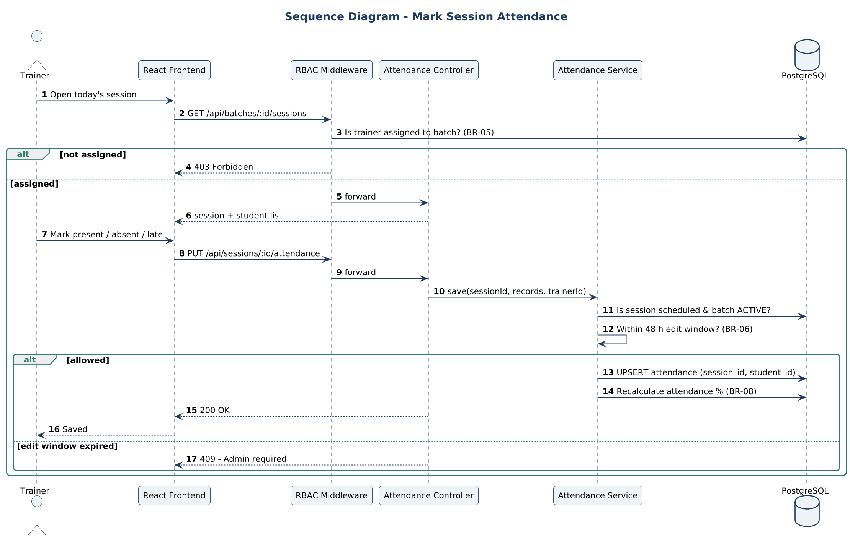
Figure 7: Ownership check (BR-05) and 48-hour edit window (BR-06).

27.8 Sequence Diagram – Assessment & Results
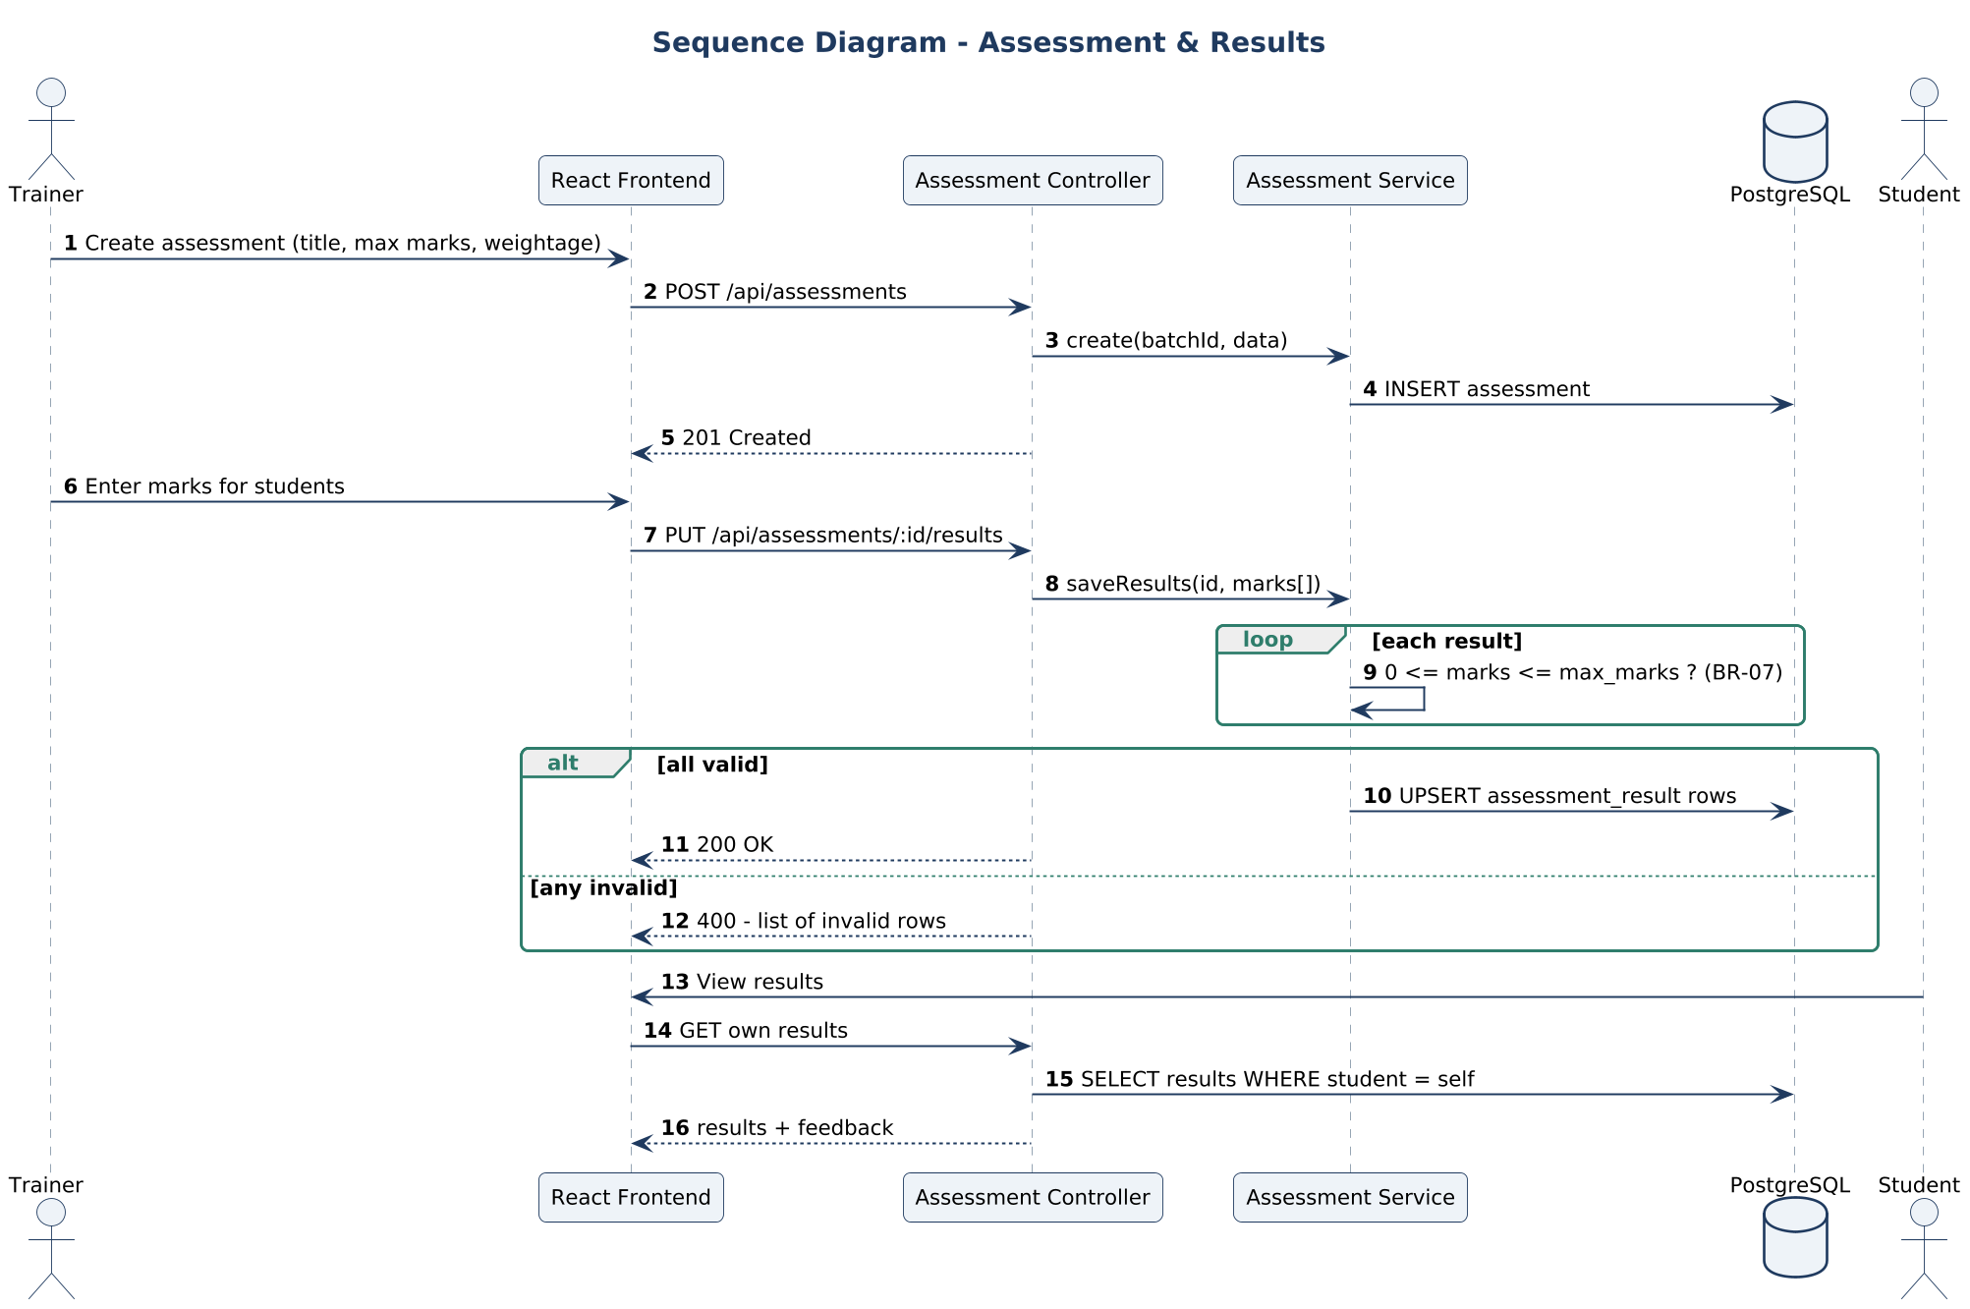
Figure 8: Assessment creation and marks validation (BR-07).

27.9 Sequence Diagram – Completion & Certificate Generation
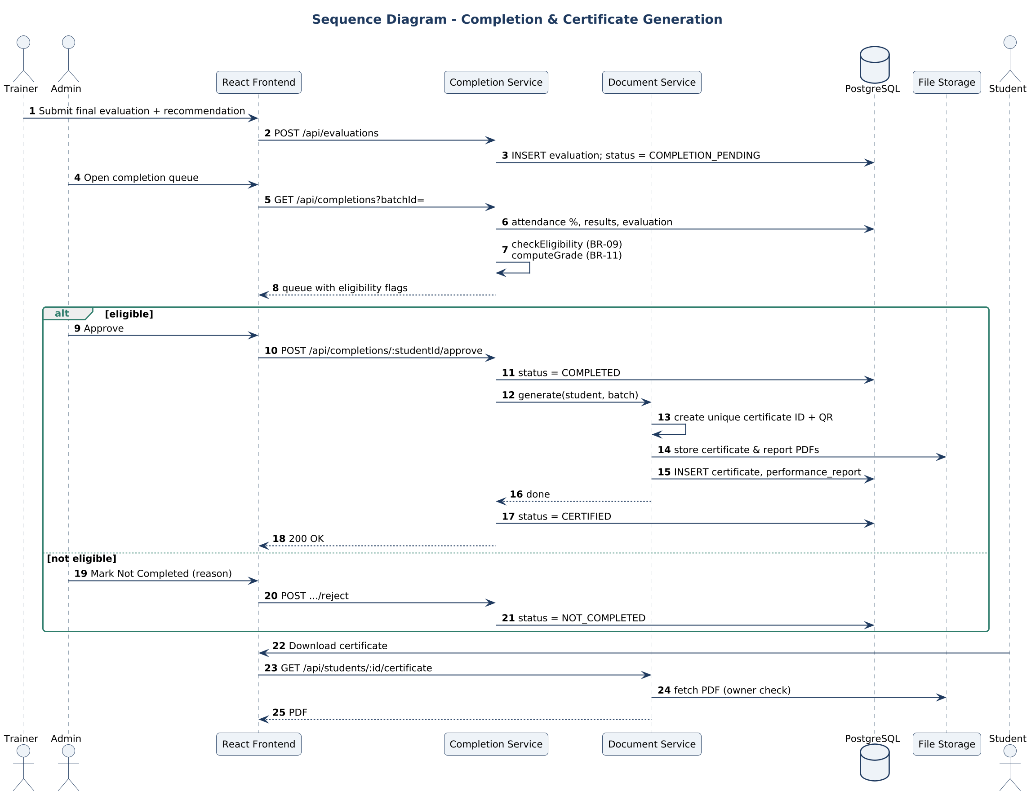
Figure 9: Eligibility check, approval and document generation.

27.10 Activity Diagram – Batch Allocation Algorithm
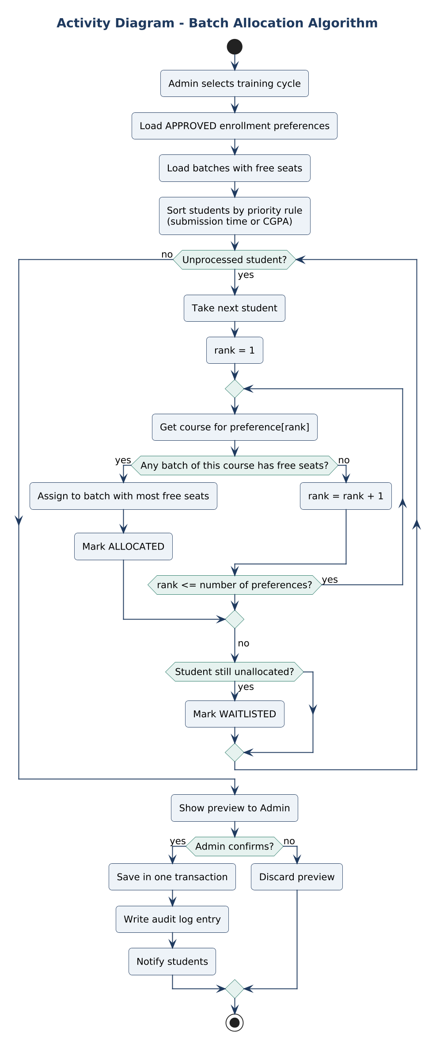
Figure 10: Allocation algorithm from Section 13.

27.11 Activity Diagram – Training Delivery
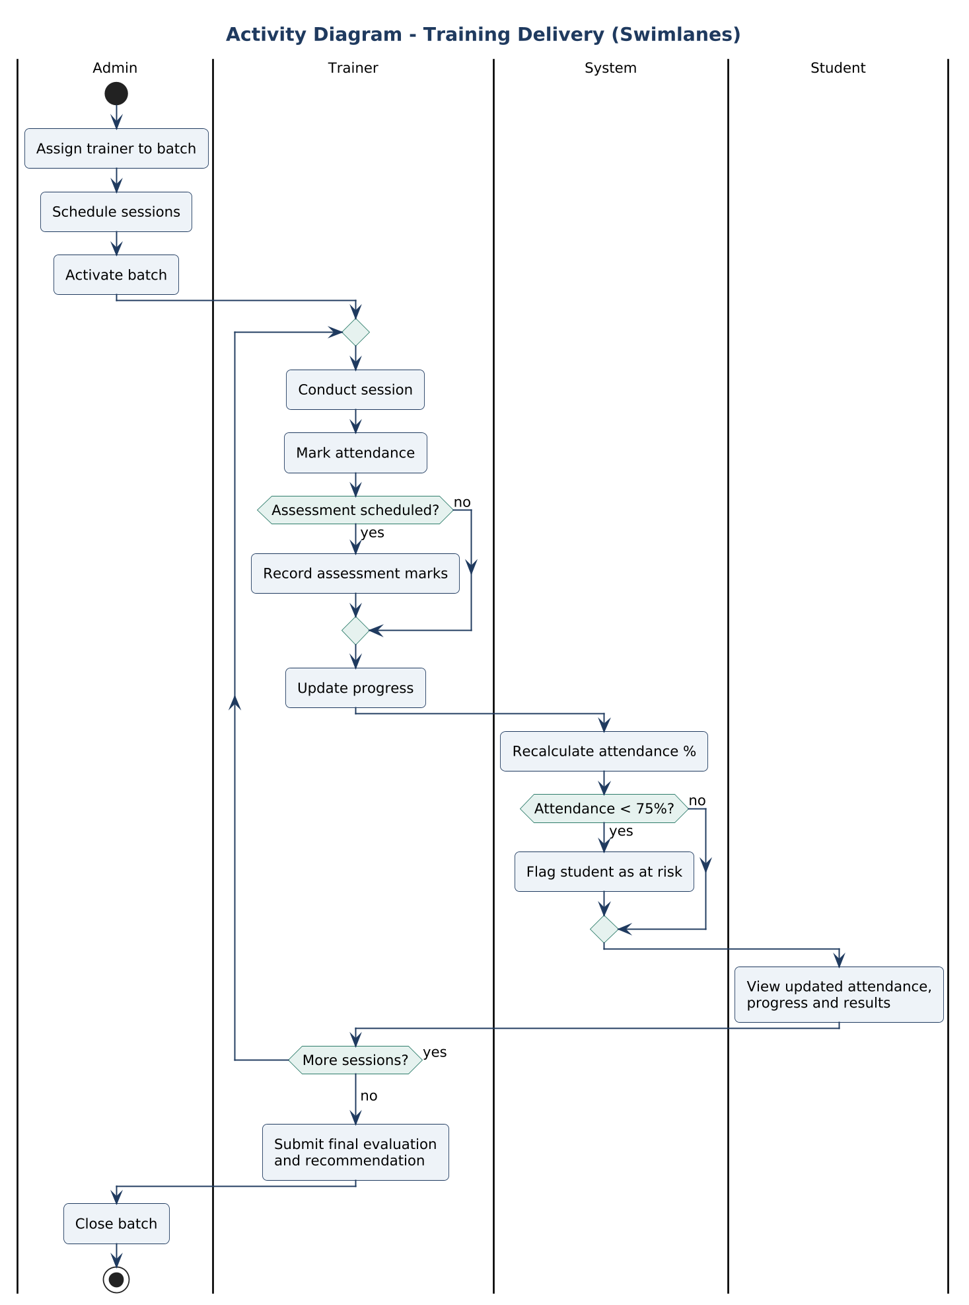
Figure 11: Swimlane view of training across Admin, Trainer, System and Student.

27.12 Activity Diagram – Completion & Certification
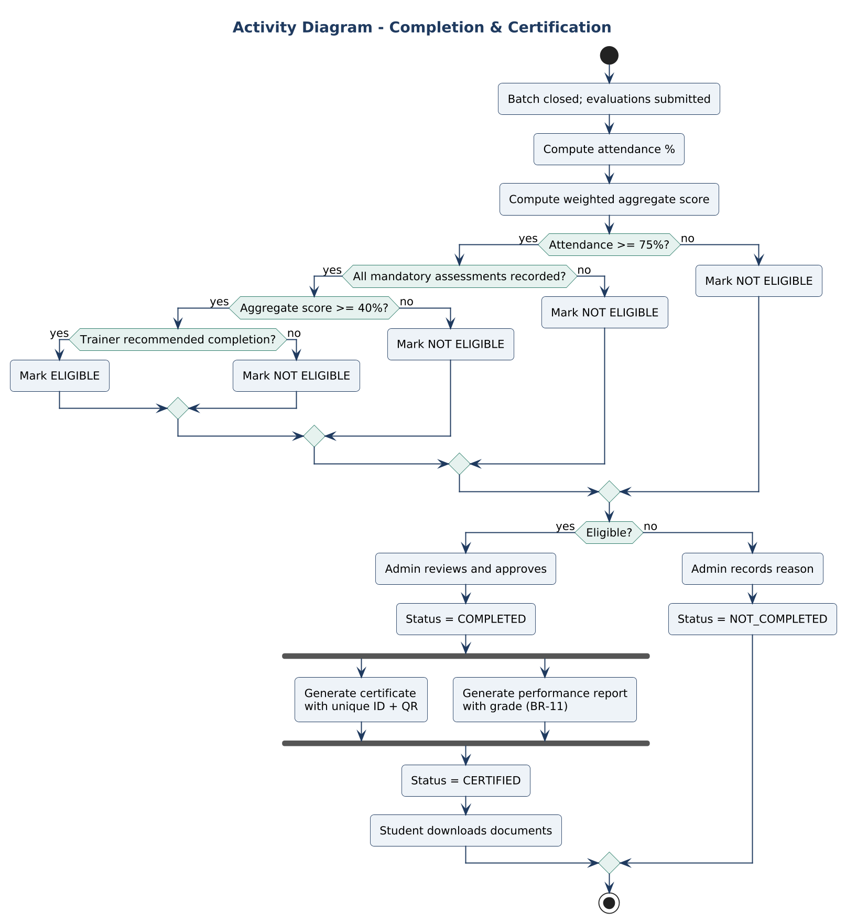
Figure 12: BR-09 eligibility checks and certificate/report generation.

27.13 State Diagram – Enrollment Status
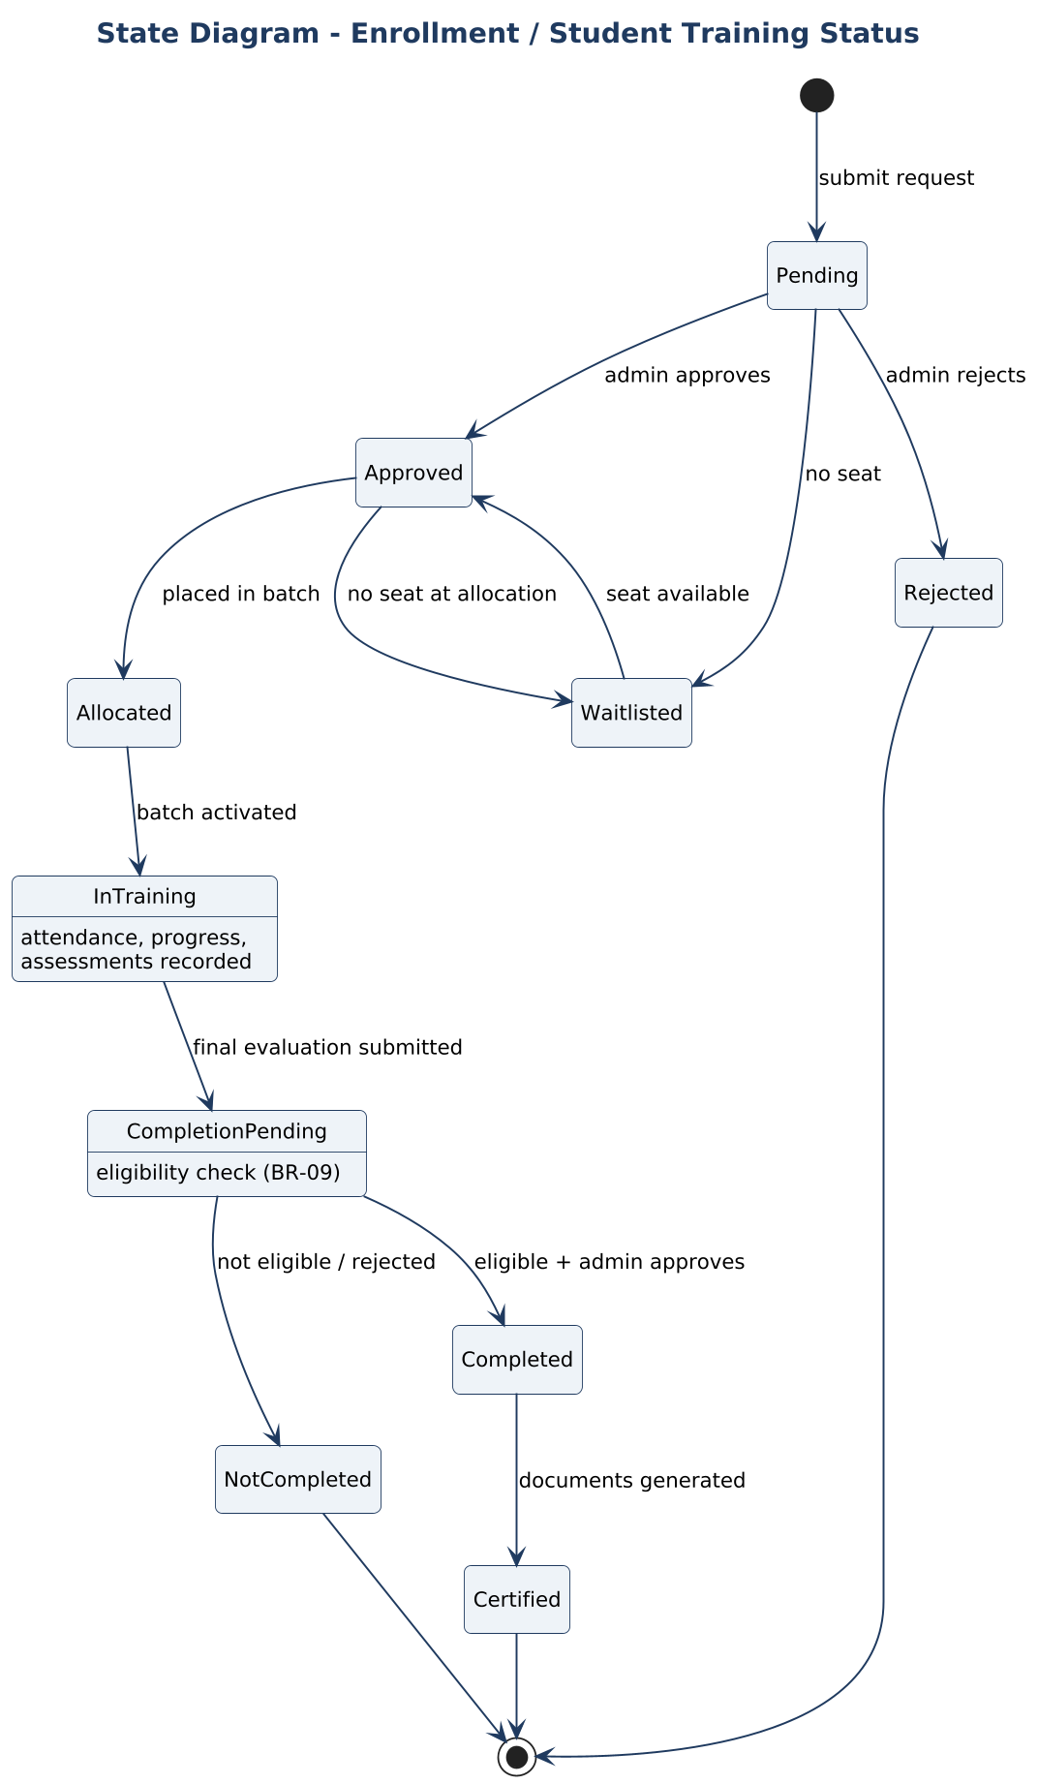
Figure 13: Enrollment and student training lifecycle (Section 7.1).

27.14 State Diagram – Batch Status
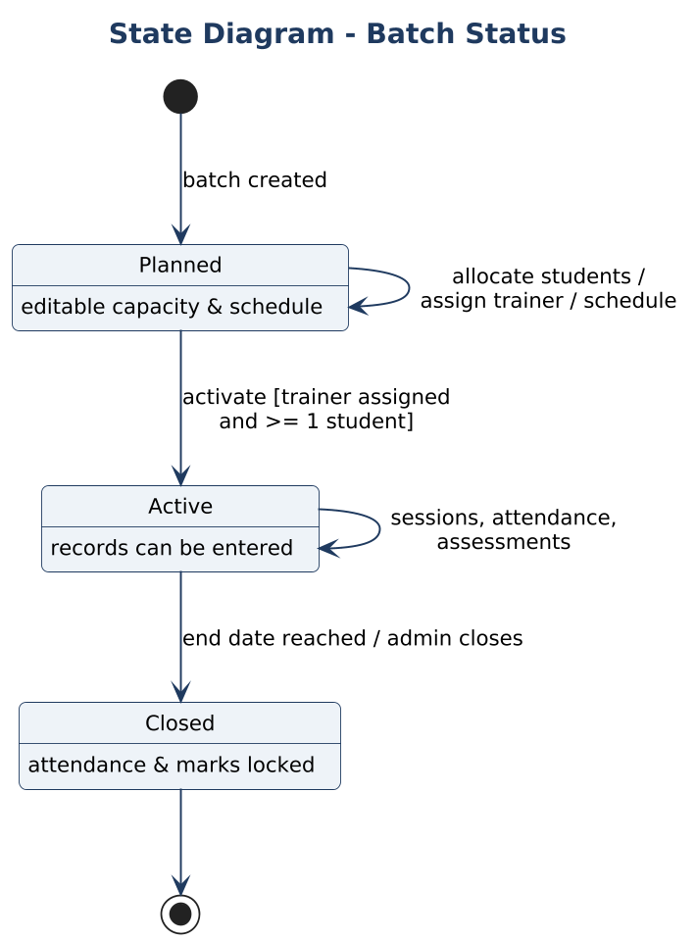
Figure 14: Batch lifecycle (Section 7.2).

27.15 Component Diagram
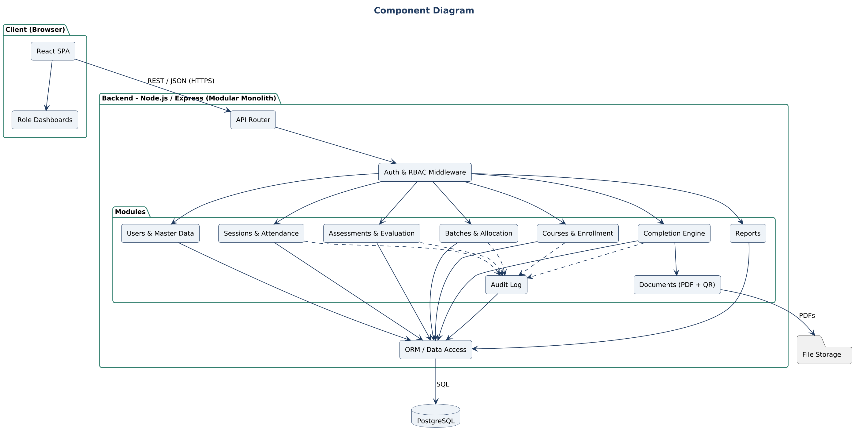
Figure 15: Modular monolith components and dependencies.

27.16 Deployment Diagram
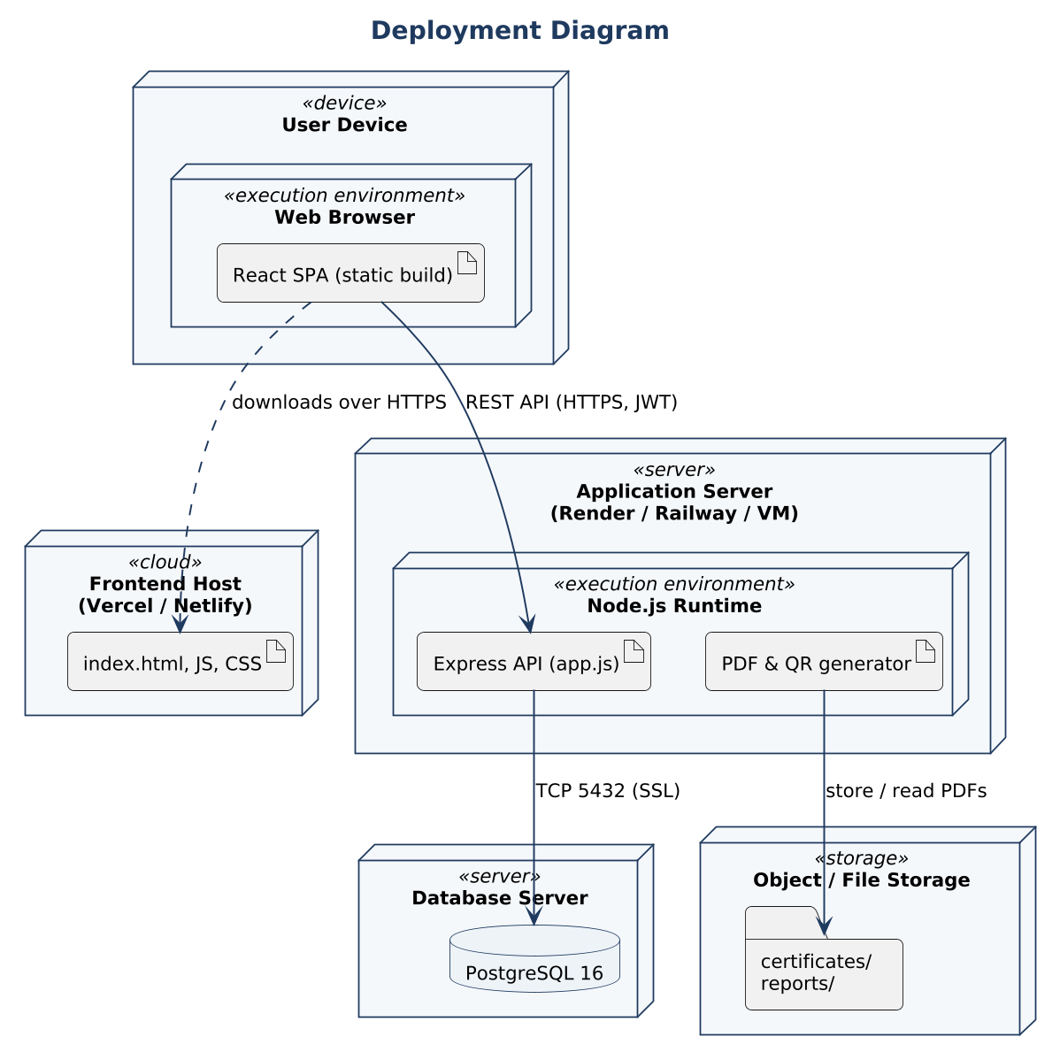
Figure 16: Runtime nodes for the deployed prototype.

Appendix A – Project Checklist
Done | Stage | Task
☐ | Design | Finalize requirements, business rules and MVP scope
☐ | Design | Complete SRS draft
☐ | Design | Use case diagram and specifications
☐ | Design | ER diagram, schema and data dictionary
☐ | Design | Class diagram
☐ | Design | API contract
☐ | Build | Repository, branching strategy and task board
☐ | Build | Authentication and RBAC
☐ | Build | Student and Trainer components
☐ | Build | Admin component and allocation
☐ | Build | Completion engine, certificates and reports
☐ | Build | Deploy prototype
☐ | Verify | Write and execute test cases
☐ | Verify | Traceability matrix
☐ | Verify | UAT walkthroughs
☐ | Deliver | Remaining UML diagrams and final documentation
☐ | Deliver | User manual and technical docs
☐ | Deliver | Demo data, presentation and rehearsal

Appendix B – Glossary
Term | Definition
Batch | A group of students taking the same course together with an assigned trainer and schedule.
Training Cycle | A period (for example a semester) in which enrollment, training and completion take place.
Allocation | The process of placing approved students into batches based on preferences and capacity.
Aggregate Score | Weighted percentage of all assessment results for a student in a batch.
Completion Eligibility | System-evaluated result of the rules in BR-09.
RBAC | Role-Based Access Control: permissions granted by user role.
Ownership Check | An authorization check that the user is linked to the specific resource (such as a trainer's own batch).
MVP | Minimum Viable Product: the smallest complete version that delivers the core workflow.
Modular Monolith | A single deployable application internally organized into independent modules.

