Exercise 3: Assertions in JUnit

Code
AssertionsTest.java
package com.bank.assertions;

import org.junit.Test;

import static org.junit.Assert.assertArrayEquals;
import static org.junit.Assert.assertEquals;
import static org.junit.Assert.assertFalse;
import static org.junit.Assert.assertNotNull;
import static org.junit.Assert.assertNotSame;
import static org.junit.Assert.assertNull;
import static org.junit.Assert.assertSame;
import static org.junit.Assert.assertTrue;

/**
* Demonstrates the most commonly used JUnit 4 assertions.
*/
public class AssertionsTest {

@Test
public void testAssertions() {
// Assert equals
assertEquals(5, 2 + 3);

// Assert true
assertTrue(5 > 3);

// Assert false
assertFalse(5 < 3);

// Assert null
assertNull(null);

// Assert not null
assertNotNull(new Object());
}

@Test
public void testMoreAssertions() {
String a = "junit";
String b = "junit";
Object obj = new Object();

// Assert equals with a delta, for floating point comparisons
assertEquals(0.3, 0.1 + 0.2, 0.0001);

// Assert array equals
assertArrayEquals(new int[] {1, 2, 3}, new int[] {1, 2, 3});

// Assert same: both references point to the same interned String object
assertSame(a, b);

// Assert not same: two distinct Object instances are never the same reference
assertNotSame(obj, new Object());
}
}

Output
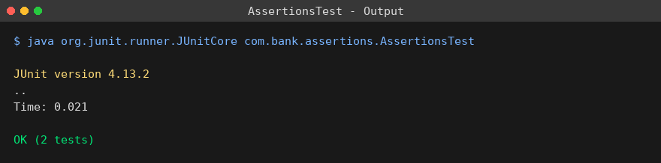
Exercise 4: Arrange-Act-Assert (AAA) Pattern, Test Fixtures, Setup and Teardown Methods in JUnit

Code
BankAccount.java
package com.bank.account;

/**
* A small bank account class used to demonstrate the Arrange-Act-Assert
* pattern together with JUnit setup/teardown methods.
*/
public class BankAccount {

private double balance;

public BankAccount(double initialBalance) {
this.balance = initialBalance;
}

public void deposit(double amount) {
if (amount <= 0) {
throw new IllegalArgumentException("Deposit amount must be positive");
}
balance += amount;
}

public void withdraw(double amount) {
if (amount <= 0) {
throw new IllegalArgumentException("Withdrawal amount must be positive");
}
if (amount > balance) {
throw new IllegalStateException("Insufficient balance");
}
balance -= amount;
}

public double getBalance() {
return balance;
}
}
BankAccountTest.java
package com.bank.account;

import org.junit.After;
import org.junit.Before;
import org.junit.Test;

import static org.junit.Assert.assertEquals;
import static org.junit.Assert.assertThrows;

/**
* Demonstrates the Arrange-Act-Assert (AAA) pattern together with a test
* fixture that is created in @Before (setup) and released in @After
* (teardown) before/after every test method.
*/
public class BankAccountTest {

private BankAccount account;

@Before
public void setUp() {
// Test fixture: a fresh account is created before every test
account = new BankAccount(1000.0);
System.out.println("setUp: created account with balance " + account.getBalance());
}

@After
public void tearDown() {
// Teardown: release the fixture after every test
account = null;
System.out.println("tearDown: account reference cleared");
}

@Test
public void testDeposit() {
// Arrange
double depositAmount = 500.0;

// Act
account.deposit(depositAmount);

// Assert
assertEquals(1500.0, account.getBalance(), 0.001);
}

@Test
public void testWithdraw() {
// Arrange
double withdrawAmount = 300.0;

// Act
account.withdraw(withdrawAmount);

// Assert
assertEquals(700.0, account.getBalance(), 0.001);
}

@Test
public void testWithdrawInsufficientBalanceThrowsException() {
// Arrange
double withdrawAmount = 5000.0;

// Act & Assert
assertThrows(IllegalStateException.class, () -> account.withdraw(withdrawAmount));
}
}

Output
