Exercise 1: Control Structures

Scenario 1: Senior Citizen Loan Interest Discount
schema.sql
-- schema.sql
-- Sample tables and data used by Scenario 1, Scenario 2 and Scenario 3.
-- Run this once before running the individual scenario scripts.

CREATE TABLE customers (
customer_id NUMBER PRIMARY KEY,
name VARCHAR2(50),
age NUMBER,
balance NUMBER(12,2),
isvip CHAR(1) DEFAULT 'N'
);

CREATE TABLE loans (
loan_id NUMBER PRIMARY KEY,
customer_id NUMBER REFERENCES customers(customer_id),
interest_rate NUMBER(5,3),
due_date DATE
);

INSERT INTO customers VALUES (1, 'Ramesh Iyer', 65, 15000, 'N');
INSERT INTO customers VALUES (2, 'Ananya Rao', 45, 25000, 'N');
INSERT INTO customers VALUES (3, 'Vikram Shah', 72, 8000, 'N');
INSERT INTO customers VALUES (4, 'Priya Nair', 58, 12000, 'N');
INSERT INTO customers VALUES (5, 'Suresh Menon', 61, 5000, 'N');
INSERT INTO customers VALUES (6, 'Kavita Desai', 39, 11000, 'N');
INSERT INTO customers VALUES (7, 'Arjun Malhotra', 68, 9500, 'N');
INSERT INTO customers VALUES (8, 'Neha Kapoor', 55, 30000, 'N');

INSERT INTO loans VALUES (101, 1, 9.5, DATE '2026-07-10');
INSERT INTO loans VALUES (102, 2, 8.0, DATE '2026-09-01');
INSERT INTO loans VALUES (103, 3, 10.0, DATE '2026-07-20');
INSERT INTO loans VALUES (104, 4, 9.0, DATE '2026-08-15');
INSERT INTO loans VALUES (105, 5, 7.5, DATE '2026-07-15');
INSERT INTO loans VALUES (106, 6, 8.5, DATE '2026-12-01');
INSERT INTO loans VALUES (107, 7, 9.8, DATE '2026-07-30');
INSERT INTO loans VALUES (108, 8, 6.5, DATE '2026-07-05');

COMMIT;
Scenario1_LoanDiscount.sql
-- Scenario1_LoanDiscount.sql
-- Loops through all customers and applies a 1% discount to the current
-- loan interest rate of every customer older than 60.

SET SERVEROUTPUT ON;

DECLARE
v_new_rate LOANS.INTEREST_RATE%TYPE;
BEGIN
FOR cust_rec IN (
SELECT c.customer_id,
c.name,
c.age,
l.loan_id,
l.interest_rate
FROM customers c
JOIN loans l ON l.customer_id = c.customer_id
)
LOOP
IF cust_rec.age > 60 THEN
v_new_rate := ROUND(cust_rec.interest_rate * (1 - 0.01), 3);

UPDATE loans
SET interest_rate = v_new_rate
WHERE loan_id = cust_rec.loan_id;

DBMS_OUTPUT.PUT_LINE(
'Customer ' || cust_rec.name ||
' (Age: ' || cust_rec.age || ') - Interest rate reduced from ' ||
cust_rec.interest_rate || '% to ' || v_new_rate || '%');
END IF;
END LOOP;

COMMIT;
DBMS_OUTPUT.PUT_LINE('Senior citizen loan discount applied successfully.');
END;
/
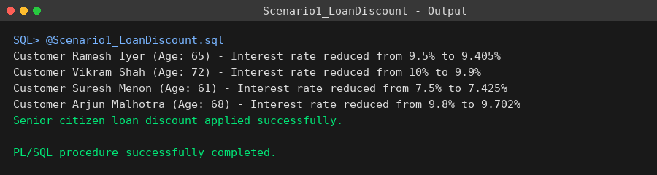

Scenario 2: VIP Status Promotion
Scenario2_VIPStatus.sql
-- Scenario2_VIPStatus.sql
-- Iterates through all customers and sets IsVIP to TRUE ('Y') for every
-- customer whose balance is over $10,000.

SET SERVEROUTPUT ON;

BEGIN
FOR cust_rec IN (
SELECT customer_id, name, balance
FROM customers
)
LOOP
IF cust_rec.balance > 10000 THEN
UPDATE customers
SET isvip = 'Y'
WHERE customer_id = cust_rec.customer_id;

DBMS_OUTPUT.PUT_LINE(
'Customer ' || cust_rec.name ||
' (Balance: $' || cust_rec.balance ||
') upgraded to VIP status.');
END IF;
END LOOP;

COMMIT;
DBMS_OUTPUT.PUT_LINE('VIP status update completed.');
END;
/
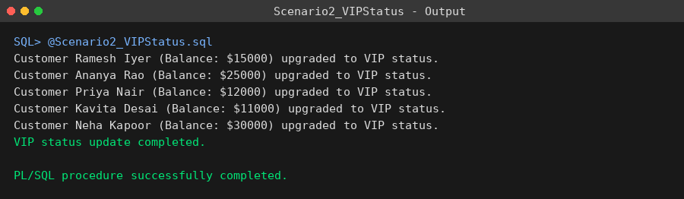

Scenario 3: Loan Due Reminders
Scenario3_LoanReminders.sql
-- Scenario3_LoanReminders.sql
-- Fetches all loans due within the next 30 days and prints a reminder
-- message for each customer.

SET SERVEROUTPUT ON;

DECLARE
v_days_left NUMBER;
BEGIN
FOR loan_rec IN (
SELECT c.name,
l.loan_id,
l.due_date
FROM loans l
JOIN customers c ON c.customer_id = l.customer_id
WHERE l.due_date BETWEEN SYSDATE AND SYSDATE + 30
ORDER BY l.due_date
)
LOOP
v_days_left := TRUNC(loan_rec.due_date - SYSDATE);

DBMS_OUTPUT.PUT_LINE(
'Reminder: Loan #' || loan_rec.loan_id ||
' for customer ' || loan_rec.name ||
' is due on ' || TO_CHAR(loan_rec.due_date, 'DD-MON-YYYY') ||
' (' || v_days_left || ' day(s) remaining).');
END LOOP;

DBMS_OUTPUT.PUT_LINE('Loan due reminders generated successfully.');
END;
/
