gCorrelation Analysis

dat <- mtcars cor(dat$hp, dat$mpg)

cor(dat$hp, dat$mpg, method = "spearman") plot(dat$hp, dat$mpg)

##########

library(ggplot2) ggplot(dat) +

aes(x = hp, y = mpg) + geom_point(colour = "#0c4c8a") + theme_minimal()

##########

# multiple scatterplots pairs(dat[, c(1, 4, 6)]) ggpairs( )

Exercise

1. Two judges gave the following rank to a series of eight one act plays in drama competition. Examine the relationship between their judgments.

|  |  |  |  |  |  |  |  |  |  |
| --- | --- | --- | --- | --- | --- | --- | --- | --- | --- |
| Judge | A | 8 | 7 | 6 | 3 | 2 | 1 | 5 | 4 |
| Judge | B | 7 | 5 | 4 | 1 | 3 | 2 | 6 | 8 |

Write a R program for above problem.

1. Calculate the rank correlation coefficient from the following data.

|  |  |  |  |  |  |  |  |  |
| --- | --- | --- | --- | --- | --- | --- | --- | --- |
| Height | 60 | 62 | 64 | 66 | 68 | 70 | 72 | 74 |
| Weight | 92 | 83 | 101 | 110 | 128 | 119 | 137 | 146 |

Write a R program for above problem.

1. In R, it is possible to calculate correlation for all pairs of numeric variables in a dataframe at once. However, this requires excluding non-numeric variables first.

Create a new dataframe, auto_num, that contains only columns with numeric values from the auto dataset. You can do this using the Filter function. Calculate correlation for all pairs of numeric variables .

1. Use the cor function to create a matrix of correlation coefficients for variables in the auto_num dataframe.
2. Find Karl Pearson’s coefficient of correlation for the following

|  |  |  |  |  |  |  |  |  |
| --- | --- | --- | --- | --- | --- | --- | --- | --- |
| X | 62 | 64 | 65 | 69 | 70 | 71 | 72 | 74 |
| Y | 126 | 125 | 139 | 145 | 165 | 152 | 180 | 208 |

Write a R program for the above problem.

|  |  |  |  |  |  |
| --- | --- | --- | --- | --- | --- |
| 6. At Hogwarts | School | of Witchcraft | and | Wizardry, | students |
| often have a | lot of | homework. The | table | below | indicates |

the number of hours students studied, and how they performed on an exam in two of their classes.

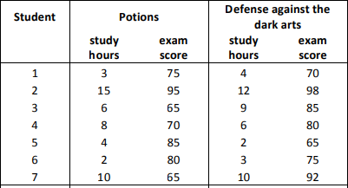

Find the correlations between hours spent studying and how students performed in their potions and defense against

the dark arts classes.