  - CLOUD COMPUTING PROJECT REPORT

DataGuard Cloud Computing Project Report
  - Cloud based CSV validation and quality reporting
A deployed AWS application for account owned dataset validation, asynchronous processing, quality reports, and auditable cloud storage.

Report detail | Value
Project | DataGuard
Deployment | dataguard-prod, AWS Mumbai Region (ap-south-1)
Report date | 28 October 2026
Evidence basis | Repository architecture, deployment status, implementation status, and verification records as of 27 October 2026

Student team
Student ID | Student name
10553 | Junaid Momin
10792 | Arnav Gurao
10657 | Darshan Patel

Prepared for cloud computing project assessment. The report describes the maintained deployment and verified behavior; it does not claim high availability or unrestricted public email delivery.

Executive summary
DataGuard addresses a common data quality problem: teams receive CSV files with missing values, duplicate identifiers, invalid ranges, and inconsistent categories, but need repeatable checks and traceable results. The implemented system lets a user define reusable rule sets, submit a dataset, follow a background validation job, inspect per rule failures, and download the original, accepted rows, rejected rows, and a JSON report. [1–3]
The maintained deployment runs the React interface, FastAPI service, publisher, and a separate validation worker on one Amazon EC2 host. A private Amazon RDS PostgreSQL instance stores accounts, rules, jobs, and summaries. Amazon S3 stores inputs and outputs; Amazon SQS decouples the API from the worker. An S3 event and AWS Lambda also support account owned ingestion folders. Amazon SES handles verification codes, while CloudWatch and SNS support operations. The deployed stack was reported as UPDATE_COMPLETE with 42 resources on 27 October 2026. [1–4]
Verification recorded 151 passing backend tests, 10 passing frontend unit tests, five local browser workflows, and live checks for uploads, report downloads, account isolation, worker recovery, S3 ingestion, email verification, and HTTPS. The design is deliberately small and cost conscious. Its principal limits are one EC2 host, a Single-AZ database, and SES sandbox restrictions. [2, 3]

1 Problem statement
Raw CSV datasets often contain errors that are not visible until analysis or import fails. A manual review process is slow, hard to repeat, and weak at preserving evidence of which rows failed which rules. DataGuard provides a controlled cloud workflow that validates files without silently modifying the source values. It separates accepted and rejected records and stores the rule snapshot and report with each job. [1, 5]

2 Project objectives
- Provide secure registration, email verification, and owner specific access to rule sets, jobs, reports, and downloads.
- Validate CSV files against required columns, required values, uniqueness, numeric ranges, and allowed values.
- Return a job identifier quickly while validation runs asynchronously and survives worker interruption.
- Persist original inputs, valid rows, rejected rows with reasons, and machine readable JSON reports.
- Support both browser uploads and controlled automatic ingestion from account mapped S3 folders.
- Deploy and monitor the complete application using a custom VPC, managed database, least privilege roles, logs, alarms, and cost alerts. [1–4]

3 Methodology

3.1 Requirements and design
The design began with the CSV quality workflow and the cloud computing requirement for compute, networking, storage, database, security, and monitoring. The team selected an EC2 hosted API and worker so the application would have persistent compute while SQS supplied durable asynchronous work. The VPC separates a public application subnet from a private RDS subnet group. Regional services such as S3, SQS, Lambda, and SES remain outside the subnet boundaries. [1, 4]

3.2 Implementation sequence
The frontend and backend were developed against a documented API contract. Database migrations establish durable accounts, rules, jobs, ingestion sources, and notification state. A CloudFormation template provisions the network and AWS services, and a deployment script builds the frontend, installs the release through Systems Manager, runs migrations, and checks the deployed application. Tests then cover the validation engine, API behavior, browser flows, and cloud recovery paths. [2, 4–6]

3.3 Validation approach
The sample dataset and automated verification exercise valid and dirty records, malformed inputs, duplicate handling, owner isolation, persistent job status, worker pause and recovery, HTTPS, and S3 event processing. Results below reflect recorded checks, rather than an independent benchmark or production scale load test. [2, 3]

4 Architecture
Figures 1 and 2 are the supplied visual summaries. The runtime has two distinct entry paths. A browser submits a manual CSV to FastAPI, which stores the input and commits a pending job. An authorized AWS operator can place a CSV directly in a registered S3 incoming folder; S3 invokes Lambda, and Lambda signs a callback to FastAPI. Both paths then converge on the same RDS backed publisher, SQS queue, and validation worker. The worker runs in a separate container on the same EC2 instance as the API. [1]
Boundary | Deployed placement
Public application | One EC2 t3.small in 10.42.1.0/24; Nginx, React build, FastAPI/publisher, separate worker container
Private database | One encrypted RDS PostgreSQL db.t4g.micro; subnet group spans two AZs, but MultiAZ is false
Regional data path | Private versioned S3 data bucket, SQS jobs queue and job DLQ, Lambda ingestion and separate ingestion DLQ
Identity and operations | SES, IAM roles, Parameter Store, CloudWatch, SNS, AWS Budgets, CloudFormation, and a separate deployment artifact bucket

4.1 Application runtime architecture
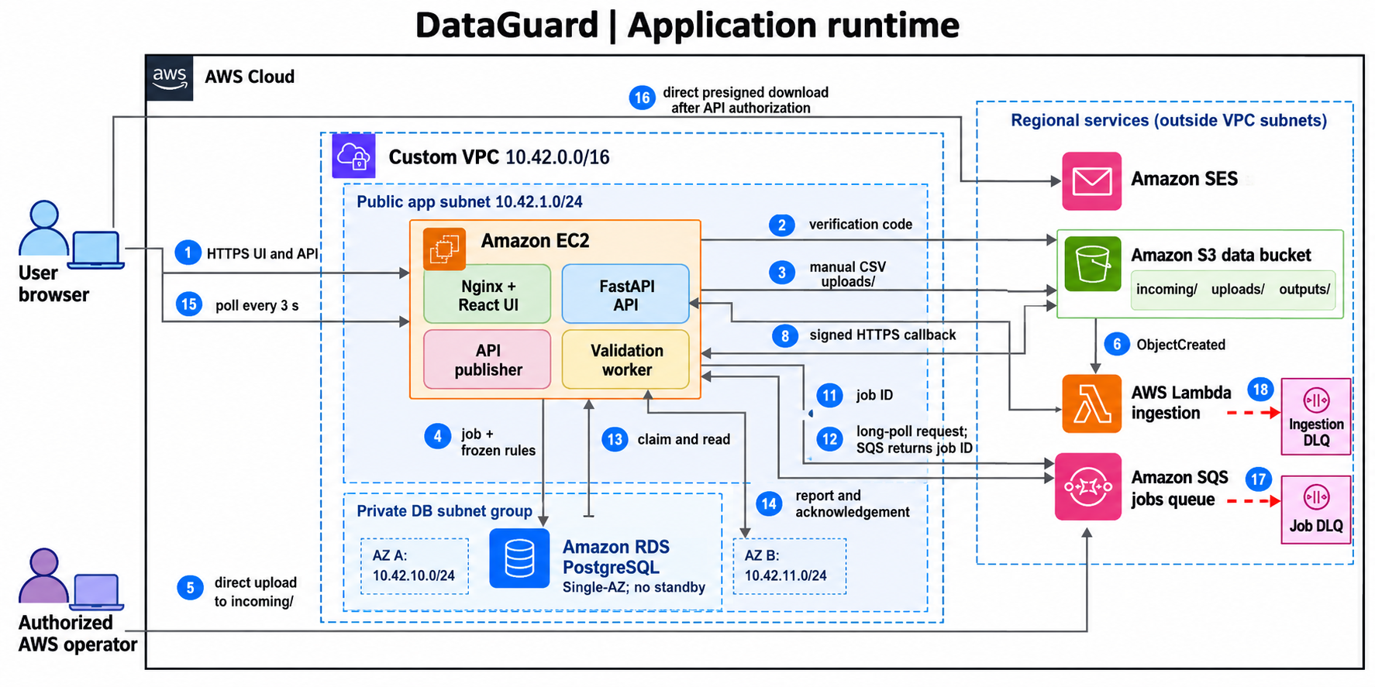
Figure 1. Supplied DataGuard application runtime illustration. The path descriptions in the accompanying text and [1] specify the exact request directions.
Manual upload: browser → FastAPI → S3 uploads/ and RDS. Automatic upload: authorized operator → S3 incoming/ → Lambda → signed HTTPS callback to FastAPI. The publisher sends job IDs to SQS; the worker initiates the long poll, reads trusted metadata and input, writes outputs, updates RDS, and acknowledges the message. A completed authorized download uses a temporary presigned S3 URL. [1]

4.2 Security monitoring and deployment
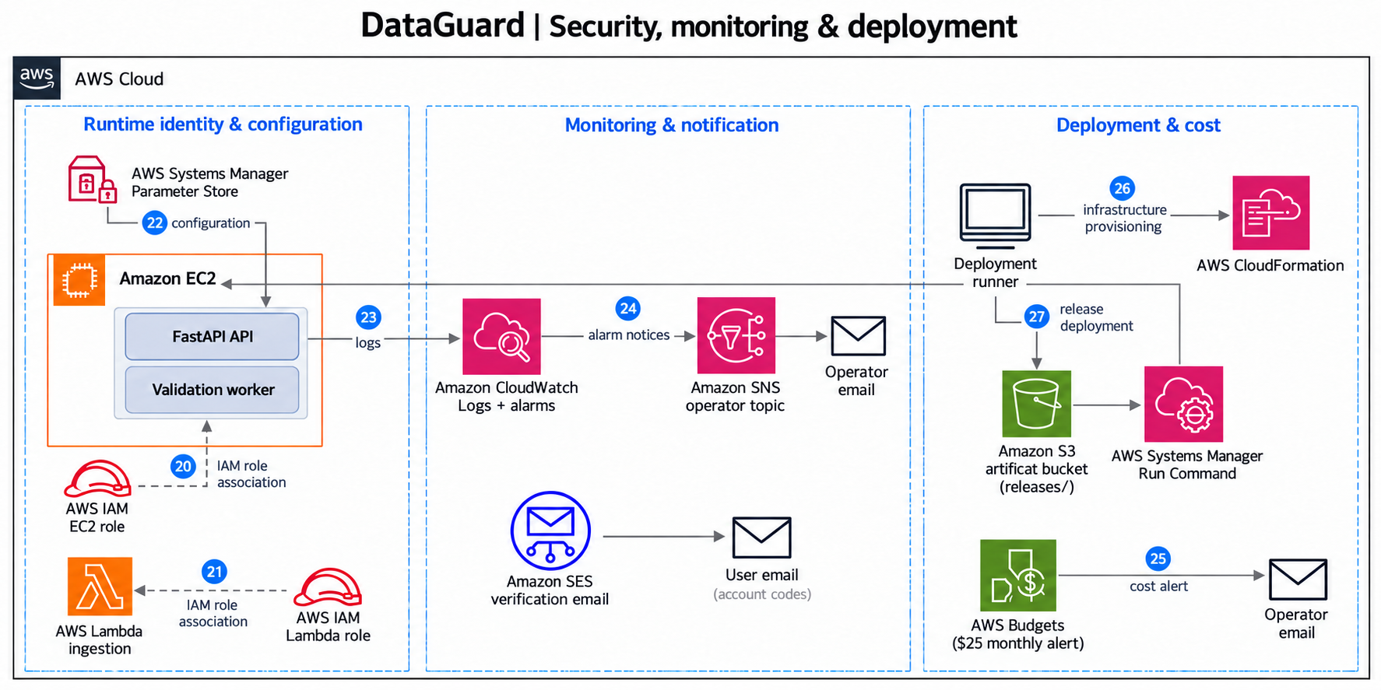
Figure 2. Supplied DataGuard security, monitoring, and deployment illustration.
EC2 and Lambda use separate scoped IAM roles. Runtime secrets come from Systems Manager Parameter Store. Application and infrastructure logs and alarms feed CloudWatch; alarms and application notices reach the operator through SNS. SES sends account verification codes to users, while AWS Budgets sends cost alerts directly by email. CloudFormation and a separate S3 artifact bucket support deployment. [1, 2, 4]

4.3 Authoritative connection paths
The supplied figures are schematic. The connection directions below follow the deployed architecture record and resolve any crowded or simplified arrows in the illustrations. [1]
Path | Direction and result
Manual upload | Browser → FastAPI → S3 uploads/; FastAPI commits the pending job and frozen rules to RDS.
Automatic ingestion | Operator → S3 incoming/ → Lambda → signed HTTPS callback to FastAPI; the API copies the exact version and creates the job.
Background validation | API publisher → SQS; worker on the same EC2 initiates SQS long polling, reads RDS/S3, writes S3 outputs, updates RDS, then acknowledges SQS.
Authorized download | FastAPI checks ownership, returns a 60 second presigned S3 GET URL, and the browser downloads directly from S3.
Failure routing | Repeated job queue receives → job DLQ; failed asynchronous Lambda invocations → separate ingestion DLQ.
Email and alerts | SES → account verification email; CloudWatch and application notices → SNS → operator email; AWS Budgets → operator email directly.

5 Implementation details

5.1 User interface and API
The responsive React and Vite frontend provides registration, verification, rule set management, upload, dataset history, job detail, quality summaries, and downloads. Nginx serves the production build over HTTPS and forwards /api/ requests to FastAPI. The API checks ownership and upload constraints before recording a pending job and returning HTTP 202 with a job ID. The browser polls active jobs every three seconds; there is no WebSocket service. [1, 2, 6]

5.2 Validation and storage
Rule sets cover required columns and values, uniqueness, numeric range, and allowed values. Each submitted job stores a frozen rule snapshot. The worker reads only a job ID from SQS and obtains trusted paths and rules from RDS. It preserves original CSV values, rejects affected rows with explanations, and writes valid.csv, rejected.csv, and report.json under the S3 outputs/ prefix. The original input remains available as an audit artifact. [1, 5]

5.3 Automatic ingestion
An account owner registers an ingestion folder and selects its rule set. An authorized operator then uploads a CSV to the corresponding versioned S3 incoming/ prefix. S3 ObjectCreated invokes Lambda, which reads its callback configuration, signs an HTTPS request, and sends the bucket, key, and exact version ID to FastAPI. The API verifies the signature, folder and rule ownership, and version; it copies an immutable audit input and creates one job and receipt per object version. Lambda failures use a dedicated ingestion DLQ; validation messages use a separate job DLQ. [1, 3, 7]

5.4 Deployment and operations
The infrastructure is generated from CloudFormation. The application runs on Amazon Linux 2023 with an Elastic IP, Nginx, and systemd managed containers. Administration and release installation use Systems Manager rather than public SSH. CloudWatch collects application and database logs and monitors queue age, dead letter messages, and EC2 health. A monthly account wide USD 25 AWS Budgets threshold sends alerts; it is not a spending cap or a statement of actual spend. [1, 2, 4]

6 Security and reliability
The RDS instance is private and accepts PostgreSQL traffic only from the application security group; the application uses a TLS database connection. S3 buckets block public access, use encryption and versioning, and require secure transport. The EC2 and Lambda IAM roles are scoped to their responsibilities. DataGuard authorizes reports and downloads by account ownership, then issues a 60 second presigned S3 GET URL for an approved object. [1, 2, 4]
SQS buffers jobs when the worker is stopped. The publisher reads committed pending records and tolerates duplicate delivery because the database and SQS send are not one transaction. The worker claims jobs with a lease, acknowledges only after committing results, and failed messages can reach the job DLQ after repeated receives. Lambda's asynchronous failure route is separate. These mechanisms improve recovery, but one EC2 host and one Single-AZ RDS instance do not provide automatic high availability. [1, 2, 8]

7 Results and verification
Check | Recorded result | Evidence
Infrastructure | CloudFormation UPDATE_COMPLETE; 42 resources | Deployment status [3]
Backend automated tests | 151 passed | Implementation status [5]
Frontend unit tests | 10 passed | Implementation status [5]
Local browser workflows | 5 passed | Deployment status [3]
Dirty sample CSV | 6 total, 2 valid, 4 rejected | Deployment status [3]
Live cloud workflow | Signup, rule creation, uploads, reports, downloads, account isolation, and persistence passed | Deployment status [3]
Recovery and integration | Worker pause/recovery, S3/Lambda version isolation, SNS delivery, and HTTPS renewal checks passed | Deployment status [3]

The recorded evidence demonstrates the intended project workflows and service integration. It does not establish throughput, latency under high load, disaster recovery time, or unrestricted SES delivery. [3, 5]

8 Limitations and future work
- The API and worker share one EC2 host, so host failure interrupts both until recovery; queued messages remain durable in SQS.
- RDS is Single-AZ. The two private subnets provide subnet group coverage, not a standby database.
- SES remains in sandbox mode; demonstration recipients must be verified until production access is approved. [5, 9]
- The deployment uses a short lived IP address HTTPS certificate renewed by a systemd timer; prolonged instance downtime can require renewal before normal access. [2]
- A future production design could add redundant application hosts, Multi-AZ RDS, measured load testing, and a formal recovery objective after evaluating their cost. These are recommendations, not deployed features.

9 Conclusion
DataGuard is a completed cloud computing project that combines a usable CSV quality workflow with real AWS compute, networking, database, storage, messaging, identity, monitoring, and deployment services. Its two upload paths converge on the same auditable validation pipeline, and verification shows that the key user and recovery workflows operate in the maintained deployment. The system meets its project goal of repeatable, account owned CSV validation and reporting while making its single host, Single-AZ database, and SES sandbox limits explicit. [1–5]

References
[1] DataGuard repository. architecture.md. Source of truth for placement, runtime connections, and diagram constraints. Accessed 28 October 2026.
[2] DataGuard repository. deploy/aws/README.md. Maintained deployment and operations guide. Accessed 28 October 2026.
[3] DataGuard repository. docs/AWS_DEPLOYMENT_STATUS.md. Live deployment and verification record, updated 27 October 2026.
[4] DataGuard repository. deploy/aws/cloudformation.json and deploy/aws/template.py. Infrastructure definition. Accessed 28 October 2026.
[5] DataGuard repository. docs/IMPLEMENTATION_STATUS.md. Feature and test status, updated 27 October 2026.
[6] DataGuard repository. docs/api-contract.md and Frontend/README.md. Interface and API behavior. Accessed 28 October 2026.
[7] Amazon Web Services. Process Amazon S3 event notifications with Lambda. https://docs.aws.amazon.com/lambda/latest/dg/with-s3.html. Accessed 28 October 2026.
[8] Amazon Web Services. Configure a dead-letter queue using the Amazon SQS console. https://docs.aws.amazon.com/AWSSimpleQueueService/latest/SQSDeveloperGuide/sqs-configure-dead-letter-queue.html. Accessed 28 October 2026.
[9] Amazon Web Services. Request production access for Amazon SES. https://docs.aws.amazon.com/ses/latest/dg/request-production-access.html. Accessed 28 October 2026.
[10] Amazon Web Services. Working with a DB instance in a VPC. https://docs.aws.amazon.com/AmazonRDS/latest/UserGuide/USER_VPC.WorkingWithRDSInstanceinaVPC.html. Accessed 28 October 2026.

