# 2024 Web & Database Computing – Group 64

Project Design Review

## Overview

This document serves to provide a brief review of the various graphics designs presented for the web application. Researched design criteria (Jakob’s Law etc) will be used to evaluate the designs, as will more generalised heuristics, such as kinetic and cognitive load.

## Home Page

Figure 1: Very rough draft of home page

The first design for the home page is clearly very rough, and has quite a lot of work to do before it is suitable for an implementation. Even then, the skeleton here is quite similar to the final design. Of note are the ‘HUNGER VAULT’ logo located in the top-left section, following Jakob’s law of where most websites locate their logo (which also navigates to the home page). Roughly outlined is also a navigation bar, featuring sections ‘Mission’, ‘What We Do’, ‘Contact’ and ‘Signup’. Below this bar is a large splash graphic, with our mission statement in an integrated text box. The intent is for news articles to be present below the mission statement, viewed once the user scrolls down on the webpage. These concepts are still largely present in the final design, however with some important changes.

In this design, the kinematic load may be quite high, as the navigation items are spread across the width of the webpage at the top. There are also quite a lot of navigation items, potentially increasing cognitive load and thus presenting an opportunity for confusion. To amend this, future designs have been designed with navigation items restricted to the top-right corner of the screen, as well as a fewer number of navigation items in general.

Moving down, while the idea of having a splash graphic can be effective at drawing attention, the example here of having a man holding a sign with the organisation’s slogan could be considered cheesy, and so the graphic to be used will be revised in later iterations.

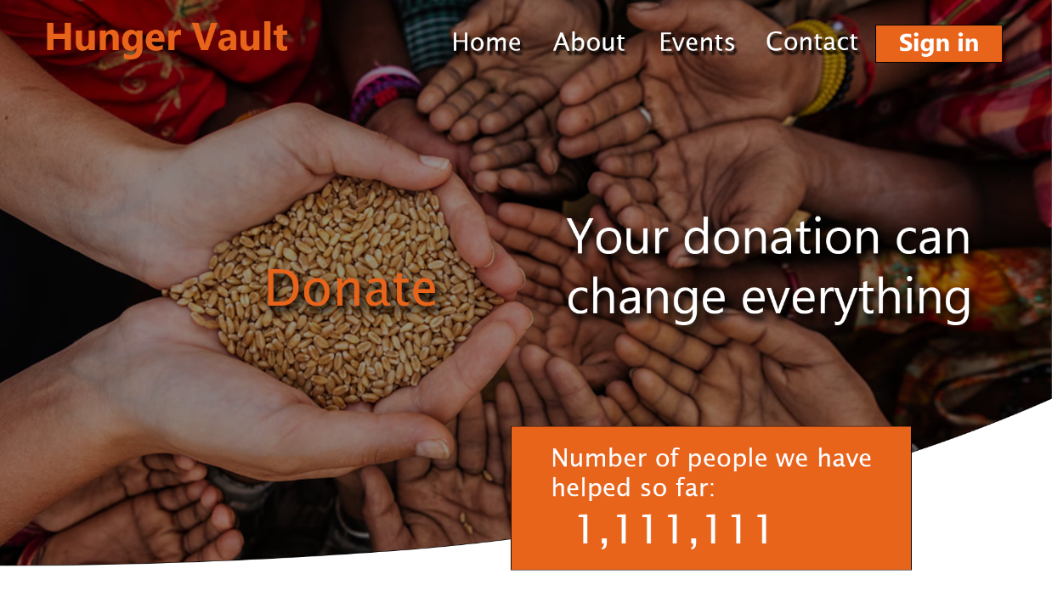

Figure 2: First 'good' home page design

This Photoshop mock-up of the home page was the first design made, loosely based on the above rough sketch. As mentioned, several key features are consistent, namely the logo in the top-left, navigation in top-right, and attention-grabbing splash image together with a slogan. All of these features have been refined here, reducing cognitive load by using as few words as possible to communicate intent, as dictated by Hick’s Law. This is most evident in the use of single words for navigation items, also adhering to Jakob’s principle by utilising common conventions for website subsections.

A criticism of the design however, could be the potential for some of the text to be lost in the image background. This has been mitigated partially by dimming the image, however could be improved further by adding a coloured border to some text items.

Kinematic load is minimised here by keeping navigational items in a distinct area, and ensuring that the ‘Donate’ button is large and obvious enough that users who intend to do so are well-guided to the correct section of the website.

The ‘number of people helped so far’ box can also show the contribution made by the organisation so far, and perhaps encourage users to stay on the website to see the facilities which made these donations possible.

Figure 3: Final home page design

This final design features small changes from the previous – most noticeably, the orange border around the header. This provides additional contrast, and allows users to more easily distinguish the important sections of the page, following the Law of Common Region. Shadows added to the text which is over the image allows these areas to also be observed easily.

## Events Page

Figure 4: Events page design

This design for the events page is intended to allow volunteers to view upcoming events, read about them, and potentially RSVP if they are interested. Here is only intended to show a preview of the events – clicking on a ‘Learn More’ button should direct volunteers to another web page which includes more details, such as time and location. This design adheres closely to the Law of Common Region, separating each event into individual boxes, as well as containing the three of the examples together in a common area on the page. Cognitive load would have to be carefully managed on this page once implemented, as if the events were given too long of a description, the flow of the page in general could be thrown off as too much text is on screen at once. This could be enforced by applying a strict rule to how much text could be included as a description.

Kinematic load is also reasonably low, as each event has a separate ‘Learn More’ button positioned very near its associated description text.

## Profile Page

Figure 5: Profile page design

This page intends to showcase all aspects of a user’s profile, or present placeholder text in the case that some details have not yet been provided. These sections are well-segmented, with headers showing what each section of the page displays. A potential improvement, however, could be to differentiate action items (view participants, post update etc) from information items (personal info etc). This could be done by adding an on-hover property, or giving the action items a background.

The same navigation bar as for the home page is used here, again minimising kinematic load by having navigational items nearby each other.

Cognitive load, however, could be of a concern depending on how many user details are decided to be shown in a final design. An approach to reduce the risk of this could include using drop-down boxes to hide information until the user chooses to show it, or a show more button to load more information.

## About Page

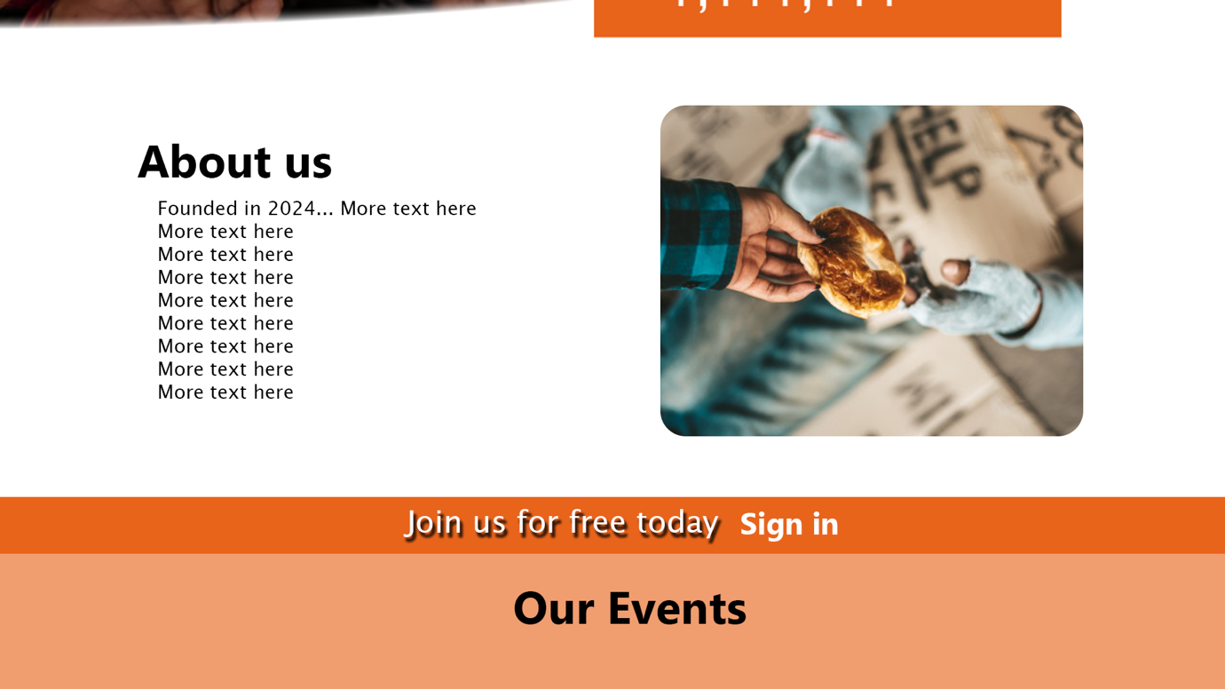

Figure 6: About page design

Finally, this section of the website should give a brief description of our organisation, and prompt users to navigate to a dedicated page to learn more. This section is located below the home page, and above the events page, and so has only limited space to address its purpose. Positioning the image adjacent to the text also helps engage users, and could serve to reduce cognitive load by avoiding this section simply being a ‘wall of text’. The ‘Sign In’ option is the only action item on the page, minimising the kinematic load of this section.