The Second Brain
Phase 2 — How Tagging, Embedding, and Retrieval Work
A plain-language walkthrough of the baseline retrieval pipeline: what each piece does, how data flows through it, and the design decisions behind the shape.
What Baseline Tagging Means
Every message sent to ChatGPT needs a simple yes-or-no label: is this personal, or is this a task or homework question? Hand-labeling all 5,530 user messages is not practical. That is what the 250-message sample was for, to build and test a labeler. Once that labeler, the classifier, is good enough, it is pointed at the whole corpus to tag every message automatically. Tagging just means running the classifier once per message and writing down what it said. Nothing more mysterious than that.
The Pipeline At A Glance
Three files, three jobs, one direction of data flow. Nothing loops back.
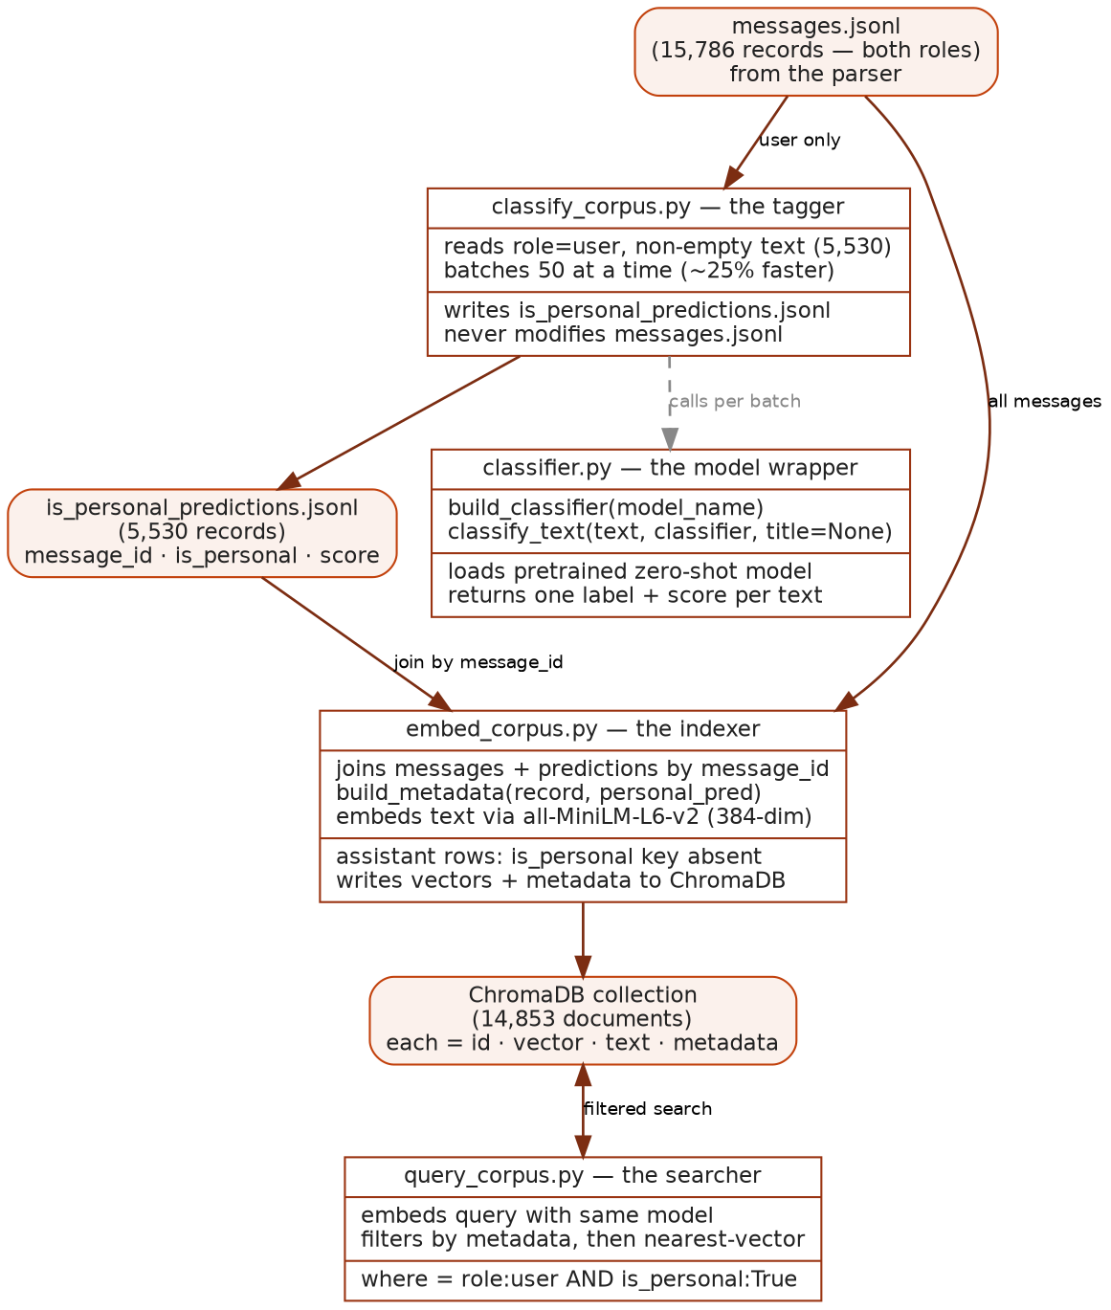
Piece 1 — classifier.py, The Model Wrapper
This is the lowest-level piece. It does not know about files or the corpus at all. It takes one piece of text and returns a label. build_classifier() downloads and loads the pretrained zero-shot model once, which is expensive, and returns a reusable object. classify_text() is the actual question-asker.
def build_classifier(model_name="MoritzLaurer/deberta-v3-large-zeroshot-v2.0"):
device = "mps" if torch.backends.mps.is_available() else "cpu"
return pipeline("zero-shot-classification", model=model_name, device=device)
Under the hood the model is not really choosing. It independently scores how well each of two sentences, "This message is an expression of personal feelings" versus "This message is a factual question," logically follows from the input text, then the higher-scoring one wins. This is zero-shot classification: a pretrained model applied to categories it was never specifically trained on. The 250 hand-labels are used only to grade it, never to train it.
Key idea: The classifier is zero-shot, not supervised or unsupervised. The categories are defined by us through label descriptions, and no training happens on our data. Our labels are the evaluation set.
Piece 2 — classify_corpus.py, The Tagger
This runs the classifier over the whole corpus. It reads all 15,786 parsed messages, keeps only user messages with non-empty text, and feeds them to the classifier 50 at a time. Batching is about 25 percent faster on the machine's accelerator with no effect on correctness. The output is a brand new file that holds only message_id, is_personal, and score. It never touches the parsed messages file.
user_records = [r for r in records if r["role"] == "user" and r["text"].strip()]
for i in range(0, len(user_records), BATCH_SIZE):
batch = user_records[i : i + BATCH_SIZE]
results = classifier([r["text"] for r in batch], candidate_labels=[...])
# write message_id, is_personal, score to predictions file
Two things this filter line quietly does. It drops all assistant text, because assistant messages never get a personal or task label, per the locked design. And it drops user messages with empty text, which is why 5,655 user messages become 5,530 classified. Those 125 skipped messages are empty or whitespace-only, and skipping them is correct.
Piece 3 — embed_corpus.py, The Indexer
This joins the tags back onto the messages and indexes everything. For every message it looks up whether a tag exists by message_id. If it does, is_personal and personal_score are attached to that message's metadata. If it does not, meaning it is an assistant message that was never tagged, that key is simply absent from the dictionary. Then each message's text is handed to ChromaDB, which computes an embedding vector and stores it alongside the metadata.
predictions = {p["message_id"]: p for p in ...} # 5,530 tags
def build_metadata(record, personal_pred):
metadata = {"role": record["role"], "conversation_id": ..., ...}
if personal_pred is not None:
metadata["is_personal"] = personal_pred["is_personal"]
return metadata
Needs verification. Because assistant messages have no tag, their is_personal key is absent rather than false. This is the right behavior, but it should be confirmed that no query filter ever relies on is_personal without also filtering role to user, otherwise a plain is_personal filter could behave unexpectedly on untagged rows.
The Embedder, In Simple Words
An embedding is just a list of numbers, 384 of them for this model, that represents what a piece of text means. The useful trick is that text with similar meaning ends up close together in that 384-dimensional space, even without shared words. "I'm nervous about my exam" and "I'm anxious about the test" land near each other; "I'm nervous about my exam" and "how do I calculate a derivative" land far apart. Search is built entirely on this: turn everything into number-lists, and searching just means finding the number-lists closest to the query's number-list.
Important for the meeting: we did not build this embedder. all-MiniLM-L6-v2 is a small, general-purpose, off-the-shelf pretrained model, and it is deliberately the baseline. The research contribution in weeks 3 and beyond is fine-tuning a model that understands emotional similarity better than this generic one. Everything built here exists so that later comparison is possible. This is the thing the custom model has to beat.
How It Ties Into ChromaDB
ChromaDB looks things up not by exact match, but by which stored vectors are closest to a given one. It needs something that knows how to turn text into vectors, and it has a plug-in slot for exactly that. A wrapper that ships with ChromaDB takes text in and hands back number-lists in a shape Chroma understands. Once it is handed to Chroma, Chroma calls it automatically whenever text goes in or a query comes in. The persistent client writes everything to disk, so the vectors survive after the script finishes and 14,853 messages do not have to be re-embedded on every search.
What A Single Stored Item Actually Is
For each batch, one call does three things at once: it hands the raw text to the embedding function and gets vectors back, it stores for each message the vector for searching, the original text so you can see what you found, the id so you can trace it back, and the metadata for filtering, and it writes all of that to disk together as one bundle.
collection.add(
ids=[r["message_id"] for r in batch],
documents=[r["text"] for r in batch],
metadatas=[build_metadata(r, predictions.get(r["message_id"])) for r in batch],
)
So a stored item is not just a vector. It is a bundle of id, vector, text, and metadata. That bundling is what makes filtered search possible: when the searcher asks for the closest vectors to a query but only among documents where role is user and is_personal is true, Chroma first narrows to documents whose metadata matches, then does the nearest-vector search only within that narrowed set. The metadata filter and the vector math are two separate steps working together, not one blended thing.
Key idea: The metadata filter and the vector search are separate cooperating steps. Chroma narrows by metadata first, then finds nearest vectors within that subset. This is what makes role and is_personal work as free filters.
Why Three Files Instead Of One
Each stage produces a file that is inspectable and reusable on its own. If a future attempt at the classifier ever happens, only the tagger is re-run to produce new tags. The indexer does not change, and nothing has to be re-parsed. This is the same keep-the-stages-decoupled principle from the original parser design, where the parser's JSONL output was kept separate from any database-loading step. Same idea, one layer up.
What The Baseline Showed
A search filtered to the user's personal messages correctly isolates personal content, and it retrieves by topic rather than by feeling. Two messages that are both anxious but about different subjects land far apart. That topic-based imprecision is not a bug. It is exactly the limitation the emotion-tuned model is meant to fix, and it is why the baseline exists: to be the measurable before.
One honest finding. Boilerplate strings such as reasoning-model placeholders appear verbatim many times across the corpus. Identical text produces identical embeddings, so these duplicates cluster together and can flood unfiltered search. This is logged as a cleaning consideration for later, a real lead rather than a bug to panic about.

