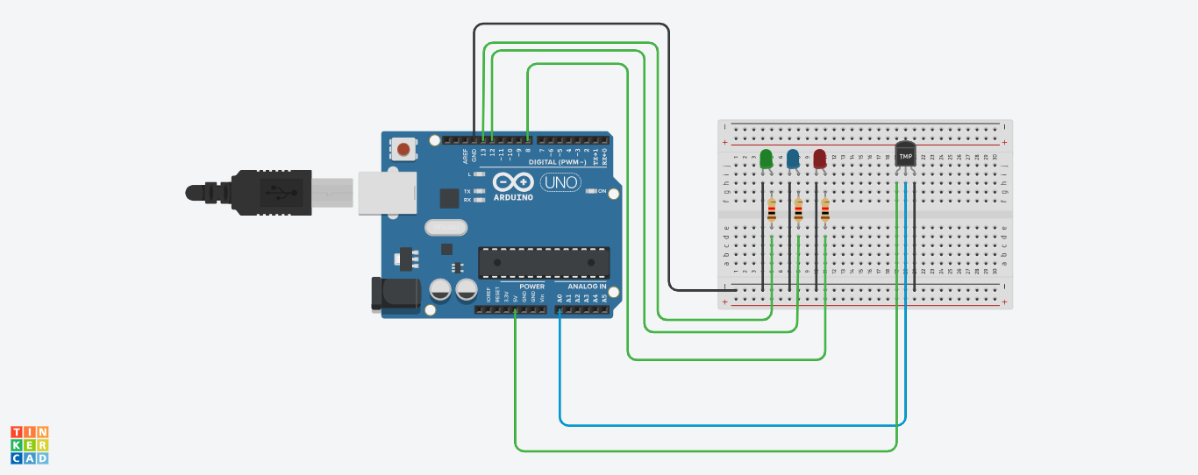

int led1 = 13;
int led2 = 12;
int led3 = 8;
int temp = A0;

void setup()
{
Serial.begin(9600);
pinMode(13, OUTPUT);
pinMode(12, OUTPUT);
pinMode(8, OUTPUT);
}

void loop()
{
int tempRead = analogRead (temp);
Serial.println(tempRead);

if (tempRead > 176 && tempRead < 186)
{
digitalWrite(13, 1);
digitalWrite(12, 0);
digitalWrite(8, 0);
}
else if (tempRead > 186 && tempRead < 203)
{
digitalWrite(13, 1);
digitalWrite(12, 1);
digitalWrite(8, 0);
}
else if (tempRead > 203)
{
digitalWrite(13, 1);
digitalWrite(12, 1);
digitalWrite(8, 1);
}
else
{
digitalWrite(13, 0);
digitalWrite(12, 0);
digitalWrite(8, 0);
}
}

